Introduction
to
Best of In2-MeC
by Abhaya Mudra Dasi
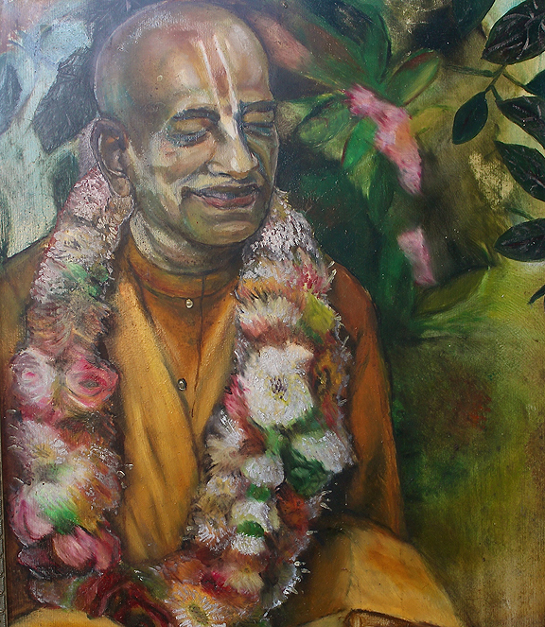

Shrila Prabhupada by Abhaya Mudra Dasi (1996)
It is very difficult to write about Shripada Shrila Suhotra Maharaja since he is an individual of many dimensions. He had personal relationship with quite few of his disciples, initiates of his God-brothers and some of his God-brothers also. All would agree that His Holiness was an erudite scholar who had vast knowledge not only in subjects related to devotional service, but also to history, anthropology, philosophy and sociology.
I met Shrila Suhotra Maharaja for the first time at a university program around 1990, but let’s go back a bit. I had already been a devotee for some time on my own, but I had decided to approach the devotees—who seemed to me to be a bit odd. But since I wanted to learn the full process of Krishna consciousness, I took the courage to seek them out. I found them in a tiny and very uptight place in the center of Sofia. They had no Deities and followed no proper program. However, I took an interest in their lives. They informed me that Shrila Suhotra Maharaja was their guru and that he visits Bulgaria twice a year. I was intrigued and wanted to meet him; moreover I had promised myself to accept as my spiritual master the first guru who would appear before me. I had sufficient trust in Lord Shri Krishna that He would guide me to the right one.
When I met him, my first impression of Shrila Suhotra Maharaja was that he was quite unusual. He started singing and his voice trembled, sometimes out of tune. I was surprised that even such singing could actually sound quite nice. My sister Liliya and I sang along to his tune, after which he spoke briefly. There was another guest with him and thus he allowed the presentation to be completed by him.
At the end of the talks, people surrounded Suhotra Maharaja to ask questions. Although I was not able to even come close to him, I observed him from a distance. Later I was surprised to learn that he had actually noticed me. I was wearing a black suit in a very manly style with a hat quite similar to what the actors in the films noir wear. Maybe that is what caught his attention. Although I never dressed in that style again, when meeting Suhotra Maharaja he often mentioned that he remembered me dressed in that black suit. Perhaps he had some sixth sense vision as well.
Since the first time I met him I was not able to speak with him, I was determined to see him again, which would be when he visited Varna on the Black Sea coast. Varna is a popular summer vacation spot where people come from all over Europe to enjoy the beach, which makes it a nice place for summer preaching. A friend back in Sofia had taken the key to their unfurnished apartment without her mother’s knowledge, and she gave it to me and Liliya. Although our place in Varna wasn’t exactly secure, it was better than nothing.
We went to see Suhotra Maharaja’s programs which had been organized at a local cultural hall. We were sitting in the audience while he was giving his lecture when all of a sudden I caught his gaze. I took in every word with a deep understanding. He was speaking about the perceptions that we have in this world. He explained how everything we can imagine already exists somewhere, and is based on something we have already seen.
He started looking in my direction. Usually, a lecturer selects one or two persons from the audience who are listening attentively, or a listener who displays a positive attitude towards the lecturer. Then he speaks to them while giving the impression that he is speaking to the entire room. And because of such a good rapport with only one or two individuals in the audience, the lecturer is able to deliver a nice presentation. After experiencing Suhotra Maharaja speaking to me in this way, I definitely wanted to meet him and speak with him.
I met the devotees who were selling books and asked them where Suhotra Maharaja was staying in Varna. As it so happened, he was staying quite a distance from Varna. The trip was difficult and it took a few hours to locate the house where he was staying along with several other devotees. When we arrived, we were offered prasadam after which I requested darshan. The then-temple president refused my request, and would not allow me to see Suhotra Maharaja. His excuse was that I am not chanting his pranama-mantra and I do not visit the temple often enough. I became quite incensed and told him in no uncertain terms that nothing can stop me from meeting my guru. By that time I felt as if I had known Suhotra Maharaja for many lifetimes. I rushed out of the house in tears and cried all the way back to Varna.
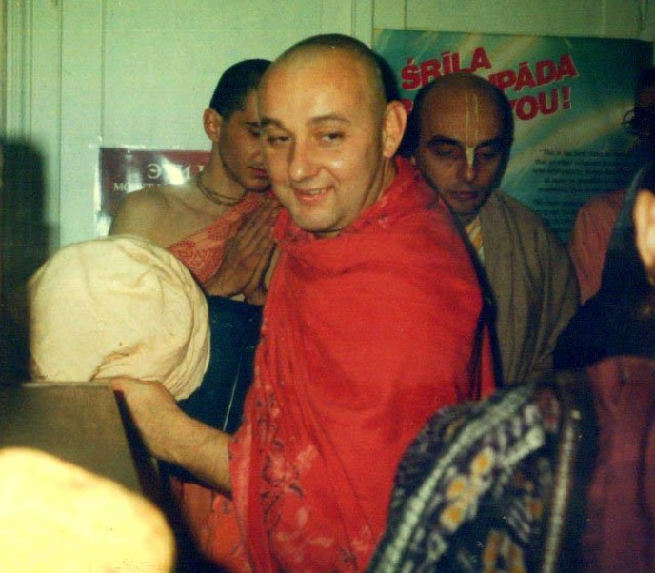

Shrila Suhotra Maharaja in Sofia during the early ‘90’s. Behind him on left is the famous book distributor Sthanu dasa. On the right is the then temple-president the late Kanjalochana dasa.
Now determined to meet Suhotra Maharaja again, I decided that I should henceforward visit the Sofia center regularly. When he returned to Sofia the following November, this time the temple president allowed me to meet Suhotra Maharaja. About hundred people had come to hear from him and in that tiny hall I had to jump over many of them. I entered his room with my sister and paid obeisance. She could not speak English and although my English was not the best either, I began to translate. It took some time and a little patching of phrases together before we got into a conversation. He was beaming with a white light and I could literally see a halo around him. He was very jolly and seemed to take an interest in us. He asked questions about our practicing Krishna Consciousness. Later, he would write to me that the first time he saw me that I spilled my heart on the floor in front of him. We saw him once or twice more before he was gone again.
On each consecutive visit I had his personal darshan, as by now the relationship of guru and disciple was growing deeper. We spoke on the philosophical aspects of Krishna consciousness. He showed much interest in our preaching, in my paintings and in our future plans. He seemed to recognize some potential on many levels. I often translated the personal exchanges between other Matajis and Suhotra Maharaja.
In December 1993 I took initiation from Suhotra Maharaja in Sofia. The initiation was small, only two devotees but still Suhotra Maharaja did the full program with yagna, lecture, bhajan and prasadam. Although my initiation had not been certain because nobody had recommended me, Suhotra Maharaja personally decided to initiate me at the last moment. I had recently purchased a
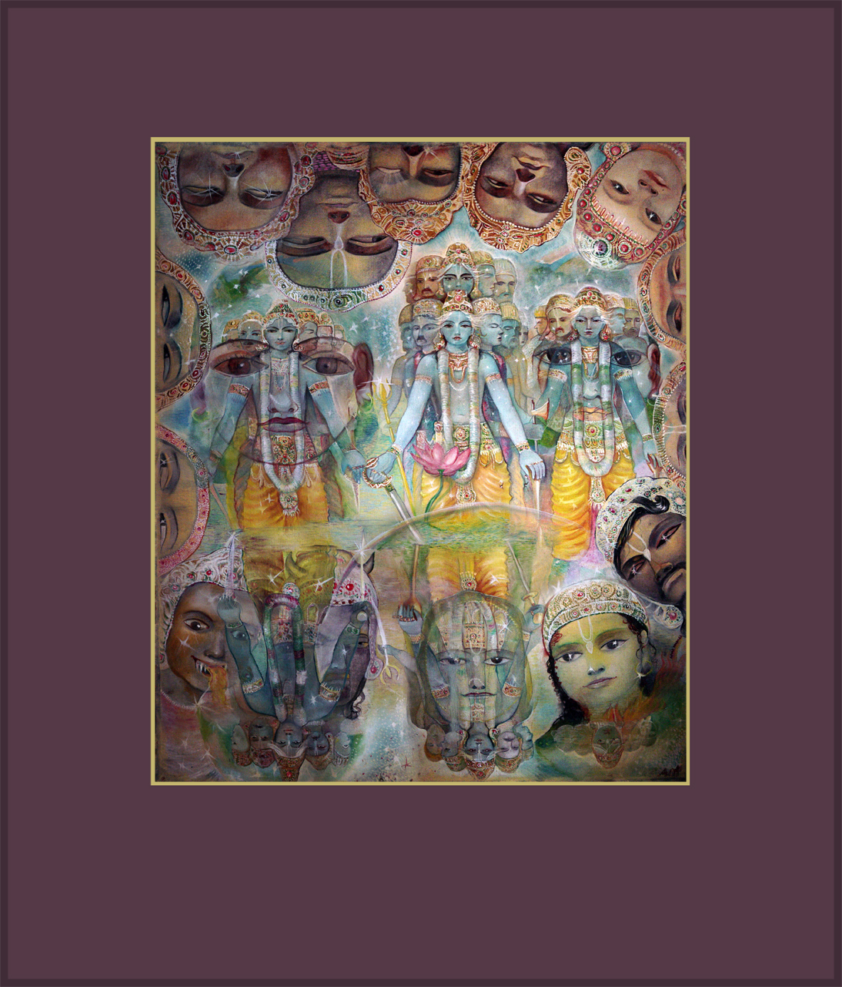

The Universal form by Abhaya Mudra Dasi (1993)
flat in Blagoevgrad which was becoming a preaching center which Maharaja called my bhajan kutir. In few years time this place would become a regular stop for the sankirtana devotees as well as a starting point from some preaching programs. It became my personal art studio from where many Krishna conscious painting came into the world.
In 1997 I went to study in USA on a full scholarship at the Savannah College of Art and Design in Georgia. During the first months of my stay I could not communicate with Suhotra Maharaja either via telephone or internet. Although I have come with the intention to study computer art, I had never even touched a computer before. I had to learn how to send an email and since I did not have a personal computer, my activities were limited to using public computers. There was a line for every machine. During these months I was sort of abducted by an Indian who later pretended to be my husband only to get his green card and live off my money. Finally when communication with my Guru Maharaja resumed, I was stuck with an impossible situation. Yet, during these years Suhotra Maharaja wrote to me almost every day and his hundreds of letters are a treasure of their own. He came to visit me three times in USA, staying for a month each time. In one of these visits he even requested me to become his mother in the future lifetime saying that he very much regretted the situation of his birth family.
His father was in the military and as a boy he had lived in Japan and in the Azores. Those travels would make a great impression on his life. But nobody visits places which he has not been connected to in the past. Suhotra Maharaja had the vibration of a Buddhist monk. He had definitely been involved with the study and discipline of all kinds of spiritually-oriented schools, including Buddhism, for many lifetimes. Through his correspondences, I began to know Suhotra Maharaja as a complex individual—not only as my guru. I began to know the essence of the person—his thoughts, his creativity and even his fears. We discussed topics related to everything black and white in the universe. He used to say that we have had these conversations back in Brahmaloka. He asked why some people imagine that there are no women on Brahmaloka. The women there are just like Goddess Saraswati—they are very learned and are the personified Vedas.
While Suhotra Maharaja was guiding me on my journey out of a dangerous relationship I was serving him in the capacity of someone who he can reveal his mind to. By the time his period of depression began I felt that I could understand him.
He did not want to lose his disciples although he was forced to by circumstances. Those that did not pass his test ended up with other gurus in ISKCON. He became very upset whenever he learned that one of his very close disciples had left him. I reassured him that I would never be unfaithful to the vow I had taken during initiation to serve him as my spiritual master. He was a real fighter for following the correct path in the footsteps of Shrila Prabhupada. Naturally he felt uncomfortable with any opportunist who wanted to replace or usurp him.
Some tried to turn his unique views of certain angles of Krishna consciousness into transgressions. Once, even my sister became critical of him due to his reading so-called karmi books. She wanted to see exactly what kind of nonsense was in the book. To her surprise she could not read the book. All she could see in the text were the names of Shri Krishna and Rukmini and stories about Them. Even if he appeared to study a karmi book, actually all he saw in them was the energy of Shri Krishna. He sometimes ventured in difficult and dangerous territories in order to explore yet another angle to the Absolute Truth. He was not a person to be confined by a dry following of the rules and regulations of devotional service. He was thirsty for the essence. Actually, he never stopped following the regulative principles and he always endeavored to increase his chanting. Though he made every effort to understand how to get the true nectar of Krishna Consciousness, some lesser minds became jealous or simply could not understand his genius.
But those who tried to understand him honestly and without judgment have experienced an unforgettable journey just by following his footsteps and observing his own journey. During his last months we spoke a lot about the experience of death. He was clear that he had few options but to leave this world behind. He could never abandon his life of renunciation as a sannyasi, yet towards the end he felt too confined as though he was not allowed to express his talents appropriately. He felt that he needed to go to some new place where all this could be possible. Despite the fact that I knew what his plan was, I interrupted out our correspondence to give him time to detach from it. When I was told that he left his body, it felt as though a hurricane had come over me, I was left with the kindness of words in his last letter.
He often told me that he was writing In2-MeC only for people like me. He was very happy that I was going online to read his journal from time to time. In2-MeC was yet another perspective on his life that was a bit more public than his personal correspondences. After all, he was quite aware that it was being read by a broad spectrum of readers. He knew that he would have to be careful about what he wrote, especially when it came to his most intimate moments and deepest realizations. To this day, even for those who believe that he is gone, still In2-MeC continues to be fresh and it can be read as if it was just written yesterday. Reading In2-MeC gives us the practical realization that he is still here and very much alive. He still longs for serving Shri Krishna even as he offers his readers deep and profound confessions of his soul. He never spared anyone, not even his own self, from his objective gaze.
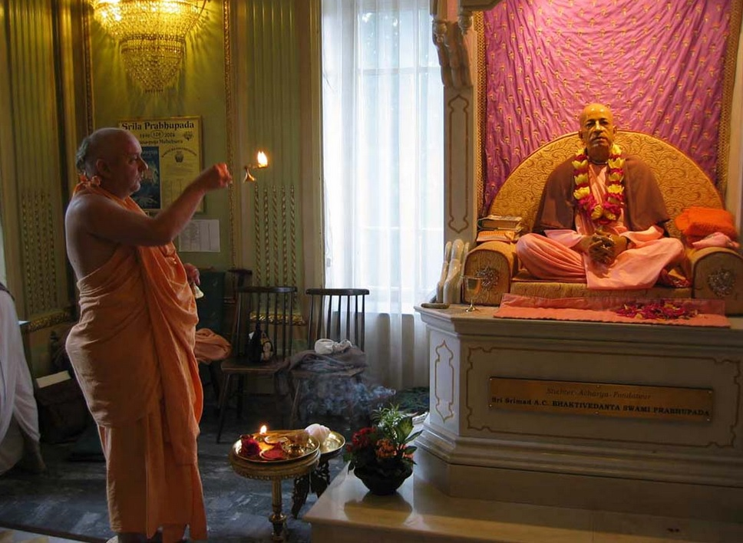

Adoring Shrila Prabhupada: His Holiness Shripada Suhotra Maharaja, Radhadesh (2004)
I very much hope that everyone who has exposure to The Best of the In2-MeC will appreciate now that it is in a more readable format, the true genius of this great seeker of Truth and servant of Shrila Prabhupada. I pray for his heart and soul and always wish to continue to walk in the footsteps of my Guru Maharaja Shripada Suhotra Swami. Hare Krishna!
Written: 18 March 2019, Amalaki Ekadashi.

