

Part Five

4th September 2004
-
4th January 2005

Kiev, the Ukraine
4 September 2004
Odessa, Karkhov, Kiev
29 August--04 September

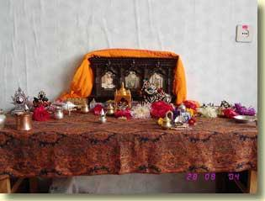
My Salagram altar, Odessa.
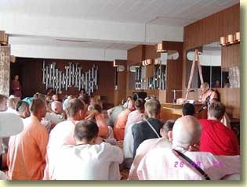
HH Bhaktivaibhava Maharaja giving a seminar, Odessa.

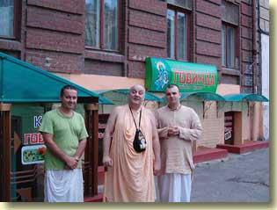
With Premavanya and Dvijata Pujaka, standing before Govinda's restaurant in downtown Odessa.
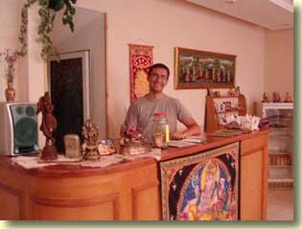
Govinda's is run very successfully by Bhakta Sasha.

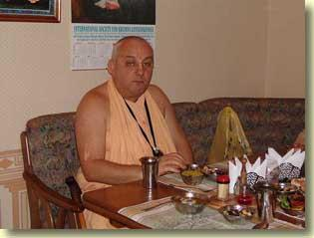
The prasadam is absolutely exquisite!
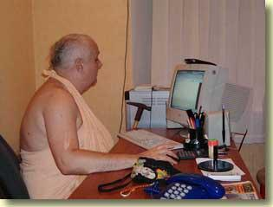
Doing my email and In2-MeC work in Sasha's office.

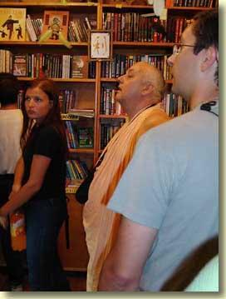
  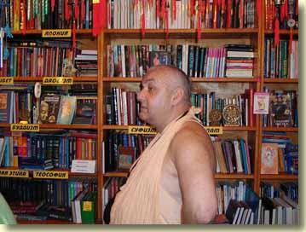
  In search of altar paraphenalia, I was taken by Sasha to a couple of esoteric import shops in Odessa. Note the brass chakras on the bookshelf. In one shop I purchased a jar of sandalwood powder mixed with saffron dust. Just add water and you have very nice chandan pulp for decorating Sri Salagram after His morning bath.

  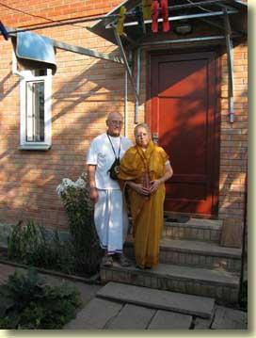
  From 30 August through 2 September I was at Kharkov. There I stayed at the home of Sandipani Muni das and his good wife Premasagara dd. Sandipani Muni was formerly a general in the Soviet Army.
  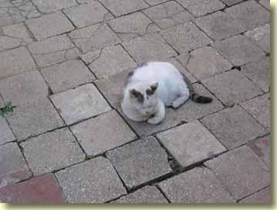
  This is Jan the Cat, who guards Sandipani's home day and night.

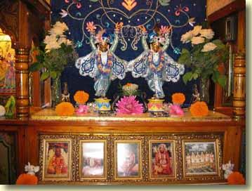
Sri-Sri Gaura-Nitai, ISKCON Kharkov. The temple is a few minute's walk from Sandipani Muni's house.

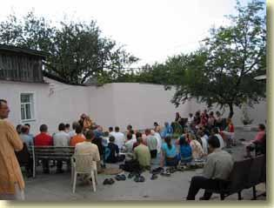 | 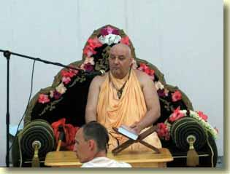
Evening program in the temple yard.

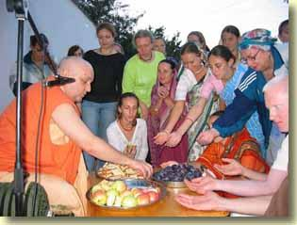
Prasad distribution to devotees and guests, ISKCON Kharkov.
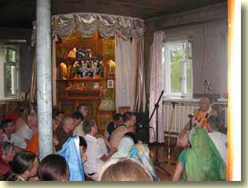
Srimad-Bhagavatam class, ISKCON Kharkov.

  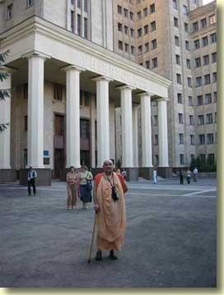
  I visited Kharkov University...
  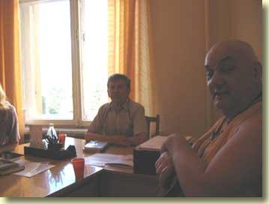
  ...where I met Professor Zechmistro, a philosopher of science, and his colleagues. We had an engaging discussion about quantum physics, consciousness, and God. Professor Zechmistro believes that modern atomic physics does not disprove ancient Indian and Greek wisdom about the nature of the world. Physics only points to a deeper reality which science cannot penetrate. I didn't tell him about the ISKCON MacNewletter article...he would have had a good laugh if I did!

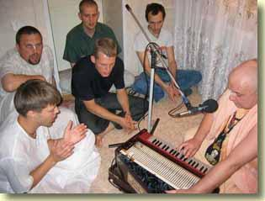 | 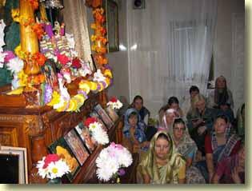
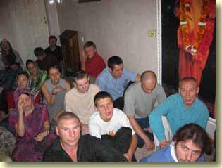 | 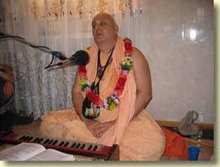
Now I am in Kiev, where there are two ISKCON centers. One is a large temple in the suburbs. The other is a preaching center downtown. Today I gave a Gita class at the downtown center.

Kiev, the Ukraine
5 September 2004
Notes from Srila Bhaktisiddhanta Sarasvati Thakura's rendition of Srimad-Bhagavatam 1. 2. 16, translated by Punya-palaka Prabhu of ISKCON Prague.
The verse as it appears in the BBT edition of Srimad-Bhagavatam, translated by His Divine Grace A. C. Bhaktivedanta Swami Prabhupada:
susrusoh sraddadhanasya
vasudeva-katha-rucih
syan mahat-sevaya viprah
punya-tirtha-nisevanat
O twice-born sages, by serving those devotees who are completely freed from all vice, great service is done. By such service, one gains affinity for hearing the messages of Vasudeva.
Srila Sarasvati Thakura's translation (rendered into English from the Thakura's Bengali):
O Saunaka and other sages, attachment to topics of Sri Hari arises in those who have faith in the words of sadhu, guru and sastra and who desire to hear about the Lord, as the result of visiting the holy places connected to Lord Visnu, serving the bona fide spiritual master and serving the saintly devotees of Krsna.
From Srila Sarasvati Thakura's explanation:
. . . The heart of a devotee of the Supreme Lord is a holy place, as is the place where he lives. These two kinds of holy places stimulate the awakening of taste for the topics of the Lord. Besides the tirtha-seva, another reason for awakening this taste is mahater-seva, a service to great personalities. Yasyasti bhaktir bhagavad akincana sarvair gunais tatra samasate surah / harav abhaktasya kuto mahad-guna mano-rathenasati dhavato bahih (SB 5. 18. 12).
. . . When one thoroughly discards bad association and associates with saintly great souls, then his bad taste transforms into taste for the topics of the Lord. . . . By serving the great souls, the proper behavior of the living entity is manifested, and he leaves aside the path of logic and reasoning. Then, accepting the path of hearing hari-katha, he takes shelter in devotional service called kirtana. The performer of kirtana ceases to consider the Lord and His illusory energy to be the same, and he exclusively dedicates himself to the service of the Lord.

This was sent in by a regular reader:
That's not a body, that's my wife!

Jeff Green is a 32 year old American who lives in Arizona. Not long ago his wife passed away. Due to the grief he suffered at her death, he did something totally out of character for a normal and sane person. He said, "I could no longer take the pain that my wife's death caused me and so I brought her back home. "
His wife, Lucy, was born with a heart condition that cut her life short at the young age of 29. Lucy's last words to Jeff were, "We will meet again in heaven. " But these words were of no consolation in Jeff's despair. At the funeral, in an act of desperation, Jeff decided that he would not let Lucy leave him.
"I called the cemetery caretaker and explained my feelings. " he said later. "I spoke with the authorities and got special permission to take my wife home with me. They thought it strange, but I was allowed to take her with me. I'd rather have her at home than six feet under ground. Lucy had a great sense of humor and I'm sure she would appreciate being my coffee table. "
Jeff ordered a special hermetically sealed glass case that eliminates the decomposition of a dead body. "It cost me about $6,000. 00, but it was worth it. "
Some of his friends and relatives, filled with fear, stopped visiting him, but his true friends respected his decision and continue coming over.
Some even comment that it makes a nice piece of furniture.

This question was emailed to me by a Bhakta in New Zealand:
Lately Ive been wandering what exactly is the exact definition of breaking the Gambling regulative principle. The other regs are quite clear. Gambling however has diffrent degrees and different forms including speculation.
For instance Gambling is generally in western terms meaning casinos and horse races etc. Dabbling with that with the expectation of making some money . It seems that the obvious transgression is that It leads to Lust and Greed and bad association etc.
However there are also other types of activity like lotto or buying a product which has attached to it a draw one can enter into to say win a car etc , by answering a question.
Also there is dabbling in various forms of sharemarkets and stock exchange. Its interesting that once Shyamasundara and Srila Prabhupada Dabbled in gold. Of course it was Shyamasundara who first bought the Gold . Then Srila Prabhupada Kind of joined in the fun. However after this he said Shyamasundara is expert wheras its better that no one else does this. In one sense buying and selling things is kind of similiar. Or entering into a business partnership with some idea of making some gain.
So my Question is what exactly constitutes breaking this principle. For instance Im aware that some devotees buy lotto tickets which could be seen as being in one sense less innocent compared to say entering a gambling casino.
I would very much appreciate what you would have to say.
Srila Prabhupada counted mental speculation as a transgression of the "no gambling" rule. See for example his letters to Dinadayal das (70-02-02), Hanuman Prasad Poddar (70-02-05), and Manmohini dasi (70-02-21). In addition, there's a letter from Srila Prabhupada to his disciple Sacisuta das in Boston, dated 68-05-30. In it Srila Prabhupada discussed the rules that initiated devotees must follow. Along with the 4 regulative principles and the 10 offenses against the holy name, several other rules are listed, including these two:
Should not waste time in idle talks
Should not become engaged in frivolous sports
In my mind, idle talks and frivolous sports are subsets of gambling, which basically means to take an unauthorized risk.
Srila Prabhupada clearly did authorize risk-taking in the preaching field. Consider this statement, from a 1968 lecture:
Krsna said that devotees, that you should not disturb them. [Prabhupada means that Krsna said in the Gita that devotees ought not to disturb persons who are attached to material activities. ] But devotees are so kind that taking all risk. Just like Nityananda Prabhu took all risk, Lord Jesus Christ took all risk. Therefore a devotee is more kind than God. A devotee is more merciful than God Himself. We should always remember this. And therefore Krsna says, mad-bhaktya pujyabhyadhika. "Anyone who worships My devotee, he worships more than what he can do for Me. " That means He appreciates the worship of His devotee than to Himself. So actually, devotees are so kind. Krsna says, "Those who are absorbed too much in material consciousness, don't disturb them. " But devotees take the risks, even at the cost of life. Therefore devotee is so dear to Krsna.
Betting money in a casino, or playing the lotto, or even just letting the mind wander here and there in haphazard mental speculation, or wasting time and energy in idle talks and frivolous sports, all amount to taking risks that are not sanctioned by our Founder-acarya. Gambling does not only entail the risk of losing money. When one engages in foolish thoughts, idle talks and frivolous sports, one risks being caught by death in the midst of material consciousness.
You mentioned Srila Prabhupada's gold-buying adventure with his disciple Syamasundara Prabhu, which took place during a visit to Switzerland. Yes, there was an element of risk involved in that--but obviously that risk was entirely for Krsna's service. And as you pointed out, Srila Prabhupada did not intend for other disciples to take such financial market risks, even if in the name of Krsna's service. The falldown of one of ISKCON's big leaders a few years ago was attributed by observers to his risking Krsna's laksmi in the Russian financial market.
In conclusion, I think it is useful to equate "gambling" with "risk-taking" because
1) by understanding what kinds of risk-taking are encouraged and what kinds are forbidden, we learn that there are gambles that can be rightly and properly taken in devotional service;
2) plus we learn that the rule against gambling encompasses more than just the games of hazard (roulette, cards, horse-betting) that in karmi society typically go under the rubric gambling.
Ergo, authorized risks constitute the absolutely best service that one can perform for the Lord; while unauthorized risks constitute gambling.

I will spend Janmastami and Srila Prabhupada Vyasa-puja in the Kiev temple. On the evening of 7 September I take a train to Dnepropetrovsk. The photo report about the Kiev festivities will be uploaded from there.

Kiev, the Ukraine
6 September 2004
Sri Krsna Janmastami ki jaya!

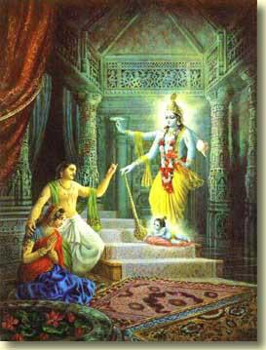 | 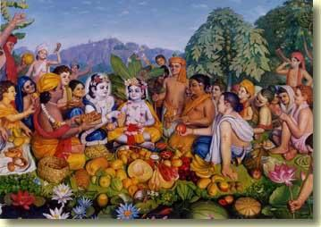

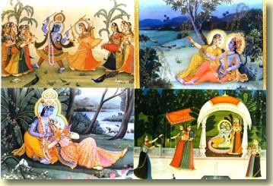 | 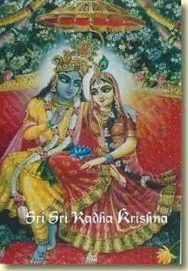

Notes from Srila Bhaktisiddhanta Sarasvati Thakura's rendition of Srimad-Bhagavatam 1. 2. 17, translated by Punya-palaka Prabhu of ISKCON Prague.
The verse as it appears in the BBT edition of Srimad-Bhagavatam, translated by His Divine Grace A. C. Bhaktivedanta Swami Prabhupada:
srnvatam sva-kathah krsnah
punya-sravana-kirtanah
hrdy antah-stho hy abhadrani
vidhunoti suhrt satam
Sri Krsna, the Personality of Godhead, who is the Paramatma [Supersoul] in everyone's heart and the benefactor of the truthful devotee, cleanses desire for material enjoyment from the heart of the devotee who has developed the urge to hear His messages, which are in themselves virtuous when properly heard and chanted.
Srila Sarasvati Thakura's translation (rendered into English from the Thakura's Bengali):
Bhagavan Sri Krsna, the hearing and chanting of whose name is the supreme source of liberation and who is the benefactor of sadhus, in the form of Antaryami Caitya-guru of all human beings uproots the heaps of sinful desires in the heart of one who engages in hearing His transcendental katha or names and qualities.
From Srila Sarasvati Thakura's explanation:
The only friend of great sadhus is Krsna. When, after entering one's ears in the form of sabda-brahma, He is glorified in the form of nama-brahma, then there is no way for all kinds of inauspicious illusory enjoyments to stay in such a person's heart. The sword of remembering Hari, mentioned earlier, cuts the other thoughts, thus completely destroying plans for enjoying maya. This sense gratificatory business, performed under the external energy of the Lord, is endangering by many anarthas. If Antaryami Krsna is being served by hearing and chanting, the living entity's thirst for getting the fruits of external enjoyment cannot stay.
Srila Visvanatha Cakravarti Thakura writes about this verse:
tatas ca srnvatam iti kramena sravana-kirtane ukte. tatas ca hrdi yany abhadrani papani antah-sthah san vidhunotiti smaranam.
The Bengali translation of Srila Cakravartipada's Sanskrit that Srila Sarasvati Thakura gives in his commentary:
tarpor (orthat sri-guru-pada-padmer
asroe labhe sri-vasudev kothate ruci labher por) srnvatam orthat sri-krsner
kotha srovon-kari manov-goner. Ekhane krame sravan o kirtaner (orthat
prothome sravan o pore kirtaner) kotha bola hoiyache. tarpor sadhaker hrdoye
ye somosto amangal (orthat aparadha-janito) pap-basona-samuho vidyaman,
seiguli sri-krsna (antaryami-rupe ba caitya-guru-rupe) ontoh-stho hoiya
vidhauto koren, ihar dvara smaran onger nirdes kora hoilo.
This means:
Thereafter (in other words, after obtaining taste for Sri Vasudeva-katha, having taken shelter at the lotus feet of the spiritual master)--srnvatam means "of humans who engage in hearing Krsna-katha"--here the talk is about gradual development of hearing and chanting (i. e. first hearing and then chanting). Thereafter, whatever inauspicious (originating from offenses) sinful desires are there in the sadhaka's heart, Sri Krsna (in the form of Antaryami or of Caitya-guru) residing within destroys them all; through this, remembering has been established.

Kiev, the Ukraine
7 September 2004
Srila Prabhupada Vyasapuja ki jaya!
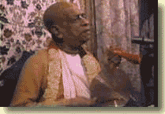
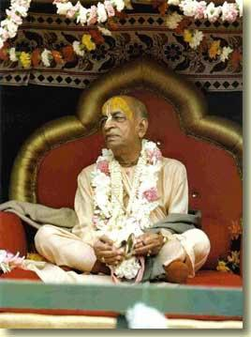

Notes from Srila Bhaktisiddhanta Sarasvati Thakura's rendition of Srimad-Bhagavatam 1. 2. 18, translated by Punya-palaka Prabhu of ISKCON Prague.
The verse as it appears in the BBT edition of Srimad-Bhagavatam, translated by His Divine Grace A. C. Bhaktivedanta Swami Prabhupada:
nasta-prayesv abhadresu
nityam bhagavata-sevaya
bhagavaty uttama-sloke
bhaktir bhavati naisthiki
By regular attendance in classes on the BhAgavatam and by rendering of service to the pure devotee, all that is troublesome to the heart is almost completely destroyed, and loving service unto the Personality of Godhead, who is praised with transcendental songs, is established as an irrevocable fact.
Srila Sarasvati Thakura's translation (rendered into English from the Thakura's Bengali):
By always attending upon a pure devotee and by hearing and chanting the Srimad-Bhagavatam, all that is inauspicious or bitter is almost completely destroyed and one's steady and undistracted loving service to Sri Krsna, who is praised with transcendental songs, becomes awakened.
From Srila Sarasvati Thakura's explanation:
Through the service to Srimad-Bhagavatam the scripture, and as a result of serving those who live according to the instructions written there, the whole false ego, and absorption in things other than Krsna, are left in the past, and thus the supreme achievement, naisthiki bhakti, or the constant engagement in the service of the Lord, is achieved. To which extent all the unfavorable desires opposing the Hari-seva become weakened, to that extent naisthiki bhakti becomes more and more prominent. The irrevocable loving service cannot appear without rejecting asat-sanga. The bad association of bhogis, karmis and falsely renounced jnanis is effaced through association of a devotee of the Lord. At that time the bad activities of the non-devotee society are no more performed.
Srila Visvanatha Cakravarti Thakura writes about this verse:
bhagavatanam vaisnavanam bhagavatasya sastrasya ca. nasta-prayesv iti. nanaparadha-laksanasyabhadrasya kascana kascana prabalo bhagah ksinatvam gacchan rati-paryanto 'pi bhavatiti bhavah. naisthiki nistha cittaikagryam tam prapta.
Srila Sarasvati Thakura's gloss of Srila Cakravartipada's comment:
Bhagavata-sevaya refers to the devotees of the Lord and to the book Bhagavatam. The meaning of nasta-prayesu is that although one achieves diminishing of all kinds of influences of the hindering offences against the holy name or, in other words, of his anarthas, some remnants remain up to the level of rati. Naisthiki or nistha means single-mindedness, the awakening of steady bhakti.

Dnepropetrovsk, the Ukraine
9 September 2004
Photos from Janmastami-Vyasa Puja, Kiev 2004

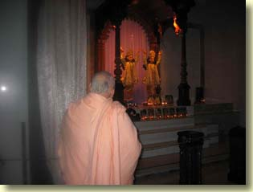 | 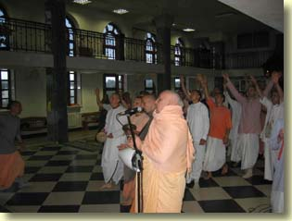
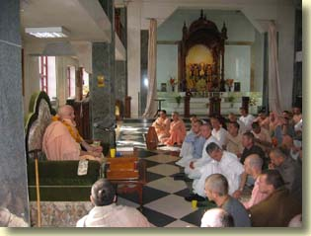 | 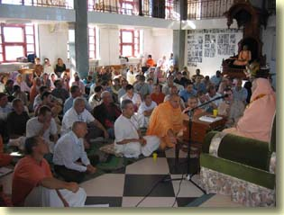
Morning in Kiev temple: mangal arati, Deity greeting, and Srimad-Bhagavatam class.

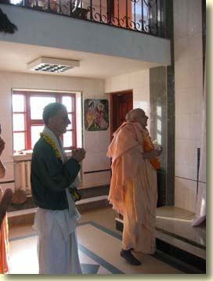
His Grace Yadubara Prabhu arrived in Kiev on Janmastami morning. Here we take Deity darsana together.
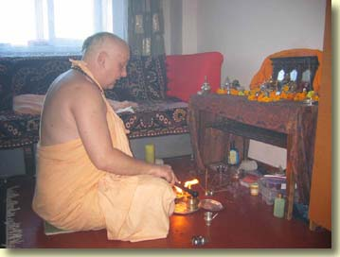
On Janmastami morning, I offer a small yajna to my Salagram silas.

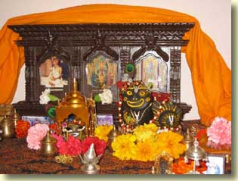 | 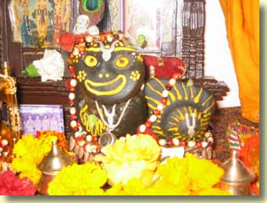
The ever-smiling Lord on the morning of His transcendental appearance!

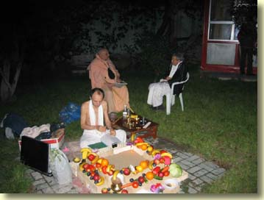
An outdoor yajna was scheduled for 8:00 PM Janmastami night. I performed the fire offering. While the fire altar was set up, I spoke with my Godbrother Ladvamsi Prabhu, who joined ISKCON in Boston a few years after me. For the last one year he has lived in the Kiev temple.

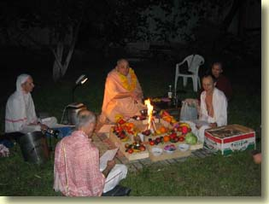 | 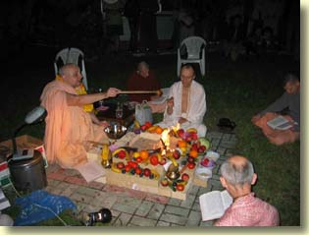
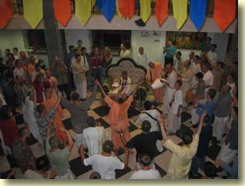
  While I did the yajna in the yard of the temple building, inside the temple room Yadubara Prabhu led an ecstatic kirtana that went on and on!

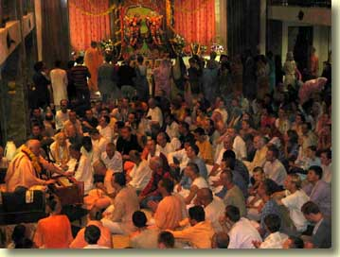
Then it was my turn to lead kirtana and give a class of my memories of Janmastami in New Vrndaban 1972 with HDG Srila Prabhupada.
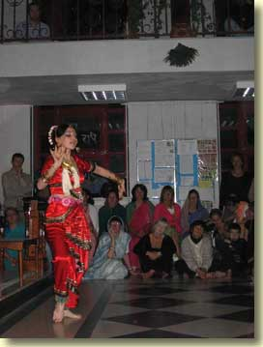
Premavanya's good wife, Moksarupa dd, performed bharatnatyam shortly before the midnight Deity greeting.

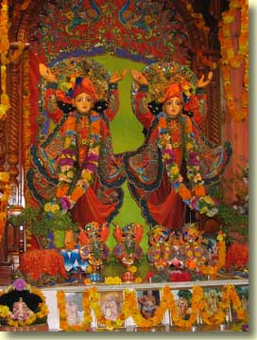
  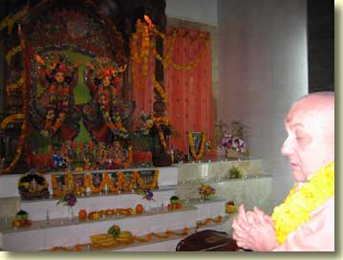
  Kiev Sri-Sri Gaura-Nitai as They appeared for the Janmastami midnight darsana and arati. Yadubara Prabhu led a beautiful kirtana in which he was accompanied by violin player.

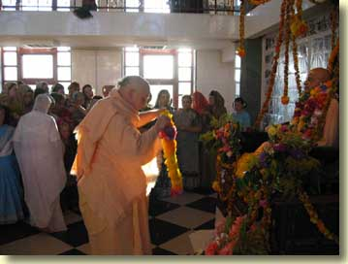
On the afternoon of the next day, Srila Prabhupada's Vyasa Puja was observed.

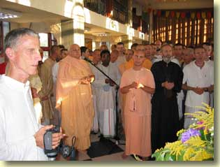 | 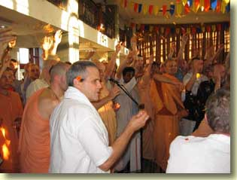
The puspanjali ceremony. Godbrother Ladvamsi throws the flowers with a heart filled with great emotion for Srila Prabhupada.
Notes from Srila Bhaktisiddhanta Sarasvati Thakura's rendition of Srimad-Bhagavatam 1.2.19, translated by Punya-palaka Prabhu of ISKCON Prague.
The verse as it appears in the BBT edition of Srimad-Bhagavatam, translated by His Divine Grace A.C. Bhaktivedanta Swami Prabhupada:
tada rajas-tamo-bhavah
kama-lobhadayas ca ye
ceta etair anaviddham
sthitam sattve prasidati
As soon as irrevocable loving service is established in the heart, the effects of nature's modes of passion and ignorance, such as lust, desire and hankering, disappear from the heart. Then the devotee is established in goodness, and he becomes completely happy.
Srila Sarasvati Thakura's word-for-word translation in prose order, rendered into English from the Thakura's Bengali:
tada (after the steady bhakti has been awakened) rajas-tamo-bhavah (situations where the influences of the modes of passion and ignorance become prominent) ye ca kama-lobhadaye (the end of the line) etaih (by them) anaviddham (not bewildered) cetah (the mind) sattve (in suddha-sattva) sthitam (existing) prasidati (becomes peaceful and satisfied)
Srila Sarasvati Thakura's translation (rendered into English from the Thakura's Bengali):
After the steady bhakti has been awakened, one is no more bewildered by all kinds of consequences of the modes of passion and ignorance, such as the six enemies beginning with kama. The mind then becomes absorbed in the mode of goodness and attains peace. Srila Visvanatha Cakravarti Thakura comment:
From the modes of passion and ignorance all kinds of distraction and destruction is produced, which means unsteadiness, coveredness, etc. The phrase kama-lobhadi (beginning with lust and greed) should be understood to include also anger, illusion and envy. Anaviddha means not deformed. Therefore it is said that once the mind becomes attached to the form of suddha-sattva, Sri Bhagavan, it attains peace.
Srila Sarasvati Thakura's gloss:
The modes of passion and ignorance in the material world produce lust, anger, greed, illusion, intoxication and envy and destroy all good qualities. When one performs all his activities driven by these modes, with the aim of sense enjoyment, he cannot achieve the unflickering mode of goodness. When the sattva-guna is predominant, or in other words, when the living entity has learned how to discriminate between what is eternal and what is temporary, then all kinds of conduct under the modes of passion and ignorance cannot cover him. At that time the pure spirit soul is not willing to go to hell any more, and his desires and inclinations are fully directed to the service of the Lord.

Dnepropetrovsk, the Ukraine
11 September 2004
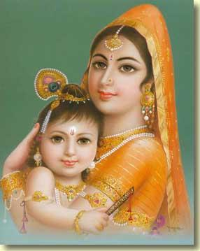
ISKCON Dnepropetrovsk
The only excuse for my repetitive poses in the outdoor pictures that follow is that the rainy season is on here--so when late yesterday afternoon the sky cleared up as the sun was nearing the horizon, I called to Premavanya to grab the camera and come with me to get some shots. Except for that brief period of time yesterday while the sun went down, the weather in Dnepropetrovsk has been constantly dark, cold and rainy.

  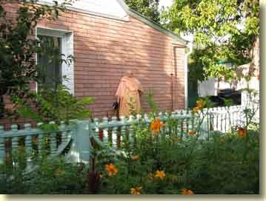
  Here I'm standing in front of the guest house where I have been staying. It is a surprisingly comfortable facility. When I was in Kiev I caught a chest cold, so my stay in Dnepropetrovsk has been largely dedicated to recovering from this illness. The nice, quiet living quarters were quite helpful in this regard. All glories to the ISKCON Dnepropetrovsk devotees for their kindness in letting me stay there.
  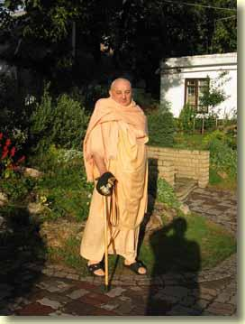
  Having left the guest house area, I've now stepped onto the temple grounds.

  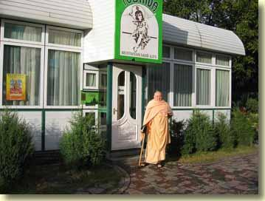
  Next, I've come to the entrance of the Govinda's restaurant, which stands close to the temple building.
  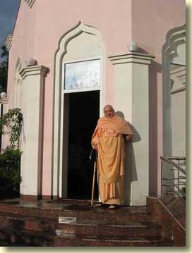
  At the entrance to the temple.

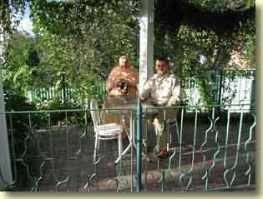
I've returned to the restaurant area. Now I am seated with the temple president, Vibhuti-sakti Prabhu, on the front terrace.
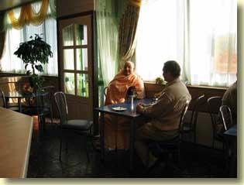
We've gone inside. Some fifty to one hundred customers eat at the restaurant every day.

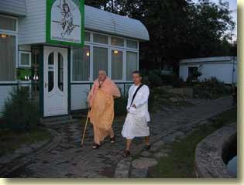
About an hour and a half later, I walk with disciple Dvijata Pujaka to the temple. He has his residence and medical practice in this city.
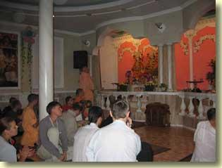
I take darsan of the Deities: Sri-Sri Gaura-Nitai and Sri-Sri-Sri Jagannatha-Baladeva-Subhadra are worshiped.

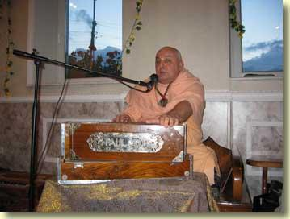
Evening class in Dnepropetrovsk temple.

Odessa, the Ukraine
12 September 2004
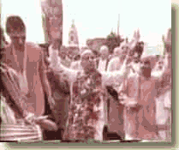


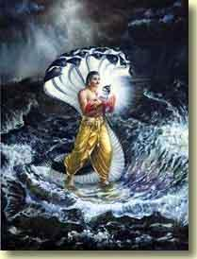 | 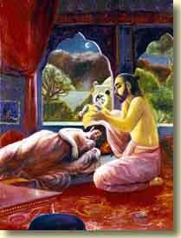 | 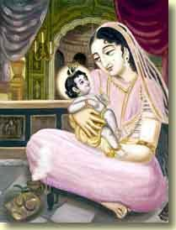
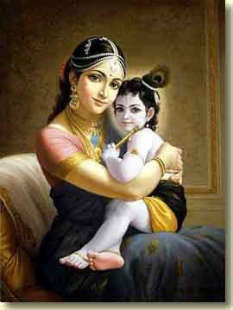
With Hari Sauri Prabhu in Odessa

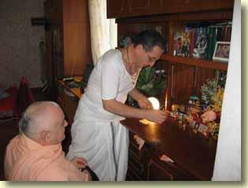
Showing me his traveling altar, Hari Sauri Prabhu takes a tooth of Srila Prabhupada from its gold container.
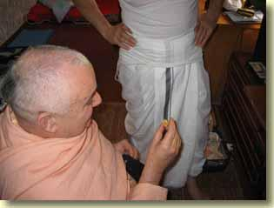
He received this tooth from his Divine Grace in 1976. It is encased in a clear solidified resin.

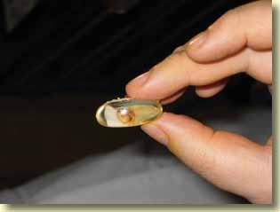
Srila Prabhupada ki jaya! In Asia there are huge and opulent temples that were built to house teeth of Lord Buddha. I wonder if this tooth of Srila Prabhupada will one day be displayed in a grand temple all its own.
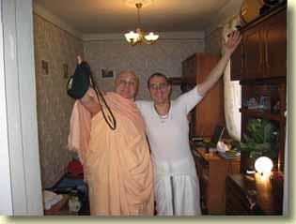
Hari Sauri Prabhu ki jaya!
Tomorrow afternoon I fly from Odessa to Warsaw. I shall stay in Poland until 20 September and then fly to Helsinki, Finland, for another preaching tour like the one I did last year from early September till the first week of November.
Hare Krsna!

Wroclaw, Poland
16 September 2004
Notes on Srila Bhaktisiddhanta Sarasvati Thakura's rendition of Srimad-Bhagavatam 1. 2. 20, translated by Punya-palaka Prabhu of ISKCON Prague.
The verse as it appears in the BBT edition of Srimad-Bhagavatam, translated by His Divine Grace A. C. Bhaktivedanta Swami Prabhupada:
evam prasanna-manaso
bhagavad-bhakti-yogatah
bhagavat-tattva-vijnanam
mukta-sangasya jayate
Thus established in the mode of unalloyed goodness, the man whose mind has been enlivened by contact with devotional service to the Lord gains positive scientific knowledge of the Personality of Godhead in the stage of liberation from all material association.
Srila Sarasvati Thakura's prose order (anvaya) translation from Sanskrit to Bengali, with English meanings of the Bengali phrases added:
Evam (purvokta-prakarena = achieved in the above-mentioned way) bhagavad-bhakti-yogatah (bhagavad-bhajana-prabhavat = by the influence of worshiping the Lord) prasanna-manasah (prasanta-cittasya ataeva = of the mind therefore pacified) mukta-sangasya (kamadi-basana-sunyasya sadhakasya = of the sadhaka who is free from desires based on lust etc. ) bhagavat-tattva-vijnana (bhagavatah tattvasya sac-cid-ananda-vigrahatva-vibhu-caitanyatvasya vijnanam anubhavah saksat-kara iti sri-jiva-padah = the one who directly realizes the truth about the Lord as the all-pervading living force who has His form which is eternal and full of knowledge and bliss, that is the glorious spirit soul) jayate (bhavati = becomes)
Srila Sarasvati Thakura's Bengali form of the verse:
ei prokar santo-ceta kamadi basona-sunyo sadhaker sa-saktika bhagavaj-jnan ba saksad-anubhaver udoe hoe
English translation:
In the practitioner who has in this way pacified his mind and has become free from all desires based on lust etc. appears the empowered knowledge of the Lord, or the direct realization.
Srila Visvanatha Cakravarti Thakura's Sanskrit comment:
evam anena prakarenasakti-purvakam pratiksanam bhagavatah krsnasya bhajanam kurvatah prasanna-manasah utpanna-rater ity arthah ratya vina sarvatha visayasam-sparsasyan-utpattes tena vina ca manah prasadasambhavad iti. tatas ca bhagavati bhakti-yogah prema tasmac ca bhagavatas tattvasya sva-rupa-guna-lilaisvarya-madhuryasya vijnanam anubhavah ity anubhavah ity anusamhitam bhakteh phalam uktam (Bhag. 1. 2. 7) janayaty asu vairagyam jnanam ca yad ahaitukam iti yat purvam uktam tad idam eva jneyam mukta-sangasya utpanna-vairagyasya.
Srila Sarasvati Thakura's rendition of Srila Cakravartipada's comment:
The point is that the mind of the sadhaka who always worships Lord Sri Krsna, having achieved attachment to it in this way, becomes satisfied which means that his attraction to the topics of the Lord has developed. The reason for this is that without rati (or bhava), one is not freed from the contact with all kinds of sense enjoyments, and without becoming free from the enjoying spirit it is impossible for the mind to become satisfied. Thereafter (after the awakening of bhava-bhakti) loving connection with the Lord, or love for Him (prema) appears, and from this love in bhakti-yoga comes the knowledge or realization of His form, qualities, activities, opulence and sweetness. About this knowledge it has been said in the scripture that it is the result of fixed, unfailing bhakti. As it was stated earlier: "If one engages in devotional service to Lord Vasudeva, he quickly acquires detachment and causeless knowledge"--here we can see that. Mukta-sangasya means "of one whose detachment has arisen. "
Srila Sarasvati Thakura explains:
After the living entity became free from unwanted desires and situated in steady devotional service, he realizes the truth about the Supreme Personality of Godhead. At that time his mind becomes satisfied, because through loving devotional service it has become liberated from the clutches of lamentation and hankering. As it is stated in the Bhagavad-gita [18. 55]:
bhaktya mam abhijanati
yavan yas casmi tattvatah
tato mam tattvato jnatva
visate tad-anantaram
One can understand Me as I am, as the Supreme Personality of Godhead, only by devotional service. And when one is in full consciousness of Me by such devotion, he can enter into the kingdom of God.

Wroclaw, Poland
17 September 2004
Speaking of Shukavak's book, Krsna-kirti Prabhu at the ISKCON Cultural Journal website published the following essay on 10 September. It is not about Hindu Encounters with Modernity per se, which I "reviewed" on 12 August. (Mine was not a review, really, it was--as I stated in In2-MeC of that date-- a "search and destroy" of one chapter of the book. I was being deliberately provocative. Yes, once in a while I do enjoy (NYUK! NYUK! NYUK!) agitating the hive mind of a certain "Gaudiya" website. ) Anyway, Krsna-kirti's essay is about an article Shukavak wrote that covers the same ground as Chapter 5 of Hindu Encounters with Modernity. I'm happy to note that he arrives at the same conclusion I did: that a devotee of today who subscribes to adhunika vada (the modern approach) in his understanding of sastra will turn into the very same sort of person that Srila Bhaktivinoda Thakura intended his Sri Krsna Samhita to be read by: the faithless Westernized Hindu.
Shri Krishna Samhita and ISKCON's Future
There is a book written by Srila Bhaktivinoda Thakura titled Shri Krishna Samhita, and over time devotees within ISKCON are going to hear more about this book and its precepts. Shri Krishna Samhita is a critical historical analysis of Vedic literature, including the Srimad-Bhagavatam, using the academic techniques prevalent in the latter part of the 19th century. Devotees are going to hear more about it because it is being acclaimed by scholars on ISKCON's periphery and within ISKCON itself as providing an academic basis for strengthening the faith of its own members by reconciling Vedic texts with modern thought. As Tamal Krishna Goswami and Krishna Kshetra Prabhu in their essay "Re-Visioning ISKCON" declare, ". . . following the lead of nineteenth-century theologian Bhaktivinoda Thakura (1838 - 1914) [9], ISKCON can reexamine its traditional texts and reappropriate them in ways consistent with modernity, discerning the symbolic through critical scholarship. "{[1]}. This is overtly a reference to Srila Bhaktivinoda Thakura's work in Shri Krishna Samhita, which the footnote in the quoted declaration (the "[9]") confirms: "For the most authoritative work on Bhaktivinoda, see Shukavak 1999 [Hindu Encounter with Modernity: Kedaranath Datta Bhaktivinoda, Vaisnava Theologian. ]
In the same book (The Hare Krishna Movement), Shukavak N. Das has contributed a short essay, "Bhaktivinoda and Scriptural Literalism," that concisely explains this position. Before examining in more detail Shukavak's thesis, it might be helpful to start off with his own experience in explaining to devotees the adhunika vada, or "modern approach" to understanding shastra (scripture).
I once presented a summary of Bhaktivinoda's analysis of Vedic history from his Upakramanika to an audience of Chaitanya Vaishnavas. I stated Bhaktivinoda's view that the Bhagavata Purana might not be a work compiled by the Vedavyasa 5,000 years ago, as orthodox Vaishnava tradition teaches, but may be a work not older than 1,000 years, compiled by a southerner writing in the name of Vedavyasa. Bhaktivinoda had reached this conclusion by analyzing certain geographic and cultural aspects of the Bhagavata. . 28 He was voicing an opinion arrived at through the use of the techniques of the adhunika vada.
A suggestion such as this coming from a secular scholar steeped in western criticism would not be unusual and could be easily deflected, but coming from Bhaktivinoda, a teacher from within the tradition, it cast a spell of disbelief over my audience. Many doubts arose: perhaps Bhaktivinoda did not actually believe these things but used them as a "preaching tactic"; perhaps he wrote his work when he was young and still learning but later came to reject these views; or perhaps my understanding of his perceptive was incorrect.
I was approached by one respected participant who was greatly perplexed by the mere suggestion that Bhaktivinoda may have said that the Bhagavata was only 1,000 years old or that it was not written by the Vedavyasa. I realized that this individual was upset because I had challenged one of his most sacred beliefs concerning certain historical details about that work, I had challenged his basic faith as a whole. The internal and subjective perspective of the traditionalist will not give credence to material facts that do not support and nurture religious faith. {[2]}
Evident here is the challenge to the faith of those devotees who always understood the Srimad Bhagavatam to be written by the Srila Vyasadeva and 5,000 years old. ISKCON's founder Srila Prabhuapada quite explicitly affirms this age and authenticity of Srimad-Bhagavatam in his commentary on the same,
Some Mayavadi scholars argue that Srimad-Bhagavatam was not compiled by Sri Vyasadeva. And some of them suggest that this book is a modern creation written by someone named Vopadeva. In order to refute such meaningless arguments, Sri Sridhara Svami points out that there is reference to the Bhagavatam in many of the oldest Puranas. {[3]}
The big problem, of course, is the claim that the Bhagavatam is no more than 1,000 years and not written by Vyasadeva has its origin in Bhaktivinoda Thakura. Now we have a real crisis of authority on our hands: on the one hand, if we accept the authority of Srila Prabhupada's commentary (and for that matter Sridhara Swami's commentary which Lord Chaitanya also accepted), then we face the possibility that one of our stalwart acharyas (in this case Bhaktivinoda Thakura) has spoken something gravely wrong and offensive, and on the other hand if we are to accept the authority of Bhaktivinoda Thakura as quoted from Shri Krishna Samhita, then that significantly weakens our faith in the authority of Srila Prabhupada and other recognized acharyas. The fact that acharyas who are recognized as beyond fault can so contradict each other on points that are so critical to Gaudiya Vaishnava theology stands to permanently wreck faith in the whole enterprise of Gaudiya Vaishnava theology and practice. If no one can be accepted as an authority in Gaudiya Vaishnavism on account of such egregious contradiction, then loss of faith is a logical consequence.
Part of the problem is with how Shukavak (and others) present Bhaktivinoda Thakura's writings to Vaishnava audiences. Shukavak is convinced that the fact that Bhaktivinoda Thakura was a stalwart Vaishnava with great faith in Lord Chaitanya and Krishna and also wrote such things is self-evident proof that one can view the scriptures through the lens of adhunika vada (modern criticism of scripture) and yet maintain even a superlative faith in Vaishnavaism. Shukavak implicitly assumes that Bhaktivinoda Thakura actually held the views he penned in Shri Krishna Samhita. Is this assumption reasonable?
We can test this assumption with a counterfactual example. Let us say that Srila Bhaktivinoda Thakura somehow reappeared in the 21st century and found out that, as Shukavak himself points out, that "his historiography is completely out of date. "{[4]} If his faith and devotion were to some extent a function of adhunika vada, then to the extent that current critical methods differed from the earlier methods on which his faith was in part based on could possibly result in some loss of faith. Since the underlying philosophical presumptions of modern historical criticism is not so much different than that of their 19th century predecessors, the differences arrived at by the older methods of historical criticism versus the newer methods probably would not be so different as to precipitate a crisis of faith. Nonetheless, fundamentally such methods rely on sense perception and inference, and the nature of conclusions solely based on these methods of understanding are thus subject to error--specifically the four defects of a conditioned soul. Today's trends in thinking and research over time often become discredited and quaint. An important philosophical point regarding adhunika vada, then, is that through adhunika vada one can never come to a correct, objective conclusion that is not subject to future revision; objective knowledge through this process is in theory unattainable. Adhunika vada thus cannot lead to higher knowledge about things which depend upon authority for understanding. (For that matter, there is plenty in the material world itself which defies the limited understanding of the human. ) Bhaktivinoda Thakura's superlative faith in Krishna, therefore, cannot be a product of adhunika vada because adhunika vada is subject to change, refutation and self-contradiction in the course of time.
Since Bhaktivinoda Thakura's faith cannot be dependent on adhunika vada, then we might well ask why he spoke it at all? Although Shukavak seems to hold a different view, the view that seems compatible with Bhaktivinoda's high faith can be found in his declared audience:
With folded hands I humbly submit to my respected readers who hold traditional views, that where my analysis opposes their long held beliefs, they should understand that my conclusions have been made for persons possessing appropriate qualifications. What I have said about dharma applies to everyone, but with regard to matters that are secondary to dharma, my conclusions are meant to produce benefits in the form of intellectual clarification only for qualified specialists. All the subjects I have outlined in the Introduction concerning time and history are based on the logical analysis of Shastra. Whether one accepts them or not, does not affect the final spiritual conclusions. History and time are phenomenal subject matters (artha-shastra) and when they are analyzed according to sound reasoning much good can be done for India. 22 {[5]}
So Srila Bhaktivinoda Thakura's intended audience, as he himself explains, are those who have certain "qualification" (western educated people) and who also do not accept the traditional means of understanding shastra. Preaching through adhunika vada, then, is to bring the faithless to the point of developing some respect for the authority of the shastras. Srila Prabhupada himself often did this, sometimes he would refer to the dictionary for the definition of a word when preaching to westerners, sometimes he would quote current events and refer to scientific discoveries as he did in Easy Journey to Other Planets. The point of using examples and evidence in the course of preaching is to guide people in the direction of accepting Vedic authority. For example, when telling someone where the Sun is, we may refer them to a tree saying something like, "The Sun is in that tree over to your left. " Now, the sun is not really in the tree, but if you look in the direction of the tree you are also looking in the direction of the Sun. If in a few years time the tree is cut down, then some other point of reference, perhaps a house, needs to be used to point someone in the direction of the Sun. The tree or the house is to the Sun what adhunika vada is to Vedic authority. Just as these local and temporary points of reference such as the tree or the house appear for some time and then disappear, so also do materialistic theories about reality appear and disappear. However, their utility lies in their potential to bring us to the threshold of devotion. Bahunam janmanam ante jnanavan mam prapadyante vasudevam sarvam iti. . . . Bhaktivinoda Thakura's intent in presenting Shri Krishna Samhita, then, is to bring the faithless to the point of accepting some faith in shastra, for which he hopes that ". . . much good can be done for India. " Accepting something from shastra as true and good is better than accepting nothing at all.
Something needs to be said, however, about who might benefit from and who might be harmed by adhunika vada. After all, one man's food is another man's poison. The Puranas, for example, are categorized according to each of the three modes of nature. Some Puranas, such as the Bhagavata and Vishnu Puranas, are meant especially for those in the mode of goodness whereas other Puranas, such as the Shiva Purana, are meant for those predominated more by the modes of ignorance. A Vaishnava partaking of religious rituals mentioned in some parts of Vedic literature can result in that Vaishnava's progressive degradation, whereas those same rituals may gradually elevate someone who is to begin with very fallen. In the case of utilizing adhunika vada as a means to understand shastra, for someone without any faith in shastra at all this could be of great help.
By clearing misunderstood statements within Vedic literature from the path of understanding--statements modern people may find exceedingly quaint or superstitious--our faithless but nonetheless educated gentleman through adhunika-vada could come to appreciate some highly elevated precept such as rasa as being superior to other concepts of love as found in other religions. This is the beginning of faith, because if someone actually comes to respect and factually understand something proffered by Vedic authority (whether it is the guru or shastra), then that opens the door to accepting as true other things found in the Vedas which before would have been dismissed as rubbish. This is something like following a map on a journey. As we progress on our journey and encounter landmarks predicted by the map, our faith grows in the authority of the map. In the same way, as people discover things in Vedic literature that are true, their faith grows to encompass more things from the Vedas as true that, before, would have been dismissed as fantasy. The distinctive characteristic of this person is that he or she is gradually rising from a position of ignorance and disbelief to a position of knowledge and faith.
Besides the faithless becoming faithful through the agency of adhunika vada is the person who already has faith but who wishes to enhance or strengthen his faith through the agency of adhunika vada. Like the faithless but educated gentleman, our devotee seeker also has doubts but unlike those who are gradually rising from a faithless condition, the devotee already has some developed faith in shastra (otherwise, why else is he a devotee?) but is turning to worldly means (adhunika vada) to try to understand shastra. Using our map analogy to describe this, we can say that the devotee has lost some faith in his map and is turning to other means to find his way. Some things can shake our faith. Perhaps he has been chanting Hare Krishna for years yet does not perceive any tangible reduction in his material desires. Perhaps he had a fall down. We start to doubt, "The map no longer works. . . . " So instead our doubtful devotee gradually begins to replace Vedic authority with adhunika vada as an authority and comes to rely on it more and more. For this devotee there may be some satisfaction in the conclusions derived from adhunika vada, and because our devotee believes himself to be advancing in spiritual knowledge as a result of cultivating an understanding of shastra from a worldly standpoint, he gradually (and happily) looses access to the absolute and objective knowledge that was once available to him. It should be remembered that one of the defining characteristics of adhunika vada is that it can never produce an objective fact that can finally be accepted as it is and without possibility of future discredit. Devotees who use adhunika vada to enhance their own understanding of shastra, rather than simply as a means to enlighten the ignorant, will most likely see their faith and knowledge brought to the level of the audience Bhaktivinoda Thakura set out to enlighten.
Adhunika vada, then, is suitable only for people who are to begin with faithless and well steeped in a non-theistic world view. For devotees who try to improve their spiritual knowledge through adhunika vada, adhunika vada is just like poison. Devotees using academic methods such as historical criticism to evaluate facts and precepts of scripture will necessarily come to see their scriptures in a different way. In the west, this happened with Christianity:
If Christianity was supported and confirmed by objective science, then the Bible should be able to be subjected to the same historical analysis as the documents of any other religion. Scientific naturalism thus became the starting point for historical inquiry into the Bible. From that point of view, of course, the Scriptures looked very different than they did if viewed with the premise that they were revealed by God. The miracle stories, for instance, became embarrassments, rather than evidences. By modern critical standards historical reporting in Scripture looked inaccurate and fabricated. Particularly the Old Testament narratives, as well as many of the claims to authorship and dating, appeared implausible if the writings were viewed as simple products of the evolving faith of an ancient primitive people. {[6]}
What these [historical] methods meant for the Bible was that it would be treated, as was often said, just "like any other book. " Once this initial move was made, of course, one was on a scholarly track that would yield conclusions consistent with the premise, namely, that the Bible was a cultural product just like any other book. {[7]}
Substitute the term "Gaudiya Vaishnavism" for "Christianity" and "Srimad-Bhagavatam" for "Bible," and you have a pretty good description of the philosophical direction ISKCON is heading in, considering that, as mentioned in the beginning of this essay, some of ISKCON's leaders advocate turning such academic methodologies on shastra for the sake of "re-visioning" ISKCON.
End Notes
- Tamal Krishna Goswami, Krishna Kshetra Das, "Re-Visioning ISKCON", as printed in The Hare Krishna Movement, The Postcharismatic Fate of a Religious Transplant, Columbia University Press, New York, 2004. Page 418 - 419
- Shukavak N. Das "Bhaktivinoda and Scriptural Literalism", as printed in The Hare Krishna Movement, The Postcharismatic Fate of a Religious Transplant, Columbia University Press, New York, 2004. Page 104 - 05
- Srila Prabhupada. Srimad-Bhagavatam 1. 1. 1 purport
- Shukavak N. Das 2004. Page 104
- Ibid. Page 106
- George M. Marsden. The Soul of the American University, From Protestant Establishment to Established Nonbelief. Oxford University Press, New York, 1994. Page 174)
- Ibid. Page 207

Wroclaw, Poland
18 September 2004
Madhuvisa Prabhu remembers Srila Prabhupada
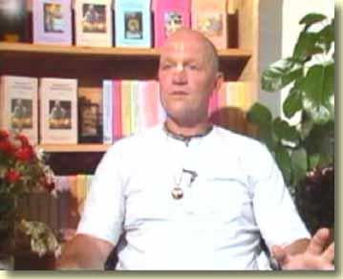
In video 4 of the Srila Prabhupada Memories series, HG Madhuvisa Prabhu recalls the following story from the old ISKCON LA temple at La Cienega Boulevard, circa 1968-9.
On this particular day there was a fire yajna. People were getting initiated. Srila Prabhupada was there. He was presiding over the yajna, as he did in those days. The temple was very full with people, and there was an Italian film-making crew at the temple at that time, and they were filming the whole thing. And if someone could get hold of that film it would be a historical piece of footage.
But Srila Prabhupada was there, and this one lady came, a Hindu lady came into the temple, and she was a guru to these Hindus. Her name was Syamadevi, and she ended up having an asrama right next to the Krsna Balarama Mandira in Vrndaban. But anyway, she came into the temple and she was sitting in the back of the temple, and they rolled out a carpet and she sat on the carpet and her disciples were older Hindu ladies and gentlemen. They sat around her.
And Srila Prabhupada was performing the yajna. So Srila Prabhupada, after he finished the yajna, he went up and got on the stage. And in those days we had Srila Prabhupada's vyasasana sitting right on the stage on the same level as the altar. Srila Prabhupada was having a kirtana, and he was playing his karatalas, and he was leading the kirtana and then he told someone else to lead, maybe it was Visnujana or someone like that.
so in those days the kirtanas were ecstatic, but they weren't uproarious, because of the dance step we used to do. We used to do the Swami Step. The Swami Step was a choreographed step that everybody would in coordination with one another dance. One foot in front of the other, one foot in front of the other. The arms would be upraised like that. And we would all be chanting and dancing like that, a long line of devotees on either side, facing one another. And we're dancing back and forth, having kirtana.
So Srila Prabhupada, during the course of this kirtana, got up from his vyasasana and he was doing the Swami Step with us, like that, we were all doing the Swami Step. And then Srila Prabhupada did something that he had never done before. Nobody had ever experienced this before. Srila Prabhupada stopped doing the Swami Step and he started jumping up and down. We had never done this jumping up and down. No one ever knew about jumping up and down. We just knew the Swami Step and we were all happy doing the Swami Step. But now, Srila Prabhupada was jumping up and down. And it was the most amazing thing, because it seemed like the whole universe was rocking becase Srila Prabhupada started jumping up and down.
So we looked at each other and said, "Wow, Srila Prabhupada is jumping up and down. I guess we can jump up and down too!"
So it's never been the same since then. Kirtana has never been the same. The Swami Step is still there but its only done by very conservative devotees. Everybody likes to jump up and down and really get into the uproarious kirtana.
So Srila Prabhupada was jumping up and down, the devotees were jumping up and down, bouncing off the walls. It was fantastic.
So meanwhile, this lady, Syamadevi, she was there, and she was having kirtana, and one of her disciples opens a bag and gives her a little mrdanga. In those days, usually there was one mrdanga per temple. One mrdanga, and only certain devotees could play that mrdanga. Very good devotees who were good mrdanga players, who wouldn't drop it, put their hand through the end of it. So they had to be good mrdanga players and they had to be very concerned that the mrdanga didn't get damaged, because in those days we didn't have American-made plastic mrdangas. If a mrdanga got broken, you have to send off to India for it. It look a long time to get it. We didn't have to the import-export thing happening so proviciently in those days. But they pulled out a mrdanga, and small clay mrdanga, khol. And they gave it to her. And she started playing the mrdanga.
So we kind of stepped aside and she kind of moved her way up to the front. And Srila Prabhupada is jumping up and down dancing. All the devotees are dancing.
And she's playing this mrdanga, and she starts to dance. And she starts to float around like a butterfly, taking little small steps. She's an elderly lady, she's about 50 or 60, she's elderly. Very, very conservative, she's dancing around like a little butterfly with her sari over her hair, and she's playing the mrdanga like a gopi.
All the female devotees, now, alright! They were thinking she was a Vaisnava, she can play the mrdanga, she was dancing, and Prabhupada was obviously approving it. He was up there on the stage, jumping up and down.
So then Prabhupada jumps off the stage, and he's in with the devotees, amongst the devotees, jumping up and down, chanting Hare Krsna. And this lady, Syamadevi, she's playing the mrdanga, and she's dancing and the kirtana ends, and Srila Prabhupada says, "Now you lead. " So she starts to lead the kirtana.
Now, the women are really ecstatic. Now here's another precedent: "We can lead kirtana. We can jump, we can dance, we can play the mrdanga and now we can also lead kirtana. Because, yeah, this old lady is doing it, Prabhupada is approving it. He's allowing her to do it. "
So everybody was in total euphoria there. She lead the most melodious kirtana. It went on and on. Prabhupada was dancing, she was dancing. It built up, and it was the most fantastic experience that all the devotees cold have had.
So before the dust even settled from the kirtana, devotees are on the phone to New York: "Prabhupada's jumping!" "Prabhupada's jumping? What do you mean, he's jumping?" "You don't have to do the Swami Step anymore, Prabhupada's jumping up and down, kirtana was going on, Prabhupada was jumping, running up back and forth, jumping up and down. "
And Brahmananda was saying, "How do you do it? How do you jump?" He said, "You don't have to do, you just jump up and down, just be ecstatic. Just put your hands in the air and jump as high as you can do. "
So Brahmananda called Boston, Boston called Montreal. Within a matter of hours, the whole country was jumping. And like I said, kirtana's never been the same since that time.

Here's an eye-opening article by Krsna-kirti Prabhu (ISKCON Cultural Journal website, September 14, 2004).
Women Who Sleep With Their Gurus
A Krishna Conscious Perspective
Jessica Roemischer in the August-October issue of What Is Enlightenment ({http://www.wie.org/}) writes a fascinating and timely piece titled "Women Who Sleep With Their Gurus . . . and why they love it. " (It seems to happen an awful lot doesn't it?) If it is any consolation to us beleaguered devotees in ISKCON who have either learned to live with it or are getting fed up, we aren't the only ones with celibate-caught-with-female-devotee problems--not by a long shot. Jessica's article is fascinating because she interviews ten women who have actually slept with their gurus (each of whom was officially celibate) and she herself had such an encounter with her spiritual teacher, a Zen master from Korea.
"How can women be victims when we want something?" said Mary, my former women's studies professor from college, who had since become a trusted friend and confidante. Infamous for defying prevailing feminist viewpoints, she was the first person I turned to when I decided to write this article on the subject of women who have been sexually involved with their spiritual teachers. And true to form, in her one short rhetorical question, Mary upended entirely the pervasive and unchallenged image of the innocent woman fallen victim to the abuse of authority.
"Enlightenment, security, spiritual power, and affirmation," she continued. "I mean, sex is a small price to pay. And whatever the extent of the flirtation or sexual involvement, you enter this relationship of intrigue, and you're the special daughter or the special wife. You experience 'number one life,' as they say in the Asian tradition. " It was hard to argue with her logic. Indeed, as I reflected more deeply on my own past with my Korean teacher, I knew she had captured the very essence of my experience.
(Jessica Roemischer. "Women Who Sleep With Their Gurus . . . and why they love it. " What Is Enlightenment. August - October 2004. Moksha Press, 2004. Page 88)
Now, this is a refreshing point of view: seeing women as actors who make choices instead of as victims who do not make choices. Second-wave feminism is so defined by the identity of vicitmhood that, until more babyboomers die off, it will probably be dominant for the next 15 to 20 more years. Note that Mary, the feminist professor, is identified as being "infamous for defying prevailing feminist viewpoints. " This new point of view, perhaps one that distinguishes third wave feminism from its predecessor, signals a new kind of thinking among western feminists, who grew up with freedoms their mothers couldn't take for granted. Harkening back to Aristophenes' Lysistrata, the Greek women, who decided to take matters into their own hands to end the Peloponnesian War by sex strike to force their husbands to make peace with Sparta, eventually realized that they too were in fact desperate for that which they withheld. What is, in a word, refreshing about this is we see here women who are seeking to understand themselves as women, not as androgynes.
Now, given the many sordid and scandalous details revealed about well-known gurus during the last two decades--Mary's was clearly a novel and controversial perspective, one that refocused attention on the woman's active role in these relationships. "We women do have a strong and unspoken investment in seeing ourselves as victims," I observed, "as unsuspecting agents or innocent players in an unfolding event beyond our control. " Mary agreed with me: "And that perspective has, in one form or another, become such a basic tenet of our time and culture, of our postmodern worldview, that we are often unaware of how much it has colored our perceptions at the most fundamental level. But it's time for women to go beyond that. Because if we are really honest with ourselves, in most cases, there's a lot more to the picture!"
(Ibid. Page 88)
It seems that the act of sincere spiritual seeking has to engender the idea that if one can actually seek an existence beyond the body, transcendence or what have you, then the self can rise above his or her body, nature and circumstances and make real choices. Transcendence means choice because at the stage of transcendence one is no longer bound by material constraints. Materialism, its antithesis, necessarily implies bondage, or lack of choice since one's material identity is created and controlled by external forces. (Prakrite kriyamanani gunai karmani sarvashah. . . ) The essence of dharma rests on choice, because without choice there can be no possibility of acting dharmically or adharmically (good and evil).
As one contact lead to another and I interviewed ten women who had been sexually involved with prominent and revered teachers, I discovered that this phenomenon has been more pervasive than I ever imagined. And not only that, it has been the product of age-old motivations and choices that have been surprisingly consistent as women became involved with their Hindu sages, Tibetan lamas, Indian yogis, Asian Zen masters, South American shamans, and the new generation of Western teachers who followed in these traditions. And that's not even to mention the untold numbers of rabbis, priests, ministers and therapists.
Considering the subject in light of my past experience and what these women shared with me, and illuminated by the insights and views of a noted anthropologist, a psychologist, a well-known author, and a feminist who I also consulted, I found myself compelled by a new and liberating perspective on this sensitive issue. "Plenty of exposes of corrupt gurus have already been done," I said to Mary in conclusion, "but what I'm really interested in is why we women almost always say yes. "
(Ibid. Page 88 - 89)
Good question! As Jessica pointed out before, it is just too easy to view these scandals according to the western, post-modern Zeitgeist, where all men in positions of power and authority are predators and all women are subordinate and (therefore) victims. Probably the most profound implication of Jessica's insight is that women can and do make choices--important ones--all the time. Once this is realized, then one can act on the platform of dharma. Of course, acting dharmically is no less available for the simple hearted and the uneducated. But for those who are by nature intellectuals, skeptics perhaps, the realization and understanding that one in fact makes choices is the gateway to freedom from the tendencies of one's body and one's circumstances. Choice means dharma, victimhood implies the life of animals, who have no choice but to act according to their nature.
"If your husband's a doctor, then you're special. If you're with Mick Jagger, you're special. If you're sleeping with your Tibetan lama, you're special. It's seen as a status symbol," explained Catherine over the phone one afternoon. "It gives you status, and it plays into women's sexual identity. Women identify themselves based on who they sleep with!" Having been the consort of a prominent Tibetan lama, Catherine was speaking from firsthand experience. And with this conversation, I entered headlong into a series of disarmingly candid and illuminating dialogues with women who have slept with their spiritual teachers.
"You want to align yourself with a man who has the kind of power you want. And in this case it's dharma power!" said Annie, a student and former lover of one of the most influential Japanese Zen masters to bring the Buddha's teachings, or dharma, to the West. Another woman, Linda, told me: "It was powerful to think that I was intimately involved with the principal disciple of one of the world's great Indian yogis. He was very charismatic and he had exceptional powers that not every human being was manifesting, which confirmed my belief that there was something more in the unseen world that was possible. What attracted me to him was that so many other people were attracted to him, because when others recognize a greatness in the person you're involved with, that affirms you even more. You think, 'Well, this says a lot about me,' whether it does or it doesn't. "
(Ibid. Page 89)
This phenomenon of women defining themselves through their relationship with their husband or lover is a natural tendency on which the system of varnasrama-dharma is based. Women assume the caste of their husbands on marriage because doing so is a natural consequence of the conjugal relationship.
"Now, woman is supposed to be assistant of man. If woman is faithful wife of the first-class man, then she also becomes first-class. If she is assistant of the second-class man then she is also second-class. If she is assistant of the third-class man, then she is also third-class. Because she is assistant, so, according to her husband, or protector, she becomes first, second, third, fourth. "
(Srila Prabhupada. Press Conference. July 9, 1975, Chicago)
We can see from this that the social system of varnashrama-dharma actually utilizes, embraces, the natural behavior of both men and women. If the natural tendency for women is to define themselves by whomever they sleep with, then that society which works with this natural propensity instead of against it will probably encounter less social disturbance than societies that disbelieve in this social arrangement. Another thing we find in this article that is also common to Vedic sociology is the understanding that women desire to have men who are at the top of society:
"Generally it is the ambition of a young girl to have a very handsome husband who is learned, clever, young and rich. "
(Srila Prabhupada. Sri Caitanya-caritamrita, Adi 14. 55 purport)
"Women love men who are at the top and have for at least four million years, and they continue to everywhere in the world," explained anthropologist and author Dr. Helen Fisher. . . . "In a study of thirty-seven societies, it's been established that women are attracted to men who have status, power, education, and resources. "
(WIE. page 90)
For women on the spiritual path, a relationship with our teacher adds an additional and ultimately compelling element to the long-standing benefits of becoming sexually involved with a powerful and influential man: spiritual capacity that I knew existed," said Leslie, who was in a relationship with a prominent American spiritual teacher. "So I thought, 'Wow, I can have this all together in one package: mentor, lover, father. ' I knew he favored women who were attractive, and that boosted whatever image I had about myself. All the attention made me feel special, like Radha--a spiritual goddess. I mean, this teacher had power; he had money. He was charismatic, and if you were the woman at his side, that had to mean something about you as well. "
(WIE. Page 90)
Urdhva mulam adah shakham. . . . , the material world is a perverted reflection of the spiritual world. The woman at Krishna's side, of course, is Radha, and aside from Her exalted qualities this fact must also say something important about Her. The fact that the material world is a perverted reflection of the spiritual reality also says something about a woman's status in the material world. Besides looks, women marry for money, power, and, it seems, enlightenment, so since this is a natural proclivity, one not ought to be ashamed about it. After all, we're in the material world, and as long as we are still materially conditioned, we are ksharah, or imperfect and subject to fault. So the Vedic system is that contact between men and women is allowed under certain restrictions. Those restrictions stipulate that it is religious for a woman to unite with a man of equal or higher social status but it is irreligious for a woman to unite with a man beneath her social status.
It appears from this verse that during the time of the Pandavas free contact between man and woman was allowed in certain conditions only. The higher-caste men, namely the brahmanas and ksatriyas, could accept a woman of the vaisya or the sudra community, but a man from the lower castes could not contact a woman of the higher caste. Even a ksatriya could not contact a woman of the brahmana caste. The wife of a brahmana is considered one of the seven mothers (namely one's own mother, the wife of the spiritual master or teacher, the wife of a brahmana, the wife of a king, the cow, the nurse, and the earth). Such contact between man and woman was known as uttama and adhama. Contact of a brahmana with a ksatriya woman is uttama, but the contact of a ksatriya with a brahmana woman is adhama and therefore condemned. A woman approaching a man for contact should never be refused, but at the same time the discretion as above mentioned may also be considered. Bhima was approached by Hidimbi from a community lower than the sudras, and Yayati refused to marry the daughter of Sukracarya because of Sukracarya's being a brahmana. Vyasadeva, a brahmana, was called to beget Pandu and Dhrtarastra. Satyavati belonged to a family of fishermen, but Parasara, a great brahmana, begot in her Vyasadeva. So there are so many examples of contacts with woman, but in all cases the contacts were not abominable nor were the results of such contacts bad. Contact between man and woman is natural, but that also must be carried out under regulative principles so that social consecration may not be disturbed or unwanted worthless population be increased for the unrest of the world.
(Srila Prabhupada. Srimad-Bhagavatam 1. 14. 42 purport)
The WIE article demonstrates that women have a natural preference for men who are of progressively higher status, and the social system of varnashrama-dharma, as nicely shown by Srila Prabhupada, appears to be based on this natural propensity. This suggests that varnashrama-dharma, in spite of all the bad publicity it has received both within and outside of ISKCON, can be more easily accepted and practiced than we are inclined to think. The biggest obstacle to implementing varnashram-dharma among us devotees is probably our own misconceptions of what varnashram-dharma is and what exactly is our own conditioned nature.
In her book Who Stole Feminism?: How Women Have Betrayed Women, Christina Hoff Sommers critiques some of the overreaching feminist viewpoints that have emerged during the last twenty or thirty years—particularly the view that women are, by and large, victims of male abuse and exploitation. From that perspective, she concurred with Dr. Fisher:
"Human psychology is just too complicated to be reduced to a simple power differential: woman equals victim equals oppressed. While it's true that the mentors have power," she said, "women have their own power to attract the mentor. So as much as there's the mentor-student dynamic, there's the male-female dynamic where there's known to be attraction. "
(WIE page 91)
This is similar to statements about women Bhishmadeva makes to Maharaja Yuddhisthira, while instructing Maharaja Yuddhisthira from his deathbed. In a purport Srila Prabhupada gives a synopsis of these instructions and remarks as follows:
As far as the women class are concerned, they are accepted as a power of inspiration for men. As such, women are more powerful than men. Mighty Julius Caesar was controlled by a Cleopatra. Such powerful women are controlled by shyness. Therefore, shyness is important for women. Once this control valve is loosened, women can create havoc in society by adultery. Adultery means production of unwanted children known as varna-sankara, who disturb the world.
(Srila Prabhupada. Srimad-Bhagavatam 1. 9. 27 purport)
The following testimonies from WIE emphatically make a similar point: women, no matter who the women are, have power over men, no matter who the men are.
. . . Many of the women I spoke with clearly articulated an awareness of their own sexual power and the ability they knew they had to attract men. "I think we all grow up with strategies that we've learned for feeling safe and secure in the world, and special," said Annie. "If you're born attractive, then you learn to use your femininity as a way of getting what you want. I was reasonably attractive and bright, and I knew from fairly early on that if there was someone who I really wanted to fall in love with me, I could bring it about. I'm very adaptable, and I knew how to match energies with people and adapt to a situation, so it wasn't hard to make my dharma instructor fall in love with me. "
"In my case," said Diane, "I have to tell you, there were several teachers, and all of them were different. I think the Buddhist was somewhat innocent, and to some degree, he knew his power. But he was also curious, because somewhere I pushed buttons in him. He wasn't a sexual being, and I helped him out with that. At the same time, he helped me spiritually. So, who do you blame? Of course, what it comes down to can be an abuse of power, absolutely, and it is up to the teacher to draw that line. And while I really do believe it is the teacher's responsibility to act appropriately, I think that as adults we all have a responsibility for our actions. I mean, he's human, too, right? And here's this young, little twenty-four-year-old babe-ette . . . What are you supposed to do? Really?
If we're honest with ourselves, seductiveness is second nature to women, and we begin cultivating our ability to attract surprisingly early in life. Some of my earliest, most vivid memories of attraction and seduction, at age fourteen, resulted in my first kiss—with the twenty-six-year-old handyman who took care of our home, shared my love of music, was physically desirable, and was older and experienced. And while it is true that he approached me, in a timeless moment I can remember like it was yesterday, what I now realize is that for months prior to that, I had been deeply intent on him. I expressed that intent in a myriad of ways—from making sure I bumped into him in whatever corner of the house he was working to sitting at the piano and playing melodies into the stillness of the afternoon, knowing he would hear them. At that young age, and even earlier, I instinctively knew how to pull him toward me, the way a young kitten instinctively knows how to hunt its prey. "
(WIE page 91 - 92)
According to Vedic wisdom, sexual attraction is a stumbling block on the path of self-realization. From the above reference it seems that these women, in whatever spiritual path they were pursuing, knew this. Nonetheless, the attraction between man and woman is so great that unless strong measures are taken to reduce the attraction, fall down is likely. Therefore we have that most famous of quotes from the Srimad-Bhagavatam, "One should not allow oneself to sit on the same seat even with one's own mother, sister or daughter, for the senses are so strong that even though one is very advanced in knowledge, he may be attracted by sex. " (Prabhuapda. Srimad-Bhagavatam 9. 19. 17) Being a gentleman does not alter this dynamic between a man and a woman:
Learning the etiquette of how to deal with women does not free one from sexual attraction. As specifically mentioned herewith, such attraction is possible even with one's mother, sister or daughter. Generally, of course, one is not sexually attracted to his mother, sister or daughter, but if one allows himself to sit very close to such a woman, one may be attracted. This is a psychological fact. It may be said that one is liable to be attracted if he is not very advanced in civilized life; however, as specifically mentioned here, vidvamsam api karsati: even if one is highly advanced, materially or spiritually, he may be attracted by lusty desires. The object of attraction may even be one's mother, sister or daughter. Therefore, one should be extremely careful in dealings with women.
(Srila Prabhupada. Srimad-Bhagavatam 9. 19. 17 purport)
The heads of the society in which Krishna and Maharaja Yuddhisthira appeared had many, many qualified and intelligent women. Yet we see that their society was not the androgynous utopia modern society claims as the social ideal. With so many intelligent, capable women of that time, you would think that if the ideal is to not discriminate against gender with regard to service (as in occupational duties), that Krishna, Yuddhisthira and others, after conquering the world, would have worked to create a feminist paradise on earth, with near equal numbers of women serving in important all manner of important positions in society. That did not happen; the Mahabharata simply did not have in the name of reestablishing dharma a feminist agenda. Instead we find that,
As we learn from the history of the Mahabharata, or "Greater India," the wives and daughters of the ruling class, the ksatriyas, knew the political game, but we never find that a woman was given the post of chief executive. This is in accordance with the injunctions of Manu-samhita, but unfortunately Manu-samhita is now being insulted, and the Aryans, the members of Vedic society, cannot do anything. Such is the nature of Kali-yuga.
(Srila Prabhupada. Srimad-Bhagavatam 10. 4. 5 purport)
So, we have a paradox before us: Many, many intelligent women lived in Krishna's society, yet those women, by mandate, seemingly occupied humble social roles. Is that not discrimination? Is that not unfair to the women even of that time in history? Why in the name of religion they should be denied equal opportunity to serve Krishna as per their desires? Aren't women also spirit souls--particularly Vaishnavis (Vaishnava women), who have realized their spiritual identity? If we presume that the leaders of society during Krishna's time were learned gentleman who knew all the principles and intricacies of dharma, then we have to rule out that the exclusion of women from certain occupations and professions was inherently and materially sexist and bigoted. Neither Krishna nor his associates were sexists. So, here are some reasons for the choice of those leaders to cultivate a society which, by all modern standards, would be considered backwards due to its gender discrimination:
Worldly duties and occupations, particularly the those duties prescribed by varnashrama-dharma, and spiritual life can be pursued side-by-side. The implications of this are that one can be in the lowest, most humble social position yet can simultaneously be a topmost devotee of Krishna. Haridas Thakura (born from a Muslim family) and Kabir (a cobbler) and were all recognized by society in India to this day as great devotees of Krishna, yet they remained within their social position (or even as social outcasts). On account of his being born in a Muslim family, Haridas Thakura could not enter the Jagannatha Temple in Puri to have darshan of Lord Jagannatha. Nonetheless, he was accepted by the Lord Himself, Sri Caitanya Mahaprabhu, as being the acharya of chanting the Lord's Holy Names. The implications of this are that one can worship and develop one's pure love for the Lord irregardless of social or occupational status. As we have seen in the lives of these great saints, it is only the love that is considered by Krishna, not social or occupational position. (Sometimes, of course, material and spiritual life come into conflict with one another, but most people in general can do their worldly duties and simultaneously become self-realized by chanting Hare Krishna Hare Krishna Krishna Krishna Hare Hare, Hare Rama Hare Rama Rama Rama Hare Hare. )
Yukta-vairagya, using a material thing in Krishna's service, was as valid then as it is now. However, not all things are as easily dovetailed in Krishna's service as are other things. For example, television can be used in Krishna's service, yet we find that many devotees who keep televisions tend to spend more time watching mundane programs than they spend time on quality hearing and chanting of Krishna's names or in reading sacred literature. Although we are Vaishnavas, the vast majority of us tend to be mixed Vaishnavas, not pure Vaishnavas. As our devotion to Krishna is still tainted by material desires and less-than-spiritual aspirations, there are plenty of things which reasonably can be used in Krishna's service but because of our own material conditioning should not be used. Thus, for the sake of elevating a society wherein most of the people were at best mixed Vaishnavas, there are some restrictions on what one can and cannot do. Some of those restrictions happen to limit the social and occupational roles of women. Although it is a fact that women in societies that implemented varnashram-dharma were for the most part limited to the domestic sphere, that limitation was chosen over the possibility of a society in which men and women have considerable latitude for intermingling.
So these regulative principles are there. So what is, what is the big plan behind these regulative principles? The big plan is: here is the attraction, pumsah striya mithuni-bhavam-to cut down this attraction between male and female. This is the big plan. Otherwise there is no need of the varnasrama.
(Srila Prabhupada. Lecture, Srimad-Bhagavatam 5. 5. 8, Vrindavan Oct 30, 1976.
Apparently, in Krishna's society, minimizing sex life was considered even more important than equal-opportunity-employment. This is Vedic civilization. Veda means knowledge, and so those things which put us in ignorance are counter productive to realizing the ideals of a Vedic civilization, namely the revival of our forgotten relationship with Krishna.
Great Vaishnavis like Kunti and Draupadi were unquestionably self-realized souls, so how do we explain their apparent restrictions to a subordinate and domestic social position? The reason they did this is because in any civilization, one must look out for others. Indeed, the symptom of a civilized person is that he or she considers others more important than one's self. So acting in ways which encourage others to do things which are not good for them is against the principles of Vedic civilization because of leading others to engage in ignorant behavior, or behavior that implicates one in ignorance. Not long ago my wife, one older woman who comes to our preaching center and I were traveling from Albuquerque, New Mexico, to Denver, Colorado, for Janmastami. I was sitting in the back seat, the older woman was driving and my wife was sitting in front of me in the front passenger seat. The sun visor for the front passenger seat had a mirror in it, and my wife was looking back at me through the mirror, wiggling her fingers and giving me one of these "I-can-see-you" grins. I grinned back, but the woman with us who was driving noticed and openly lamented that she did not have some man in her life with which she can share cute smiles and side-long glances. So even we are self-realized or act religiously all the time, it is also important to act in such a way as to not incite lust in others. As we can see, even innocuous flirtation between a husband and wife in public can produce lust in others. The general behavior of people in modern society suggests that people are to a spiritually unhealthy degree interested in themselves more than others.
Finally, how do we explain the presence of women like Gangamata Goswamini in societies that implemented varnashrama dharma? Gangamata Goswamini at an early age accepted diksa from Haridas Pandita and lived for many years in Vrindavan as a renunciate practicing madhukara, or going from house-to-house begging only for as much as one needs and not more. Later when she went to Puri, she gave discourses on the Srimad-Bhagavatam that were so famous that people from far away would come to hear her speak. She also had many disciples in high social positions, like Maharaja Mukundadeva, the King of Puri. Why can't our Vaishnavis follow Gangamata Goswamini's example and become gurus and acharyas just like her? Why can't ISKCON be full of Gangamata Goswaminis liberating conditioned souls all over the world? If we would just give them the chance and change attitudes and enact laws in ISKCON that are "woman friendly," we might see an unprecedented spiritual renaissance the likes of which the world has never seen, right? We need to remember that Gangamata Goswamini was respected in a society that strictly followed varnashram-dharma, wherein women in general were relegated to the domestic sphere. The varnashram-society of East India at that time could give that respect to Gangamata Goswamini because factual spiritual knowledge was to some degree widely intact. She was recognized as a transcendentalist and not required by society to follow the ordinary course of life prescribed for women because she was steady in her renunciation and service to guru and Krishna. She did not require family maintenance, nor social security checks, nor did she require food, saris and ashram from institutional largesse. In all circumstances she practically depended on Krishna and remained steady in her determination, and therefore she could be identified as a liberated transcendentalist fixed in devotion and thus not required to follow the ordinary course of life prescribed for women by varnashrama society. This can be understood from the point of view of an ordinary woman who might try to imitate her. Let us say our imitator accepted a spiritual master, vows and a way of life similar to that of Gangamata Goswamini. After some days, or weeks or possibly months, our imitator would become dissatisfied with the life of madhukara and find for herself a more comfortable situation. If we need maintenance, even on the plea that ISKCON the institution owes it to us, then we had better implement and uphold the principles of varnashrama-dharma in our own lives--for our sake and for other's sake. (This is true both for men and women. ) Gangamata Goswamini, on the other hand, was recognized and honored as an uncommonly advanced sadhu (sadhvi) and excused from following the prescribed life for women because not only did she demonstrate a high level of renunciation, but she was also steady in her renunciation: mam ca yo 'vyabhicarena bhakti yogena sevate, sa gunan samatityetan brahma bhuyaya kalpate, "One who performs devotional service, unfailing in all circumstances, at once transcends the modes of material nature and comes to the level of brahman. " (Bhagavad-gita As It Is 14. 26) The varnashram society she appeared in could honor her because that society also had this spiritual knowledge.
The article, "Women Who Sleep With Their Gurus" in What Is Enlightenment magazine has a major shortcoming: namely that the authoress did not consult any theological authorities on this topic,
Considering the subject in light of my past experience and what these women shared with me, and illuminated by the insights and views of a noted anthropologist, a psychologist, a well-known author, and a feminist who I also consulted, I found myself compelled by a new and liberating perspective on this sensitive and confusing issue.
(WIE page 89)
She mentions Hindu sages, Tibetan lamas, Indian yogis, Asian Zen masters and South American shamans as having been involved in so many sordid trysts with young, female disciples, but never does she get their point of view. Perhaps it is because they are not women. But if there is a spiritual dimension to us, something that factually transcends the body, then why cannot men--particularly those who are spiritually advanced--also have a perspective that is correct and illuminates the original question she posed (why do women almost always say "yes")? Nor were holy books such as the Bhagavad-gita, the Bible, the Lotus Sutras or any other scripture consulted as to why this happens. At the end of her article Jennifer Roemischer discusses the feminist perspective, and her exploration of what could possibly alter the power differential between guru and (female) disciple ultimately centered on being more aware of the choice to also say "no" to a tryst with a spiritual teacher. There was also considerable discussion about more women taking up the mantle of guru and changing the power differential between men and women and, thus, the results of such encounters.
Choice seems to be the hallmark of third-wave feminism that distinguishes it from the implied victimhood of second-wave feminism, and it is the recognition of this choice that is hailed as a great gain for women. I agree that this characteristic of third-wave feminism is an improvement in the knowledge and consciousness of women who subscribe to the feminist ethos because without choice, there is no question of acting on the platform of dharma. However, feminism (whatever its wave) is still a material ideology, and because it is material, it lacks any criteria by which to adjudicate dharmic or adharmic action. From the vantage point of third-wave feminism, saying "yes" to a sexual relationship with one's guru could be just as good, enlightening and spiritually fulfilling as saying "no". Nonetheless, it is the "choice-consciousness" of third-wave feminism that makes for Western women who are more open to dharma and all it entails than were those who subscribed to older, more radical forms of feminism which affirmed their chronic victimhood.
Merve Kavakci, a former parliamentarian in Turkey who was ejected from Turkey's parliament for wearing the hijab (headscarf), has a refreshing view on choice that concurs with third-wave-feminism's "choice-ism":
Regrettably, Western feminists also fuel the common misunderstanding of Muslim women's motivations for wearing headscarves. , Western feminists also fuel the common misunderstanding of Muslim women's motivations for wearing headscarves. In late 2003, several dozen prominent Frenchwomen, including philosopher Elisabeth Badinter and writer Catherine Millet, sent an open letter to French President Jacquest Chirac, arguing that "the Islamic veil sends us all—Muslim and non-Muslim—back to a discrimination against women that is intolerable. " These thinkers link headscarves with suffering and conclude that they impede the personal growth and social development of women.
But such feminists make two significant mistakes. First, they fail to understand that, in some Muslim societies, gender inequalities have much less to do with the religious requirements of Islam than with old cultural traditions. If headscarves were inherently linked to female suffering, then women probably would have experienced particular hardships in the earliest days if Islam, during the life of the Prophet Mohammed in the seventh century. Yet Muslim women of the time were prominent professional members of society. They experienced neither the brutality that Afghani women endured under the Taliban nor the repression that Saudi women still endure. Over time, though, equality deteriorated in the most of the Muslim world and women were coerced into more traditional household roles.
Second, Western feminist critics of the headscarf overlook its important religious value. The two other Abrahamic religious also originally mandated female covering. (Today, some Christian and Jewish women still opt to wear the headscarf. ) Mainstream Islamic tradition considers the headscarf an obligation for Muslim women because it conceals their physical allure. By covering themselves, Muslim women can be recognized not only for their religious beliefs but for their contributions to society as well; they can be judged for their intellect and not just their appearance.
Certainly, some Muslim women today are forced to cover themselves against their will. However, it is incorrect to claim that every woman that does so is necessarily coerced and oppressed. Muslim women everywhere must refute this all-too-prevalent Western misconception. For women who choose it, the headscarf is an indispensable part of their personal identity, one that should not be compromised. If Western feminists and other critics want to advance women's rights, they are better off honoring a woman's right to choose rather than trying to impose their prejudices on Muslims.
(Merve Kavakci. "Headscarf Heresy. For one Muslim woman, the headscarf is a matter of choice and dignity. " Foreign Policy May / June 2004. Page 67)
What does this all mean for us in ISKCON? If we're over fifty (or under fifty and still believe small doses of Gloria Steinem could help ISKCON) and think that things like arranged marriages or Vaishnavis covering their heads will be unwelcome by the men and women we preach to or has nothing to do with Krishna consciousness, then we're behind the times. Third-wave feminism is all about choice, so if we want to make the culture that comes with Krishna consciousness relevant to the younger women (and men) in today's world (including those who aren't Western by culture), then we have to present our social customs as a choice, along with sound reasons to back up those choices. As men and women find themselves more and more oppressed by secularism and come to the unambiguous conclusion that the happiness promised by sociologists, psychologists and other doyens of secular society are simply false promises, they will find what we have to offer a more refreshing, colorful, rational and truly spiritual alternative to the secular culture they grew up in. As devotees, we need to study more carefully varnashrama-dharma and the customs that have in part or fully evolved from it in order to understand how following varnashram-dharma is a rational choice for those who are serious about getting out of material existence and, hence, develop their full love for Krishna with minimal disturbance from the material energy.

Wroclaw, Poland
19 September 2004
21 September is
Srimati Radharani's Appearance Day!
(Radhastami)
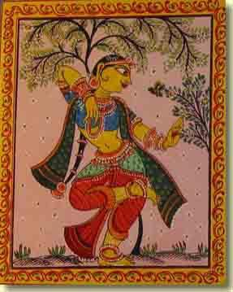
Srila Prabhupada's Radhastami lecture, Calcutta 1974
Prabhupada: So our request is. . . Everyone who is present here. . . Today is Radhastami. So pray to Radharani. And She is hare, hara. This hare, this word, is Radharani. Hara, Radharani. Radha or hara, the same thing. So Hare Krsna. So we are praying to Radharani, "My Mother, Radharani, and Krsna. " Hare Krsna. “O Krsna, O the Lord. ” Hare Krsna Hare Krsna, the same thing, repetition. “O Radharani, O Krsna. " "O Radha-Krsna. " "Radha-Krsna" or "Hare Krsna", the same thing. Hare Krsna Hare Krsna Krsna Krsna Hare Hare. Again addressing, "O Krsna, O Krsna, O Radharani. " Hare Rama. The same thing, again. Hare Rama. Rama is also Krsna. Rama is Rama, Rama is Balarama. They are all Krsna. Hare Rama Hare Rama Rama Rama Hare Hare. So this repetition of addressing Radha and Krsna or Hare Krsna is to pray, "My dear Lord, the, and the energy, the spiritual energy of the Lord, kindly engage me in Your service. " That’s all. "I am now embarrassed with this material service. Please engage me in Your service. "
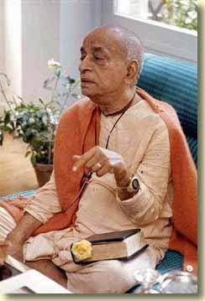
What is Radharani? Radharani is the pleasure potency of Krsna.
This is good sense. We are servants here. We are engaged in so many services. But it is not giving us comfort. The service which we are rendering to others, they are not satisfied, I am not satisfied. This is material service. But if you give service to Krsna, a little service can save you from the greatest danger. This is the formula.
Just like Ajamila. Ajamila, in his boyhood, he was brahmana. He was giving service to Visnu. But in young age he became a victim of a prostitute, and he fell down. But at the end, when Yamaduta was coming and were so fearful, he did not know whom to take shelter, but he was attached to his youngest son, whose name was Narayana. So he thought, "This Narayana would give me protection. " So he asked him, "Narayana!" But at the same time he remembered that "That Narayana, oh, hm, I sometimes gave service. " So immediately Narayana saved him.
So it is our duty therefore. . . That is the duty of human life, to become Krsna conscious. And that is stated here. It is not that one or two. Many. Jnana-tapasya. Jnana. That is required, knowledge and tapasya. That is human life. If, if we remain just like cats and dogs, eat, sleep and have sex life, beget children and die someday, this is cats' and dogs' life. This is not human life. Human life is different. To become purified by knowledge and tapasya. Tapo divyam yena suddhyet sattvam. That is the statement of Rsabhadeva. Everywhere. We have to purify our existence, and get out of this repetition of birth and death. That is success of life.
So we shall pray to Radharani. . . What is Radharani? Radharani is the pleasure potency of Krsna. Pleasure potency. Parasya saktir vividhaiva sruyate. The Supreme Lord has many potencies. Na tasya karyam karana ca vidyate. Therefore He has nothing to do. He has got so many potencies. Just like big man, a rich man. He’s sitting. But his energies, his potencies, are working. Big, big factory. And he knows everything. Similarly, He has got many multi-potencies. One of them is this pleasure potency. Pleasure potency. . . He also wants pleasure. So when Krsna wants. . . Krsna is Parabrahman. He cannot enjoy anything material. He has to create the source of enjoyment by His own spiritual potency. That is Radharani.
So Radharani is described in the sastra:
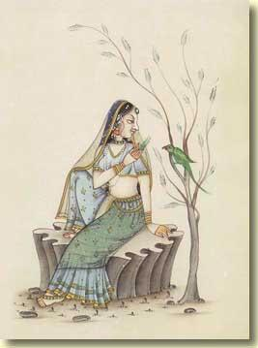
radha-krsna-pranaya-vikrtir hladini-saktir asmad. That is Krsna’s hladini-sakti. She gives pleasure to Krsna. So She is very kind. And today is Radhastami. If we pray to Srimati Radharani. . . Therefore in Vrndavana you’ll see. They are first of all glorifying, "Jaya Radhe!" Everywhere you’ll hear. "Jaya Radhe. "
Guest: Jaya Radhe.
Prabhupada: To glorify Srimati Radharani. So if Radharani’s pleased, he’ll be able to approach Krsna very easily. And that is the goal of our life. That is the goal of life. Vita-raga-bhaya-krodha man-maya mam upasritam. Mam upasritam means you have to take. . . You cannot take shelter of Krsna directly. You have to take shelter of His potency. Krsna is therefore trying to help us. Guru-krsna-krpaya paya bhakti-lata-bija. He is within. He is called caitya-guru. If you are purified. . . Krsna. . . Buddhi-yoga dadami tam. He’ll directly speak you. And so long you cannot, then He sends His representative, the spiritual master, the guru. You can ask through the spiritual master about Krsna. Yasya prasadad bhagavat-prasada.
So in this way we have to be absorbed in the thought of Krsna. We have to take shelter of Krsna. Then. . . If you take shelter of Krsna, this jnana. . .
vasudeve bhagavati
bhakti-yogah prayojitah
janayaty asu vairagyam
jnanam ca yad ahaitukam
The same thing. Krsna will speak. Krsna is within you. Simply you have to take shelter of Krsna, always thinking of Krsna, chant Hare Krsna Hare Krsna Krsna Krsna Hare Hare, Hare Rama Hare Rama. . .
Guests: Hare Rama Rama Rama Hare Hare.
Prabhupada: Thank you very much. That’s all.
(23 September 1974, class on BG 4. 10, Srimati Radharani's Appearance day, Calcutta. )
Srila Prabhupada's Radhastami lecture, Montreal 1968
Now today is our Radhastami ceremony. I must speak now something about Radharani, and then I shall go up, reach my apartment at twelve. In the meantime, you can observe the ceremonies. So, so far Radharani, Radharani, today is the birthday of Srimati Radharani. Radharani is the pleasure potency of Krsna. Krsna is the Supreme Brahman. Just try to understand. Krsna is the Supreme Brahman. Param brahma param dhama pavitram paramam bhavan. So when Parambrahma wants to enjoy. . . That enjoying spirit is there in the Parambrahman. Otherwise we cannot have this enjoying spirit. Because we are part and parcel, therefore we have got that enjoying spirit; but that is materially contaminated. But the fact is there, because Krsna, He is enjoying, this enjoying spirit we have got also, but I do not know how to enjoy. We are trying to enjoy in the matter, in the dull matter. That is spiritual. So Brahman, brahma sukhanubhrtya. People are trying to feel what is brahma-sukha, pleasure of brahmanubhava.
That is not material pleasure. So many yogis, they have given up their family life, their kingdom, and meditating to achieve that Brahman pleasure. Actually, the idea is Brahman pleasure. So many brahmacaris, so many sannyasis, they are trying to achieve that Brahman pleasure, and in order to achieve that Brahman pleasure they are neglecting, they are kicking off all this material pleasure. Do you think that Brahman pleasure is ordinary, this material pleasure? To achieve a portion of Brahman pleasure, if they are kicking off all this material pleasure. . . Don’t talk of ourselves. We are ordinary men. In the history we have got instances, that of Bharata Maharaja. Bharata Maharaja, under whose name this planet is called Bharatavarsa. That Bharata Maharaja was the emperor of the whole world. And as emperor he had his beautiful wife, young children. But at the age of twenty-four years, just young man, he gave up everything. All right. This is very old story, of course, but you know Lord Buddha. He was also a prince. He was also prince, not ordinary man, and he was ksatriya, and he was always enjoying with beautiful women. That is the palace pleasure accustomed in every, in Oriental countries, that in the palace there are many beautiful girls, they’re always dancing and giving pleasure to the kings and the prince. So Lord Buddha was also in such pleasure, but he gave up everything and began to meditate.
There are many hundreds of instances in Indian history that to realize the Brahman pleasure they gave up everything. They gave up everything. That is the way. Tapasya means voluntarily accepting something severe for realizing the supreme pleasure. That is called tapasya. So if, for tasting a little Brahman pleasure, all materialistic pleasures are to be given up, do you think that the Supreme Brahman, Lord Krsna, is enjoying this material pleasure? Is it very reasonable? This Krsna, He’s enjoying laksmi-sahasra-sata-sambhrama-sevyamanam. Hundreds and thousands of goddess of fortune are engaged in His service. Do you think these Laksmis are material women? How Krsna can take pleasure in the material women? No. This is mistake.
Ananda-cinmaya-rasa-pratibhavitabhis tabhir ya eva nija-rupataya kalabhih. In the Brahma-samhita you’ll find that He expands His ananda-cinmaya-rasa, the mellow of transcendental pleasure potency. And these gopis are expansion of His pleasure potency. And Radharani is the center. Radharani is the center. So Radharani is not. . . Don’t take that Radharani is an ordinary woman like we have our wife or sister or mother. No. She is the pleasure potency. And the birth of Radharani was not from the womb of any human being. She was found by her father in the field. While father was plowing, he saw one little nice child is lying there, and he had no children, so he caught it and presented to the queen, "Oh, here we have got a very nice child. " "How you got?" "Oh, in the field. " Just see. Radharani's janma is like that. So this janma is today and Radha, this name is sometimes not found in Bhagavata. So the atheistic class of men protest this Radharani’s name is not in the Srimad-Bhagavatam. How this name came, Radharani? But they do not know how to see it. There is anayaradhyate. There are many gopis, but there is mention that by this particular gopi He is served more pleasingly. Krsna accepts this gopi’s service more gladly. Anayaradhyate. Aradhyate. This aradhate, this word, aradhyate means worshiping. From this word aradhyate, Radha has come. But Radha’s name are there in other Puranas. So this is the origin.
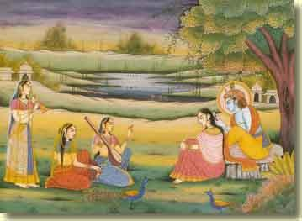
So Radha, so Radha and Krsna. Krsna is the enjoyer and He wants to enjoy. So He’s the Supreme Brahman. He cannot enjoy anything, atmarama, He can enjoy it in Himself. Therefore Radharani is the expansion of His pleasure potency. Krsna hasn’t got to seek external things for His pleasure. No. He is in Himself full, atmarama. So Radharani is expansion of Krsna. Krsna is the energetic, and Radharani is the energy. Just like energy and energetic, you cannot separate. Fire and the heat you cannot separate. Wherever there is fire there is heat, and wherever there is heat there is fire. Similarly, wherever there is Krsna there is Radha. And wherever there is Radha there is Krsna. They are inseparable. But He is enjoying. So Svarupa Damodara Gosvami has described this intricate philosophy of Radha and Krsna in one verse, very nice verse. Radha krsna-pranaya-vikrtir hladini-saktir asmad ekatmanav api bhuvi pura deha-bhedam gatau tau. So Radha and Krsna is the one Supreme, but in order to enjoy, They have divided into two. Again Lord Caitanya joined the two into one. Caitanyakhyam prakatam adhuna. That one means Krsna in the ecstasy of Radha. Sometimes Krsna is in ecstasy of Radha. Sometimes Radha is in ecstasy of Krsna. This is going on. But the whole thing is Radha and Krsna means the one, the Supreme.
So Radha-Krsna philosophy is a very great philosophy. It is to be understood in the liberated stage. Radha-Krsna philosophy is not to be understood in the conditioned stage. But when we worship Radha-Krsna in our conditional stage, actually we worship Laksmi-Narayana. You have seen that picture, this viddhi-marga and raga-marga. Radha-Krsna worship is on the platform of pure love, and Laksmi-Narayana worship is on the regulative principles. So long we do not develop our pure love, we have to worship on the regulative principles. One has to become a brahmacari, one has to become a sannyasi, one has to perform the worship in this way, in the morning he has to rise, he has to offer. So many rules and regulations. There are at least sixty-four rules and regulations. So we shall introduce them gradually as you develop. So in the viddhi-marga, when you have no love for God or Krsna, we have to follow the regulative principles and automatically. . . , there is practice. When practicing. Just like you practice this mrdanga playing. In the beginning it is not in order, but when you become well versed in the practice, the sound will come so nice. Similarly, when we are engaged by regulative principles in the worship of Radha-Krsna, that is called viddhi-marga. And actually when you are on the love platform, then that is called raga-marga. So without viddhi-marga, if anyone wants to learn the raga-marga immediately, that is foolishness. That is foolishness. Nobody can pass M. A. examination without going through the regulative principles of primary schools and colleges. So therefore I do not, I mean to say, indulge in the discussions of Radha and Krsna so easily. Rather go on with the regulative principle at the present moment. Gradually, as you become purified, as you become on the transcendental platform, you’ll understand what is Radha-Krsna. Don’t try to understand Radha-Krsna very quickly. It is a very big subject. If we want to understand Radha-Krsna very quickly, then there will be so many prakrta-sahajiyas.
In India there are prakrta-sahajiyas. Just like Radha-Krsna dancing. Radha-Krsna has become a plaything. The painting Radha-Krsna, Krsna is kissing Radha, Radha is kissing. These are all nonsense. Radha-Krsna philosophy has to be understood by the liberated person, not by the conditioned soul. So we shall await for the fortunate moment when we are liberated, then we shall understand radha-krsna-pranaya-vikrtir. Because Krsna and Radha, They are not on the material field. Try to understand. This is Jiva Gosvami’s analysis, that Krsna is the Supreme Brahman. The Supreme Brahman cannot accept anything material. So Radha is not in the material field.
Now there is a very nice song. I shall sing if you can play on the harmonium. Yes. This is a Rupa Gosvami’s song. (sings)
radhe jaya jaya mädhava-dayite
gokula-tarumi-mandala-mahite
damodara-rati-vardhana-vese
hari-niskuta-vrnda-vipinese
vrsabhanudadhi-nava-sasi-lekhe
lalita-sakhi guëa-ramita-visakhe
karunŕ kuru mayi karuëa-bharite
sanaka-sanatana-varnita-carite
radhe jaya jaya madhava-dayite
This song was sung by Rupa Gosvami. He is the real person, actual person, to understand Radha and Krsna. So he says, "All glories to Radharani. " Radhe jaya jaya madhava-dayite. "She’s so dear to Krsna. " Krsna, everyone is trying to love Krsna, but Krsna is trying to love somebody. Now how great She is. Just try to understand. Everyone, the whole world, the whole universe, all living entities, they are trying to love Krsna. Krsna-prema. Lord Caitanya describes, prema-pumartho mahan. And Rupa Gosvami described that "You are distributing krsna-prema. " So krsna-prema is so valuable, but Krsna is after Radharani. Just see how Radharani is great. Just try to understand the greatness of Radharani. Therefore She is so great, and we have to offer our respect. Radhe jaya jaya madhava-dayite. How She is? Gokula-taruni-mandala-mahite. Taruni, taruni means young girls. You’ll see the pictures, they are all young girls. But of all the young girls, She is the most beautiful. She is enchanting to the young girls also. She is so beautiful. Gokula-taruni-mandala-mahite.
Damodara-rati-vardhana-vese. And She always dresses Her so nicely that Damodara, Krsna, becomes attracted by Her beauty. Hari-niskuta-vrnda-vipinese. And She is the only lovable object of Krsna, and She is the queen of Vrdnavana. This queen of Vrndavana. . . You’ll find in Vrndavana, if you go to Vrndavana, everyone is worshiping Radharani. Radha means queen. They are always speaking, "Jaya Radhe!" Radharani. All the devotees in Vrndavana, they are worshiper of Radharani. Hari-niskuta-vrnda-vipinese. Vrsabhanudadhi-nava-sasi-lekhe. And She appeared as the daughter of King Vrsabhanu, and Her companion, Lalita-sakhi and Visakha-sakhi, and the devotees. . . So on behalf of the pure devotees of Krsna, Rupa Gosvami is praying, karunŕ kuru mayi karuna-bharite. "Oh, my worshipable Radharani, You are full of mercy. So I am begging of Your mercy because You are so merciful, very easily You offer, bestow Your mercy. So I am begging Your mercy. " Karuna kuru mayi karuna-bharite, sanaka-sanatana-varnita-carite. Now somebody may say, "Oh, you are so great, learned scholar, you are so great saintly person, and you are begging mercy from an ordinary girl? How is that?" Therefore Rupa Gosvami says, "Oh, this is not ordinary girl. " Sanaka-sanatana-varnita-carite. "This girl’s description is possible to be made by great saintly persons like Sanaka-Sanatana. She is not ordinary. "
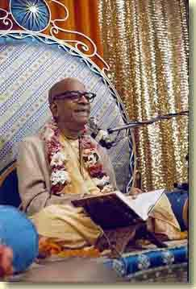
And She always dresses Her so nicely that Damodara, Krsna, becomes attracted by Her beauty.
So the lesson is that we should not treat Radharani as ordinary girl, or Krsna as ordinary man. They are the Supreme Absolute Truth. But in the Absolute Truth, there is the pleasure potency, and that is exhibited in the dealings of Radha and Krsna. And Radha’s expansion all the gopis, and Krsna is the Supreme Lord.
Thank you very much. Chant Hare Krsna. You can chant? Can you chant? Janardana? All right, you can chant. What is that? No, I have explained that one sloka from this Rama-carita-manasa. Chant Hare Krsna. (30 August 1968, Srimati Radharani's Appearance Day, Montreal. )

The real X-Files?

The following article is from www.steamshovelpress.com/latestword14.html.
Strange Secrets: An Interview With Author Nick Redfern
by Kenn Thomas, Editor of Steamshovel Press
Nick Redfern emigrated to the USA to live in 2001. Nick's new book, Strange Secrets: Real Government Files on the Unknown (co-written with British author Andy Roberts), is just about to be published by Simon & Schuster. We speak with him about the book and its revelations linking the world of British, American and Russian Intelligence with that of the unexplained.

Q: What, broadly, is Strange Secrets about?
A: Essentially, the book is an examination of official files created from the 19th Century to the present day and shows the way in which various Intelligence agencies, such as the CIA, MI5, the US Defence Intelligence Agency and former KGB--among numerous others--have investigated unexplained phenomena and unsolved mysteries and have collated what might be termed real-life X-Files.
Q: Can you give the readers a few examples of the information that appears in the book?
A: Sure. The first thing I would want to stress to anyone reading this interview and who is contemplating buying the book, is that it does not rely on questionable or anonymous sources or unverifiable data. Even though some of the subject matter might be considered bizarre, the book is based solely on an examination of official documents that have surfaced via the US Government's Freedom of Information Act or the British Government's Thirty Year Ruling. I guess that perhaps one of the strangest revelations is the fact that both British and US Intelligence have investigated the so-called Crop Circle mystery. Practically everyone who reads UFO Magazine, I am sure, has heard of Crop Circles and has seen photographs of the various formations--or pictograms-- that appear throughout England and the world each year. But less well known is what has been learned about the subject at an official level. For more than a decade rumours have circulated to the effect that the British Government has undertaken covert investigations of Crop Circles. To an extent, at least, that is true. At the Public Record Office at Kew there exists an intriguing file prepared at the height of the Second World War by none other than MI5 and that was declassified in 2001. The file deals with the way in which MI5 suspected that Nazi sympathisers and Fifth Columnists in the UK were sending messages to--and communicating with--the enemy. Interestingly, MI5 learned that in Poland, Holland, France and Belgium, this included 'the cutting of cornfields into guiding marks for aircraft'. To illustrate how closely this parallels today's Crop Circles, the official file refers to enemy sympathisers 'beating out signs twenty metres in diameter on harrowed fields or mowing such signs on meadows or cornfields'. Crop circles in other words! Interestingly, MI5 investigated a number of such formations that appeared in various British fields from 1940-1943 to determine if any of those same formations were some form of coded message intended for German pilots flying overhead.
Q: Have British authorities been involved in investigating other, similar mysteries, too?
A: Yes, and particularly during the Second World War. One perfect example is contained in a chapter we title 'The Dowsing Detectives. ' This is a look at a fascinating and never-before-seen file on a piece of wartime history that reveals the way in which elements of the British Police Force used people with dowsing abilities to locate dead bodies buried under the rubble created by Hitler's forces. As with many controversial subjects, the Police file reveals that there were as many believers in the ability of the dowser as there were those who thought that the subject should be ignored. But what is perhaps most interesting is that it was police personnel themselves that were doing the dowsing. And they had some startling successes too in locating dead bodies purely by water divining-means. And these events attracted the keen attention of the British Government, with the files and reports reaching the wartime Ministry of Home Security, which took a close interest in the way in which the controversy developed.
Q: What is the oldest file you have in the book?
A: This would have to be a series of documents that we found in the files of the British Admiralty that are held at the Public Record Office at Kew. Contained in these documents are various accounts of sightings by naval personnel of what can only be described as Sea Serpents. Let me quote to you the text of one such report, written in 1830 by Captain James Stockdale of the ship the Rob Roy, who had an amazing encounter near the island of St. Helena on Sunday, May 9 of that year. Stockdale wrote: 'About five p. m. all at once while I was walking on the poop my attention was drawn to the water on the port bow by a scuffling noise. Judge my amazement when what should stare us all in the face as if not knowing whether to come over the deck or to go around the stern--but the great thundering big sea snake! My ship is 171 feet long overall--and the foremast is 42 feet from the stern which would make the monster about 129 feet long. The brute was so close I could even smell his nasty fishy smell. ' This is just a small extract from Stockdale's account and it makes for bizarre and illuminating reading. And this is just one of a number of such accounts held in the British Admiralty's Sea Serpent File.
Q: The Press Release for the book also talks about British Government files on Foo Fighter sightings during the Second World War.
A: Yes. As many readers will know, the Foo Fighters were essentially a precursor to what would later become known as Flying Saucers and UFOs. All credit to finding these Air Ministry and Royal Air Force files must go to my co-author Andy Roberts and Dr. David Clarke. Throughout much of the war, military pilots--both Allied and Axis--reported close encounters with strange aerial phenomena that became known as Foo Fighters and that were described as being like small balls of light or globes of light that would approach military aircraft at high speed, fly alongside them and then usually streak away at high speed without exhibiting any outward hostility. The Air Ministry's files from the War reveal the details of a number of such cases and the way in which they were investigated at an official level, along with the theories that the Foo Fighters were possibly some sort of German secret weapon. But one report in particular falls into a classic UFO category and refers to the sighting by a Royal Air Force crew taking part in a raid on Turin in 1942 of a 2-300 foot long object seen flying at an estimated speed of 500 MPH.
Q: The book contains several other chapters that have a UFO connection to them.
A: Yes. We also include an extensive chapter on FBI files on the so-called Cattle Mutilation mystery that has afflicted much of the USA for decades. On numerous occasions dating back to at least the 1960s, ranchers across the USA have reported finding their cattle dead with blood drained from their bodies and organs removed with what looks like surgical precision. Unmarked helicopters are often seen in the vicinity of the mutilations, as are unusual and unidentified aerial lights. Again, for the sceptical, I would stress that this is all corroborated in the FBI's own officially released records that are reproduced in the book. Various theories have been put forward that these mutilations are linked with UFOs or Satanic cults. However, I dug very deeply into this mystery and located at the National Archives in Maryland various formerly Top Secret files from the late 1940s showing that the US Government's Research and Development Board was very concerned that a hostile nation would attempt to cripple the US food chain by deliberately infecting the cattle herd with a lethal biological agent. Moreover, it was stated at the time that US authorities should keep a regular check on the cattle herd to determine if someone had successfully infected it with lethal and dangerous viruses. Personally, I'm now convinced that many of the so-called Cattle Mutilations are the work of covert military units that periodically and randomly carry out stealthy checks on the US cattle herd to determine the presence of these emerging viruses and diseases that might have been introduced deliberately by foreign and unfriendly nations and maybe, today, even by terrorist-type groups.
Q: Strange Secrets also addresses the way in which the US Government and the Nazis attempted to build Flying Saucer-like aircraft. Can you expand on this?
A: Yes. There have been long-standing rumours to the effect that the Nazis developed prototype aircraft in the latter stages of the Second World War that would broadly fit the classic description of a UFO or a Flying Saucer. Several such reports exist in the files of the FBI in the form of interviews with former Luftwaffe personnel, for example. Similarly, the FBI's records reveal that as far back as 1947, a number of FBI agents were personally convinced that UFOs were the product of a secret US programme that was designing and building Flying Saucer-like craft based on captured German technology brought to the US at the close of the Second World War and in conjunction with the Paperclip operation that secured the use of numerous German scientists for postwar research. But perhaps most eye-opening are the files we reproduce in the book from the US Air Force that show as far back as 1962, studies were being undertaken to try and build and deploy a fleet of battle-ready and fully armed Flying Saucer-style spacecraft that would orbit the Earth at a height of 300 miles for up to six weeks! We also show the way in which the CIA carefully exploited the UFO mystery as a cover for its covert U-2 flights at the height of the Cold War.
Q: In terms of content, what would you say is the strangest official file that appears in the book?
A: That would have to be the FBI's file on the Contactees. These, as I'm sure you're aware, were people who, in the 1950s and 1960s, claimed to be in contact with human-like aliens who wanted us to disarm our nuclear arsenals and live in peace. Many of the accounts are of an outrageous, bizarre nature and are very cult-like. And as strange as it seems, the FBI collated extensive files on many of these people who claimed alien contact. However, the Freedom of Information Act shows that the foremost reason for the FBI's interest and concern in these people was not because of the alien aspect of their stories per se. Rather, it was because several of the Contactees, such as the notorious George Adamski, were claiming that their alleged alien friends had a Communist style of government! Today this aspect of the FBI's investigations might seem totally unbelievable and unwarranted; but 50 years ago, at the height of the Cold War, J. Edgar Hoover dispatched agents to uncover anyone that might have Communist leanings; and this included the so-called Contactees. Sometimes truth really is stranger than fiction.
Q: The book also focuses on religion, too.
A: That's correct. We have a chapter in there on the CIA's file on Noah's Ark. There have been stories quietly told for many years that in the late 1940s and 1950s the CIA carried out a covert search for the remains of the legendary Ark of Noah that, according to the Bible, came to rest on Mount Ararat, Turkey. There are references to satellite and aircraft imagery of the Ark and even tales of remnants of the Ark having been recovered by US Intelligence. The files that the CIA has released via the Freedom of Information Act add valuable and intriguing data to this story. Within the CIA, the Ark--or what some suspected to be the Ark--became known as The Ararat Anomaly.
Q: It's been a long-standing and acknowledged fact that US Intelligence has spent a lot of time delving into the world of Remote Viewing or what might be termed Psychic Spying.
A: That's right. Our book includes a whole section titled Mind Games that includes 5 chapters on the way that research into the power of the mind as a potential tool of espionage has been studied in both Russia and the USA. Maybe strangest of all was the research that both the US Department of Defence and the Russian military carried out to determine if Extra-Sensory Perception--or ESP--existed in the Animal Kingdom. Their conclusions--reached entirely independently--suggested it probably did exist in some form in higher animals such as dogs. The US DoD report also focuses on the possibility of an afterlife in the animal kingdom and discusses various experiments that had been undertaken to try and ascertain this. We also show that in 1952 the US Department of Defense was briefed on the way in which extrasensory perception could be used as a tool of psychological warfare. On this later subject of psychological warfare, we also reveal the way in which the US Army exploited legends of Vampires, Werewolves, Witchcraft and Sorcery to terrify superstitious enemy troops on various battlefields in the Philippines and in Vietnam.
Q: Having conducted all of this research, what are your conclusions about the way in which the worlds of officialdom and the unexplained have crossed paths?
A: Well, it's quite clear from examining the files on ESP and Psychic Spying that this research was carried out purely to determine if, at the height of the Cold War, there was a chance that the phenomena could be used as a tool of espionage. Similarly, the FBI's files on the Contactees had deep Cold War overtones and related directly to FBI Director J. Edgar Hoover's concerns about Communism and the very real Soviet threat that existed at the time. And it can be argued that the British Government files on Crop Circles, Dowsing and the Foo Fighters were created largely as a result of the Nazi threat of the 1940s. And of course, the issue of lethal viruses and biological warfare as it relates to the Cattle Mutilation issue is one that is very relevant in today's post-9-11 world. But there are files in the book that are more problematic in terms of the motive for their creation--such as the CIA files on Noah's Ark.
Q: Briefly and finally, does the book focus on any other areas?
A: Yes. We have chapters on the Royal Air Force's files on sightings of the Loch Ness Monster; FBI records on so-called Spontaneous Human Combustion; official records on encounters with real-life Men in Black; US Government files on rare weather phenomena such as Ball-Lightning; British Government records on sightings of large, predatory cats seen roaming the countryside--such as pumas and panthers and much more.
Q: Can we expect to see any other titles from you in the future and what are you doing in the US now?
A: I'm doing a lot of work with Ryan Wood, of http://www.majesticdocuments.com/ on the whole MJ12 controversy. Andy Roberts and I have a book coming out next year on an alleged UFO crash incident in Wales in 1974 and that coincides with the 30th anniversary of the case, and I also have another book out next year on another big interest of mine--cryptozoology, or the search for unknown animals.
Strange Secrets: Real Government Files on the Unknown by Nick Redfern & Andy Roberts is published by Simon & Schuster's division, Paraview Pocket Books in May 2003. ISBN: 0-7434-6976-3.

Helsinki, Finland
22 September 2004
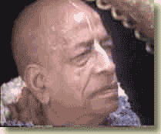
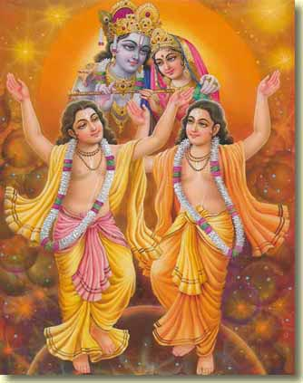
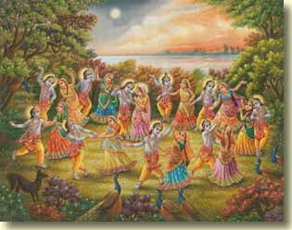 | 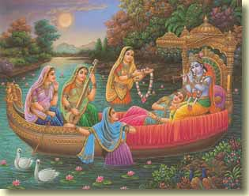
Notes on Srila Bhaktisiddhanta Sarasvati Thakura's rendition of Srimad-Bhagavatam 1. 2. 21, translated by Punya-palaka Prabhu of ISKCON Prague.
The verse as it appears in the BBT edition of Srimad Bhagavatam, translated by His Divine Grace A. C. Bhaktivedanta Swami Prabhupada:
bhidyate hrdaya-granthis
chidyante sarva-samsayah
ksiyante casya karmani
dsrta evatmanisvare
Thus the knot in the heart is pierced, and all misgivings are cut to pieces. The chain of fruitive actions is terminated when one sees the self as master.
Srila Sarasvati Thakura's translation:
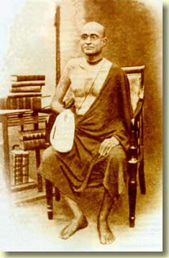
Srila Bhaktisiddhanta Sarasvati Thakura
If one encounters the Lord in His own form as the Supersoul, or the soul of the soul, in other words, if he sees his real self, then for such knower of the bhagavat-tattva the chain in the form of the false ego which is binding the mind gets destroyed, all kinds of ropes of doubts like thinking "This is not possible," are cut and he gets rid of all reactions which he has not yet received.
Srila Visvanatha Cakravarti Thakura's Sanskrit comment upon this verse:
hrdaya granthir avidya bhidyata iti karma-kartari prayogenavidya dhvamso bhaktanam ananusamhitam phalam evam eva chidyante sarva-samsayah asambhavanadi-rupah. atmaniti isvara ity asya visesanam yad va atmany eva manasy eva drste kim punah saksad drste satiti sphurti saksatkaravyaktau. satam krpa mahat-seva sraddha guru-padasrayah. bhajanesu sprha bhaktir-anarthapagamastatah. nistha-rucir athasakti-ratih premattha darsam. harer-madhuryanubhava ityarthah syus caturdasa.
Srila Sarasvati Thakura's rendition of Srila Cakravartipada's commentary:
"The knots in the heart are cut" means that ignorance (the false ego) is destroyed. Here bhidyate means that by the sword of his activities, the devotee annihilates, as a side effect, his ignorance. In this way all doubts like thinking that "This is absurd," are cut. In this verse isvare is an attribute of atmani-- it is the soul of the soul, or the Lord as the Supersoul, which is to be seen. The question may arise: which is the point here--"After seeing the Lord in one's heart or mind," (the knot in the heart and all doubts are destroyed), or "After direct encounter?" This statement includes both revelation in the mind and direct meeting.
Here talk is about the 14 unavoidably needful items of the devotees' spiritual practice: (1) sadhu-joner krpa, the mercy of the saints, (2) mahater seva, serving the great souls, (3) sraddha, faith, (4) guru-padasraya, taking shelter of the lotus feet of the spiritual master, (5) bhajane sprha, an inclination to perform the worship, (6) bhakti, devotional service, (7) anartha-nivrtti, getting rid of the unwanted desires, (8) nistha, steadiness, (9) ruci, taste, (10) asakti, attachment, (11) rati, pleasure, (12) prema, love, (13) darsan, meeting, and (14) sri-harir madhuryer anubhab, perception of the sweetness of the Lord.
tathya: bhagavater ekados skondho bimso odhyae 30 slok o ei slok eki.
mundakopanisade 2/2/8--drsto evatmanisvare sloke tasmin drste paravare mantramso drsto hoe.
Information: The verse 11. 20. 30 of the Srimad-Bhagavatam says the same thing as this verse. In the Mundaka Upanisad (2. 2. 8), the verse drsta evatmanisvare contains the phrase tasmin drste paravare.
Explanation (vivrti):
To see Isvara in the inferior energy is dharma of the conditioned soul. Mayavadis, instead of seeing Isvara in the substance of the inferior energy, always see the supreme principle somewhere far away from the illusory variegatedness. When a living entity accepts monism (nirvisesa-vada) as the ultimate truth, then he cannot see the Lord in Vaikuntha. On the other hand, devotees always take shelter at the feet of the spiritual master. Through performing one's constitutional occupation, devotional service at the lotus feet of Sri Gurudeva, one comes to know his master. This elevated assistant of Lord Hari, Sri Gurudeva, is constantly engaged in the activities of the soul. Although Sri Gurudeva himself belongs to isvara-tattva, providing shelter on behalf of the disciplic succession based on the Vedic scriptures, he nevertheless prides himself upon being a subordinate servant of the Lord. The one who properly sees in the eternal Supreme this variety of the worshiped and worshiping achieves the ultimate goal. As it is stated in the Svetasvatara Upanisad:
yasya deve para bhaktir
yatha deve tatha gurau
tasyaite kathita hy arthah
prakasante mahatmanah
There is no way to know the purport of the srutis other than the mercy of the spiritual master. On the path of arguments, the inconceivable transcendental isvara-bhava is never revealed. But it can be obtained on the path of hearing by the mercy of the spiritual master.
In the Mundakopanisad it is said:
yam evaisa vrnute tena labhyas
tasyaisa atma vivrnute anum svam
The conditioned soul cannot attain the Supersoul just from the descriptions of the scriptures, or in other words, the Lord does not reveal Himself for the mundane vision.
In the three mantras beginning with dva suparna, the Lord and the controlled, the worshipable entity and the devotees, as well as the subject matter of their eternal worship are explicitly described. Without realizing this topic of devotional service, one is unable to grasp the meaning of the Vedic literature. Those endowed with bhakti for Sri Gurudeva and his worshipable Lord get liberated from the clutches of enjoying the fruits of karma. By the combined mercy of guru and Krsna one can receive the seed of the creeper of devotional service. At that time the many knots of the gross and subtle world in the heart get cut apart. The living entity attains liberation from the clutches of his temporary designative mind, intelligence and false ego, and he is no more cheated by the knowledge perceived by material senses. At that time all his doubts are removed and his inclination to enjoy the fruits of his activities diminishes. Needless to say, as long as the conditioned soul remains bound by the shackles in the form of gross and subtle designations, his false ego of the worldly enjoyer does not get destroyed, his doubts are not cut, and his enjoying of the fruits of karma is not finished. Until he is able to understand that Bhagavan, the Supreme Personality of Godhead, is his master and that he is a Haridasa Vaisnava, His servant devotee, he will remain embarrassed by his two kinds of bodies, the gross and the subtle, and their many engagements. When one sees, with the eyes of devotion, the shelter, Lord Syamasundara, surrounded by His servants, all contaminations of his mind and any inability in worshiping the Lord are removed.
Anyone who is devoid of the service to the Lord has forgotten his constitutional position and becomes either a bhogi or a tyagi. In the presence of a Vaisnava there is eternal service. Avaisnavas, being estranged from bhakti, are deprived of their power of seeing, are blind, and they invoke various imaginations; then they maintain their enjoying the fruits of karma, doubts and all kinds of tamasic ideas.

Startling Breakthrough in the Science of Consciousness!
Researcher Demonstrates Robot that Responds to Human Thought!
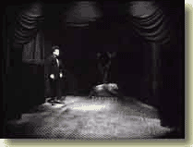
A film clip released by the University of Vineland of Prof. Key demonstrating how Morgus works.
After five years of often dangerous experiments with electricity, Professor Don Key of the University of Vineland has constructed a robot that responds to his thoughts. Morgus is the name he has given the machine.
"I've found that the robot actually responds best when I send out thoughts that address it as 'Morgus'", Prof. Key explained in a telephone interview. "I tried other names. 'Ptahotep' worked pretty well for a while, but 'Morgus' turned out to be the real winner. "
Morgus's 'brain' is a purpose-built computer that runs software written in a code that Dr. Key claims is the same code used by the human central nervous system. "It took me years to finally break into the data system that the brain and the sensory pathways operate in the process of neurotrasmission. I put my own mental health at risk by charging up my nervous system with jolts of electricity. I had to, because ethically there was no way to perform such dangerous experiments on another human being. "
One noticable side effect of these experiments is the tall frizzy perm atop Prof. Key's pate.
He told of a second vital breakthrough, the one by which he was able to get Morgus's on-board computer to respond to his thoughts. This was the installation of a pair of reindeer antlers as antennae.
"I can't explain why this has worked out so well, but I suspect it is because the antlers are made of organic material. "
"Morgus doesn't do much yet except move in a straight line across the floor. I'm sure it will learn to do more in time. I've just got to keep concentrating my thoughts. "

Helsinki, Finland
24 September 2004
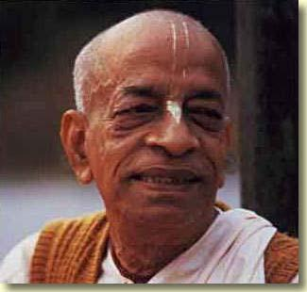
Radhastami Scenes, ISKCON Helsinki

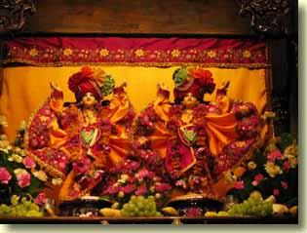
The main Deities at ISKCON Helsinki are Sri-Sri Gaura-Nitai.
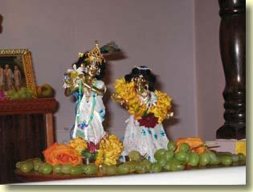
For the Radhastami celebration, these Sri-Sri Radha-Govindaji Deities were mercifully present.

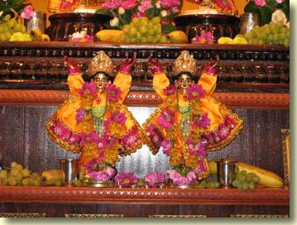
Utsava-murties of Sri-Sri Gaura-Nitai.

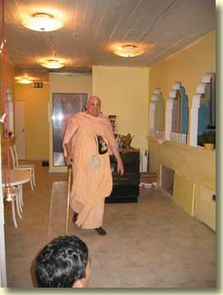 | 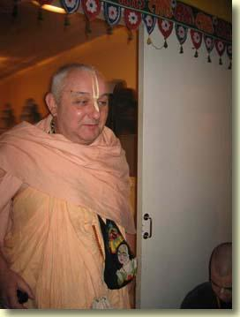

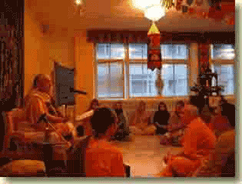
I arrive to give the Radhastami lecture.
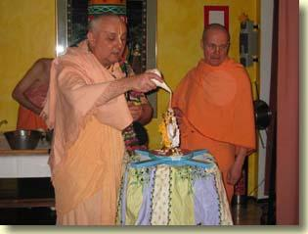
Abhiseka for Sri-Sri Radha-Govindaji.

Helsinki, Finland
1 October 2004
Preaching in Turku, Finland
29-30 September
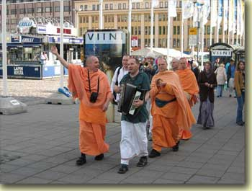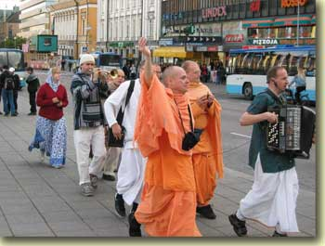
Harinama Sankirtana in the city of Turku. By way of street chanting and book distribution, the devotees invited people to attend the India Experience program that was held on the evening of 29 September.
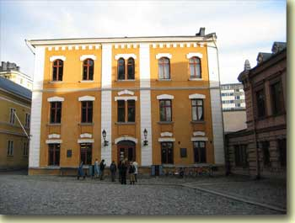 | The India Experience program has toured Finland for more than a decade. In Turku it took place in this historic public hall.

Dance, bhajana, lecture, a multimedia slideshow, kirtana, and prasadam--all this is presented by the India Experience to an eager public. | 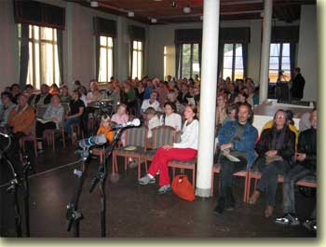
 | 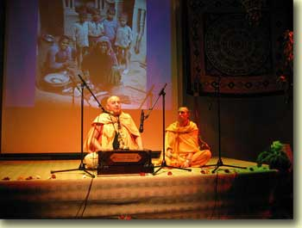

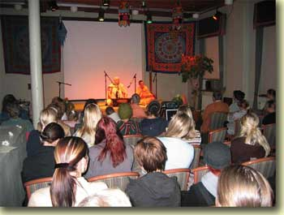 | 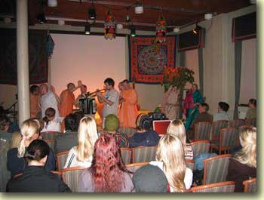
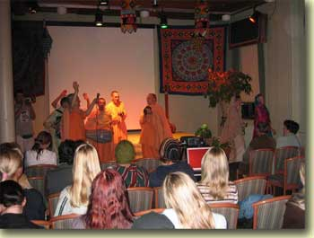 | 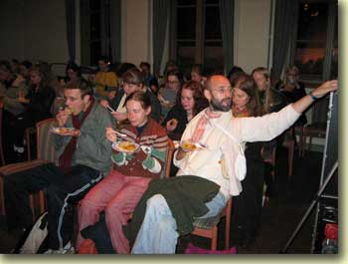

After the program is over, the devotees load the equipment into this convoy of sankirtana vehicles. | 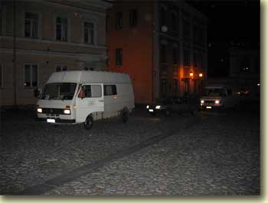

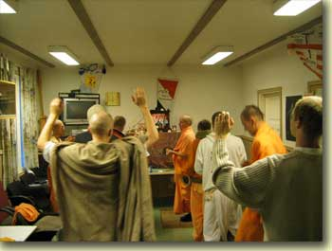 | 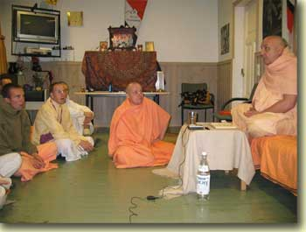
Morning program. The India Experience team stayed in a large building in the woods outside of Turku. The building normally serves as the clubhouse of a hiking organization.
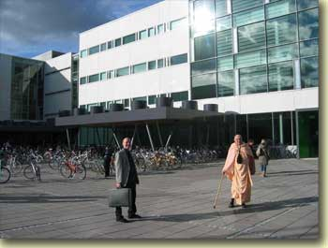 | Standing before the University of Turku. I am with Tattavada Prabhu, the Helsinki temple president.

Today, on the afternoon of 30 September, I am to give a talk to the students and faculty of the philosophy department. | 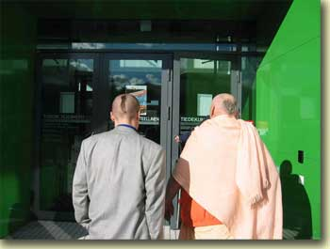

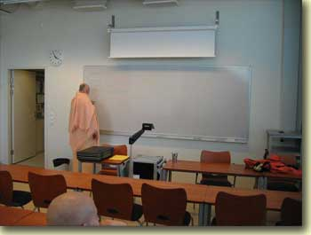 | Before the attendees arrive, I write key points of my presentation on the whiteboard.

Both the devotees and the philosophy department faculty were surprised at how many attendees there were for my talk. Attendance was voluntary; students were not obliged by the university to come. But so many came that extra chairs had to be brought in from other rooms. | 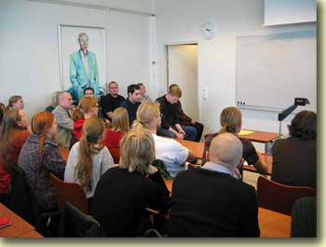

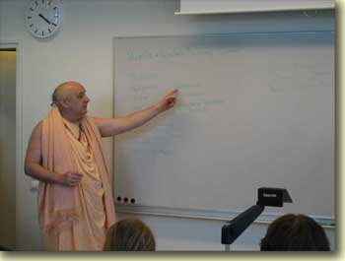 | 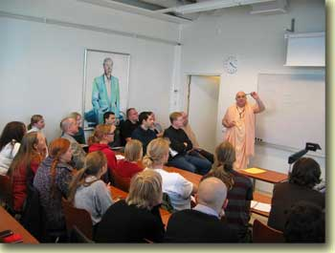
Here I explain that empiricism relies upon the "correspondence theory of knowledge", which holds that our language must correspond to physical objects readily evident to the senses in order for us to say anything true and meaningful. For example, the term "green felt pen" makes valid sense because it corresponds to a physically apparent green felt pen. Then I went on to tell why this theory of knowledge is deficient.
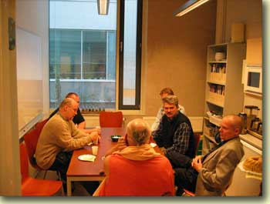 | After the lecture, Tattvavada Prabhu and I met with faculty members for herbal tea and prasadam cake and cookies.

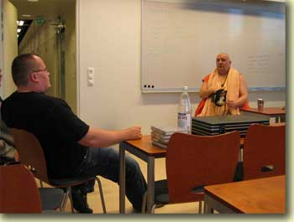 | 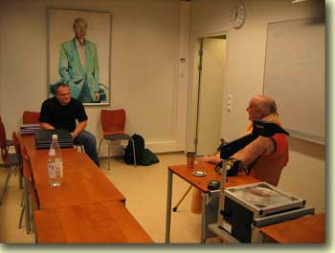
After the tea party, I spent some time with Juha-Pekka Pellonpaa, a member of the physics faculty who holds a Ph.D. in quantum physics. His specialty is quantum field theory, which is concerned with the mathematical "ether" in which quantum events take place. We had a lively discussion.
Here Dr. Pellonpaa explains the workings of a special microscope that is used to "see" objects as small as a single atom. The microscope has an extremely tiny electrified needle as its sensor. When the needle is brought near an atom, the microscope registers an image that looks like a ball. "We call these balls atoms," Pellonpaa explained. "However, when we change the microscope's needle, then the image of the ball looks different from the way it did with the old needle. So I don't know that we are really seeing atoms with this instrument." | 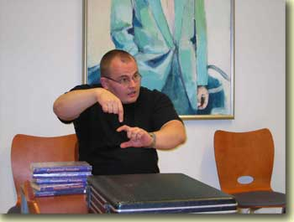

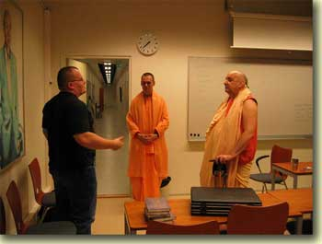 | Dr. Pellonpaa told me that the modern conception of the size of the universe is based upon assumptions that he personally is not convinced of. "I don't believe in the Big Bang theory," he said. He is very interested in the Vedas and had many questions about Vedic atomism and cosmology.

Helsinki, Finland
3 October 2004
A Visit with Dr. Igor Alexeev and Family
Dr. Alexeev, formerly of St. Petersberg, Russia, is a lecturer in the chemistry faculty of the Univerity of Turku. Myself, Tattvavada and Tapo Divyam Prabhus visited his home and family on the afternoon of Friday, 1 October, before we returned to Helsinki from Turku.
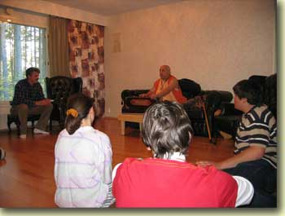 | 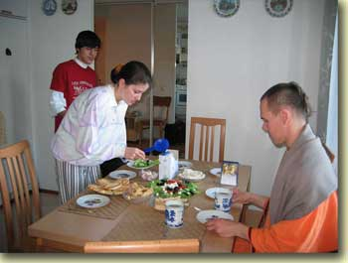
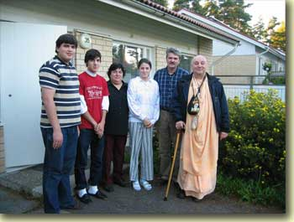 | 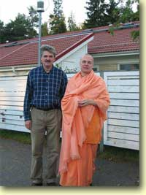

Sunday Feast Program, Helsinki
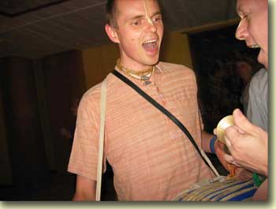 | 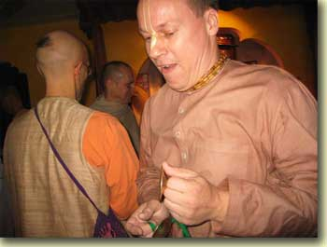
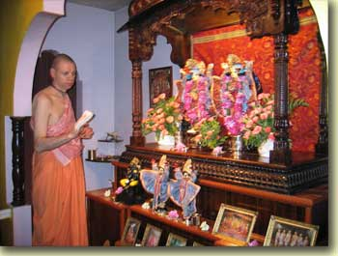 | 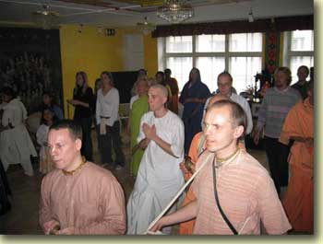
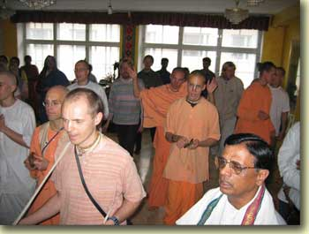 | 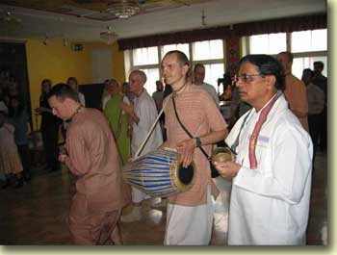
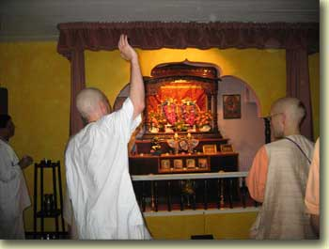 | 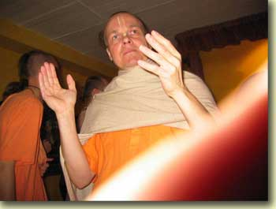
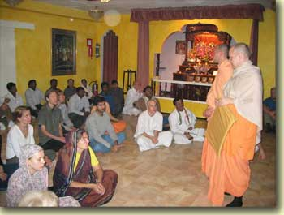 | 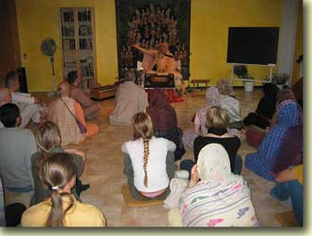
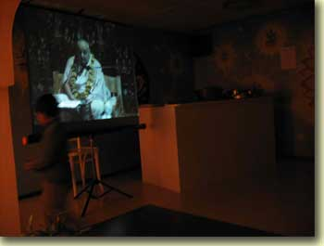 | 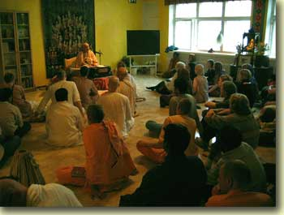
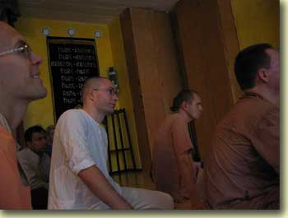

Hare Krsna Mahamantra
The meaning as explained by Gopala Guru Gosvami, disciple of Sri Svarupa Damodara Gosvami
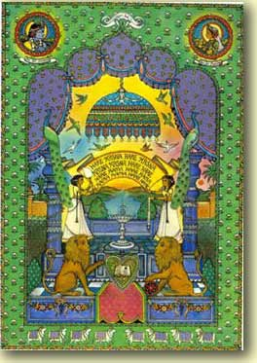
The word hare :
hari harati papani dusta cittair api smrtah
anicchayapi samsprsto dahaty eva hi pavakah
vijnapya bhagavat tattvam cid ghanananda vigraham
haraty avidyam tat karyam ato harir iti smrtah
Just as the fire, on contacting an object, automatically burns it, so the name of Hari takes away ( harati ) or burns up all the sins of the people with materialistic hearts. It removes ( harati ) all ignorance and reveals the transcendental, blissful form of the Lord. Also, hari means that personality who attracts ( harati ) the minds of all the people in the universe when they hear stories of His transcendental qualities; or, He who attracts the minds of people by His beautiful youthful form. Hari in the grammatical form of address, the vocative, or calling out to a person, becomes hare .
The word hare has another meaning:
svarupa prema vatsalyair harer harati ya manah
hara sa kathyate sadbhih sri radha vrsabhanuja
Hara is Srimati Radhika, daughter of Vrsabhanu, who steals ( harati ) the mind of Hari, Krsna, by her unalloyed love. Hara , in the form of address, also becomes hare .
The word Krsna :
krsir bhu vacakah sabdo nas cananda svarupakah
tayor aikyam param brahma krsna ity abhidhiyate
The word krsna is composed of the root krsi meaning bhu , the shelter of all existence and the word na meaning nivriti or the form of supreme bliss. Combined they form the word krsna which signifies the param brahma , the Supreme Personality of Godhead with blissful form.
Krsna in the form of address remains as krsna .
The word Rama :
ramante yogino 'nante nityanande cidatmani
iti rama padenaiva param brahmadbhidhiyate

The param brahma is known as Rama because the yogis take pleasure ( ramante ) in meditating on His eternal, blissful form.
vaidagdhi sara sarvasva murti liladbhidevatam
sri radham ramayan nityam rama ity abhidhiyate
The Supreme Lord is called Rama because He carries out pastimes of pleasure with the most beautiful Sri Radha.
Hare Krsna Hare Krsna Krsna Krsna Hare Hare
Hare Rama Hare Rama Rama Rama Hare Hare
Oh Radha, please attract my mind, and free me from this material world.
Oh Krsna, please attract my mind.
Oh Radha, attract my heart by showing your sweetness.
Oh Krsna, purify my mind by giving knowledge of how to perform worship of You through Your pure devotee.
Oh Krsna, give me steadiness to appreciate Your name, qualities and pastimes.
Oh Krsna, may I develop a taste for serving You.
Oh Radha, please make me qualified for your service.
Oh Radha, please instruct me on how I can serve you.
Oh Radha, let me hear of your intimate pastimes with your beloved.
Oh Rama (Krsna), let me hear of Your intimate pastimes with your beloved.
Oh Radha, reveal to me your pastimes with your beloved.
Oh Rama, reveal to me Your pastimes with Your beloved.
Oh Rama, engage me in remembering Your name, form, qualities and pastimes.
Oh Rama, please make me qualified for your service.
Oh Radha, be pleased with me.
Oh Radha, be pleased with me.

Helsinki, Finland
4 October 2004
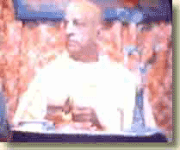
Mukunda-mala Stotram
by King Kulasekhara
krsna tvadiya-pada-pankaja-panjarantam
adyaiva me viata manasa-raja-hamsah
prana-prayana-samaye kapha-vata-pittaih
kanthavarodhana-vidhau smaranam kutas te
This, the 33rd verse of the Mukunda-mala Stotram, was a great favorite of Srila Prabhupada. Below are translations for all 53 verses of this ancient and beautiful Sanskrit poem.
TEXT 1
O Mukunda, my Lord! Please let me become a constant reciter of Your names, addressing You as Sri-vallabha ("He who is very dear to Lakími"), Varada ("the bestower of benedictions"), Dayapara ("He who is causelessly merciful"), Bhakta-priya ("He who is very dear to His devotees"), Bhava-lunahana-kovida ("He who is expert at plundering the status quo of repeated birth and death"), Natha ("the Supreme Lord"), Jagan-nivasa ("the resort of the cosmos,") and Naga-sayana ("the Lord who lies down on the serpent bed").
TEXT 2
All glories to this Personality of Godhead known as the son of Srimati Devakidevi! All glories to Lord Sri Krsna, the brilliant light of the Vrsni dynasty! All glories to the Personality of Godhead, the hue of whose soft body resembles the blackish color of a new cloud! All glories to Lord Mukunda, who removes the burdens of the earth!
TEXT 3
O Lord Mukunda! I bow down my head to your Lordship and respectfully ask you to fulfill this one desire of mine: that in each of my future births I will, by your Lordship's mercy, always remember and never forget Your lotus feet.
TEXT 4
O Lord Hari, it is not to be saved from the dualities of material existence or the grim tribulations of the Kumbhîp€ka hell that I pray to your lotus feet. Nor is my purpose to enjoy the soft-skinned beautiful women who reside in the gardens of heaven. I pray to Your lotus feet only so that I may remember You alone in the core of my heart, birth after birth.
TEXT 5
O my Lord! I have no attachment for religiosity, or for accumulating wealth, or for enjoying sense gratification. Let these come as they inevitably must, in accordance with my past deeds. But I do pray for this most cherished boon: birth after birth, let me render unflinching devotional service unto your two lotus feet.
TEXT 6
O Lord, killer of the demon Naraka! Let me reside either in the realm of the demigods, in the world of human beings, or in hell, as You please. I pray only that at the point of death I may remember Your two lotus feet, whose beauty defies that of the lotus growing in the Sarat season.
TEXT 7
I always think of Lord Hari, whose joyful lotus face bears a gentle smile. Although He is the son of the cowherd Nanda, He is also the supreme Absolute Truth worshiped by great sages like Narada.
TEXT 8
The desert of material existence has exhausted me. But today I will cast aside all troubles by diving into the lake of Lord Hari and drinking freely of the abundant water of His effulgence. The lotuses in that lake are His hands and feet, and the fish are His brilliant shining eyes. That lakes water relieves all fatigue and is agitated by the waves His arms create. Its current flows deep beyond fathoming.
TEXT 9
O mind, please never stop taking pleasure in thinking of the Mura demons destroyer, who has lotus eyes and bears the conch and disc weapons. Indeed, I know of nothing else that gives such extreme pleasure as meditating on Lord Haris divine feet.
TEXT 10
O foolish mind, stop your fearful fretting about the extensive torments dealt out by Yamaraja. How can your enemies, the sinful reactions you have accrued, even touch you? After all, is your master not the Supreme Lord, the husband of goddess Sri? Cast aside all hesitation and concentrate your thoughts on Lord Narayana, whom one very easily attains through devotional service. What can that dispeller of the whole worlds troubles not do for His own servant?
TEXT 11
The people in this vast ocean of birth and death are being blown about by the winds of material dualities. As they flounder in the perilous waters of sense indulgence, with no boat to help them, they are sorely distressed by the need to protect their sons, daughters, and wives. Only the boat that is Lord Visnu can save them.
TEXT 12
Dear mind, do not bewilder yourself by anxiously thinking How can I cross this fathomless and impassable ocean of material existence? There is one who can save you--Devotion. If you offer her to the lotus-eyed Lord, the killer of Narakasura and the destroyer of hell, she will carry you across this ocean without fail.
TEXT 13
O Lord of the three worlds, we are drowning in the vast ocean of samsara, which is filled with the waters of material hankering, with many waves of illusion whipped up by the winds of lust, with whirlpools of wives, and with vast schools of sharks and other sea monsters who are our sons and brothers. O giver of all benedictions, please grant me a place on the boat of devotion that is Your lotus feet.
TEXT 14
Once our savior has been seen, the whole earth becomes like a mere speck of dust, all the waters of the ocean become mere droplets, the totality of fire becomes an insignificant spark, the winds become just a faint sigh, and the expanse of space becomes a tiny hole. Great lords like Rudra and Grandfather Brahma become insignificant, and all the demigods become like small insects. Indeed, even one particle of dust from our Lords feet conquers all.
TEXT 15
O people, please hear of this treatment for the disease of birth and death! It is the name of Krsna. Recommended by expert yogis steeped in wisdom, such as Yajńavalkya, this boundless, eternal inner light is the best medicine, for when drunk it bestows complete and final liberation. Just drink it!
TEXT 16
O mortal beings, you have submerged yourselves fully in the ocean of material existence and are now standing deep within it. Please hear as I briefly tell you how to attain your supreme benefit. Just put aside your various attempts at gaining knowledge and instead begin constantly chanting this mantra: om namo narayanaya.
TEXT 17
Our master, the Personality of Godhead Narayana, who alone rules the three worlds, whom one can serve in meditation, and who happily shares His personal domain, has manifested Himself before us. Yet still we beg for the service of some minor lord of a few villages, some lowly person who can only meagerly reward us. Alas, what foolish wretches we are!
TEXT 18
O lotus-eyed Lord, please sustain our lives as we constantly relish the nectar of meditating on Your lotus feet, with our palms prayerfully joined, our heads bowed down, and our bodily hair standing up in jubilation.
TEXT 19
That head is the loftiest which is white with dust from bowing down to Lord Krsna. Those eyes are the most beautiful which darkness has abandoned after they have seen Lord Hari. That intelligence is spotless like the white glow of the moon or a conchshell which concentrates on Lord Madhava. And that tongue rains down nectar which constantly glorifies Lord Narayana.
TEXT 20
O tongue, praise the glories of Lord Ke®ava. O mind, worship the enemy of Mura. O hands, serve the Lord of Sri. O ears, hear the topics of Lord Acyuta. O eyes, gaze upon Sri Krsna. O feet, go to the temple of Lord Hari. O nose, smell the tulasi buds on Lord Mukunda's feet. O head, bow down to Lord Adhoksaja.
TEXT 21
All glories to Lord Narayana! Without remembrance of His lotus feet, recitation of scripture is merely useless crying in the wilderness, regular observance of severe vows enjoined in the Vedas is no more than a way to lose weight, execution of prescribed pious duties is like pouring oblations onto ashes, and bathing at various holy sites is no better than an elephant's bath.
TEXT 22
O Cupid, abandon your residence in my mind, which is now the home of Lord Mukunda's lotus feet. You have already been incinerated by Lord Siva's fiery glance, so why do you neglect Lord Murari's disc?
TEXT 23
Think only of your master and sustainer, the Supreme Lord, who is known as Narayana and Madhava and who lies on the body of the serpent Ananta. He is the darling son of Devaki, the hero of the demigods, and the Lord of the cows, and He holds a conchshell and the bow Sarnga. What will you gain by thinking of anything else?
TEXT 24
O Madhava, please do not let me even glance at those whose pious credits are so depleted that they have no devotion for Your lotus feet. Please do not let me be distracted from listening to the worthy narrations of Your pastimes and become interested in other topics. Please, O Lord of the universe, let me pay no attention to those who avoid thinking of You, and let me never be unable to serve You in some menial way, birth after birth.
TEXT 25
O enemy of Madhu and Kaitabha, O Lord of the universe, the perfection of my life and the most cherished mercy You could show me would be for You to consider me the servant of the servant of the servant of the servant of the servant of the servant of Your servant.
TEXT 26
My dear tongue, I stand before you with joined palms and beg you to recite the names of Lord Narayana. These names describing the Supreme Absolute Truth bring great pleasure, as if exuding honey.
TEXT 27
At every moment I bow down to the lotus feet of Narayana, I perform worship to Narayana, I recite the pure name of Narayana, and I reßect on the infallible truth of Narayana.
TEXTS 28-29
O Srinatha, Narayana, Vasudeva, divine Krsna, O kind friend of Your devotees! O Cakrapani, Padmanabha, Acyuta, Kaitabhari, Rama, Padmakía, Hari, Murari! O Ananta, Vaikuthha, Mukunda, Krsna, Govinda, Damodara, Madhava! Although all people can address You, still they remain silent. Just see how eager they are for their own peril!
TEXT 30
He is the jewel riding on the back of Garuda, who carries away the Lord's devotees on his wings. He is the magic jewel protecting the three worlds, the jewellike cloud attracting the Cataka-bird eyes of the gopis, and the jewel among all who gesture gracefully. He is the only jeweled ornament on the ample breasts of Queen Rukmini, who is herself the jewel of beloved consorts. May that crown jewel of all gods, the best of the cowherds, grant us the supreme benediction.
TEXT 31
O tongue, please constantly chant the mantra composed of Sri Krsna's names. This is the only mantra for destroying all enemies, the mantra worshiped by every word of the Upanisads, the mantra that uproots samsara, the mantra that drives away all the darkness of ignorance, the mantra for attaining infinite opulence, the mantra for curing those bitten by the poisonous snake of worldly distress, and the mantra for making one's birth in this world successful.
TEXT 32
O mind, please drink the transcendental medicine of Sri Krsna's glories. It is the perfect medicine for curing the disease of bewilderment, for inspiring sages to engage their minds in meditation, and for tormenting the mighty Daitya demons. It alone is the medicine for restoring the three worlds to life and for bestowing unlimited blessings on the Supreme Lord's devotees. Indeed, it is the only medicine that can destroy one's fear of material existence and lead one to the attainment of the supreme good.
TEXT 33
O Lord Krsna, at this moment let the royal swan of my mind enter the tangled stems of the lotus of Your feet. How will it be possible for me to remember You at the time of death, when my throat will be choked up with mucus, bile, and air?
TEXT 34
O mind, think of the lotus-eyed Lord who reclines on the mountainlike serpent Ananta. O tongue, glorify Him. O head, bow down to Him. O hands, join your palms in supplication to Him. O body, offer outstretched obeisances to Him. O heart, take full shelter of Him. That Supreme Lord is the topmost Deity. It is He alone who is all-auspicious and supremely purifying, He alone who awards eternal perfection.
TEXT 35
One who hears descriptions of Lord Janardana's pastimes and glorious qualities but whose bodily hair fails to bristle in ecstasy and whose eyes fail to ßood with tears of pure love such a person is indeed the most degraded rascal. What a condemned life he leads!
TEXT 36
O Lord, the powerful thieves of my senses have blinded me by stealing my most precious possession, my discrimination, and they have thrown me deep into the pitch-dark well of delusion. Please, O Lord of lords, extend Your hand and save this wretched soul.
TEXT 37
This body's beauty is fleeting, and at last the body must succumb to death after its hundreds of joints have stiffened with old age. So why, bewildered fool, are you asking me for medication? Just take the Krsna elixir, the one cure that never fails.
TEXT 38
The greatest wonder in human society is this: People are so incorrigible that they reject the life-giving nectar of Lord Narayana's names and instead drink poison by speaking everything else.
TEXT 39
Let my relatives all abandon me and my superiors condemn me. Still, the supremely blissful Govinda remains my life and soul.
TEXT 40
O mankind, with arms raised high I declare the truth! Any mortal who chants the names Mukunda, Nrsimha, and Janardana day after day, even in battle or when facing death, will come to regard his most cherished ambitions as no more valuable than a stone or a block of wood.
TEXT 41
Raising my arms, I utter this compassionate advice as loudly as I can: If those in the renounced order want to be delivered from the terrible, poisonous condition of material life, they should have the good sense to constantly hear the mantra, om namo narayanaya.
TEXT 42
My mind cannot turn from Sri Krsna's lotus feet, even for a moment. So let my dear ones and other relatives criticize me, my superiors accept or reject me as they like, the common people spread evil gossip about me, and my family's reputation be sullied. For a madman like me, it is honor enough to feel this flood of love of Godhead, which brings such sweet emotions of attraction for my Lord.
TEXT 43
May Krsna, the spiritual master of the three worlds, protect us. Continually bow down to Krsna. Krsna has killed all our enemies. Obeisances to Krsna. From Krsna alone this world has come into being. I am the servant of Krsna. This entire universe rests within Krsna. O Krsna, please protect me!
TEXT 44
O young cowherd boy! O ocean of mercy! O husband of Laksmi, the ocean's daughter! O killer of Kamsa! O merciful benefactor of Gajendra! O Madhava! O younger brother of Rama! O spiritual master of the three worlds! O lotus-eyed Lord of the gopîs! I know no one greater than You. Please protect me.
TEXT 45
Your wife is the beautiful daughter of the ocean, and Your son is Lord Brahma. The Vedas are Your panegyrist, the demigods comprise Your company of servants, and liberation is Your pleasure, while this entire universe is a display of Your magic power. Srimati Devaki is Your mother, and Arjuna, the son of Bala's enemy, is Your friend. For these reasons I have no interest in anyone but You.
TEXT 46
The wise inhabitants of the heavenly regions know that the perfection of the head is to offer prostrate obeisances to the Supreme Lord, the perfection of the life-breath is to worship the Lord, the perfection of the mind is to ponder the details of His transcendental qualities, and the perfection of speech is to chant the glories of His qualities.
TEXT 47
What person, even if he be most sinful, has ever said aloud the blessed name Narayana and failed to fulfill his desires? But we, alas, never used our power of speech in that way, and so we had to suffer such miseries as living in a womb.
TEXT 48
The unlimited and infallible Visnu, who is always present within the lotus of the heart, grants fearlessness to those who fix their intelligence upon Him. The devotees who meditate on Him will reach the supreme perfection of the Vaisnavas.
TEXT 49
O Supreme Lord, O Visnu, You are the most compassionate. So now please show me Your favor and bestow Your mercy upon this helpless soul. Kindly uplift this wretch who is drowning in the ocean of material existence. O Lord Hari, You are the Supreme Personality of Godhead.
TEXT 50
Obeisances to Lord Madhava, enemy of the Madhu demon. His beautiful form, lying on the couch of the serpent Ananta, is speckled by the shower of spray from the milk ocean's waves.
TEXT 51
By themselves the words "Krsna, Krsna" are sufficient to drive away the sins of all living beings. Anyone who possesses devotion for Lord Mukunda that is densely imbued with ecstasy holds in the palms of his hands the gifts of liberation, worldly influence, and splendor.
TEXT 52
This work was composed by King Kulasekhara, a bee at the lotus feet of the lotus-eyed Lord. The king's two beloved friends are the twin lotus stems of Brahmanahood, expert Vedic scholars renowned as leaders of the community of poets.
TEXT 53
Who among those who recite this Mukunda-mala will not achieve complete happiness? An embodied being who chants these prayers will have all his sinful reactions eradicated and proceed straight to the supreme abode of Lord Visnu.

Helsinki, Finland
5 October 2004
Report from Tijuana, Mexico
HH Bhakti-Tirtha Maharaja's Health Seems to Improve
Dear devotees, friends and well wishers,
Please accept our most humble obeisances
All glories to our beloved Spiritual Master
All glories to ISKCON Founder Acharya Srila Prabhupada
Hari Hari !! We spent last Thursday at the clinic in Tijuana, Gurumahraja had a sonogram of his liver to see if the cancer had spread. His doctor shared with us that he was most concerned about the liver, not so much the foot. The results from the sonogram showed that one of the nodes had completly dissapeared and the other was just a small shadow, remember when we first arrived in Mexico the same sonogram test showed that there were 2 prominent nodes in the liver as well as the cancer in his foot. The cancer is still in his foot, however, the doctors were releived that the cancer was checked from going to any other organs, and most importantly that the cancer has almost left the liver area. Of course, Gurumaharaja has to be as vigilent as ever, because as we said before, Melanoma is a tricky cancer, and do not have a word of honor. His doctor recommended at least three months continuation of this intensive theraphy. Our goal, if it is the desire of Srila Prabhupada and Krsna is to assist the doctors and Gurumaharaja to become cancer free--It is possible because Gurumaharaja started the program to attack the cancer cells fairly early. He is walking on the foot, actually we are thankful that he is still hooked up to IV's several hours in the day, otherwise he would probably be walking much more than he should at this stage. We want to extend our deepest appreciation to Yudisthira Prabhu and Radha Devi, Radha's mom, Yamuna Prabhu and Jaysri Devi for making the best possible arrangements for our Gurumaharaja during his stay on the West Coast. Yudisthira Prabhu was ever present and available for all of our needs, even driving us from Palm Springs to Tijuana at 4:30am so that Gurudeva could get to his appointment on time. Yamuna (Gurudeva's godbrother) had travelled with Gurudeva on the library party many years ago, he and his sweet wife hosted us in their home for the night prior to flying back East. They both served Gurumaharaja with such love and respect, both Ekavira and I felt extremely fortunate to be in their presence. We will be on the East Coast for possibly 2 weeks, and then we will be leaving for a warmer climate for Gurudeva to continue with his healing process.
SO HERE IT IS DEVOTEES, GURUMAHARAJA WILL BE IN G.N. FOR A LITTLE OVER A WEEK AFTER THIS COMING TUESDAY OCT 5TH.
Ekavira and I would like to thank all the disciples and friends for making it possible for Gurumaharja to receive first class medical care for his illness. Our faith in the process and love for the devotees have increased beyond what we can express in words. Seeing the sacrifices you are all making to show your love for our father has deeply affected our hearts. we are truly inspired to continue in our services to assist with his on going health care for as long as Gurumaharaja will have us. We would like to thank Bhurijana Prabhu for sending our Gurudeva the most incredible tapes to assist with his recovery. Also Haridas Prabhu for the incredible CD made especially for Gurumaahraja from my dear friend Gaurangi and her father. Thank you so much Cintamani for taking time from your responsibilities of being a wife, a working mother with two children that has to be driven an hour every day to school, for so deligently overseeing the fundraiser, for connecting with the devotees, for wireing the laxmi weekly to the Doctor, for your consistently loving emails, for your phone calls at the clinic, just when I most needed to hear a warm devotee voice, for demonstrating your love for our beloved Gurumaharaja through actions--THANK YOU. CINTAMANI DASI KIJAYA!! Just as importantly, thank you Jaganatha Pandit prabhu for always being such a loving support for your wife. We know that it was your efforts in supporting Cintamani that made it possible for her to offer this service. You guys continue to teach us how to be exempleary as a grhasta team.
All GLORIES TO OUR BELOVED GURUMAHARAJA All GLORIES TO ALL THE WONDERFUL VAISNAVAS
Your aspiring servants
With Love
Ekavira and Vrajalila

Helsinki, Finland
8 October 2004
Jyvaskyla Preaching Tour, 5-8 October
Jyvaskyla is a city in central Finland

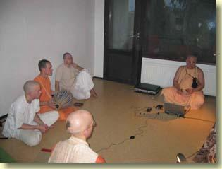
Here I give a class to the India Experience preaching team. We stayed in an unfurnished 5-room apartment that we rented for one week.
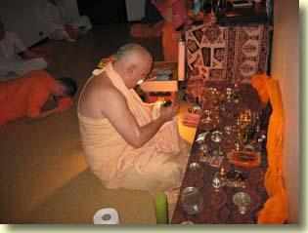
Morning puja for Sri Salagram silas.

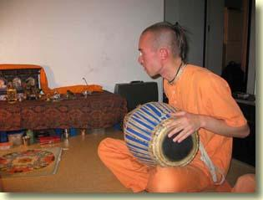
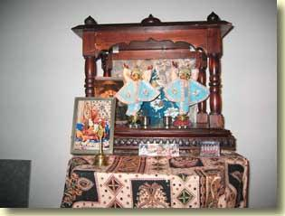
These traveling Gaura-Nitai Deities grace every India Experience program with Their divine presence.

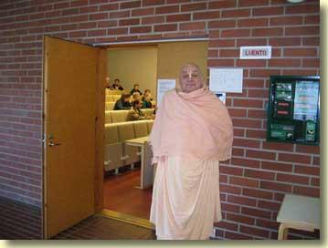
My first speaking engagement was on Wednesday, 6 October, at the philosophy department of the University of Jyvaskyla.

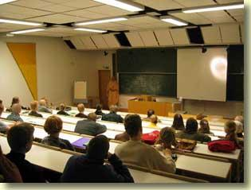 | 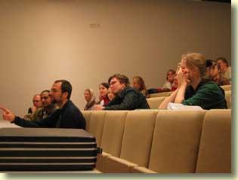

 | 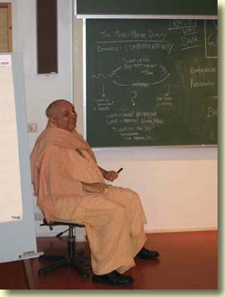
  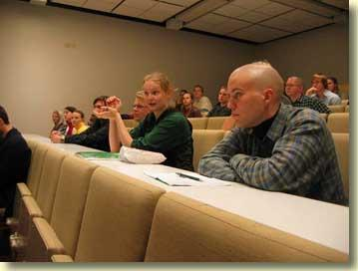
  The students were attentive and asked intelligent questions.

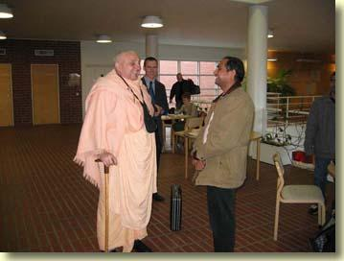
Outside the philosophy lecture hall I spoke with a faculty member from India who attended my talk.

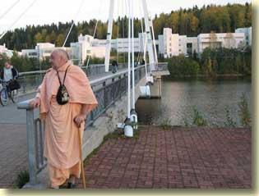 | 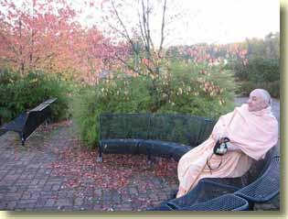
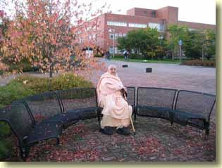 | 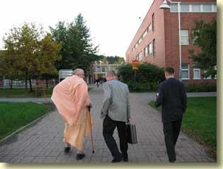
After leaving the philosophy lecture hall I had a look around the U of J campus.

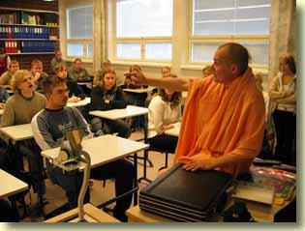 | 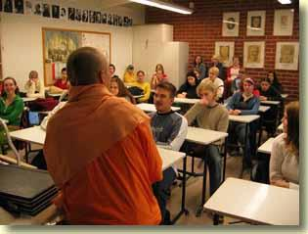
Tattvavada Prabhu gave a presentation to a Jyavaskyla high school class.

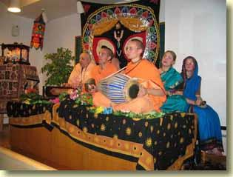 | 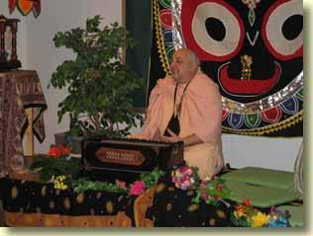
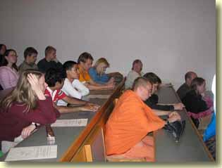 | 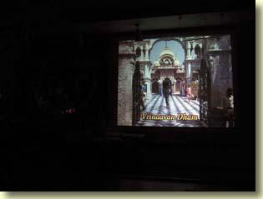

 | 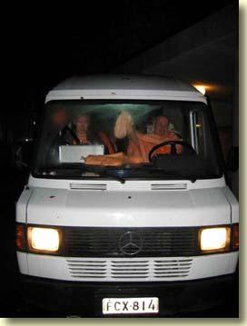
  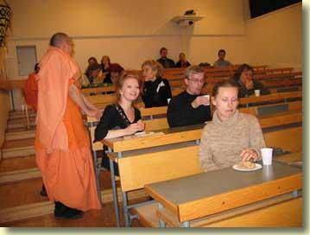
  The India Experience at Jyvaskyla University, 7 October. A few born-again Christians showed up to plead their case, but were silenced when I showed the audience that they had no philosophy.

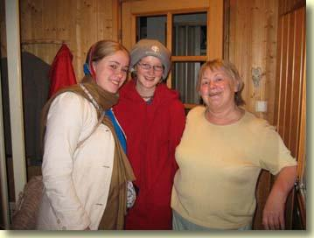
The India Experience's two blissful Finnish bhaktins stayed with a devotional Russian lady who lives in Jyvaskyla.

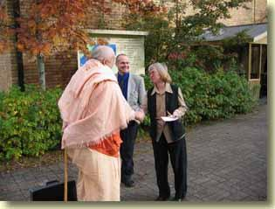 | 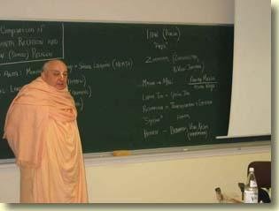
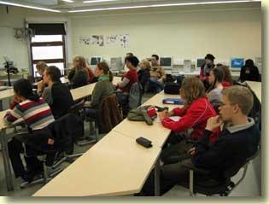 | 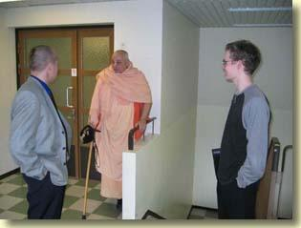
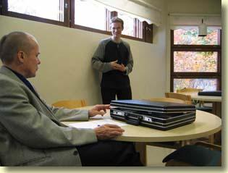 | 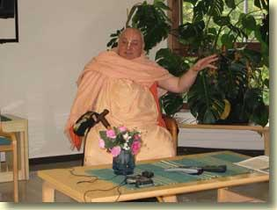

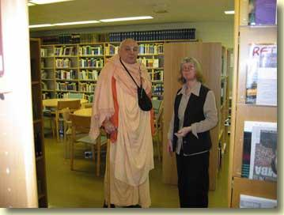
On Friday, 8 October, I spoke to a social sciences class at a Jyvaskyla community college. The instructor of the class, and our most gracious host, was a lady professor. She asked me to compare Indian Vedanta with Western religion. Afterward, in a nearby lounge, a student and I had a discussion while Tattvavada translated for us. This student was raised in the Bahai religion. Then the lady professor took me on a tour of the college.
Srila Jiva Gosvami's
Sri Gopala-virudavali
"Calling Out to Lord Gopala"
Translated by HG Kusakratha dasa
A Glimpse into the Life of Srila Jiva Gosvami
In the Gaura-ganoddesa-dipika it is said that Srila Jiva Gosvami was formerly Vilasa-Manjari gopi. From his very childhood Jiva Gosvami was greatly fond of Srimad-Bhagavatam. He later came to Navadvipa to study Sanskrit, and following in the footsteps of Sri Nityananda Prabhu, he circumnambulated the entire Navadvipa-dhama. After visiting Navadvipa-dhama he went to Benares to study Sanskrit under Madhusudana Vacaspati, and after finishing his studies, in Benares, he went to Vrndavana and took shelter of his uncles, Sri Rupa and Sanatana. This is described in Bhakti-ratnakara. As far as our information goes, Srila Jiva Gosvami composed and edited at least twenty-five books. They are all very celebrated, and they are listed as follows: Hari-nama-vyakarana, 2. Sutra-malika, 3. Dhatu-sangraha, 4. Krsnarca-dipika, 5. Gopala-virudvali, 6. Rasamrta-sesa, 7. Sri Madhava-mahotsava, 8. Sri Sankalpa-kalpavrksa, 9. Bhavartha-sucaka-campu, 10. Gopala-tapani-tika, 11. a commentary on Brahma-samhita, 12. a commentary on Bhakti-rasamrta-sindhu, 13. a commentary on Ujjvala-nilamani, 14. a commentary on Yoga-sara-stava, 15. a commentary on the Gayatri-mantra as described in the Agni Purana, 16. a description derived from the Agni Purana of the lotus feet of the Lord, 17. a description of the lotus feet of Srimati Radharani, 18. Gopala-campu (in two parts), and 19-25 seven sandarbhas; the Krama, Tattva, Bhagavat, Paramatma, Krsna, Bhakti, and Priti Sandarbhas. After the disappearance of Srila Rupa Gosvami and Sanatana Gosvami in Vrndavana, Srila Jiva Gosvami became the acarya of all the Vaisnavas in Bengal, Orissa, and the rest of the world, and it is he who used to guide them in their devotional service.
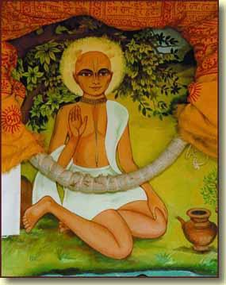
Srila Jiva Gosvami, author of Sri Gopala-Virudavali and many other important works of Gaudiya Vaisnavism.
--His Divine Grace A.C. Bhaktivedanta Swami Prabhupada
1. May this poem, Gopala-virudavali, become like a garden of desire-creepers to give pleasure to Lord Gopala.
2. If Brahma, Brahma's sons, Siva, all the splendid devotees of the goddess of fortune's husband, the personified Vedas, and all the residents of the material universes and the spiritual Vaikuntha worlds, are singing the Vrndavana pastimes of the killer of Agha without their lips ever becoming tired, then why do I now write these words in verse and prose?
3. Although this poem is just like the mediocre poetry of many other foolish, greedy authors, proud of thinking themselves learned poets, I shamelessly continue to write.
4. O Lord whose pastimes please Your devotees, O Lord whose descent to the Earth has created spiritual narrations everywhere, O Lord whose virtues have no equal or superior, O Lord whose splendour defeats the splendour of a host of sapphires, O Lord dressed in a splendid golden dhoti, O Lord whose transcendental qualities delight the ear, O Lord decorated with colourful jewels, O Lord whose victory over the demons delights your friends, O Lord whose glories fulfil the world's desires, O Lord whose names, when even briefly glorified, bring great pleasure, O Lord whose sweet flute music enchants all moving and non-moving living entities, O glistening nectar moon risen from the ocean of Your father and glorified by a great family, O Lord who liberated those who deserve a terrible hell, O splendid sun whose face delights the eyes, O Lord who filled this world with pleasure and then returned to Your own abode, O Lord who joked with playful words of rebuke, O Lord who sits, as if bound, in the hearts of the faithful, O Lord fragrant with kindness to the devotees, O Lord whose smile protects those filled with terrible fears, O Lord whose eyes are glorified in hundreds and hundreds of books, all glories to You!
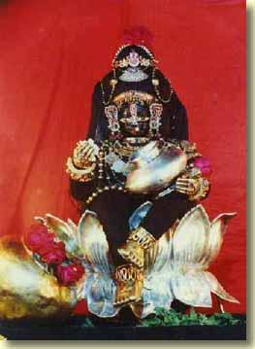
5. May my heart rest on He who is the crown of all handsome men, whose splendour defeats the king of sapphires, who has a host of glorious virtues, who is the king of all opulences, whose power is limitless, who checks the demons' pride, whose pastimes please everyone, and who is fond of the flute.
6. O shelter of Vrndavana, O auspiciousness of Vrndavana, O Lord whose nectar glances are drunk by the people of Vrndavana!
7. O Lord, as You enter Vrndavana, you come with the cows and boys to a place where all can see You. The people gaze at You at every moment.
8. O Lord who pleased Your affectionate relatives, O Lord who celebrated Your birthday with a party like those in Svargaloka, O Lord to whom visitors gave many gifts, O Lord who delighted the happy and prosperous king of Vraja, O Lord who made the demoness Putana a follower of Your mother, O Lord whose soft feet overturned the cart, O Lord whose transcendental names were revealed by Garga Acarya, O Lord who easily killed the menacing Madhu demon, O Lord eager to purchase some fruit with the golden coins of Your broken words, O Lord who day after day filled eloquent Sukadeva Gosvami with bliss, O Lord who enjoys many wonderful pastimes with Your friends, O Lord embraced by smiling Balarama and Your devotees, O Lord who tried to solve the mystery of the wandering calves' disappearance, O Lord who to keep the peace returned home with calves that were only a magical illusion, O Lord who made a new stream of happiness flow from the theft of the boys and calves, O Lord who, personally becoming the calves, bested Brahma in the contest of strength, O Lord whose waist Your mother bound with a long rope, O Lord who rescued Nalakuvara and Manigriva from the the fate of being trees, O Lord who enjoys pastimes without ever becoming tired, O Lord who wanders in the forest with Your friends,
9. because Your birth created a birth of happiness, Your opulence opulence, and Your pastimes pastimes, and because Vraja became plunged in a rising ocean of nectar, intense hope now rises in this old man.
10. O Lord who lives in glorious, splendid, ever-new Vraja, O Lord who without embarrassment plays and jokes with countless friends in the forest named Vrndavana, O Lord whose pastimes are happy and auspicious,
11. O form of bliss, beautiful Govardhana, Vrndavana, and the sandy banks of the Yamuna which all gave great pleasure to You, bring us under their spell.
12. O Lord who plays with the calves, O Lord who killed Vatsasura, O Lord who, swallowed by Baka forced Him to spit You out,
13. it is not wonderful that You quickly pushed into the void the demon Vyomasura, who pretended to join the boys' game of stealing lambs, or that when Aghasura swallowed You and everyone else, You made him pure and sinless, although these were a great wonder for Dama and Your other friends. May my mind be always fixed on these pastimes.
14. O Lord who, when Brahma stole the cowherd boys, tricked him and bewildered his intelligence, O Lord whose thoughts are filled with mercy, O lord who attracts Your followers,
15. even though Brahma, displaying his illusory potency, stole away Your Vraja-friends, still, You gave him Vraja-bhakti and You were filled with mercy and forgiveness for him.
16.(a) O Lord, holding the flute, and covered by the dust raised by Your cows, Your walking defeats the graceful movements of the elephant.
16.(b) "O Lord who went to the serpent's lake, O Lord who wished to destroy the poison, O Lord who dove into the water, O Lord who, fighting with the king of serpents, broke his strength and danced on him, please bewilder him, please place him in distress." This was the sages' prayer.
17. Day after day herding Your cows, You please all the forest-goddesses. O Lotus-eyed Lord, crushing Kaliya’s head with the violence of Your dancing, You made the Yamuna free of poison.
18.(a) O Lord who plays with the cowherd boys, who meets with Your friends, who playfully fights with them, who easily defeats the demons, who went to the serpent's lake, who became happy when the poison was gone, You shine with great splendour. O Lord whose dancing weighed heavily on the serpent's hundreds of splendidly jewelled hoods, who exiled the dangerous, sinful snake and his followers, who thus made the lake beautiful, who is splendidly powerful, free of all cares, who rests in Your own home, and who gently smiles, please appear before me.
19. O Lord who extinguished the poison fire in the water, who extinguished the forest fire on the land, and who, having extinguished both fires, returned to Vraja and with a glance created a great shower of nectar, I worship You.
20. O source of auspiciousness, happiness, and protection for Vrndavana's cows, all glories to You!
21. Protecting the cows, playing, delighting Your friends, killing Dhenukasura, gradually becoming full of lustre, increasing the glory of Your youth with the splendour of Your face and limbs in Your sixth year, and delighting the eyes of the beautiful-eyed gopis, You are very happy.
22. O Lord who dances with Your friends, O wrestler, O Lord more splendid than bilvas and other fruits, O Lord who would playfully imitate the cows and run like the horses, O Lord who would jump without any inhibition, O Lord who killed the demon who kidnapped Your elder brother, O Lord who mercifully drank up the great forest-fire,
23. O Lord, Your pastimes with Your friends, which seem bound with rivalry, and in the midst of which You swallowed a forest-fire, are only for their pleasure.
24. O Lord charming as spring, O Lord pleasant as summer, O Lord splendid as the monsoon season, O Lord with the limitless playfulness of autumn, O Lord with the wonderful handsomeness of winter!
25. O Lord whose splendid, sweet music makes the living entities wild with bliss!
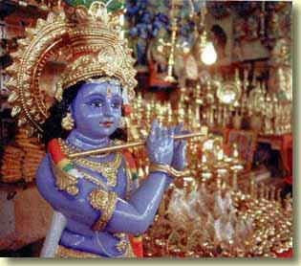
26. "O Lord, again and again manifesting the glorious music of Your flute, with Your extraordinary transcendental teachings You make the conscious and unconscious tremble with love." Ah! These were the gopis' words.
27. O Lord who stopped the sacrifice for Indra, O Lord decorated for the splendid sacrifice for Govardhana Hill, O Lord whose form is graceful, O Lord who delights Your friends, O Lord who circumambulated the hill, O Lord who made Your people offer respect to the hill, O Lord who appeared as the hill, O splendid, handsome Lord, O Lord whose splendid handsomeness broke crooked-hearted Indra, O Lord who lifted the tall hill, O Lord who neutralised the rainclouds' poison, O Lord who was kind to Indra, O Lord whom the demigods crowned king with a coronation bath,
28. May He who, speaking to his father and others, rejected the Indra-yajna as opposed to the Vedic scriptures, stopped the yajna and, seeing rain bringing great suffering, placed a hill on the tip of His hand and became the shelter of Vraja's people, protect us.
29. O Lord crowned by the surabhi cow in a coronation-bathing ceremony, O Lord to whom Your offensive adversary surrendered with life and soul,
30. You were then bathed by the demigod kings, Your transcendental position become perfectly manifest, and everyone's heart became anointed with love and joy.
31.(a) O Lord who mercifully protected Your father when he was kidnapped by Varuna, O Lord worshipped because You expertly protect the devotees!
31.(b) O Lord who returned with Your father, O Lord who dispelled Your father's illusion, O Lord whose eyes are the abode of transcendental glory, O maintainer of the maintainers of the universe, O Lord whose graceful lotus feet delight everyone!
32. I take shelter of He whose eyes are red lotus flowers, who rescued His father from Varuna, and who showed to His people His own abode.
33.(a) O Lord who, as time gradually turned into the hemanta season, stole the gopis' garments and was pleased by their prayers,
33.(b) O Lord who, as it gradually became winter was decorated with a great garland of delightful blossoming flowers reaching from Your auspicious cheeks to Your waist, to Your lotus feet, and filled with bumblebees, O Lord who with strength greater and more splendid than the untouchable sun protects the people of Vraja,
33.(c) O Lord who paints pictures with Your friends, O Lord who happily plays with them in a great banana tree,
33.(d) O Lord whose handsome eyes and smile defeat jasmine flowers, O Lord who intelligently killed the demons disguised as devotees, and made them flee Your transcendental power, O Lord who, drinking a great forest fire, protected Your frightened friends,
33.(e) O Lord whose voice is the thunder of monsoon clouds, O Lord who in a wonderful moment glanced at the beautiful forest, which was like a dancing arena, O Lord whose desires were aroused by the splendour of autumn, which made the land glisten with thousands of lakes, O Lord who forgot Your home, O Lord who enjoyed a festival with Your friends, O Lord who played a flute as Your cows rested,
34. the arrogance of Your flute attracts airplanes from far away. Your sweetness stuns the demigoddesses and makes them fall from their airplanes.
35. O Lord who went on a pilgrimage to Ambikavana, O auspicious and opulent Lord, O Lord who enjoys limitless pastimes, O Lord glorious when You saved Your father from being swallowed by a serpent, O Lord who celebrated the holi festival with the gopis, although You were destined to be separated from them, O Lord who, when Sankhacuda interrupted Your pastimes, distressed the gopis and fled, took his conch-shaped jewel and destroyed his sins,
36. O Lord who was very happy to herd the cows, O Lord whose pastimes of music and dancing delighted the beautiful gopis, O Lord who is the greatest in all respects, O Lord who killed the fearful bull Arista, who was repeatedly attacking everyone, O Lord the description of whose glorious pastimes brings great transcendental pleasure,
37. After bringing a great calamity to Arista, He became pleased to see the prosperity of His happy relatives. He is glorified as He travels the Earth. All glories to Him!
38. May Lord Krsna, who is famous for killing the demons, who killed Kamsa, who is the destiny that kills repeated birth and death for the intelligent, who is an ocean of the splendour of transcendental glory, whose footprints in Vraja Brahma and the demigods yearn to attain, who was born in a family of His own devotees, and who is fond of the flute, appear before us.

Helsinki, Finland
11 October 2004
Srila Prabhodhananda Sarasvati
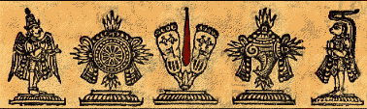
In this connection it may be mentioned that sometimes the sahajiya class of devotees opine that Prakasananda Sarasvati and Prabodhananda Sarasvati are the same man. Prabodhananda Sarasvati was a great Vaisnava devotee of Lord Caitanya Mahaprabhu, but Prakasananda Sarasvati, the head of the Mayavadi sannyasis in Benares, was a different person. Prabodhananda Sarasvati belonged to the Ramanuja-sampradaya, whereas Prakasananda Sarasvati belonged to the Sankaracarya-sampradaya. Prabodhananda Sarasvati wrote a number of books, among which are Caitanya-candramrta, Radha-rasa-sudha-nidhi, Sangita-madhava, Vrndavana-sataka and Navadvipa-sataka. While traveling in Southern India, Caitanya Mahaprabhu met Prabodhananda Sarasvati, who had two brothers, Vyenkata Bhatta and Tirumalaya Bhatta, who were Vaisnavas of the Ramanuja-sampradaya. Gopala Bhatta Gosvami was the nephew of Prabodhananda Sarasvati. From historical records it is found that Sri Caitanya Mahaprabhu traveled in South India in the year 1433 Sakabda (A.D. 1511) during the Caturmasya period, and it was at that time that He met Prabodhananda, who belonged to the Ramanuja-sampradaya. How then could the same person meet Him as a member of the Sankara-sampradaya in 1435 Sakabda, two years later? It is to be concluded that the guess of the sahijiya-sampradaya that Prabodhananda Sarasvati and Prakasananda Sarasvati were the same man is a mistaken idea.
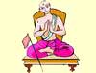
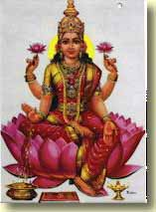
--His Divine Grace A.C. Bhaktivedanta Swami Prabhupada
A few nectarean verses from
Sri Radha-rasa-sudha-nidhi
by Srila Prabodhananda Sarasvati
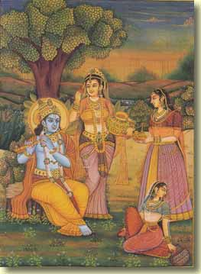
Yasyah kadapi vasanancala-khelanottha
Dhanyati dhanya pavanena krtartha-mani
Yogindra-durgama-gatir madhusudano’pi
Tasya namo’stu vrsabhanu-bhuvo dise’pi
Obeisances to the direction that faces Sri Vrsabhanu's daughter. When the breeze coming from that direction playfully moves the edge of His garment, Lord Krsna, who cannot be attained by even the kings of the yogis, thinks that His life has now become a great success.
Brahmesvaradi-su-duraha-padaravinda
Srimat-paraga-paramadbhuta-vaibhavayah
Sarvartha-sara-rasa-varsi-krpadra-drstes
Tasya namo’stu vrsabhanu-bhuvo mahimne
Obeisances to the glory of Sri Vrsabhanu's daughter. Even Brahma, Siva and all the demigods cannot attain the pollen of Her lotus feet. Her merciful glance showers the best of all nectars.
Yo brahma-rudra-suka-narada-bhisma-mukhyair
Alaksito na sahasa purusasya tasya
Sadyo-vasi-karana-curnam ananta saktim
Tam radhika-carana-renum anusmarami
I meditate on the dust of Sri Radha's feet, dust that even Brahma, Siva, Sukadeva, Narada, Bhisma and a host of great saints cannot see, dust that has limitless power, dust that at once transforms the Supreme Personality of Godhead into Sri Radha's submissive servant.
Yat-pada-padma-nakha-candra-mani-cchataya
Visphur jitam kim api gopa-vadhusv adarsi
Purnanuraga-rasa-sagara-sara-murtih
Sa radhika mayi kadapi krpam parotu
May Sri Radha, who is the personified nectar ocean of perfect spiritual love, and the splendour of whose candrakanta-jewel toenails glistens amongst the gopis, be merciful to me.
Sat-prema-sindhu-makaranda-rasaugha-dhara
Saran ajasran abhitah sravad-asritesu
Sri-radhike tava kada caranaravindam
Govinda-jivana dhanam sirasa vahami
O Sri Radha, when will I place on my head Your lotus feet, which are a flood of the nectar of spiritual love, a flood that always flows among Your devotees, and are the treasure more dear than life for Lord Krsna?
Sunday in Helsinki:
Thundering Kirtan, Thumbling Hurt-on

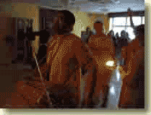
The Helsinki Sunday feast kirtan, led on 10 October by Radhavinoda Prabhu, really gets them normally quiet Finns a'dancing!




The arati for the Sunday feast program was offered by HG Avadhuta Candra Prabhu.


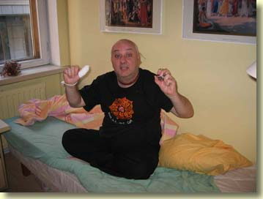
Unfortunately for me, before mangala-arati early Sunday morning I had an accident in the apartment in which I stay: I shut the bathroom door on my right thumb! This tore away the whole nail, leaving a bloody wound. Instead of attending mangala-arati, I went to the polyclinic for medical treatment. Now the thumb has to remain under the bandages for at least a week. It may take a month for a new thumbnail to grow in. The doctor gave me some painkillers and told me to take it easy. I spent the rest of the day in the apartment nursing my injured digit, even as the blissful Sunday kirtan got the whole congregation dancing!

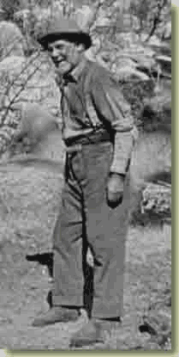
Though I couldn't physically join in the Sunday festivities, the svarupa of the cow(herd)boy in my heart joy-jumped to the kirtan beat!
Helsinki, Finland
12 October 2004
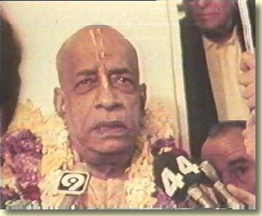
Tomorrow (Wednesday 13) I fly to Stockholm, where I shall stay until the coming Monday. Then I visit Oslo and Copenhagen. I'm back here in Helsinki on 25 October. I'll then embark upon another Finnish preaching tour.
My injured thumb seems to heal (slowly) without complication. It only hurts when I move around. Thus since Sunday I haven't been doing much. Of course, tomorrow, when I start my Scandinavian travels, I'll have to face more discomfort. But it is not too bad. It's getting better.
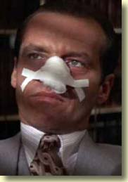
"It only hurts when I breathe."
While I'm doing the Stockholm-Oslo-Copenhagen jaunt I'll post journal entries, but it is highly unlikely that I'll publish photos from these places before I return to Helsinki. I won't have the Internet opportunities that I need to upload photos. Furthermore the bandaged thumb slows computer ops down.
After I'm back in Finland, you'll see some photos of the Scandinavian tour.

Stockholm, Sweden
13 October 2004
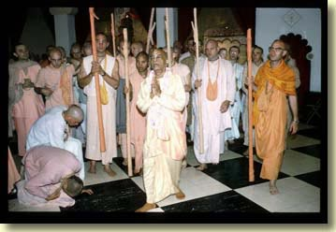
Chicago ISKCON temple, summer 1975. On Srila Prabhupada's right are HH Visnujana Swami, HH Satsvarupa dasa Goswami, HH Sudama Swami. To his Divine Grace's right are HH Brahmananda Swami and HH Tamal Krsna Goswami. I am standing at the far left.
Sri Skanda Purana's
Sri Vasudeva-mahatmya
Sri Narada's Visit to Goloka Vrndavana
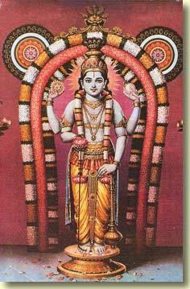
Part One
Meditation on Sri Sri Radha-Krsna
From Sri Skanda Purana, Sri Vaisnava-khanda, Sri Vasudeva-mahatmya, Chapter 28
Text 1
One should meditate on Sri Radha's master, Lord Krsna, who is peaceful and handsome, and who is surrounded by a great spiritual effulgence.
2
One should meditate on Lord Krsna, His youthful, splendid, transcendental form is more handsome than many millions of Kamadevas. . .
3
. . . His limbs graceful, spiritual, and splendid like an autumn moon, His long arms graceful. . .
4
. . . His lotus feet with soft, reddish toes, His glistening toenails embarrassing the moon,. . .
5
. . . His graceful feet decorated with tinkling anklets, His legs and knees graceful,. . .
6
. . . His graceful waist bound with a yellow garment and a jewel belt and decorated with a deep navel and graceful lines of tri-bali,. . .
7
His broad chest decorated with Srivatsa, with the restlessly moving king of great pearl necklaces. . .
8
. . . with a garland of many fragrant flowers, and with a golden sacred thread, His blossoming red lotus hands decorated with bracelets,. . .
9
. . . His slender fingers glistening with jewel rings as He plays sweet flute music that charms everyone's heart,. . .
10
. . . His shoulders broad, His collar hidden, His great and splendid arms decorated with armlets, the sweet fragrance of His forest-flower garland attracting greedy, humming bees,. . .
11
. . . a splendid Kausthuba necklace on His conchshell neck, His chin handsome, His lips like splendid red bimba fruits. . .
12
. . . a gentle smile decorating His full-moon face, His nose graceful like a sesame flower,. . .
13
. . . His graceful ears decorated with glistening shark-shaped earrings and wonderful flower ornaments,. . .
14
. . . His cheeks splendid with the moonlight of His graceful teeth, His large eyes like red lotus petals,. . .
15
. . His forehead high and broad, His eyebrow's like Kamadeva's bow, the hair on His head fine, black, curly, splendid, and charming,. . .
16
. . . the crown on His head splendid with many jewels, and His glance filled with love for His devotees.
17
After meditating on Lord Krsna in this way, one should meditate on two-armed Sri-Radha at His left, Her limbs fair like gold, Her garments like red kausumbha flowers,. . .
18
. . . Her ears and nose graceful, Her garments and jewel ornaments splendid, Her form youthful, Her eye's like a fawn's, Her breasts full, high, and firm,. . .
19
. . . Her waist slender, Her hips broad, her belt splendid with jewels, Her many ornaments splendid, her face a blossoming lotus,. . .
20
. . . Her hands and arms splendid with jewel rings, bracelets, and armlets, Her lotus feet splendid with twinkling anklets,. . .
21
. . . Her broad forehead decorated with kunkuma decorations, her lips bimba fruits, her chest graceful, and her braids decorated with malati flowers,. . .
22
Lovingly gazing at Her master, She places a lotus flower in His hand. Please meditate on Sri Radha in this way and then worship Her and Her master.
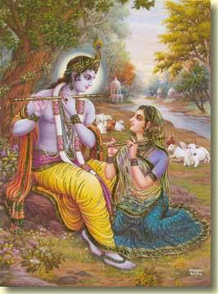
Part Two
Description of Sri Goloka Vrndavana
Sri Skanda Purana, Sri Vaisnava-khanda, Sri Vasudeva-mahatmya, Chapter 16
Texts 1 & 2
Standing on the summit of Mount Meru, and with transcendental vision gazing on Svetadvipa, thousands of liberated souls there, and the Supreme Personality of Godhead, Lord Vasudeva in their midst, the great yogi Narada suddenly flew there. He arrived there in a single moment.
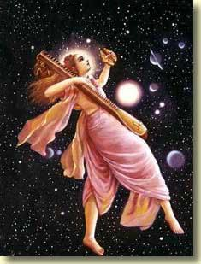
3
Happy at heart, Sri Narada arrived in Svetadvipa. There he saw many devotees, each one splendid like the moon.
4
He worshipped them by bowing his head, and they also worshipped him in their minds. Austere Narada was very eager to see the Supreme Lord.
5
Happy at heart to know that he was a pure devotee of Lord Visnu, the devotees spoke to Narada as he was chanting the twelve syllable mantra.
6
The liberated residents of Svetadvipa said : O best of sages, you are a great devotee of Lord Krsna. You have come here and you are able to see us whom even the demigods cannot see. What do you desire, that you perform such severe austerities?
7
Sri Narada said : I am eager to see the Supreme Personality of Godhead, Lord Krsna. O kings of the devotees, O you are very dear to the Lord, please show Him to me.
8
Sri Skanda then said : Then, inspired in his heart by Lord Krsna, one of the liberated residents of Svetadvipa said, "Come with me. I will show Lord Krsna to you," and began to walk ahead.
9
Travelling on the path of the sky, joyful Narada followed him. Narada saw the homes of the demigods, and then he flew above them.
10
Unattached, he saw first the seven planetary systems and then Dhruvaloka. Then he flew past Maharloka, Janaloka, and Tapaloka.
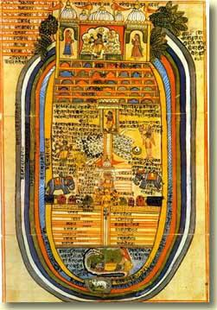
11
Then Narada saw Brahmaloka. Then, yearning to see Lord Krsna, Narada followed the liberated resident of Svetadvipa into the great darkness that is the eight-fold covering that envelops the universe.
12
One by one he passed through the layers of earth, water, fire, air, ether, false-ego, mahat-tattva, and prakrti, each layer ten times greater than the one before. Finally he came to the wonderful abode of Goloka.
13
As he approached that effulgent realm only pure devotees of Lord Krsna may enter, he saw the wide and fathomless Viraja river,. . .
14
. . . which was beautiful with white, red, and blue lotus flowers and fragrant with sandal paste from the gopis and gopas who bathed there.
15
Then he went to the river's beautiful shore, which was splendid with white, green, red and yellow jewels,. . .
16
. . . beautiful with many kalpa-vrksa trees and new coral sprouts, decorated with mines of syamantakas, sapphires, and other jewels,. . .
17
. . . beautiful with jewel stairways and the sweet cooing of swans, karandavas, and other birds,. . .
18
. . . and filled with splendid and pure waters drunk by hosts of surabhi cows, regal elephants, and horses. Then Narada continued on his journey.
19
Crossing that splendid transcendental river, by the Lord's will Narada came to a great moat and the hundred peaks of Mount Govardhana,. . .
20
. . . which was eighty million miles tall, eight hundred million miles broad, golden, very beautiful and charming,. . .
21
. . . beautiful with many thousands of kalpa-vrksa, parijata, and other trees and with mallika, yuthika, lavanga, aila, and other flowering vines,. . .
22
. . . with golden banana trees and other trees, with splendid deer, with elephant, and with sweetly cooing birds.
23
Then, on the beautiful peaks of that impassable mountain, Narada saw many great and beautiful pavilions for Lord Krsna's rasa dances,. . .
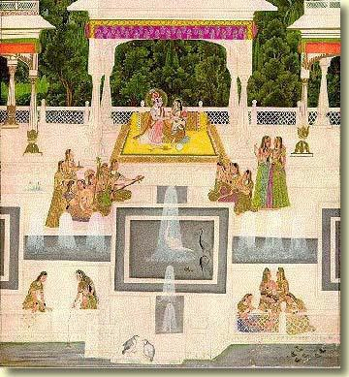
24
. . . pavilions filled with fragrant gardens, blossoming flowers, guarded by four entrances of four jewelled gates,. . .
25
. . . Splendid with many thousands of colourful archways, jewel pillars, bananas trees, pearl awnings,. . .
26
. . . beautiful with auspicious durva grass, moistened grains, and unbroken fruits, beautiful with courtyards sprinkled with sandal, agrur, musk, and kumkuma,. . .
27
. . . and filled with many kinds of beautiful instrumental music pleasing to the heart. There Narada saw many millions of groups of gopis,. . .
28
. . . gopis beautifully dressed in priceless garments and decorated with priceless ornaments with jewel bracelets, belts anklets, armlets, and rings,. . .
29
. . . gopis whose youthful beauty is beyond the power of words to describe, who are followers of Sri Radha, who are expert in amorous pastimes,. . .
30
. . . gopis who in these pavilions filled with many pleasing things sing songs glorifying Lord Krsna and enjoy many happy pastimes.
31
In the valley of that mountain Narada Muni saw the great forest named Vrndavana,. . .
32
. . . Which is famous pastime-place of Sri Sri Radha-Krsna, which is beautiful with many kalpa-vrksa trees, many lakes, many lotus flowers,. . .
33
many mango, amrataka, nipa, badari, pomegranate, kharjuri, betel, orange, coconut and sandalwood trees,. . .
34
. . . many jambu, jambira, pasana, aksoda, suradruma, banana, and campaka trees, and many vines of grapes and golden ketaki flowers,. . .
35
. . . which is splendid with many trees bending with a great burden of many fruits and flowers, which is splendid with many mallika, madhavi, kunda, lavanga, yuthika, and other flowering vines,. . .
36
. . which is served by gentle, fragrant, cooling breezes, which is everywhere the home for many clear streams swiftly flowing from the hundred peaks of Govardhana Mountain,. . .
37
. . . which is always opulent with the glory of springtime, which is filled with many groves lit with jewel lamps and filled with ornaments,. . .
38
. . . and which was everywhere filled, O sage, with the sounds of gopas and gopis chanting the glories of Lord Krsna, with the calls of cows and calves, and birds, with the tinkling of various ornaments, and with the sound of churning yoghurt.
39
Now gaze on this forest beautiful with many trees bending with many fruits and blossoming flowers, a place filled with thirty-two other forests.
40
Seeing this, joyful Narada entered the splendid town of Goloka, which was surrounded by a jewel fortress, beautiful with many royal roads,. . .
41
. . . splendid with many millions of airplanes and chariots made of regal jewels, beautiful with tinkling ornaments, and filled with devotees of Lord Krsna,. . .
42
. . . beautiful with many millions of wonderful regal-jewel palaces decorated with rows of jewel pillars,. . .
43
. . . beautiful with many charming pastime-pavilions made of the best jewels, illumined with jewel lamps, and graceful with jewel courtyards,. . .
44
. . . anointed with kesara, aguru, musk, and kumkuma, beautiful with many courtyards auspicious with yoghurt, durva grass, moistened grains, and betelnuts,. . .
45
. . . auspicious with many gates and golden pots filled with water, beautiful and royal roads paved with jewels, roads where many elephants and horses travel,. . .
46
. . . and crowded with many Brahma's, Sivas, and other demigods who have come, bearing gifts in their hands, to see Lord Krsna.
47
When he saw the great road filled with gopas and gopis eager to see Lord Krsna, Narada became filled with happiness.
48
Then Narada came to the all-wonderful and very beautiful palace of Lord Krsna, which was near the palace of Lord Krsna, which was near the palaces of Nanda, Vrsabhanu, and the other gopas,. . .
49
. . . and which was surrounded by sixteen moats and fortresses, each with four gates, and each gate guarded by ten million gopa gatekeepers.
50
Then Narada saw the gatekeepers standing before each of the jewel gates and jewel pillars.
51-53
Bowing down before Virabhanu, Candrabhanu, Suryabhanu, Vasubhanu, Devabhanu, Sakrabhanu, Ratnabhanu, Suparsva, Visala, Rsabha, Amsu, Bala, Subala, Devaprastha, Varuthapa, and Sridama, and receiving their permission one by one, Narada finally entered a great courtyard. There he saw a brilliant effulgence.
Seeing Lord Krsna
Sri Skanda Purana, Sri Vaisnava-khanda, Sri Vasudeva-mahatmya, Chapter 17
1
Sri Skanda said: O sage, there Narada saw a great effulgence brighter than millions of millions of suns shining together.
2
This effulgence was the impersonal Brahman. Shining in all directions, above, and below, it was eternal and full of knowledge and bliss.
3
This Brahman is the original cause of matter and the material identities of the conditioned souls. Perfect yogis who pass through the six cakras attain this Brahman.
4
By the mercy of Lord Krsna these yogis travel through the Brahma-randhra at the top of the head and then they see this impersonal Brahman. This impersonal Brahman illumines the entire world. The sun, moon, stars, and fire shine with its reflected light.
5
The devotees call it Brahma-pura, for it is the abode of the Supreme Personality of Godhead. It shines everywhere like ten million suns.
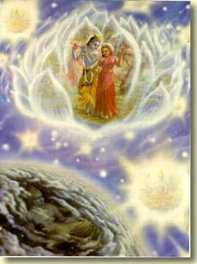
6
Many gopas, gopis, Brahmas, and Sivas respectfully approach Lord Krsna in the centre of the Brahman. They fall to the ground to offer respects. They carry gifts in their hands.
7
One who has attained Lord Krsna's mercy can see Lord Krsna at the centre of the impersonal Brahman. Others, who have not attained His mercy, see only impersonal light. O sage, they cannot see Lord Krsna there.
8
In that great effulgence Narada saw a wonderful, splendid, transcendental palace beautiful with wonderful regal jewels, thousands of splendid jewel pillars, and many great assembly houses and pavilions,. . .
9
. . . and splendidly surrounded by many, many palaces of Lord Krsna's men and women devotees, palaces decorated with wonderful fine curtains and splendid jewels.
10
Happy at heart, Narada saw there a great throne splendid with the best of regal jewels, a throne that filled with wonder the heart of everyone who saw it.
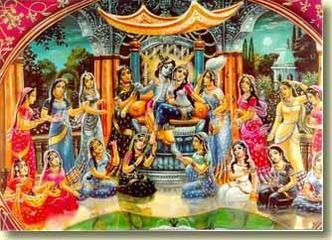
11
Narada saw sitting on that throne Lord Krsna, who is the master of all opulences, the resting place of all living entities, beyond the touch of the modes of material nature, glorious with spiritual qualities, all-knowing, all-powerful, the Supreme Person whom the devotees call Vasudeva,. . .
12
. . . the Supreme Lord whom some say is the Supersoul, others say is the impersonal Brahman, greater than the greatest, and the devotees say is all-opulent, all-glorious Lord Visnu, the supreme master,. . .
13
. . . the Supreme Lord who is eternally youthful, filled with mercy, more handsome than many thousands of Kamadevas, supremely independent, not under the control of any liberated or conditioned soul,. . .
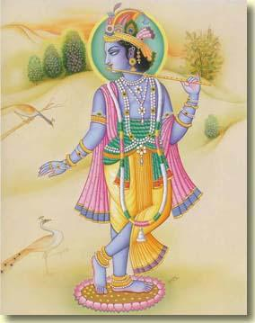
14
. . . the Supreme Lord who with a playful sidelong glance creates, maintains and destroys a multitude of material universes, who is the king of many millions of material universes, who is the only object of worship in all the universes, who is colourfully dressed like the best of dancing actors,. . .
15
. . . the Supreme Lord who is dressed in splendid and priceless yellow garments, who is opulent with many jewel ornaments, who is the colour of a new monsoon cloud, whose ears are splendid with shark shaped earrings,. . .
16
. . . the Supreme Lord whose limbs are splendid with a great effulgence, whose crown is splendid with many jewels, whose eyes are beautiful like autumn lotus flowers,. . .
17
. . . the Supreme Lord whose limbs are anointed with fragrant sandal paste, the door of whose chest is marked with Srivatsa, whose lotus arms place the flute to His mouth as he plays sweet music,. . .
18
. . . the Supreme Lord who is worshipped by Radha, Rama, Jaya, Susila, Lalita, Bhama, Kalindaja, Jambavati, and a host of others,. . .
19
the Supreme Lord who is served by religion, the Vedas, all opulences, transcendental knowledge and other virtues, and by the personified weapons, all standing with respectfully folded hands,. . .
20
. . . the Supreme Lord who is served by Nanda, Sunanada, and His other personal associates who are white or are the other colours of emeralds, rubies, or gold, and who all carry a cakra, club, lotus, and conchshell in their splendid hands,. . .
21
. . . the Supreme Lord who is worshipped by Sridama and a host of two-handed gopas, their heads bowed with devotion, and by Garuda standing before Him, and by the eight opulences, their heads bowed with respect,. . .
22
. . the Supreme Lord who is served by beauty, peace, mercy, protection, happiness, intelligence, faith, piety, noble-heartedness, friendship, tolerance, memory, and wisdom.
23
Gazing at the Supreme Lord's very wonderful and splendid transcendental form, Narada became filled with joy. All of his sense were captured by the Lord's handsomeness. The hairs of his body stood erect with transcendental love. His eyes were filled with tears of joy.
24
Offering respects, Narada fell to the ground like a stick. Then he stood up. Then he folded hands. Overcome with ecstatic love, he gazed at Lord Krsna's face.
25
With a glance Lord Hari respectfully welcomed His pure devotee Narada, who so earnestly desired to see Him.
26
Filled with bliss by gazing at the Lord and drinking the nectar of His words, Narada Muni devotedly praised the Lord with many prayers.
27
Sri Narada said : O Lord Sri Krsna, O Supreme Personality of Godhead, O resting place of all living entities, O master of the universes, O Vasudeva, O all-pervading Lord, O Lord dear to the pure devotees, all glories to you!
28
Your wonderful feet are always worshipped by Radha, Kamala, and their followers. You are the eternal goal for they who desire the highest good.
29
O Lord Krsna, You are the Supreme eternal soul among all other eternal souls. You are the supreme conscious being among all other conscious beings. You are the Supreme Personality of Godhead, greater than all liberated and conditioned souls.
30
Perfection and purity are attained only by devotional service to You. They cannot be attained by performing austerities or in any other way.
31
They who yearn for liberation keep in their hearts the moonlight of Your feet. O master of the devotees, no one has the power to remove Your feet from their hearts.
32
All the Vedas worship, honour, and know You O Lord, they declare that You are the first cause of all causes.
33
The devotees keep the effulgence of Your lotus feet in their hearts. Your feet are peaceful and full of bliss. They are more glorious than many millions of moons.
34
You are the Supreme Person, beyond the touch of the modes of material nature. You stay eternally in this effulgent and eternal abode, which is filled with bliss and beyond the touch of the modes of material nature.
35
By worshipping You, the devotees become free from the fear of Your illusory potency Maya, and also from time, which makes one fear the material universes.
36
Now I take shelter of You and surrender to You, the all-powerful Supreme Person, the all-pervading Supersoul, the master of the universes.
37
O master of the demigods, if you would be merciful to me, then please grant that I may always have unwavering devotion for Your lotus feet.
38
Sri Skanda said : When Narada devotedly offered these prayers, the Supreme Personality of Godhead pleased him by speaking the following words, which are sweet like nectar.
Description of the Incarnations of Lord Krsna
Sri Skanda Purana, Sri Vaisnava-khanda, Sri Vasudeva-mahatmya, Chapter 18
1
The Supreme Personality of Godhead said : O great sage, because You are my pure devotee eternally, and because you are free of pride and hypocrisy, You are able, by My own wish, to see Me.
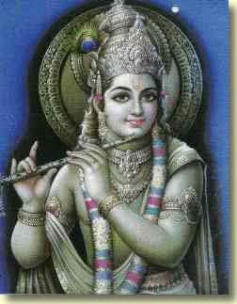
2
In you always stays non-violence, celibacy, duty, peacefulness, renunciation, surrender to the Lord,. . .
3
. . . association with devotees, astanga-yoga, sense control, eating little, austerity, freedom from all vices,. . .
4
. . . knowledge of My glories, and pure devotion to Me. O saintly one, it is because of all these that you are now able to see Me.
5
O brahmana, anyone who has qualities like these will see Me in this way, for I dearly love my pure devotees.
6
O brahmana, accompanied by Goddess Radha and the pure devotees who take shelter of Me, I stay always in this eternal abode.
7
I am Lord Vasudeva, who gives all results of karma. I am the Supersoul. I am not dependent on any living being.
8
Accompanied by Laksmi, Nanda, Garuda, and many other personal associated, in my four armed form I stay in the transcendental abode called Vaikuntha.
9
Every day in the five periods of time I allow the liberated residents of Svetadvipa to see Me.
10
Manifest in my forms as Aniruddha, Pradyumna, and Sankarsana, I create, maintain and destroy a host of material universes.
11
O Narada, in the beginning of creation Brahma was born from the lotus flower of My navel. He worshipped Me with austerities and with many yajnas.
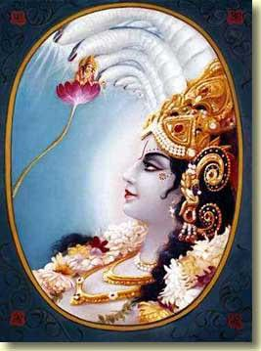
12
Pleased with him, I granted all the boons he wished, I said to him : O Brahma, you have the power to create the material bodies of the living entities.
13
Because of the boon I now give, all living entities in the universe will be subject to your command. Also, the eternal Vedas will become manifested in your intelligence.
14
You will also attain knowledge of My transcendental form. No one will disobey you.
15
You will become the giver of boons to the demigods, demons, sages, and saintly persons.
16
When you are thwarted in performing your duty and become bewildered, simply think of Me. I will become manifest and do what needs to be done.
17
As you are creating the universe, the earth will fall into the great ocean. Appearing in the form of a boar, I will kill the demon Hiranyaksa, who is very proud of his own strength. Then I will return the earth to it's proper place.
18
At the end of one of your days I will become a fish. Until the end of your night I rescue in a boat Vaivasvata Manu, the sages, and the plants.
19
When the Kasyapa's son wish to churn nectar from the ocean but have no place for the churning rod, I will become a tortoise and I will place Mount Mandara on My back.
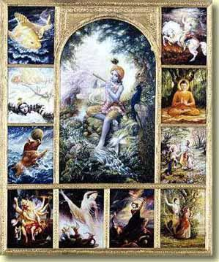
20
Manifesting a form half man and half lion, for the demigods' sake I will kill the demon Hiranyakasipu, who tried to stop all yajnas.
21
A powerful demon will take birth as Virocana's powerful son Bali. Bali will make Indra fall from his kingdom.
22
When Bali captures the three world from Indra, I will take birth as the twelfth son of Kasyapa and Aditi.
23
Then I will give the kingdom to Indra and return the demigods to their homes in Devaloka. I will make Bali live in Patalaloka.
24
I will become Kapila, the son of Kardama and Devahuti, and I will restore the Sankhya philosophy, which teaches renunciation, and which had become lost in the course of time.
25
I will become Dattatreya, son of Atri and Anasuya, and I will teach the science of logic to joyful Yadu.
26
I will become Rsabha, the son of Nabhi and Meru-devi, and I will teach the eternal duties of the paramahamsas.
27
In the Treta-yuga I will take birth in the Bhrugu dynasty as Parasurama and I will kill the ksatriyas.
28
During the junction of Treta and Dvarpara yugas I will take birth as Rama, the son of Dasaratha and Kausalya.
29
Goddess Laksmi will become Janaka's daughter Sita. I will marry her and I will also break Lord Siva's great bow.
30
In battle I will kill a great demon who hates the demigods and sages and who kidnapped Sita. I will kill him and his brother.
31
Valmiki Muni and other great sages will sing in many ways of my pastimes in this incarnation. They who hear these pastimes will be cleansed of their sins.
32
At the end of the junction of Dvarpara and Kali yugas, I will take birth in Mathura city as the son of Vasudeva and Devaki. My mission will be to kill the demons burdening the earth and to protect religion and the pious devotees.
33
I, Krsna, will be known as the son of Vasudeva. Balarama will be Sankarsana. Pradyumna and Aniruddha will take birth in the Yadu dynasty.
34
O Brahma, Radha will become the daughter of Vrsabhanu-gopa. I will enjoy pastimes with her in Vrndavana.
35
Laksmi will become Bhismaka's daughter Rukmini. After defeating many kings in battle, I will marry her.
36
Killing many demon kings and establishing the true religion, I will remove the earth's burden.
37
Whoever somehow or other thinks of Me, I take to the spiritual world.
38
I will establish religion and then I will destroy the Yadu dynasty. Then, as the demigods look on, I will leave the earth.
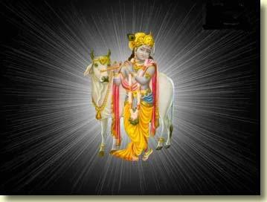
39
Krsna Dvaipayana Vyasa and others will sing many songs of my heroic activities, songs that remove sins in a single moment.
40
I will become Parasara Muni's son Krsna Dvaipayana Vyasa. I will divide the one Veda into many branches, like a tree.
41
Becoming Buddha, I bewilder the demons who, pretending to take shelter of the rules of Vedas, trouble the three worlds.
42
When many demons establish irreligion on the earth, I will come in My original form as a Krsna and, accompanied by Arjuna, I will kill them in battle.
43
In Kosala-desa on the earth I will be born as Narayana Rsi, the son of Dharma.
44
O Brahma, when cursed by a muni, some rsis take birth as human beings, I will protect them from the demons.
45
At the end of Kali-yuga I will become Kalki. Riding on a spiritual horse, I will kill the barbarian sinners.
46
Whenever the demons try to destroy the religion of the Vedas, I will come to protect it.
47
Therefore, please do not worry. Please do your duty of creating the living entities.
After speaking these words, I gave Brahma many boons as before, and then I disappeared.
48
O sage, whatever boons I promise, those boons I will certainly fulfill with my transcendental powers.
49
O brahmana, the opportunity to see Me, the supreme master of all living entities, is very rarely obtained. It is only obtained by pure devotion to Me.
50
O best of sages, please ask a boon from Me, whatever you wish. I am very pleased with you. The sight of Me never goes in vain.
51
Sri Skanda said : O sage, hearing the Lord's words, the great sage Narada reflected on his own good fortune, and then spoke the following words :
52
O master, by seeing You all my desires are fulfilled. I think it is very rare and difficult for anyone to see You.
53
My only desire is to see You, Your devotees, and Your eternal abode. I do not desire anything but that.
54
O infallible Lord, I ask only that You be pleased with me. Nothing else is rare or desirable in the whole material world.
55
Whatever material happiness is attained by following the Vedas, performing pious deeds, or worshipping the devas or pitas, is all temporary and subject to destruction.
56
O Lord, I do not desire any material pleasures. I ask only one boon from You, the best of all givers of boons.
57
May I always be eager to chant the glories of You and Your devotees. May I always be filled with love for You.
58
Sri Skanda said: Hearing this request, Lord Krsna said, "So be it. " Giving Narada a great vina, Lord Krsna spoke again.
59
The Supreme Personality of Godhead said: O saintly Narada, now please go to sacred Badarikasrama. There worship Me in My form of Sri Narayana Rsi, the son of Dharma Rsi.
60
You are a pure devotee. Neither pride nor hypocrisy stay in your heart. Therefore I think that you are better than even Brahma, your father.
61
O sage, pure devotees know everything about Me, My transcendental form, and My glories.
62
Pure devotees always think of Me in their hearts. They do not wish anything from Me, and I do not wish anything from them.
63
As devoted wives bring a good husband under their control, so pure devotees use their own transcendental virtues to bring Me under their control.
64
The goddess of fortune and I devotedly follow them. Wherever they go, there I am also.
65
They who desire liberation in the material world may attain it only by associating with My devotees. There is no other way. Please know that this is the truth.
66
They who take shelter of Me and surrender to Me escape the bondage of material bondage.
67
They who somehow or other take shelter of Me and surrender to Me attain whatever they wish. They do not return to the world of birth and death.
68
Sri Skanda said: After hearing these words spoken by the Supreme Personality of Godhead, and after thus attaining the Lord's mercy, Sri Narada bowed down before the Lord. Then, with tears of love in his eyes, Sri Narada returned to the material world.

Stockholm, Sweden
15 October 2004
Prathama Caitanyastaka
Eight Prayers Glorifying Lord Caitanya
by Srila Rupa Gosvami
Translated by Srila Prabhupada and Kusakratha dasa
(Note: Translations followed by an asterisk [*] are Srila Prabhupada’s. )
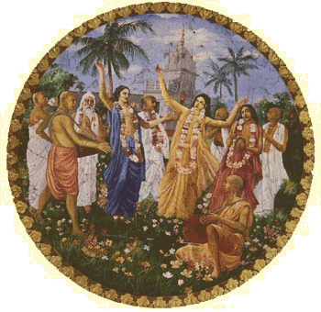
TEXT 1
Lord Caitanya Mahaprabhu is always the most worshipable Deity of the demigods, including Lord Siva and Lord Brahma, who came in the garb of ordinary men bearing love for Him. He instructs His own pure devotional service to His own devotees. Will He again become visible before the path of my eyes?*
TEXT 2
Sri Caitanya MahÄprabhu is the protector of the demigods, the supreme goal of the Upanisads, the be-all and end-all of the great sages, the beautiful shelter of His devotees, and the essence of the love of the lotus-eyed gopis. Will He again be visible before the path of my eyes?*
TEXT 3
Sri Caitanya Mahaprabhu has manifested His own form, which cannot be compared to anything in the material universe. He is very dear to Advaita Acarya, and Srinivasa Pandita is surrendered to Him. He is very respectful to Paramananda Puri. He takes away the ignorance of the material world and delivers the conditioned souls suffering from the threefold miseries. He showered His mercy on Maharaja Prataparudra, the king of Orissa. Will He again become visible before the path of my eyes?*
TEXT 4
Sri Caitanya Mahaprabhu becomes maddened by tasting the mellows of devotional service. His effulgent form is the abode of sweetness for millions of Cupids, and He is the crest jewel of sannyasis. His garments display the effulgence of the sun, and the splendor of His body eclipses the beauty of gold. Will He again become visible before the path of my eyes?
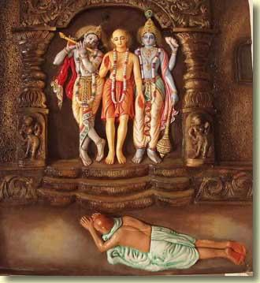
TEXT 5
Sri Caitanya Mahaprabhu chants the Hare Krsna mantra in a loud voice, the holy name dancing on His tongue as He counts the number of recitations on a beautiful knotted string held in His effulgent hand. His eyes are large, and His long arms, bending as He performs His pastimes, reach down to His knees. Will He again become visible before the path of my eyes?
TEXT 6
Sri Caitanya Mahaprabhu is the topmost of all devotees. Sometimes, while walking on the beach, He would see a beautiful garden nearby and mistake it for the forest of Vrndavana. He would thus be completely overwhelmed by ecstatic love of Krsna and begin to chant the holy name and dance. His tongue worked incessantly as He chanted “Krsna! Krsna!” Will He again become visible before the path of my eyes?*
TEXT 7
Sri Caitanya Mahaprabhu danced down the main road in great ecstasy before Lord Jagannatha, the master of Nilacala, who was sitting on His car. Overwhelmed by the transcendental bliss of dancing, and surrounded by the Vaisnavas who sang the holy names, He manifested waves of ecstatic love of Godhead. Will He again become visible before the path of my eyes?
TEXT 8
Sri Caitanya MahÄprabhu became joyful during the loud chanting of the holy names, and he sprinkled the earth with showers of tears. All the hairs of His body, standing on end, appeared like beautiful filaments of fresh kadamba blossoms, and His body glistened with profuse perspiration. Will he again become visible before the path of my eyes?
TEXT 9
May the great ocean full of waves of pure love for the two white lotus flowers of the feet of Sri Caitanya Mahaprabhu become immediately manifested at every moment to whatever pious person reads these eight most auspicious verses, his pure intelligence shining with faith as he meditates on Lord Gauranga.
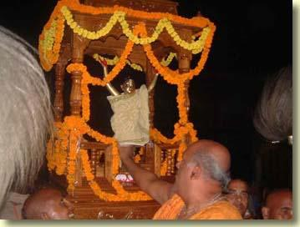

Stockholm, Sweden
16 October 2004
Dvitaya Sri Caitanyastaka
Second Composition of Eight Prayers Glorifying Lord Caitanya
by Srila Rüpa Gosvami
Text 1
kalau yam vidvamsah sphutam abhiyajante dyuti-bharad
akrsnangam krsnam makha-vidhibhir utkirtanamayaih
upasyam ca prahur yam akhila-caturthasrama-jusam
sa devas caitanyakrtir atitaram nah krpayatu
By performing the sacrifice of congregational chanting of the holy name, scholars in the age of Kali worship Lord Krsna, who is now non-blackish because of the great upsurge of feelings of Srimati Radharani. He is the only worshipable Deity for the paramahamsas, who have attained the highest stage of the fourth order (sannyasa). May that Supreme Personality of Godhead, Lord Caitanya, show us His great causeless mercy.
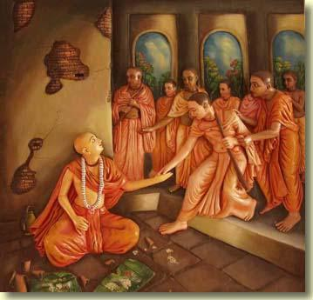
Text 2
caritram tanvanah priyam aghavad-ahladana-padam
jayodghosaih samyag-viracita-saci-soka-haranah
udancan-martanda-dyuti-hara-dukulancita-katih
sa devas caitanyakrtir atitaram nah krpayatu
Loudly shouting "jaya" as He manifested His sankirtana pastimes that delighted even the fallen and sinful, and His hips bound by a silk garment that eclipsed the splendor of the rising sun, He pacified His mother's grief. May that Supreme Personality of Godhead, Lord Caitanya, show us His great causeless mercy.
Text 3
aparam kasyapi pranayi-jana-vrndasya kutuki
rasa-stomam hrtva madhuram upabhoktum kam api yah
rucam svam avavre dyutim iha tadiyam prakatayan
sa devas caitanyakrtir atitaram nah krpayatu
Lord Krsna desired to taste the limitless nectarean mellow of love of one of His multitude of loving damsels (Sri Radha), and so He has assumed the form of Lord Caitanya. He has tasted that love while hiding His own dark complexion with Her effulgent yellow color. May that Supreme Personality of Godhead, Lord Caitanya, show us His great causeless mercy.
Text 4
anaradhyah pritya ciram asura-bhava-pranayinam
prapannanam daivim prakrtim adhidaivam tri-jagati
ajasram yah sriman jayati sahajananda-madhurah
sa devas caitanyakrtir atitaram nah krpayatu
By the demons He is never worshiped with love. For the surrendered devotees He defeats the power of material destiny in the three worlds. He is handsome, blissful, and charming. May that Supreme Personality of Godhead, Lord Caitanya, show us His great causeless mercy.
Text 5
gatir yah paundranam prakatita-navadvipa-mahima
bhavenalankurvan bhuvana-mahitam srotriya-kulam
punaty angi-karad bhuvi paramahamsasrama-padam
sa devas caitanyakrtir atitaram nah krpayatu
He is the shelter of the people of Bengal. His glory is manifested in Navadvipa. By birth He ornaments the brahmana community, which is worshiped in all the worlds. By accepting it, He purifies the paramahamsa-asrama in this world. May that Supreme Personality of Godhead, Lord Caitanya, show us His great causeless mercy.
Text 6
mukhenagre pitva madhuram iha namamrta-rasam
drsor dvara yas tam vamati ghana-baspambu-misatah
bhuvi premnas tattvam prakatayitum ullasita-tanuh
sa devas caitanyakrtir atitaram nah krpayatu
To reveal the truth of pure transcendental love in this world He first jubilantly drank with His mouth the nectar of the holy name, and then discharged it from His eyes on the pretext of shedding tears. May that Supreme Personality of Godhead, Lord Caitanya, show us His great causeless mercy.
Text 7
tanum aviskurvan nava-purata-bhasam kali-lasat-
karankalankaras taruna-gaja-rajancita-gatih
priyebhyo yah siksam disati nija-nirmalya-rucibhih sa
devas caitanyakrtir atitaram nah krpayatu
His form is splendid as new gold. His waist is decorated with a waterpot. He is as graceful as a regal young elephant. By appreciating His own krsna-prasadam garlands, He teaches His dear associates. May that Supreme Personality of Godhead, Lord Caitanya, show us His great causeless mercy.
Text 8
smitalokah sokam harati jagatam yasya parito
giram tu prarambhah kusala-patalim pallavayati
padalambaů kam va pranayati na hi prema-nivaham
sa devas caitanyakrtir atitaram nah krpayatu
His smiling glance at once drives away all the bereavements of the world, and His very words enliven the auspicious creepers of devotion by expanding their leaves. Taking shelter of His lotus feet invokes transcendental love of God at once. May that Supreme Personality of Godhead, Lord Caitanya, show us His great causeless mercy.
Text 9
saci-sunoh kirti-stabaka-nava-saurabhya-nibidam
puman yah pritatma pathati kila padyastakam idam
sa laksmivan etam nija-pada-saroje pranayitam
dadanah kalyanim anupadam abadham sukhayati
At every step may the glorious Supreme Personality of Godhead bring transcendental happiness and grant auspicious pure love for His own lotus feet to that person who very happily reads these eight verses, which contain the fresh, sweet fragrance of the many blossoming flowers of the glories of Lord Caitanya, the son of Saci.
Sri Gauranga-stava-kalpa-vrksa
The Desire Tree of Prayers to Lord Gauranga
by Srila Raghunatha dasa Gosvami
Text 1
gatim drsta yasya pramada-gaja-varye 'khila-jana
mukham ca sri-candropari dadhati thutkara-nivaham
sva-kantya yah svarnacalam adharayac chidhu ca vacas-
taraěgair gauraggo hrdaya udayan mam madayati
When everyone sees His graceful motions they revile the graceful mad elephant and when they see His face they spit at the moon. He is splendid as a gold mountain and the waves of His words are nectar. The appearance of Sri Caitanya Mahaprabhu, awakening in my heart, maddens me.
Text 2
alaěkrtyatmanam nava-vividha-ratnair iva valad-
vivarnatva-stambhasphuta-vacana-kampasru-pulakaih
hasan svidyan nrtyan siti-giri-pater nirbhara-mude
purah sri-gaurango hrdaya udayan mam madayati
Decorating Himself with the jewels of paleness, becoming stunned, stuttering, trembling, shedding tears, and bodily hairs erect with joy, and laughing and perspiring as He danced for the pleasure of Lord Jagannätha, may Sri Caitanya Mahäprabhu rise in my heart and make me mad with love.
Text 3
rasollasais tiryag-gatibhir abhito varibhir alam
drsoh sincal lokan aruna-jala-yantratva-mitayoh
muda dantair dastva madhuram adharam kampa-calitair
natan sri-gaurango hrdaya udayan mam madayati
Staggering about in ecstasy, sprinkling everyone with water from the reddish syringes of His eyes, joyfully biting His charming lips with His teeth, and trembling as He dances, may Sri Caitanya Mahaprabhu rise in my heart and make me mad with love.
Text 4
kvacin misravase vraja-pati-sutasyoru-virahat
slathac chri-sandhitvad dadhad adhika-dairghyam
bhuja-padohluthan bhumau kakva vikala-vikalaŕ gadgada-vaca
rudan sri-gaurango hrdaya udayan mam madayati
Sometimes Sri Caitanya would go to the house of Kasi Misra. There He would be greatly aggrieved, feeling separation from Krsna. The joints of His transcendental body would slacken, and His arms and legs would become elongated. Rolling on the ground, the Lord would cry out in distress in a faltering voice and weep very sorrowfully. The appearance of Sri Caitanya Mahaprabhu, awakening in my heart, maddens me.
Text 5
anudghatya dvara-trayam uru ca bhitti-trayam aho
vilaighyoccaih kaliěgika-surabhi-madhye nipatitah
tanudyat-saěkocat kamatha iva krsnoru-virahad
virajan gaurango hrdaya udayan mam madayati
How wonderful it is! Sri Caitanya Mahäprabhu left His residence without opening the three strongly bolted doors. Then He crossed over three high walls, and later, because of strong feelings of separation from Krsna, He fell down amidst the cows of the Tailaěga district and retracted all the limbs of His body like a tortoise. Sri Caitanya Mahäprabhu, who appeared in that way, rises in my heart and maddens me.
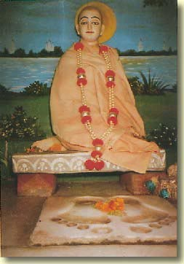
Text 6
svakiyasya pranarbuda-sadrsa-goshasya virahat
pralapan unmadat satatam ati kurvan vikala-dhih
dadhad bhittau sasvad vadana-vidhu-gharsena rudhiram
ksatottham gaurango hrdaya udayan mam madayati
Because of separation from His many friends in Vrndavana, who were like His own life, Sri Caitanya Mahäprabhu spoke like a madman. His intelligence was transformed. Day and night He rubbed His moonlike face against the walls, and blood flowed from the injuries. May that Sri Caitanya Mahäprabhu rise in my heart and make me mad with love.
Text 7
kva me kantah krsnas tvaritam iha tam lokaya sakhe
tvam eveti dvaradhipam abhivadann unmada iva
drutam gaccha drastum priyam iti tad-uktena dhrta-tad-
bhujantar gaurango hrdaya udayan mam madayanti
"My dear friend the doorkeeper, where is Krsna, the Lord of my heart? Kindly show Him to Me quickly. " With these words Lord Sri Caitanya Mahäprabhu addressed the doorkeeper like a madman. The doorkeeper grasped His hand and replied very hastily, "Come, see Your beloved!" May that Lord Sri Caitanya Mahäprabhu rise within my heart and thus make me mad also.
Text 8
samipe niladres cataka-giri-rajasya kalanad
aye gosthe govardhana-giri-patim lokitum itah
vrajann asmity uktva pramada iva dhavann avadhrto
ganaih svair gaurango hrdaya udayan mam madayati
Near Jagannatha Puri was a great sand dune known as Cataka-parvata. Seeing that hill, Sri Caitanya Mahaprabhu said, "Oh, I shall go to the land of Vraja to see Govardhana Hill. " Then He began running madly to it, and all the Vaisnavas ran after Him. This scene awakens in my heart and maddens me.
Text 9
alam dola-khela-mahasi vara-tan-mandapa-tale
svarupena svenapara-nija-ganenapi militah
svayam kurvan namnam ati-madhura-ganam murabhidah
sa-rango gaurango hrdaya udayan mam madayati
Under a charming pavilion at the swing festival, with Svarupa Damodara and the other devotees He sweetly sang the holy names of Lord Krsna. May Sri Caitanya Mahaprabhu rise in my heart and make me mad with love.
Text 10
dayam yo govinde garuda iva laksmi-patir alam
puri-deve bhaktim ya iva guru-varye yaduvarah
svarupe yah sneham giridhara iva srila-subale
vidhatte gaurango hrdaya udayan mam madayati
As Lord Narayana is kind to Garuda, He is kind to Govinda dasa. As Lord Krsna is devoted to His guru, He is devoted to Isvara Puri. As Lord Giridhari loves Subala, He loves Svarupa Damodara. May that Sri Caitanya Mahaprabhu rise in my heart and make me mad with love.
Text 11
maha-sampad-davad api patitam uddhatya kapaya
svarupe yah sviye kujanam api mam nyasya muditah
uro-gunja-haram priyam api ca govardhana-silam
dadau me gaurango hdaya udayan mam madayati
Although I am a fallen soul, the lowest of men, Sri Caitanya Mahaprabhu delivered me from the blazing forest fire of great material opulence by His mercy. He handed me over in great pleasure to Svarupa Damodara, His personal associate. The Lord also gave me the garland of small conchshells that He wore on His chest and a stone from Govardhana Hill, although they were very dear to Him. That same Lord Sri Caitanya Mahäprabhu awakens within my heart and makes me mad after Him.
Text 12
iti sri-gaurangodgata-vividha-sad-bhava-kusuma-
prabha-bhrajat-padyavali-lalita-sakham sura-tarum
muhur yo 'ti-çraddhausadhi-vara-balat-patha-salilair
alam sinced vindet sarasa-guru-tal-lokana-phalam
One who, with the water of careful reading mixed with the medicine of strong faith, waters this celestial tree, its charming branches the verses of this poem, and the splendor of its flowers pure love for Lord Gauranga, will reap that tree's heavy fruit: the sight of Sri Caitanya Mahäprabhu.
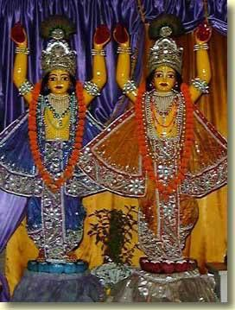
Sri-Nityanandastaka
Eight Prayers Glorifying Lord Nityananda
by Srila Vrndavana dasa Thakura
Text 1
sarac-candra-bhrantim sphurad-amala-kantim gaja-gatim
hari-premonmattam dhata-parama-sattvam smita-mukham
sada ghurnan-netram kara-kalita-vetram kali-bhidam
bhaje nityanandam bhajana-taru-kandam niravadhi
I worship Lord Nityananda, the limitless root of the tree of devotional service, who is pure and splendid as the autumn moon, who walks as gracefully as majestic elephant, who is maddened with pure love of Krsna, who is the Absolute Truth, who smiles, whose eyes are always rolling, who holds a staff in His hand, and who breaks the power of the age of Kali.
Text 2
rasanam agaram svajana-gana-sarvasvam atulam
tadiyaika-prana-pramita-vasudha-jahnava-patim
sada-premonmadam param aviditam manda-manasam
bhaje nityanandam bhajana-taru-kandam niravadhi
I worship Lord Nityananda, the limitless root of the tree of devotional service, who is the abode of the mellows of devotional service, to whom no one can be compared, who is His devotees' life-treasure, who is the Lord of Jahnava-devi and Vasudha-devi, who both think Him more dear than life, who is always maddened with pure love of Krsna, and whom the unintelligent non-devotees cannot understand is the Supreme Personality of Godhead Himself.
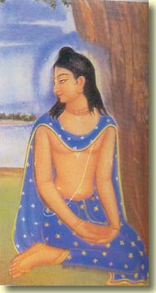
Text 3
sacisunu-presham nikhila-jagad-istam sukha-mayam
kalau majjaj-jivoddharana-karanoddhama-karunam
harer akhyanad va bhava-jaladhi-garvonnati-haram
bhaje nityanandam bhajana-taru-kandam niravadhi
I worship Lord Nityananda, the limitless root of the tree of devotional service, who is very dear to the son of Saci-dev, who is worshiped by the entire universe, and who by chanting the name of Lord Hari mercifully rescues the souls drowning in the age of Kali and crushes the pride of the ocean of repeated birth and death.
Text 4
aye bhratar nrnam kali-kalusinam kim nu bhavita
tatha präyascittam racaya yad-anayasata ime
vrajanti tvam ittham saha bhagavata mantrayati yo
bhaje nityanandam bhajana-taru-kandam niravadhi
I worship Lord Nityananda, the limitless root of the tree of devotional service, who said to Lord Caitanya, "O Brother, the people will become infected by the sins of Kali-yuga. How will they atone for them? Please give them a way easily to approach You. "
Text 5
yathesam re bhratah kuru hari-hari-dhvanam anisam
tato vah samsarambubdhi-tarana-dayo mayi laget
idam bahu-sphotair atati ratayanyah pratigrham
bhaje nityanandam bhajana-taru-kandam niravadhi
I worship Lord Nityananda, the limitless root of the tree of devotional service, who went to each house and raised His arms, saying, "O brother, if you will, please constantly chant the Holy Name of Lord Hari. If you do this, you will become free from the ocean of repeated birth and death. Please give this gift of your liberation to me. "
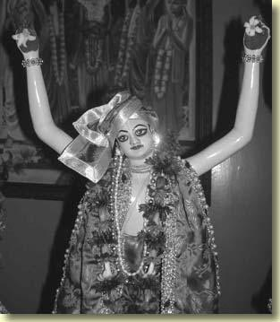
Text 6
balat samsarambhonidhi-harana-kumbhodbhavam aho
satam sreyah-sindhunnati-kumuda-bandhum samuditam
khala-sreni-sphurjit-timira-hara-surya-prabham aham
bhaje nityanandam bhajana-taru-kandam niravadhi
I worship Lord Nityananda, the limitless root of the tree of devotional service, who is an Agastya Muni forcibly swallowing the ocean of repeated birth and death, who is a rising full moon expanding the ocean of the saintly devotees' welfare, and who is a blazing sun extinguishing the darkness that is the community of demons.
Text 7
natantam gayantam harim anuvadantam pathi pathi
vrajantam pasyantam svam api na dayantam jana-ganam
prakurvantam santam sakaruna-drg-antam prakalanad
bhaje nityanandam bhajana-taru-kandam niravadhi
I worship Lord Nityananda, the limitless root of the tree of devotional service, who traveled on every path, dancing, singingthe names of Lord Hari, and mercifully glancing at the people.
Text 8
su-bibhranam bhratuh kara-sarasijam komalatara
mitho vaktralokocchalita-paramananda-hrdayam
bhramantam madhuryair ahaha madayanta pura-janan
bhaje nityanandam bhajana-taru-kanda niravadhi
I worship Lord Nityananda, the limitless root of the tree of devotional service, who wandered here and there, delighting the townspeople with His sweetness, and whose heart became filled with bliss when he held His brother's (Lord Caitanya) gentle lotus hand and They gazed into each other's face.
Text 9
rasanam adharam rasika-vara-sad-vaisnava-dhanam
rasagaram saram patita-tati-taram smaranatah
param nityanandastakam idam apurvam pathati yah
tad-anghri-dvandvabjam sphuratu nitaram tasya hrdaye
May Lord Nityananda place His two lotus feet in the heart of one who who reads this unprecedented Nityanandastaka, which is the abode of the mellows of devotional service, the great treasure of the great devotees that know what is really sweet, the abode of sweetness, and the savior the memory of which delivers the fallen souls.
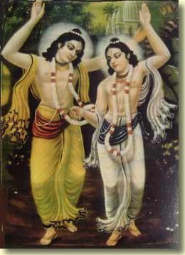

Stockholm, Sweden
17 October 2004
Tritiya Caitanyastaka
Third Composition of
Eight Prayers Glorifying Lord Caitanya
by Srila Rupa Gosvami
TEXT 1
O Lord Caitanya, Your lotus feet are worshiped by the devoted jiva and other demigods. You are splendidly manifested in the best of cities, Jagannatha Puri. For the surrendered devotees You are a desire tree. O Sacinandana, O Mukunda, please be merciful to this great fool.
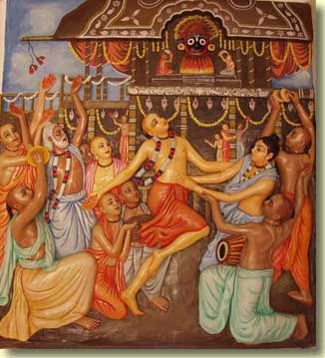
TEXT 2
Neither the great incarnations (headed by Dattatreya and Vyasadeva) nor the great intellectuals, headed by Sarvabhauma Bhattcarya, can properly describe You. Who is more intelligent than You? I offer my respectful obeisances unto You. O Sacinandana, O Mukunda, please be merciful to this great fool.
TEXT 3
The Upanisads did not reveal the jewel of pure devotional service, nor did the great incarnations describe it, yet You have now cast this priceless jewel into this world from the nectar ocean. O Sacinandana, O Mukunda, please be merciful to this great fool.
TEXT 4
O Lord whose dancing in ecstatic love filled Siva with wonder, O Lord who revealed to the surrendered devotees the nectar of pure devotion, O Lord who cannot be understood by the proud egoists, O Sacinandana, O Mukunda, please be merciful to this great fool.
TEXT 5
Out of Your great and splendid mercy You deliver even the low-born and sinful. This has made me very happy at heart, and thus I take shelter of You. O Sacinandana, O Mukunda, please be merciful to this great fool.
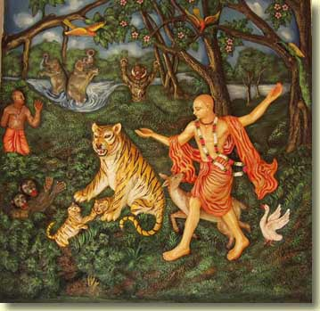
TEXT 6
You delight the bumblebees of Your surrendered devotees with the honey of the words trickling from Your lotus mouth. You are an ocean of the jewels of the holy names, which are auspicious for all people. O Sacinandana, O Mukunda, please be merciful to this great fool.
TEXT 7
O moon-faced Lord, O Lord with glistening, wide-awake lotus-eyes, O Lord whose smile is a cluster of flowers, O Lord whose lips are handsome, O Lord whose chest is broad, O Lord whose arms are like two glorious snakes, O Lord as splendid as millions of Cupids, O Sacinandana, O Mukunda, please be merciful to this great fool.
TEXT 8
O Lord as splendid as a golden ketaka flower, I am the most wicked person in the world. Still, even if a person is filled with a great host of faults, You do not see the slightest fault in him. For this reason, O Lord who is kind to the fallen, I worship You with a humble heart. O Sacinandana, O Mukunda, please be merciful to this great fool.
TEXT 9
O festival of happiness for this world, O pleasure of the heart of Saci, O splendid moon of glory, O Supreme Personality of Godhead, please grant auspicious love for You to those persons who, their hearts rapt in meditation on Your footprints, read these eight verses.
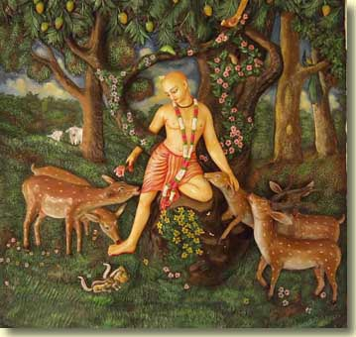

Copenhagen, Denmark
24 October 2004
What follows is material I've collected on the spiritual identities of the 6 Gosvamis. It's thought-provoking. To some readers, perhaps even controversial. I'm not answering any questions about it! Thanks to Gauranga-premananda and Punya-palaka Prabhus for their contributions to this compilation.
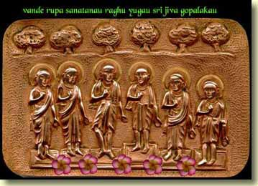
Letter to Jadurani from Srila Prabhupada
dated 9 September, 1967
at Vrndaban
My Dear Jadurani,
Please accept my blessings. Your letter of 8/24 contains some important questions. The six goswamis are not all eternal associates of Krishna. Only Rupa and Raghunath Goswami are eternal associates. You know there are two kinds of living entities: nityamukta or eternal associates of the Lord, and nityabaddha or eternally conditioned. This material manifestation is a chance for the eternally conditioned entities to go Back to Godhead; but when they go back there is no distinction between the two. When Krishna appears some of his eternal associates come with Him to assist Him in His different incarnational activities; and some of the living entities from conditioned life are liberated by following the footprint of Lord Krishna and His bona associates; so all the six became eternal associates of Krishna. Regarding Sarvabhauma Bhattacarya, he decended from higher planet for being liberated in the association of Lord Caitanya, so his conditioned life came to an end after he contacted Lord Caitanya.
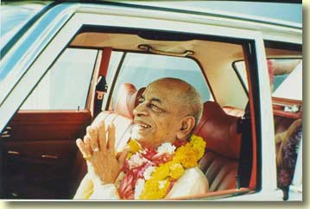
From a lecture on SrI Caitanya-caritamrta, Madhya-lila 20. 107 given in New York on July 13, 1976
yogya-pAtra hao tumi bhakti pravartAite
krame saba tattva zuna, kahiye tomAte
So to propagate the devotional service of KRSNa consciousness, it requires the fit person. Not that one can imitate. It is not possible. One who is fit to take this responsibility, he receives proper instruction and help from higher authorities. So Caitanya MahAprabhu selected SanAtana GosvAmI as the fit person, SanAtana GosvAmI and RUpa GosvAmI. They were ministers, but when Caitanya MahAprabhu first met them in RAmakeli, in Maldah district, at that time the headquarters of Bengal government, so He thought. . . Not only He thought, but. . . These Caitanya MahAprabhu associates, they are eternal associates. They appear somewhere. . . Just like HaridAsa ThAkura appeared somewhere in Muhammadan family, SanAtana GosvAmI was found engaged in government service, RaghunAtha dAsa GosvAmI was a zamindar's son. In different places. But actually they appear to fulfill the mission of Caitanya MahAprabhu. Therefore they are called nitya-siddhas. Just like Arjuna. Arjuna is nitya-siddha friend, eternal friend. Otherwise how KRSNa said that "Arjuna, when I spoke to sun-god. . . " Arjuna inquired that "KRSNa, how can I believe? Sun-god is long, long millions of years ago. How it is that You taught him?" So what KRSNa replied? KRSNa said, "Yes, you were also present there, but you have forgotten. I have not forgotten. " So similarly, whenever KRSNa goes anywhere, His eternal associates also go with Him. So sAGgopAGgAstra -pArSadam.
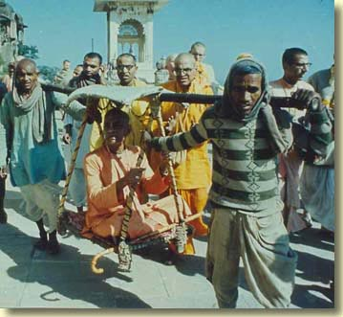
About Caitanya MahAprabhu it is said in the BhAgavatam, kRSNa-varNaM tviSAkRSNaM sAGgopAGgAstra-pArSadam (SB 11. 5. 32). SaGga, associates. Therefore we worship Caitanya MahAprabhu with His associates. zrI-kRSNa-caitanya prabhu-nityAnanda zrI-advaita gadAdhara zrIvAsAdi-gaura-bhakta-vRnda. These are principal associates, and similarly other devotees of zrI Caitanya MahAprabhu, just like six GosvAmIs and many others--we have got the list in the Caitanya-caritAmRta--so they are all nitya-siddhas, eternal. There are two kinds of living entities: nitya-siddha and nitya-baddha. Nitya-siddha means they never fall a victim of mAyA. That is nitya-siddha. Even though they are within this material world, they are never victimized. That is called nitya-siddha. And one who is victimized, he is called nitya-baddha. But the actual constitutional position of every living entity is nitya-siddha, because God is eternal and His part and parcels, the living entities, they are also eternal. So that is nitya-siddha.
Nitya-siddha, sAdhana-siddha, kRpA-siddha--there are different grades. They are all described in The Nectar of Devotion. So one can become sAdhana-siddha. By following the rules and regulations and instructions of the spiritual master, he can also become siddha. He can become again nitya-siddha. So the KRSNa consciousness movement is to make the nitya-baddhas again nitya-siddha, to bring them. It is a difficult task. Just I was talking in the morning, it is very difficult task to. . . Just like a madman. A madman, to again bring him to the normal life is very difficult task. You have got in your country so many institutions. So the whole world, anyone who is in this material world, he's a madman.
It is clear that Srila Rupa and Raghunatha dasa Gosvamis were the special objects of prayer of later acaryas like Narottama (rupa raghunath pade hobe akuti) and Krishnadas Kaviraj (sri rupa raghunatha pade jar ash). About the other Gosvamis and direct associates of Mahaprabhu, Narottam das Thakur sings: gaurangera sangi gane nitya siddha kori mane--"I consider all the associates of Gauranga to be nitya siddhas. " The previous names of the Gosvamis in krsna-lila are mentioned in the commentaries of Srila Bhaktisiddhanta Sarasvati Thakura and Srila Prabhupada. Sri Kavi Karnapura's Gaura-Ganoddesa-Dipika (A Lamp to See the Associates of Lord Gauranga) is the ultimate source of knowledge of "who's who" in Caitanya-lila.
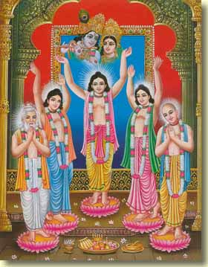
RUPA
CC Adi 10. 84 purp. , par. 6:
In the Gaura-ganoddesa-dipika (180) Sri Rupa Gosvami is described to be the gopi named Sri Rupa-manjari. . .
Anubhasya to CC Adi 10. 84: Sri Rupa - Gaura-ganoddese 180 sloke -
sri-rupa-manjari khyata yasid vrndavane pura
sadya rupakhya-gosvami bhutva prakata-tamiyat
G-g-d 180: Sri Rupa-manjari, who had been famous in Vrndavana-dhama, appeared as Srila Rupa Gosvami.
SANATANA
CC Adi 10. 84 purp. , par. 7: Sri Sanatana Gosvami is described in the Gaura-ganoddesa-dipika (181). He was formerly known as Rati-manjari or sometimes Lavanga-manjari. . .
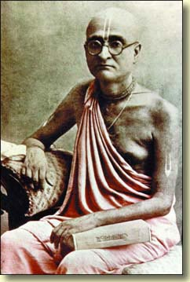
Anubhasya 10. 85: Sanatana - Gaura-ganoddese 181-182 sloke -
ye rupa-manjari-prestha purasid rati-manjari
socyate nama-bhedena lavanga-manjari budhaih
sadya gaurabhinna-tanuh sarvaradhyah sanatanah
tam eva pravisat karyan-muni-ratnah sanatanah
G-g-d 181: Rupa-Manjari's closest friend, who was known by the names Rati-manjari and Lavanga-manjari, appeared as Srila Sanatana Gosvami, who was honored by everyone, and who was considered to be like an extension of the transcendental body of Lord Caitanya Mahaprabhu. Sanatana Kumara, the jewel among the sages, entered the body of Sanatana Gosvami, who is therefore also considered to be an incarnation of Sanatana Kumara.
JIVA
CC Adi 10. 85 purp. , par. 7: In the Gaura-ganoddesa-dipika (195) it is said that Srila Jiva Gosvami was formerly Vilasa-manjari gopi. . .
Anubhasya 10. 85: Jiva - Gaura-ganoddese 203 sloke - susilah panditah sriman jivah sri-vallabhatmajah. 195 sloke - ini vraja-lilae vilasa-manjari.
G-g-d 194-207: Malati, Candralatika, Manjumedha, Varangada, Ratnavali, Kamala, Gunacuda, Sukesini, Karpura-manjari, Syama-manjari, Sveta-manjari, (12) Vilasa-manjari, Kamalekha, Mauna-manjari, Gandhonmada, Rasonmada, Candrika, and Candrasekhara, were among the maidservants of Srimati Radharani.
Assuming male forms they appeared among Lord Caitanya's associates, and each displayed his particular kind of ecstatic love for the Lord.
These gopis became Subhananda Dvija, Sridhara Brahmacari, Paramananda Gupta (who wrote the book Sri Krsna-stavavali), Raghunatha Dvija (who was an unalloyed servant of Lord Caitanya), Kamsari Sena, Sri Jagannatha Sena Mahasaya, Subuddhi Misra, Sriharsa, Raghu Misra (who was the best of the brahmanas), Jitamitra (whose appropriate name, meaning 'conqueror of the enemies', was given by Lord Caitanya because Jitamitra had completely subdued lust and the other five enemies of the conditioned soul), Sriman Bhagavatacarya (who was very dear to Lord Caitanya, and who wrote the book Sri Krsna-prema-tarangini), (12) Sriman Jiva Pandita (who was the saintly son of Sri Vallabha), Vaninatha Dvija (who lived in the village of Campahatta, and who was very dear to Lord Caitanya), Isanacarya, Kamala, Laksminatha Pandita, Ganga-mantri, Jagannatha Mamu (who was a very elevated brahmana), Srikanthabharana Ananta (who was born in the Catta dynasty), Hastigopala (who lived in Rangaksetra, and who was very dear to Lord Caitanya), Hari Acarya, Srinayana Misra (who was a close associate of Lord Caitanya), Kavidatta, Ramadasa, Ciranjiva, and Sulocana respectively.
RAGHUNATHA DASA
CC Adi 10. 91 purp. , the end: . . . In the Gaura-ganoddesa-dipika (186) it is stated that Srila Raghunatha dasa Gosvami was formerly the gopi named Rasa-manjari. Sometimes it is said that he was Rati-manjari.
Anubhasya 10. 91: Gaura-ganoddese 186 sloke -
dasa sri-raghunathasya purvakhya rasa-manjari
bhanumaty akhya ye kecid ahus tam nama-bhedatah
G-g-d 186: Srila Raghunatha dasa Gosvami was the incarnation of Rasa-manjari. Some say that Raghunatha das Gosvami was the incarnation of Rati-manjari, and others say he was the incarnation of Bhanumati-devi.
GOPALA BHATTA
CC Adi 10. 105 purp. , the end: . . . In the Gaura-ganoddesa-dipika (184) it is mentioned that his previous name in the pastimes of Lord Krsna was Ananga-manjari. Sometimes he is also said to have been an incarnation of Guna-manjari.
Anubhasya 10. 105: Gaura-ganoddese 184 sloke -
ananga-manjari yasit sadya gopala bhattakah
bhatta-gosvaminam kecit ahuh sri-guna-manjari
G-g-d 184: Ananga-manjari appeared as Srila Gopala Bhatta Gosvami. Some say that Gopala Bhatta Gosvami was actually the incarnation of Sri Guna-manjari.
RAGHUNATHA BHATTA
CC Adi 10. 158 purp. , the end: . . . Later Raghunatha Bhatta Gosvami lived by Radha-kunda in a small cottage. In the Gaura-ganoddesa-dipika (185) it is said that Raghunatha Bhatta Gosvami was formerly the gopi named Raga-manjari.
Anubhasya 10. 153-158: Gaura-ganoddese 185 sloke -
raghunathakhyako bhattah pura ya raga-manjari
krta-sri-radhika-kunda kutira vasatih sa tu
G-g-d 185: Raga-manjari appeared as Srila Raghunatha Bhatta Gosvami, who lived in a cottage by the shore of Radha-kunda.
As quoted earlier, Srila Prabhupada stated in a letter:
Regarding Sarvabhauma Bhattacarya, he decended from higher planet for being liberated in the association of Lord Caitanya, so his conditioned life came to an end after he contacted Lord Caitanya.
CC Adi 10. 130 purp. : The Gaura-ganoddesa-dipika (119) states that Sarvabhauma Bhattacarya was an incarnation of Brhaspati, the learned scholar from the celestial planets.
Anubhasya 10. 130: Gaura-ganoddese 119 sloke - bhattacaryah sarvabhaumah purasid gispatir divi
G-g-d 119: Sarvabhauma Bhattacarya had formerly been Brhaspati, the foremost scholar in the heavenly planets.
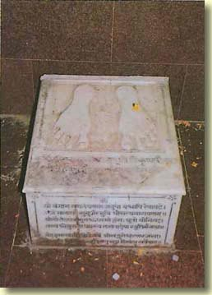
The lotus feet of Lord Caitanya

Oulu, Finland
26 October 2004
I arrived in north Finland safely. Am with the devotees in a camping house. There is a preaching program tomorrow--expect a photo report the next day. We do have Net access in this town, fortunately. Hare Krsna!
Dawkins' Bright Idea
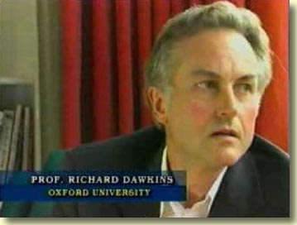
Writing in the Guardian ("The Future Looks Bright", 21 June, 2003) evolutionist Richard Dawkins had this to say:
Paul Geisert and Mynga Futrell, of Sacramento, California, have set out to coin a new word, a new "gay." Like gay, it should be a noun hijacked from an adjective, with its original meaning changed but not too much. Like gay, it should be catchy...Like gay, it should be positive, warm, cheerful, bright. Bright? Yes, bright. Bright is the word, the new noun. I am a bright. You are a bright. She is a bright. We are the brights. Isn't it about time you came out as a bright? Is he a bright? I can't imagine falling for a woman who is not a bright. The website www.celebs-atheists.com suggests numerous intellectuals and other famous people are brights...A bright is a person whose world view is free of supernatural and mystical elements. The ethics and actions of a bright are based on a naturalistic world view...You can sign on as a bright at www.the-brights.net.
OK, so atheists and evolutionists shall henceforward be known as brights. I am all for it. Really. Because bright already has a non-dictionary connotation, namely: stupid. When I was in school, dummies were called bright boys and dumb ideas were called bright ideas. This is long-standing usage, at least in America. Listen to this, its from 1946:

Oulu, Finland
28 October 2004
I finished editing the 5 Transcendental Psychology articles that I published in In2-MeC last year. The articles will soon be published as chapters of a book.
Some devotees tell me the original articles are difficult to penetrate. I tried to make them easier going for the book. Though I made changes, I did not completely rewrite the 5 chapter articles. It remains to be seen if readers will understand more than before. I hope so.
The book is a product of my endeavor to cope with my own personal psychological challenge, depression. Mental health professionals classify depression as disease. Lots of books are in print about how bad depression is. Having studied this condition for years now, I agree: it is a disease, and it is bad. It's more than just sadness. A month ago, when I was told about a Godbrother's spiritual crisis, I became so depressed that I couldn't sleep for several nights. It's been rough right up till now.
Modern psychology doesn't know the cause of depression. Even Ayurveda as practiced today, as I have seen myself, doesn't go the full route. Today's Ayurveda attempts to treat depression by Panchakarma and medicine for the body. But about the subtleties of consciousness, there weren't clear, realized answers from the Ayurvedic physicians I spoke to.
Quite recently I came in touch with a mental health professional whose explains depression and other mental illnesses from the standpoint of consciousness. His teachings are very much in line with sastra. I am going to leave this person unnamed, for several reasons.
He says that prayer and meditation are the best means of purifying the mind. (Prayer and meditation, of course, are what devotees do when they chant japa. ) He advises his patients to be vegetarian and in general to live a sattvik life. And he teaches a model of the mind quite similar to the one that is taught in the Srimad-Bhagavatam and other Vedanta literature.
What particularly sets him apart from many other professionals are his views on the invasion of the mind by subtle entities. Now, when this topic is brought up, under such names as "possession" and "psychic attacks", it is viewed by mental health professionals as a superstition. On the other hand, those who do believe in it often do so because they think it's a neat way to excuse themselves of blame: "The devil made me do it. " But according to the teachings I'm describing, the invading entities take shape within the mental energy of a person's state of mind. The invaded person is responsible for what state his mind is in.
Let us take for example the depressed state of mind: being tamasic, depression plays host to tamasic entities that intensify the apathy, unhappiness, lack of energy, and loneliness that are typical of depression. Such entities do more than that. They can make a person mad. They take command of his activities. They haunt him.
Such subtle entities become "lords" of the inauspicious mental state (depression, for example). The mental energy these entities exert is actually our own. They "take a body", so to speak, from our mind-force. The control of that force is taken over by them. But their entry ticket--the inauspicious mental state--is our own making. It's a question of quality of mind.
What are these entities that enter the material mind and grow strong there? Srila Prabhupada gives this answer:
Krsna is described here as Madhusudana, the killer of the demon, Madhu. Madhu-kaitava-ari. So Arjuna was attacked by a demon of forgetting his duty, being too much afflicted by bodily relationship. This is our position. In this material world, we are so much attached to this bodily relationship that it is to be considered just like we are ghostly haunted. In a poetry, Prema-vivarta, it is said that pisace paile yena mati chana haya, maya-grasta jivera sei dasa upajaya.
Note that Srila Prabhupada said that Arjuna was attacked by the demon of doubt because he was too afflicted (depressed!) by bodily relationship. His affliction brought on the attack. The pisace paile verse Prabhupada quoted compares people in maya to people haunted by ghosts. So again, what are these entities that enter the material mind and grow strong there? Ghosts and demons, of which there are many kinds. Lust can be mentioned in this connection. Gita 3. 40 talks about lust invading the mind, intelligence and senses. In the purport Srila Prabhupada writes:
The enemy has captured different strategic positions in the body of the conditioned soul, and therefore Lord Krsna is giving hints of those places, so that one who wants to conquer the enemy may know where he can be found. Mind is the center of all the activities of the senses, and thus when we hear about sense objects the mind generally becomes a reservoir of all ideas of sense gratification; and, as a result, the mind and the senses become the repositories of lust.
This mental health professional teaches that deep and sincere prayer (e. g. chanting good rounds of the Hare Krsna mahamantra) purifies the mind, thus making it uninhabitable for such subtle entities of the darkness.
We know that when the mind is purified completely, perfectly spiritualized, it is host for pure spiritual entities. Doyal Nitai Caitanya bole nach re amar man, goes a song of Srila Bhaktivinoda's: "Chanting the holy names 'Doyal Nitai Caitanya'--O my mind, please dance!", which means that the purified mind dances with Lords Nitai and Caitanya as They appear within it.
I saw a book the other day about the psychopathic mentality. (A psychopath is not a raving crazy man, as one might suppose from hearing this word without knowing what it means; a psychopath is someone who leads a very primitive, self-centered emotional life, though in other areas he may appear normal. ) The psychopathic individual really has sympathy only for himself/herself. He/she can shed tears for himself/herself, but not for others. When the psychopath is punished for a violent crime, s/he only understands "I am being hurt. " S/he therefore expects of others, "You should feel sorry for me. " There's little sense of responsibility, that "I hurt this other person needlessly, therefore my hurt is deserved. " And of course there's no empathy--no resonance with the pain the victim feels. The other guy--the victim--deserved it, the psychopath believes.
Reading the curriculum vitae and psychological profile of a psychopath can induce in the reader a strong sense of creepiness. It seems like some dark force took the psychopath over to cover his conscience, his sense of guilt and responsibility, and his normal emotions.
I think that force is an entity of sinfulness. When someone--not a determined psychopath, just an average person who chooses to do wrong--gives up to sin, a limited sort of psychopathology manifests in the mind to help the sinner do the sin, to justify it, and to assure the sinner that he'll not be caught and punished for what he did.
According to sastra there is a papa-purusa, "sin personified", a universal controller of sinful activities. This entity invades minds that are infected with kuta, sinful propensity.
Kesava tuya jagata vicitra. Bhaktivinoda Thakura has sung that the Lord's creation is full of strange and wonderful variety. Commenting on this in a 1976 class, Srila Prabhupada said,
Vicitra means varieties. "So if God is kind, why He has made so many varieties?" Is this not the common question you meet? You are preaching. They inquire like this, "Why God is not kind to everyone? Why He has made this distinction?" So this is not God's creation. We should know that it is my creation. Therefore Prahlada Maharaja said, evam sva-karma-patitam. Just like a man is condemned to death. In the court the judge gives the judgement that "This murderer should be hanged. " So it is not the judge that he is giving order to the murderer to be hanged. It is the murderer who has created his situation, to be hanged.
There it is, plainly stated: "We should know that it is my creation. " A person in the grip of powerful sin personified got into that condition by his own dedication to sinfulness. Man proposes, God disposes. Anyway, there is another nature, the transcendental nature, with unlimitedly more variety than this material nature. The pure devotees, the mahatmas, Sri Krsna tells Arjuna in Gita, are under the protection of this nature, His own nature.
Chanting the holy names without offenses, that is this divine protection. Dedicate to that! I find that knowing clearly how the conditioned mind works, and how dedicated chanting rectifies the mind's conditioning, is a great help. Because the beginning is to give up mental speculation:
The process is how to become mahatma. That process is recommended by Caitanya Mahaprabhu. Not it is His manufactured process, but it is recommended in the Vedic sastra. What is that? Jnane prayasam udapasya namanta eva. The process is don't try to speculate on God. Give up this process, this bad habit. You cannot speculate. No. Jnane prayasa.
This is called jnana. Jnana means knowledge, acquired knowledge. Everyone is trying to. . . Nobody is interested now to understand what is God, but there are some. But they are trying to understand God by mental speculation. So Caitanya Mahaprabhu said, "This practice should be given up, speculation. " Jnane prayasam udapasya namanta eva. Just become submissive, namanta. Don't think that "I am very learned scholar. I can manufacture my own way how to find out God," or "I am God," and so on, so on. This practice should be given up. Just become humble and meek. Jnane prayasam udapasya namanta eva.
"Then what shall I do, becoming humble and meek?" San-mukharitam bhavadiya-vartam. You try to understand about God from a God-realized person. That you do. That will help you. Sthane sthitah. There is no need of changing your position. You remain wherever you are. Sruti-gatam tanu-van-manobhih. Just lend your, this aural reception and try to hear about God from the self-realized person, from mahatma.
Then one day it will become so, that although God is unconquerable, you will conquer Him. Prayena ajita jito 'py asi. You'll conquer over God. You cannot conquer God, but God agrees to be conquered by His devotee.
--Srimad-Bhagavatam lecture, 22 October 1975 in Johannesburg

Dark Moon
Dark Moon is a book of 568 pages written by Mary Bennet and David S. Percy. It was published in London in 1999. They announce the purpose of the book is
to question the entire validity of the official record of mankind's exploration of the Moon especially the Apollo lunar landings themselves.
Although the book does look quite interesting, replete as it is with lots of photos, skillful drawings and catchy titles (Arctic Antics, Radiant Daze, Rocket Rackets), the author's prose is heavy going. As I read this. . .
Notwithstanding that, the LM was always going to be a showcase craft for NASA. Its much vaunted temperament would enhance the 'courage' of the astroboys. Whether intentional or not, giving it the same characteristics as a wigwam, alien remoulded by the technological requirements of the day, could be seen as a statement. Twentieth century progress was allied to the fact that these incomers (who now considered themselves as the rightful owners of their own land) were once again appropriating a territory and all that went with it. This time it was our Moon, not a country and as we shall see, it was for their own purposes--not for all mankind.
. . . and a good number of other prolix paragraphs, it became clear that I was not destined to read the whole book, nor even half of it. This is not a book for reading. It is for deciphering.
Another difficulty is that despite the stated intention to question the Moon landings, there's a LOT of stuff between the covers that's not about that intention. Stuff about Yuri Gagarin and the Russian space program. (Thing is, the Russians never claimed to put a man on the Moon. ) Stuff about the mysterious huge explosion in the sky above Siberia in 1908. Stuff about alleged flying saucers that crashed in Roswell, New Mexico in 1947. Stuff about the Face on Mars compared to the Egyptian Sphinx. (Seems that only old Viking photos of the Face from the '70s appear in Dark Moon. . . but NASA published Face photos taken at higher magnification by the Mars Explorer just a few years ago. The latter photos tend to support NASA's argument that the Viking-era Face photos show an optical illusion of light and shadow. Face on Mars? There ain't any, sez NASA. In any case, the Face doesn't have much to do with the Apollo Moon landings. )
After all that, what's spot-on about the Apollo program does still add up to quite a bulk of material. As I browsed through it I noted that a good portion of the issues raised here looked familiar--other books and magazines took them up prior to Dark Moon. Plus the authors indulge in considerable speculation about what they think was really going on with Apollo and other government projects. For example, they relate that in the 1940s the superwealthy aircraft manufacturer Howard Hughs invested excessive money into the construction of a single, very huge airplane made entirely out of wood. They don't believe all that money could have actually been spent on just one plane, and they wonder if Hughs gave some of it to a secret government project called Overcast. Well, OK, but why should I believe that?
The stated intention of Dark Moon is fine. But after looking through it several times I didn't come away with an impression that the authors had accomplished their intention in a way that impelled me to sit down and read the whole thing from cover to cover.

Oulu

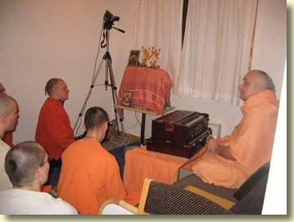
Morning class in the camp house.

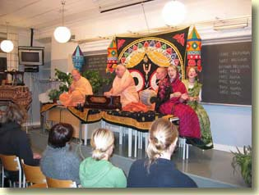 | 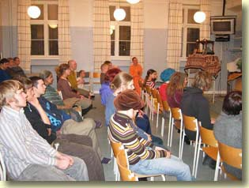
Preaching in Oulu, North Finland.

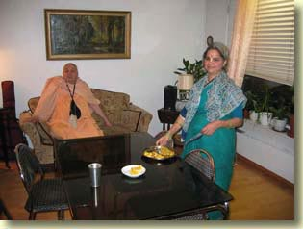
Visiting Sulocana, a friend of the movement in Oulu. . .
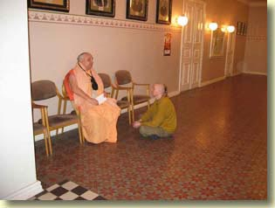
. . . and talking with Janardana, an initiated devotee who lives there.

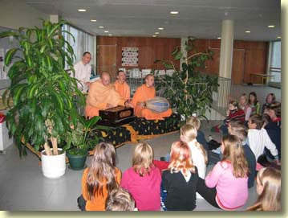
The devotees hold kirtana in a school.

Helsinki, Finland
29 October 2004
Fingerprints of the Gods
In 1995, a British journalist named Graham Hancock published Fingerprints of the Gods--The Evidence of Earth's Lost Civilization. Lalitanatha Prabhu loaned it to me when I visited his house in the Danish countryside. I have not read the whole thing, it's 570 pages long, but I've gone through several chapters.
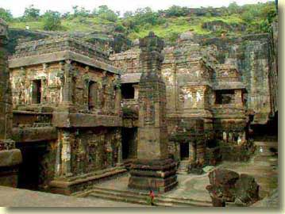
The book is useful in that it argues there was civilization on this earth tens of thousands of years ago. It backs up this argument with a good spectrum of evidence. It also shows how this evidence was covered up by so-called experts.
For example, there is the widely respected history of Egypt that was written in the 3rd century BC by Mantheo, a priest of Heliopolis. Today it exists only in fragments. These fragments form the framework of Egypt's past as studied by modern scholars. There's a little problem, though. Mantheo traces civilization in Egypt back 24,925 years before his time. From this record, modern Egyptology accepts only the part about 30 royal dynasties, but not the part about the long periods when demigods, superhumans and spirits ruled. The streamlining of Mantheo's data began early in the Christian era. There was a need to fit world history into the Biblical narrative of creation. Accordingly, before about 4000 years before Christ, the world did not yet exist. Eusebius, who wrote a commentary on Mantheo, arbitrarily interpreted "year" to mean "month. " He thus reduced 24,925 years to a little over 2000 years so that Mantheo's record would nicely fit in the 2242-year period between Adam and the Flood.
Another point in this connection is that there are no traces of "evolution" in back of ancient Egyptian civilization. For all that can be examined of it today, it looks as if it suddenly appeared fully formed. One expert on the subject, John Anthony West, concludes that this shows civilization did not 'develop' in Egypt. It was a legacy from an earlier age. Mantheo told that it was established by demigods like Isis and Osirus. Later it was handed over to earthly kings.
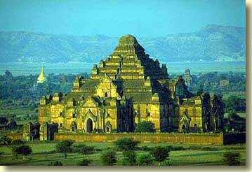
Similarly, according to the record of history compiled by the Mayan people of Mexico and Central America, the source of Mayan culture was a race of superhumans known as the First Men. With names like Balam-Quitze, Balam-Acab, Mahucutah and Iqui-Balam, these personalities rivaled the demigods above in wisdom and power.
There is evidence that ancient Egypt was somehow linked to the Mayan civilization. In both we find large pyramids built from stone. The Great Pyramid of Giza (Egypt) and the Pyramid of the Sun (Mexico) were built according to similar mathematical formulas. These formulas employ the "transcendental number" pi. When the length of the diameter of any circle is multiplied by pi, then the distance round the circle is the result. Pi is 3. 14 plus decimal fractions after the 4 that extend without apparent end. Because the number is endless, pi is considered eternal. Pi is fundamental to advanced mathematics. The point is that it would have been much more "natural" for the Egyptians and the Mayans to build their pyramids with corners of simple 45 degree angles. Such a pyramid be the same length on all sides. You could set it down on any of its sides and the structure would look exactly the same. But the Giza and Sun pyramids have corner angles that are multiples of pi. Hence the base line is longer than the line of the sides rising to meet at the top. This is most unusual and prompts us to ask, Why "pi", and why pi in two cultures that modern historians say could have had no contact with one another?
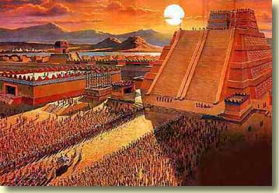
Within the colossal stone ruins of Tihuanaco in Bolivia is the Kalassaya, which is accepted today as an ancient observatory. On the basis of how it was designed by its builders to line up with the rising sun, a number of scientists, beginning with Arthur Posnansky (who studied Tihuanaco for 50 years), concluded that the Kalassaya is at least 15,000 years old. Featured in the Kalassaya are clear carvings of elephants' heads. There are no elephants in South America today, but science says there were prior to 10,000 years ago. Yet in spite of such scientifically verified evidence, historians and archaeologists are very reluctant to admit a date for Tihuanaco earlier than AD 500!
To me, Chapters 28-31 are most interesting. Hancock walks us through another book, Hamlet's Mill, which I read years ago. Written by Giorgio de Santilla and Hertha von Dechend and first published in the late '50s, Hamlets Mill is a brilliant, sweeping comparative study of the astronomy embedded in ancient iconography and "mythology" around the world. What is revealed is a knowledge of what is termed today as the cycle of precession. Precession is the opposite of succession, thus its simple meaning is "going before" while succession means "going after. "
In the sky around the Earth there is a great circle of 12 constellations of the Zodiac. In the course of one year, the point at which the sun rises over the eastern horizon passes through the "houses" of each of the constellations. This is a cycle of succession: in mid-summer on the longest day of the year, the sun rises in Sagittarius, a month later it rises in Capricorn, a month after that it rises in Aquarius, and so on. The cycle of precession is traced through the same 12 houses, but what moves here is the point at which the sun rises on the vernal equinox. There are two times in the year, in spring and autumn, when day and night are the same length. These times are the equinoxes. The vernal equinox is the springtime equinox. Every year on the morning of the vernal equinox we see the sun rise in the house of Pisces. But year by year the exact point where the sun pops up on that morning is gradually sliding over to Aquarius, which is before Pisces in the cycle of succession. Hence the vernal equinox moves in precession, backwards through the 12 houses. It will take some 600 more years for the vernal equinox to move into the house of Aquarius (and when it does, that will be the dawning of the "Age of Aquarius. . . Aquarius. . . la-la-la-la-la-la"). It takes 25,776 years for the sun to move round the entire cycle of precession.
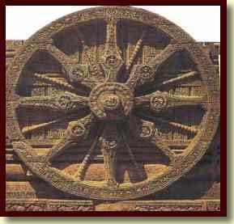
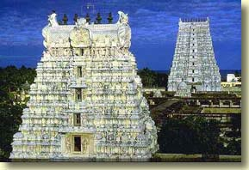
Now, the official line is that the cycle of precession was worked out sometime in the 2nd century BC by a Greek astronomer and mathematician named Hipparchus. What Hamlet's Mill demonstrates by presenting many impressive evidences from Vedic India, Ancient Egypt, Babylon, China, South America and other places, is that the cycle of precession was known long, long before Hipparchus. Moreover, it was known all around the world. De Santilla and von Dechend suggest that this knowledge goes back at least 8000 years.
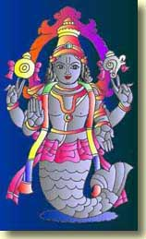
In Chapter 24, Hancock compares the flood narratives of various ancient civilizations, including the story of Matsya Avatara and King Satyavrata. In the ruins of Mesopotamia and in the Kalassaya of Tihuanaco are stone depictions of fish-gods that are reminiscent of Indian depictions of Matysa.

Helsinki, Finland
30 October 2004
Under the Banner of Heaven
To me, the most fascinating part of this book starts on page 298 and ends on page 311. These pages recount the testimony of experts at a 1996 murder trial in the US state of Utah. On trial was a member of the FLDS, for Fundamentalist Latter-Day Saints.
"FLDS" is not a designation for one particular sect; it refers to all persons who have broken away from the Mormon Church (known also as the Church of Latter-Day Saints) over the issue of polygamy, or plural marriage. Within the FLDS there are different communities, some of which have been in violent disagreement with one another, but which stand on one common ground: that God wants His chosen people (the Mormons, who accept Joseph Smith and his disciple Brigham Young as prophets of the latter days) to multiply throughout the world. To this end a man should have many wives and through them produce many, many children. The mainstream Mormon Church headquartered in Salt Lake City, Utah, outlawed polygamy within its ranks 114 years ago. The FLDS did not accept this ruling and so formed their own denominations.
The FLDS man was on trial for murdering a mainstream Mormon mother and child. The prosecution had a very strong case that showed he committed these murders because he believed God told him to. The strategy of the defense was to put experts on the stand who argued that the accused was insane and thus not competent to stand trial because of his bizarre beliefs. For example, he lived in dread of the angel Moroni, whom he thought would invade his body. The prosecution, on the other hand, put its own experts on the stand to testify that any person of strong religious faith has beliefs that to outsiders appear insane. Therefore strange religious beliefs should not be a criteria for judging whether a person accused of a crime is mentally incompetent.
Under the Banner of Heaven (2003) by Jon Krakauer is two things at once: an examination of the murder case, and a history of Mormonism. (By the way, Mormon is the name of an ancient prophet whom the Mormons believe was something like our Srila Vyasadeva--a compiler and organizer of scripture. The prophet Mormon is supposed to have lived in America long ago. ) The Mormon Church, as we see in the appendix, was not pleased by this book. Krakauer shows fairness by publishing a lengthy criticism by a Mormon spokesman. He goes on to answer the spokesman point by point, admitting that on some points he was wrong. But on the most important points Krakauer believes himself correct, and accuses the Church spokesman of juggling words in his treatment of these issues.
I'm a Hare Krsna, not a Mormon, so I'm not about to comment on this debate. In addition I understand that Srila Prabhupada's attitude to other religions was in the main supportive. Sometimes he would compare Krsna consciousness with another doctrine to show the theological superiority of the former. But he appreciated and encouraged the elements of faith and devotion in other religions.
One thing can be said about Mormon theology: it has characteristics that are reminiscent of demigod worship and karma-kanda. Mormons aspire to be not merely saved by being taken up to heaven like other Christians; they aim to become lords in heaven. According to the Encyclopedia Britannica they even believe that God evolved from man (and therefore, in turn, they believe man can evolve into a god). They accept that the soul pre-existed before the conception of the body. The mainstream Christian doctrine, as far as I know, holds that the soul is created along with the body. But like many mainstream Christians the Mormons are apocalyptic; they await the second coming of Jesus Christ at the fast-approaching End Time, and the establishment of his kingdom on earth. Mormonism is supposed to be the fastest-growing religion in the world today. If the church continues to expand at its present rate, by the end of this century there will be 300 million Mormons.
I think Under the Banner of Heaven offers a useful read for thoughtful devotees. The Mormon Church is a strong and respected institution today, but it gained that status only after passing through a long period of persecution from outside and fanaticism from within. The book raises large questions that ISKCON devotees also grapple with. One of Krakauer's principle concerns is the question of how a meaningful history of a religious movement should be put to record. He writes on page 383:
The men who run the modern LDS Church deem the history of their religion to be sacred, and have long tried to retain tight proprietary control over how that history is presented to the world. Indeed, LDS leaders have explicitly stated that they believe account of Mormon history should be, above all else, "faith promoting"--that is to say, accounts of Mormon history should be celebratory rather than critical, and should downplay, omit, or deny sensitive or unsavory aspects of that history.
Krakauer quotes a contemporary Mormon leader who said in 1981:
There is a temptation. . . to want to tell everything, whether it is worthy or faith-promoting or not. Some things are not very useful. . . In an effort to be objective, impartial, and scholarly, a writer or a teacher may unwittingly be giving equal time to the adversary. . . In the Church we are not neutral. We are one-sided. There is a war going on, and we are engaged in it.
I think there is something to be said for this point of view. We have Vedic histories, the 18 Puranas, in which many of the same narratives are retold in terms of different modes of nature. The Bhagavatam narrative is considered to be the spotless narrative. One way of stating this is to say, "The Bhagavatam is purified of things that are not useful, worthy, and faith-promoting. "
Purifying a narrative, removing the overlay of the modes of material nature, is a valid principle. Srila Prabhupada said in London on 12 July 1973,
Everything has two sides, black side and bright side. We are interested with the bright side. Black side we can point out, but anyone who is sincere, he'll take the bright side. Sajjano gunam icchanti dosam icchanti pamarah. There are guna and dosa, fault and good qualities. So those who are sajjana, they take the good qualities, give up the bad qualities. Then there, gradually things will come out. But if we accept God, "God is all-good," then all good qualities automatically manifest. Yasyasti bhaktir bhagavaty akincana sarvair gunais tatra samasate surah. All good qualities manifest.
In Calcutta in 1974 he said:
So Krsna takes only the bright side of your devotional service. He never takes the dark side because anyone in this material world, he has got only dark life. So try to serve Krsna. Svalpam apy asya dharmasya trayate mahato bhayat: "Even little service rendered to Krsna can save you from the greatest dangerous life. "
We are encouraged to be good when the good in us is encouraged. Finding faults is discouraging. That doesn't mean that faults are best ignored, even when they are glaringly apparent. Since faults are manifestations of ignorance, they are to be removed with knowledge. That means knowledge of perfection, not knowledge that a fault is there.
Purifying the narrative does not mean whitewashing it, perpetrating a coverup. It is what the acaryas do when they comment on Sri Krsna's pastimes--when they explain, for example, that His lila with the gopis is not impelled by material lust, though it may appear that way to some. In much the same way, when an ordinary man hears from the acaryas, his personal misconceptions about himself--"I am this body", "I am a helpless servant of lust", "I am too sinful to become a pure devotee"--are removed by transcendental knowledge.
Anyway. . . an interesting book. Grappling with the questions Krakauer raises strengthened my mind.
siddhanta baliya citte na kara alasa
iha ha-ite krsne lage sudrdha manasa
A sincere student should not neglect the discussion of such conclusions, considering them controversial, for such discussions strengthen the mind. Thus one's mind becomes attached to Sri Krsna.
Cc Madhya 2. 117

Helsinki, Finland
31 October 2004
Tolerate Harsh Words
SB 11. 23. 5
Once a certain sannyasi was insulted in many ways by impious men. However, with determination he remembered that he was suffering the fruit of his own previous karma. I will narrate to you his story and that which he spoke.
PURPORT
Srila Bhaktisiddhanta Sarasvati Thakura comments as follows. “Often those who give up the materialistic path and devote themselves to renunciation are attacked by impious persons. This analysis, however, is superficial, since the punishment is actually the cumulative result of one’s past karma. Some renunciants show lack of tolerance when presented with the remnants of their previous sins and thus are forced to enter again onto the path of impious life. Sri Chaitanya Mahaprabhu therefore instructs that one should become as tolerant as a tree. If a neophyte on the path of devotional service to the Lord’s pure devotees is attacked by envious persons, he must accept it as a consequence of his previous fruitive activities. One should be intelligent and avoid future unhappiness by rejecting the ethic of an eye for an eye, a tooth for a tooth. If one refuses to enter into enmity with envious men, they will automatically leave him alone. ”
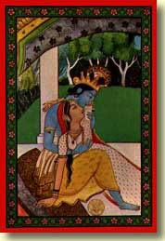
The Divine Couple, Sri-Sri Radha-Krsna.

Sri Yugala-kisorastaka
Eight Prayers Glorifying the Youthful Divine Couple
TEXT 1
nava-jaladhara-vidyud-dyota-varnau prasannau
vadana-nayana-padmau caru-candravatamsau
alaka-tilaka-bhalau kesa-vesa-praphullau
bhaja bhaja tu mano re radhika-krsnacandrau
nava--new; jaladhara--cloud; vidyud--lightning; dyota--splendor; varnau--color; prasannau--happy; vadana--face; nayana--eyes; padmau--lotuses; caru--beautiful; candra--moon; avatamsau--crowns; alaka--curling locks of hair; tilaka--"tilaka"; bhalau--foreheads; kesa--hair; vesa--garments; praphullau--blossoming; bhaja--please worship; bhaja--please worship; tu--indeed; mano--heart; re--O!; radhika-krsnacandrau--Sri Sri Radhika-Krsnacandra.
O heart, please, please worship Sri Sri Radhika-Krsnacandra, who are magnificent as a fresh monsoon cloud and a lightning flash, who are cheerful, who are merciful, whose faces and eyes are lotus flowers, who wear beautiful moon-crowns, whose foreheads are decorated with "tilaka" and curling locks of hair, and whose hair and garments blossom with splendor.
TEXT 2
vasana-harita-nilau candanalepanangau
mani-marakata-diptau svarna-mala-prayuktau
kanaka-valaya-hastau rasa-natya-prasaktau
bhaja bhaja tu mano re radhika-krsnacandrau
vasana--garments; harita--yellow; nilau--and blue; candana--with sandal paste; alepana--anointed; angau--limbs; mani--jewels; marakata--sapphires; diptau--effulgent; svarna--of svarna flowers; mala--with garlands; prayuktau--endowed; kanaka--golden; valaya--bracelets; hastau--hands; rasa--"rasa"; natya--dance; prasaktau--engaged.
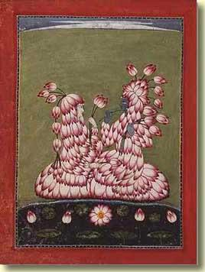
Radha-Krsna dressed in lotus flowers.
O heart, please, please worship Sri Sri Radhika-Krsnacandra, whose garments are yellow and blue, whose limbs are anointed with sandal paste, who are splendid with sapphires, who are decorated with garlands of (t3)svarna(t1) flowers, who wear golden bracelets, and who enjoy the "rasa" dance.
TEXT 3
ati-matihara-vesau ranga-bha/ni-tri-bhangau
madhura-mrdula-hasyau kundalakirna-karnau
natavara-vara-ramyau nrtya-gitanuraktau
bhaja bhaja tu mano re radhika-krsnacandrau
ati--very; matihara--charming; vesau--appearance; ranga--dancing; bha/ni-tri-bhangau--three-fold bending; madhura--sweet; mrdula--gentle; hasyau--smiles; kundala--earrings; akirna--adorned; karnau--ears; natavara--of the best of dances; vara--most; ramyau--charming; nrtya--dancing; gita--and music; anuraktau--enjoying.
O heart, please, please worship Sri Sri Radhika-Krsnacandra, who are very handsome and charming, whose forms bend in three places as They dance, whose gentle smiles are sweet, whose ears are decorated with earrings, who are the best of graceful dancers, and who enjoy pastimes of singing and dancing.
TEXT 4
vividha-guna-vidagdhau vandaniyau su-vesau
manimaya-makaradyaih sobhitaggau sphurantau
smita-namita-kataksau dharma-karma-pradattau
bhaja bhaja tu mano re radhika-krsnacandrau
vividha--various; guna--virtues; vidagdhau--expert; vandaniyau--worshipable; su-vesau--handsome; manimaya--of jewels; makara--with sharks; adyaih--beginning; sobhita--decorated; aggau--whose forms; sphurantau--manifesting; smita--with a smile; namita--bending; kataksau--sidelong glances; dharma--religion; karma--the results of activities; pradattau--giving.
O heart, please, please worship Sri Sri Radhika-Krsnacandra, who are filled with all virtues, who are worshipable, who are handsome, whose transcendental forms are decorated with jewel ornaments in the shape of sharks and other objects, who cast crooked, smiling glances from the corners of Their eyes, and who give the results of all pious activities.
TEXT 5
kanaka-mukuta-cudau puspitodbhusitangau
sakala-vana-nivistau sundarananda-pusjau
carana-kamala-divyau deva-devadi-sevyau
bhaja bhaja tu mano re radhika-krsnacandrau
kanaka--golden; mukuta-cudau--crowns; puspita--of flowers; udbhusita--with decorations; angau--whose limbs; sakala--all; vana--forests; nivistau--entered; sundara--beautiful; ananda--bliss; pusjau--abundance; carana--feet; kamala--lotus; divyau--splendid; deva-deva-adi--by the greatest demigods; sevyau--served.
O heart, please, please worship Sri Sri Radhika-Krsnacandra, who wear golden crowns, whose limbs are decorated with flowers, who go to all the forests of Vrndavana, who are filled with splendid bliss, whose feet are glittering lotuses, and who are served by the greatest demigods.
TEXT 6
ati-suvalita-gatrau gandha-malyair virajau
kati kati ramaninam sevyamanau su-vesau
muni-sura-gana-bhavyau veda-sastradi-vijsau
bhaja bhaja tu mano re radhika-krsnacandrau
ati--very; suvalita--graceful; gatrau--limbs; gandha--fragrant; malyair--with garlands; virajau--splendid; kati--how many?; kati--how many?; ramaninam--by beautiful girls; sevyamanau--served; su-vesau--handsome; muni--of sages; sura--and demigods; gana--by hosts; bhavyau--meditated; veda-sastra-adi--in all Vedic literatures; vijsau--learned.
O heart, please, please worship Sri Sri Radhika-Krsnacandra, whose graceful forms are splendid with fragrant flower garlands, who are served by numberless beautiful gopis, who are handsome, on whom the sages and demigods meditate, and who are learned in all Vedic literatures.
TEXT 7
ati-sumadhura-murtau dusta-darpa-prasantau
suravara-varadau dvau sarva-siddhi-pradanau
ati-rasa-vasa-magnau gita-vadyair vitanau
bhaja bhaja tu mano re radhika-krsnacandrau
ati--very; sumadhura--charming; murtau--forms; dusta--of the demons; darpa--the pride; prasantau--quelling; suravara--to the demigods; varadau--granting benedictions; dvau--two; sarva--all; siddhi--perfections; pradanau--granting; ati--sweet; rasa--nectar; vasa-magnau--plunged; gita--singing; vadyair--and playing musical instruments; vitanau--expert.
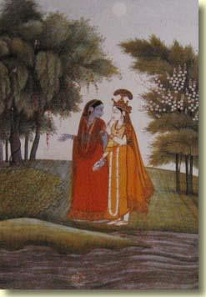
Radha-Krsna dressed in one another's clothes.
O heart, please, please worship Sri Sri Radhika-Krsnacandra, whose transcendental forms are very sweet and charming, who curb the demons' pride, who are the benefactors of the best of the demigods, who grant all perfections, who are plunged into the sweetest nectar, and who expertly sing and play musical instruments.
TEXT 8
agama-nigama-sarau srsti-samhara-karau
vayasi nava-kisorau nitya-Vrndavana-sthau
samana-bhaya-vinasau papinas tarayantau
bhaja bhaja tu mano re radhika-krsnacandrau
agama-nigama--of Vedic scriptures; sarau--the ultimate goal; srsti--creation; samhara--and annihilation; karau--doers; vayasi--in age; nava--new; kisorau--youths; nitya--eternally; Vrndavana--in Vrndavana; sthau--staying; samana--strife; bhaya--and fear; vinasau--destruction; papinas--the sinful; tarayantau--delivering.
O heart, please, please worship Sri Sri Radhika-Krsnacandra, who are the ultimate goal of all Vedic scriptures, who create and destroy the universes, who are youthful, who eternally stay in Vrndavana, who destroy all fear and strife, and who deliver the sinful.
TEXT 9
idam manoharam stotram
sraddhaya yah pathen narah
radhika-krsnacandrau ca
siddhidau natra samsayah
idam--this; manoharam--beautiful; stotram--prayer; sraddhaya--with faith; yah--one who; pathen--reads; narah--a person; radhika-krsnacandrau--Radhika-Krsnacandra; ca--and; siddhidau--granting perfection; na--not; atra--in this; samsayah--any doubt.
Sri Sri Radhika-Krsnacandra grant perfection to whoever reads this beautiful prayer with faith and devotion. Of this there is no doubt.
Helsinki, Finland
1 November 2004
Some photos from Sweden from a couple weeks ago...
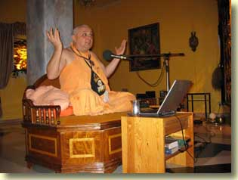 | 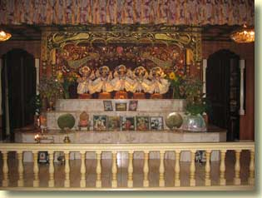

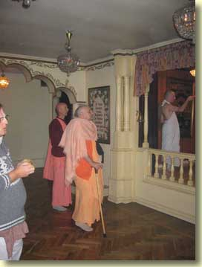 | 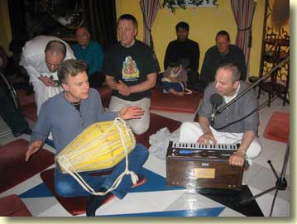

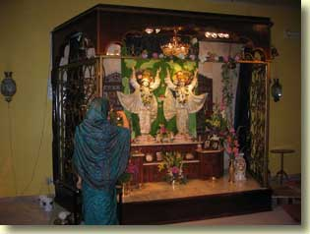 | 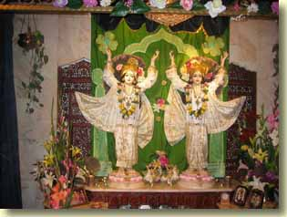

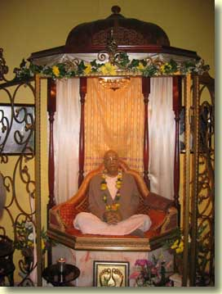 | 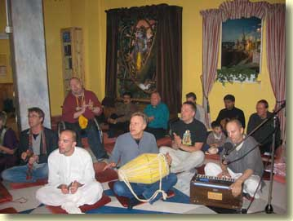

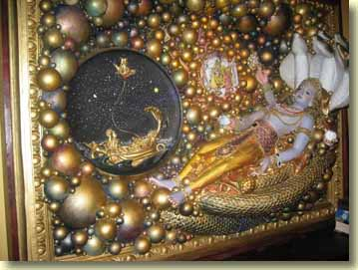 | 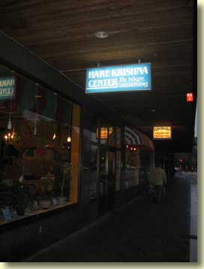

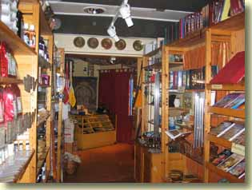 | 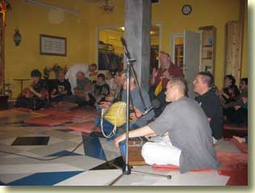

Helsinki, Finland
2 November 2004
I have a couple of science magazines at hand. One is the September edition of the venerable Scientific American, the other is the October issue of Wired, which tries its best to look cool (the word "cool" appears in this issue at least a dozen times).
The Scientific American is a special issue dedicated to Einstein. Reading it brought to mind the "Worry about Adam, not the atom" article I published here last summer. Although in the first decade of the 20th century Albert Einstein helped bring the basic concepts of the New Physics into the world, in the '20s and '30s, the boomtime of quantum mechanics, he became its most famous critic. Einstein, as he is so often quoted, could not believe that God plays dice with the universe. The Young Turks of the New Physics like Bohr and Heisenberg shrugged Einstein's complaints off as reactionary mysticism.
On page 70 is an article titled "Was Einstein Right?" which reports on the second thoughts some of today's physicists are having about Einstein's doubts about quantum mechanics. You know, if you want to go around telling people that modern science has disproved the Bhagavatam account of the atom, you will generate curiosity about just what it is in the atomic realm that modern science claims to have established as unarguable fact. If it turns about that scientists are still arguing about what is going on in the microworld of quantum events, then your posturing that you know something that other devotees don't about what atoms really are seems clownish.
Still, something is rotten in the state of quantumland, too. As Einstein was among the first to realize, quantum mechanics, too, is incomplete. It offers no reason why individual physical events happen, provides no way to get at an objects' intrinsic properties and has no compelling conceptual foundations. (pg. 71)
Just see. Those "objects" that quantum mechanics can't get at the properties of are the invisible units of matter: atoms, protons, neutrons, electrons, and so on. What is then "proven" by science about atoms, pray tell?
In Srimad-Bhagavatam 2. 5. 3, Narada Muni prays to his father Lord Brahma:
My dear father, all this is known to you scientifically because whatever was created in the past, whatever will be created in the future, or whatever is being created at present, as well as everything within the universe, is within your grip, just like a walnut.
It is revealed here that Brahma has mastery over the creative function of time in its three phases of past, present and future. He knows what the future holds, but modern scientists don't. And that is why their theories are left begging for completeness.
Various physicists and philosophers have mused that quantum mechanics seems odd because we assume that only the past affects the present. What it the future did, too? Then the past probabilistic qualities of quantum theory could merely reflect our own ignorance of what is to come. (pg. 72)
In the last summer's article about atoms, I cited Srila Prabhupada as stating that atoms are ultimate units of time. Scientific American, in discussing the work of Mark Hadley of the University of Warwick, states:
He has also resurrected an idea that Einstein worked on in the 1930s: elementary particles are not objects sitting in spacetime but rather parts of spacetime itself, not lint clinging to the fabric but rather small knots in the fabric.
At the end of page 73, Scientific American admits that quantum mechanics is a theory of the universe, and theories of the universe are arbitrary. The dictionary defines arbitrary as "Determined by chance, whim, or impulse, and not by necessity, reason, or principle. " In other words, theories are a different animal from reality.
On page 155, Wired starts an article about the latest challenge to Darwin's theory of evolution: the IDM or intelligent design movement. Written by Evan Ratliff, the tone of the piece is clearly pro-evolution. Still, the article leaves no doubt that evolutionists are most unhappy and not a little scared of ID. A box item gives time to George Gilder, described as a "technogeek guru" and a leader of the Discovery Institute, which promotes ID. I'm reproducing Gilder's words here (great stuff!):
Our high schools are among the worst performers per dollar in the world--especially in math and science. Our biology classes, in particular, espouse anti-industrial propaganda about global warming and the impact of DDT on the eggshells of eagles while telling just-so stories about the random progression from primordial soup to Britney Spears. In a self-refuting materialist superstition, teachers deny the role of ideas and purposes in evolution and hence implicitly in their own thought.
The Darwinist materialist paradigm, however, is about to face the same revolution that Newtonian physics faced 100 years ago. Just as physicists discovered that the atom was not a massy particle, as Newton believed, but a baffling quantum arena accessible only through mathematics, so too are biologists coming to understand that the cell is not a simple lump of protoplasm, as Charles Darwin believed. It's a complex information-processing machine comprising tens of thousands of proteins arranged in fabulously intricate algorithms of communication and synthesis. The human body contains some 60 trillion cells. Each one stores information in DNA codes, processes and replicates it in three forms of RNA and thousands of supporting enzymes, equisitely supplies the system with energy, and seals it in semipermeable phopholipid membranes. It is a process subject to the mathematical theory of information, which shows that even mutations occuring in cells at the gigahertz pace of a Pentium 4 and selected at the rate of a Google search couldn't beget the intricate interwoven fabric of structure and function of a human being in such a short amount of time. Natural selection should be taught for its important role in the adaption of species, but Darwinian materialism is an embarrassing cartoon of modern science.
What is the alternative? Intelligent design at least asks the right questions. In a world of science that still falls short of a rigorous theory of human consciousness or of the big bang, intelligent design theory begins by recognizing that everywhere in nature, information is hierarchical and preceds its embodiment. The concept precedes the concrete. The contrary notion that the world of mind, including science itself, bubbled up randomly from a prebiotic brew has inspired all the reductionist futilities of the 20th century, from Marx's obtuse materialism to environmental weather panic to zero-sum Malthusian fears over population. In biology classes, our students are not learning the largely mathematical facts of 21st century science; they're imbibing the consolations of a faith-driven 19th century materialist myth.
I'll have more to write about the ID movement. Stay tuned. . .

Helsinki, Finland
3 November 2004
More about the Intelligent Design Movement (IDM)
When I was in Denmark, Lalitanatha Prabhu loaned me two books by William A. Demski, a mathematician, author and a leader of the Discovery Institute. Lalitanatha has met Dembski personally; hence the books are autographed by the author. The titles are The Design Revolution--Answering the Toughest Questions About Intelligent Design (2004) which is written by Dembski, and Uncommon Dissent--Intellectuals Who Find Darwinism Unconvincing (2004), which he edited and wrote an introduction for.
I've given both books a cover-to-cover skim. And yesterday I picked up the magazine Wired which I mentioned already (I called it a science magazine, but it may be more accurate to call it a pop computer tech magazine). As you know from reading yesterday's journal, Wired for October features an article on ID. Titled "The Plot to Kill Evolution", it isn't without bias. A header in the article shouts, SOME PEOPLE DENY THE HOLOCAUST, BUT WE DON'T TEACH THAT IN HISTORY. This is how evolutionists decry the recent inroads that the IDM has made into some American schools. The IDM's strategy is to keep pushing the fact that Darwin knew nothing about the incredible complexity of the microscopic structures of cellular tissue; and then argue that it is therefore time that schools also teach ID, because it addresses this gap. Evolutionists, the IDM maintains, are programmed by their theory to ignore or wave away the overwhelming evidence of high design at the cellular level. The evolutionists retort by comparing the IDM to holocaust-deniers--people who don't believe the Nazis murdered 6 million Jews in the 2nd World War. In a similar cranky, myopic way, the IDM denies evolution. Evolutionists maintain that nobody teaches in history class that "some say it is not true that 6 million died in the camps. " Why should biology class be a place where students have to hear that maybe evolution isn't true?
Well, the answer to that question is pretty simple, but the evolutionists don't get it. The people on the school boards who plan curriculum are not convinced by Darwinian arguments that the case for evolution is as open-and-shut as the case for the Holocaust. And the evolutionists' own brand of dogmatism--in which they see the threat of fundamentalist religion behind every doubt in Darwin--hasn't helped their cause.
Uncommon Dissent takes the reader into the smoke and fire of this fray. We learn that evolutionist Daniel Dennet, author of Darwin's Dangerous Idea, looks forward to the day when religious believers will be kept in zoos to provide entertainment for "normal" (read: atheistic) people. Professor William Provine of Cornell University campaigns to persuade the public that it is high time to choose between Darwin and God (or science and superstition); and if it chooses Darwin, then the public must at last accept that there is no free will nor objective morality.
The IDM takes pains to distinguish itself from Creation Science, an anti-evolution movement that attempts to prove by scientific means the literal Biblical account of creation. IDMers on the contrary do not argue from scripture. They stick to demonstrations in nature of intelligent design, particularly at fundamental levels where Darwinian orthodoxy holds that things must be less evolved and thus more simple. IDMers don't argue that evidence for intelligent design must mean that God exists. Obviously, though, students who learn to see design in nature are likely to come to this conclusion.
That's why the evolutionists feel so threatened by IDM. They say schools should teach real science. . . but by that they mean that in real science there is no room for God anywhere at all. Funny thing, as Dembski explains in The Design Revolution, even some Christian theologians are anti-IDM. These are the theologians who have adapted evolution to belief in God. Their God is, of course, the stripped-down Deistic version, who is utterly uninvolved with the world except to give the first push.
Anyway, evolutionists portray the IDM's silence on God as just a cunning strategy (which I am sure, in a way, it is). It's all PR, the Darwinists fume: "when science education is decided by charm and stage presence, the Discovery Institute wins. " (Wired, pg. 203).
Turning back to Scientific American for September, which I wrote about yesterday, there's an article on page 24 that I believe explains the real reason why people in general are still skeptical of evolution and thus open to the IDM appeal. It's called "Mustangs, Monists and Meaning" by Micheal Shermer. Shermer admits that we are all natural-born dualists. (He means that we all naturally distinguish between "my body" and "I", or between matter and consciousness. ) Religion is likewise dualistic. Science, however, is monistic--it aspires to reduce all experience down to one ultimate fact: matter. Shermer writes that the problem is, the brain doesn't perceive itself. Consciousness comes from the brain, but since the brain doesn't know that, we think consciousness is different from matter. Consequently everyone is in illusion. And therefore religion still holds sway over much of the population, making the work of science so much harder.
Shermer's scientism is Mayavadi materialism. It's a lot like Buddhist philosophy. There's no God, no soul, only matter (maya). Problem is, there's really no way to know that directly, since if we experienced ourselves as matter-only, then we would be devoid of consciousness. It would be an experience of nothingness, or no experience at all. Shermer hopes that soon science will generate consciousness from silicon chips. That would be indirect proof that we are only matter.
Taking this into account, it becomes clearer why evolutionists are not interested in the evidence the IDM offers that life is designed. The notion of design is merely a phantasm arisen from the illusion of consciousness. IDMers are simply reading their own subjective maya into nature, which is blind and unknowing and works by chance, not by plan.
Well, Mike, materialist scientists are also using consciousness and intelligence to argue that ultimate reality is unconscious and unintelligent. Hence your standpoint is self-refuting, as George Gilder points out (quoted in yesterday's In2-Mec). Shermer offers the germ of a reply.
If this is all there is, then every moment, every relationship and every person counts--and counts more if there is no tomorrow than if there is.
That's awfully mystical, Mikey! You're saying that since our life is so very fleeting and temporary, it becomes more real than it would be if it was eternal. Taking the implication of your words further, you're hinting that by acknowledging ourselves to be just insentient, unknowing lumps of ignorance, our knowledge (i. e. science) becomes more meaningful and valuable than knowledge would be if we were actually non-material beings of pure consciousness.

Helsinki, Finland
4 November 2004
Icons of Evolution
A book published in 2000, Icons of Evolution--Science or Myth by Jonathan Wells is bashed by Wired (Oct. 2004, pg. 203) with these words:
Icons attempts to discredit commonly used examples of evolution, like Darwin's finches and peppered moths. Writing in Nature, evolutionary biologist Jerry Coyne called Icons stealth creationism that "strives to debunk Darwinism using the familiar rhetoric of biblical creationists, including scientific quotations out of context, incomplete summaries of research, and muddled arguments. "
About the "familiar rhetoric of biblical creationists," that phrase is an example of the pejorative labeling that evolutionists use on most anyone who speaks up to say Darwinism is wrong. I looked from cover to cover in Wells' book for a quotation from the Bible. Didn't find one. I checked the index. No entry for "Holy Bible". I looked in the concluding chapter for an argument in favor of God creating life. Nada. What are we to understand from this? In the Darwinian taxonomy of ideology, either you are with evolution or you are not, and if you are not, you must be a preacher of biblical rhetoric.
The complaint about "scientific quotations out of context" is repeatedly groaned by Darwinists against the IDM. They are deeply offended that this rascally movement of non-Darwinists dares to publish quotations from sincere believers in evolution who are troubled by gaps in the theory. For an example of what I mean, let's consider something from pages 321-2 of The Design Revolution by William Dembski. While putting forward an idea of what he would like to see in a school biology textbook, Dembski comments:
Note that such a text would provide a fair and detailed treatment of Darwinian evolution. In fact, it would tell students more about Darwinian evolution than Darwinists typically want them to hear, notably about the theory's problems and weaknesses. (And we don't even need to cite ourselves here. Critics within evolutionary biology's own ranks, like the late Stephen Jay Gould and now Lynn Margulis with her theory of symbiogenesis, have saved us the trouble).
This sort of teasing reference to prominent evolutionists who have admitted in print that there are holes in their favorite theory just riles Darwinists no end with righteous indignation. They protest that the proper arena for discussion of the problems and weaknesses of evolution is inside the fold of believers in evolution. Outside that fold, those who talk of holes in evolution are creationists (or, if they don't overtly bring God into the picture, then they are stealth creationists). From the Darwinist, materialist standpoint, a creationist cannot be a real scientist, even if, like Jonathan Wells, he holds a PhD in biology.
Next Wells stands accused in Wired of presenting muddled thinking in Icons of Evolution. Seems to me that the clearest examples of muddled thinking in his book are to be found in the evolutionists that he writes about. On pages 130-1 Wells relates what happened in the world of Darwinian academia after a team of molecular biologists extracted a DNA sample from the fossil bones of a Triceratops, a huge lumbering dinosaur with three horns jutting out of a bony face shield. A week later the magazine Science announced that the Triceratops DNA was most similar to bird DNA. Now, there is a "sect" of evolutionists called the cladists who are trying to prove that birds evolved from dinosaurs--and in fact that birds are dinosaurs. The cladists are opposed by ornithologists--that is, biologists who specialize in the study of birds. So the announcement in Science that Triceratops had bird DNA brought ecstasy to the cladist camp. But that's not the end of the story. Trouble quickly brewed up out of that DNA sample, spoiling the cladists' party. First, according to paleontology, there are two main branches in the dinosaur family. Cladistic theory maintains that birds evolved from only one of these branches; alas, Triceratops is classed in the other. Next, it was admitted that the DNA sample allegedly from Triceratops was 100% turkey DNA! Which is utterly ridiculous and forces us to ask just whose thinking is muddled. As cladistic evolutionists ran for cover from the fallout of this monumental faux pas, they lamely pleaded that while the DNA sample was being taken, one of the scientists may have been eating a turkey sandwich.
At a Symposium on Dinosaur Bird Evolution held at Fort Lauderdale, Florida, in 2000, a cladist named Kevin Padian, who happens to be president of the National Center for Science Education, brazenly attacked the ornithological, birds-are-not-dinosaurs camp with a windy blast of rhetoric so empty of logic that, with a few word changes, it would typify the sort of argument evolutionists make against the IDM.
On page 133 of Icons, Wells (who personally attended the symposium) lists the key elements of Padian's attack on the ornithologists. I'm rendering his list into my own words for the sake of readers who are not comfortable with English scientific jargon:
1) Padian charged that those who criticize the theory that birds evolved from dinosaurs have failed to propose an alternative hypothesis that can be tested by evidence.
2) After saying they had no alternative hypothesis at all, Padian then told the symposium that critics of the dino-to-bird theory base their hypothesis on evidence that they have interpreted in a biased way.
3) Next Padian asserted that while science is not democratic, the majority of the scientific community rejects the method of the critics, no matter what evidence they put forward.
4) Padian concluded that criticisms of the dino-to-bird theory ceased to be science 10 years ago. Therefore in fact the controversy is dead.
Wells writes that Padian's argument reminds him of an old lawyer's joke: Jones sues Smith for borrowing his kettle and returning it with a crack in the side. Smith's lawyer defends his client with this 4-part argument (which at the logical level is structured much as Padian's 4-part argument was).
1) Smith never borrowed the kettle.
2. When Smith returned the kettle, it wasn't cracked.
3) The kettle was already cracked when Smith borrowed it.
4) There is no kettle.
Yes, this is muddled thinking! But the muddle is in Padian's brain, not Wells'.
Finally, Wells is accused of putting forward incomplete summaries of research. But this anecdote he offers on page 58 of Icons of Evolution seems to me to really point out whose research is incomplete--due to being blindsided by a theory that doesn't work, namely Darwin's theory of evolution.
In 1999, a Chinese paleontologist who is an acknowledged expert on Cambrian fossils visited the United States to lecture on several university campuses. I attended one lecture in which he pointed out that the "top-down" pattern of the Cambrian explosion contradicts Darwin's theory of evolution. Afterwards, scientists in the audience asked him many questions about specific fossils, but they completely avoided the topic of Darwinian evolution. When our Chinese visitor later asked me why, I told him that perhaps they were just being polite to their visitor, because criticizing Darwinism is unpopular with American scientists. At that he laughed, and said: "In China we can criticize Darwin, but not the government; in America you can criticize the government, but not Darwin. "
"Icons attempts to discredit commonly used examples of evolution, like Darwin's finches and peppered moths," grumbles Wired. Well, is the book successful in that attempt? I think so, seeing that author Wells is a qualified biologist who marshalls numerous quotations from acknowledged experts (who are mostly evolutionists themselves) to prove that indeed, the icons of evolution are false idols.
He starts with the 1953 experiment of Stanley Miller. While school textbooks still to this day cite this experiment as demonstrating that the chemical building blocks of life could readily have been generated in an ancient sea electrified by lightning, at the level of professional science, it is completely discredited.
Darwin's tree of life--the bottom-up branch-out of increasingly complex life-forms from primitive roots--doesn't fit the facts. (See footnote at the bottom of this page. )
The recapitulation of species ancestry in the human child's body as it takes shape in the mother's womb--evolving in nine months from protoplasm to fish, amphibian, mammal and then human--is shown to be utter bunk. Not just wrong, but a plain fraud. Yet bogus drawings from the 1800s of the embryo passing through evolutionary stages of development are still to be found in recent school textbooks.
Archaeopteryx, the strange winged, feathered, toothed skeleton hailed in Darwin's day as the first fulfillment of his hope that missing links between species would be discovered in the fossil record, is dismissed by today's science as mostly likely not an ancestor of modern birds. Yet school texts continue to present it as the link between two species, reptiles and birds.
The industrial melanism of the peppered moth, a subject not new to In2-MeC, is given a full treatment in Chapter 7 of Icons. A twisted tale of fudged data, staged photos of dead moths glued to tree trunks--where in nature they do not alight--and a grudging admission by leading biologists, long delayed by doctrinal intransigence, that the evolving peppered moth is a peppered myth.
About Darwin's Galapagos finches, whose varied beak sizes were hailed as proof of adaptive evolution, The Wall Street Journal is quoted as stating:
When our leading scientists have to resort to the sort of distortion that would land a stock promoter in jail, you know they are in trouble. "
Four-winged fruit flies as the proof of Darwinian genetics; branching evolutionary lines of prehistoric, miniature horses; and the ultimate icon, the transition from ape to human, are similarly examined in the light of Wells' reasoned scrutiny and found to be hopeful monsters of the Darwinian imagination. Wonderous beasts of myth--like the sphinx, a human-lion-bird; like the mutant one-eyed cyclops; like the half-man, half-goat satyr. I must correct myself: the superhuman Kinnaras and Kimpurusas, whose bodies exhibit the combined features of different species, are not myths. Exactly as these icons of Darwinism that Wells exposes are not science.
________________
The "top-down" pattern refers to the dispersion of the explosion of life in that epoch. According to Darwinian theory, life should "explode" from bottom-up; that is, simpler forms of life are to appear first, at the bottom of the explosion. From these primitive living entities more complex forms of life should evolve, spreading out upward in different branches. However, paleontological evidence shows the opposite. The Cambrian explosion began above with more advanced forms of life, and spread downward in branches of less advanced forms. In this "top-down pattern a symmetry can be seen with the Bhagavatam description of creation. It starts with Brahma, the most advanced jiva, and spreads from him downward throughout the universe.
"The Cambrian explosion" refers to the sudden appearance of many species within a relatively short time during the Cambrian epoch of prehistory, estimated to have been from 600 to 500 million years ago.

Helsinki, Finland
5 November 2004
The ksudra-brahmanda
(microcosmic universe of the human body)
as described in Srimad-Bhagavatam 7. 12. 25-30
khe khani vayau nisvasams
tejahsu-smanam atmavan
apsv asrk-slesma-puyani
ksitau sesam yathodbhavam
A sober, self-realized person who has full knowledge should merge the various parts of the body in their original sources. The holes in the body are caused by the sky, the process of breathing is caused by the air, the heat of the body is caused by fire, and semen, blood and
mucus are caused by water. The hard substances, like skin, muscle and bone, are caused by earth. In this way all the constituents of the body are caused by various elements, and they should be merged again into those elements.
vacam agnau savaktavyam
indre silpam karav api
padani gatya vayasi
ratyopastham prajapatau
mrtyau payum visargam ca
yatha-sthanam vinirdiset
diksu srotram sa-nadena
sparsenadhyatmani tvacam
rupani caksusa rajan
jyotisy abhinivesayet
apsu pracetasa jihvam
ghreyair ghranam ksitau nyaset
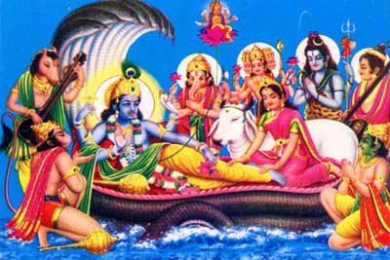
Thereafter, the object of speech, along with the sense of speech [the tongue], should be bestowed upon fire. Craftsmanship and the two hands should be given to the demigod Indra. The power of movement and the legs should be given to Lord Visnu. Sensual pleasure, along with the genitals, should be bestowed upon Prajapati. The rectum, with the power of evacuation, should be bestowed, in its proper place, unto Mrtyu. The aural instrument, along with sound vibration, should be given to the deities presiding over the directions. The instrument of touch, along with the sense objects of touch, should be given to Vayu. Form, with the power of sight, should be bestowed upon the sun. The tongue, along with the demigod Varuna, should be bestowed upon water, and the power of smell, along with the two Asvini-kumara demigods, should be bestowed upon the earth.
mano manorathais candre
buddhim bodhyaih kavau pare
kamaany adhyatmana rudre
yad-aham mamata-kriya
sattvena cittam ksetra jne
gunair vaikarikam pare
apsu ksitim apo jyotisy
ado vayau nabhasy amum
kutasthe tac ca mahati
tad avyakte 'ksare ca tat
The mind, along with all material desires, should be merged in the moon demigod. All the subject matters of intelligence, along with the intelligence itself, should be placed in Lord Brahma. False ego, which is under the influence of the material modes of nature and which induces one to think, "I am this body, and everything connected with this body is mine," should be merged, along with material activities, in Rudra, the predominating deity of false ego. Material consciousness, along with the goal of thought, should be merged in the individual living being, and the demigods acting under the modes of material nature should be merged, along with the perverted living being, into the Supreme Being. The earth should be merged in water, water in the brightness of the sun, this brightness into the air, the air into the sky, the sky into the false ego, the false ego into the total material energy, the total material energy into the unmanifested ingredients [the pradhana feature of the material energy], and at last the ingredient feature of material manifestation into the Supersoul.

Deva-sarga (the creation of demigods)
includes eight kinds of entities
as described in Bhag. 3. 10. 28-29
deva-sargas casta-vidho
vibudhah pitaro 'surah
gandharvapsa rasah siddha
yaksa-raksamsi caranah
bhuta-preta-pisacas ca
vidyadhrah kinnaradayah
dasaite vidurakhyatah
sargas te visva-srk-krtah
The creation of the demigods is of eight varieties: (1) the demigods, (2) the forefathers, (3) the asuras, or demons, (4) the Gandharvas and Apsaras, or angels, (5) the Yaksas and Raksasas, (6) the Siddhas, Caranas and Vidyadharas, (7) the Bhutas, Pretas and Pisacas, and (8) the superhuman beings, celestial singers, etc. All are created by Brahma, the creator of the universe.
The perverted conception (vaikarika) of the living entity exists under the spell of the modes of material nature. The universal demigods are manifest within those modes and thus are present and active even within the gross and subtle embodiment of the individual living being. When we say "the demigods" their counterparts in opposition, the demons, are also included. Hence the personified forces of good and evil wage their cosmic struggles with one another within the body and mind of every person in this world. | 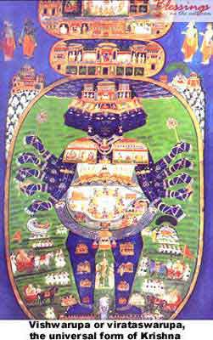
The local cosmos of an individual's body and mind, and the greater cosmos of the virat , are features of Lord Krsna's Visvarupa, His universal form. This means that each of us is always with Krsna, whether we be "good" or "bad" or "inbetween. " Good and bad are relavent to the modes of material nature ( sattva-guna , tamo-guna and rajo-guna ). From Krsna's standpoint we are neither good nor bad, but are His eternal parts and parcels, pure spirit souls and perfect, though tiny, samples of His transcendental essence.
However, we can only take comfort in this, our true non-material identity, if we strive to be Krsna conscious. If we sluggishly stick to material consciousness, then we must accept the consequence of that choice. We must accept the perverted conception of identity, described above by Srimad-Bhagavatam , and we must accept all the miseries that follow that perverted conception in the flow of time.
Being Krsna conscious means not to wait for some future apocalypse of divine intervention in the greater universe. It means to act now in terms of our own local universe of the body and mind. We should evoke the Lord's presence in our life. We should chant: Hare Krsna Hare Krsna Krsna Krsna Hare Hare/Hare Rama Hare Rama Rama Rama Hare Hare. As Krsna makes His presence known to us, the effects of our long association with the material modes diminishes to zero. At that zero-point of material influence on consciousness, there is no more doubt that everything in existence is really only the all-blissful Sri Krsna and His divine energy.

Die Before Dying
Just as there is life, there is death. Someone or something takes birth, grows, stays for some time, deteriorates, and then dies. Another name for birth is death. You cannot have one without the other, meaning that when someone is born, someone will soon die (as most species do not live very long);
and when someone dies, someone is soon born. Everyone and everything in its normal state wants to live as long as possible—eternally. Eternality, however, is not associated with matter, but is a spiritual affair. Death to matter and to our material bodies is inevitable, but if we master the science of dying before dying, we will connect with that which is eternal—our soul and its home in the spiritual world. After all, death is to remove everything false and secondary.
My mother, who is deceased, often used to say, "Give me my flowers while I can still see them. " As I child, I thought of it as strange, but as an adult, I thought of it as a sign of wisdom. My mother understood the body to be transient and she celebrated life—"the now," realizing one must show their love and affection for life at every moment. Our life or the lives of others will be taken away in the near future. If one lives with proper preparation and detachment, one will master the science of dying before dying so as to connect with the soul and its home—the spiritual world. After all, death is to remove everything false and secondary.
When we die before dying, we put first things first. The activities that nourish our souls and help us detach from the illusion and confusion of material culture are our priorities. Since we know that life is meant to prepare for a glorious death, we can live each day as if it is our last. Therefore, there is no time to waste on irrelevant, superfluous activities. Even when we must give time to somewhat superficial things, it must be done in a way that enhances or strengthens the primary, significant involvements. If one lives with proper
preparation and detachment, one will master the science of dying before dying so as to connect with the soul and its home—the spiritual world. After all, death is to remove everything false and secondary.
There are so many offenses that can be made in devotional services. It is these offenses which are our greatest enemy. Devotional service is extremely potent, but offenses can stagnate our spiritual growth very seriously and can ever destroy the devotional creeper. Offenses are activities that try to redirect our consciousness back to previous sinful life or which serve as barriers to our unfoldment. Offenses are like a town courier who delivers an urgent message designed to distract the individual from his or her relevant
and important activities. When one stops making offenses, one will live with proper preparation and detachment. One will master the science of dying before dying so as to connect with the soul and its home—the spiritual world. After all, death is to remove everything false and secondary.
So many people have cheated, disappointed, lied, manipulated, and even abused us. When we reflect on the experience, it is as if we relive it again. Such experiences have definitely shaped us in various ways. Many of
these abusers and cheaters have traumatized us. In some cases, they have scarred us for life. The normal position is for the hurt or abused to seek revenge and severely punish the offender. It is easier to do but will not fully resolve the problem. What is important is for forgiveness to be the major means of addressing such problems. If one lives with proper preparation and detachment, one will master the science of dying before dying so as to connect with the soul and its home—the spiritual world. After all, death is to remove everything false and secondary.
Most people have special friends they would like to meet, places they would like to visit, and experiences they would like to have. When we meet, know, or associate with important people, it makes us more important, at least in the eyes of others. When we can travel to many exciting places, life seems to be more adventurous. Most important, when we can have many exciting experiences, life seems more meaningful. We are all pleasure seekers and are always eager to experience pleasure. But the true spiritualist does
not get overwhelmed by these concerns for he understands the temporary and even illusory nature of the world. If one lives with proper preparation and detachment, one will master the science of dying before dying so as to connect with the soul and its home—the spiritual world. After all, death is to remove everything false and secondary.
Sometimes we are so busy doing things and even doing things for those we love that we don't have time to be with them, show them, or tell them how much we love them. Sometimes others are so busy doing things and doing things for us that they also have no time to be with us, show us, or tell us how much they love us. However, if we truly understand how this life is a preparation for death, we will always have time to give and receive love.
When someone dies, much of the sadness usually comes from a lack of sufficient closure in the relationships. There is something we wanted to tell them or do with them, and there is something they wanted to tell us or
do with us. Each party has a tendency to procrastinate on or minimize the important opportunities and moments. Especially when a person lives solely for eating, sleeping, mating and defending, or when he or she is captured by a very strong false ego, there is a tendency to miss opportunities to be fully present. The person misses the chance to say or do what will best honor other people's highest needs as well as blocks the chance for others to honor his or her needs.
Quality association is most important. Where there is quality association, one is always either learning something or teaching something. Such association is based on being with those who also are determined to end the cycle of birth, disease, old age, and death. With quality association, one understands that just as there is life, there is death. So one acts with the knowledge that life is for self-realization, and that death, which is inevitable for matter and the material body, is not associated with the soul. We must die to live! That comes as we accept the inevitability of destruction and elimination of all matter. We can then honor the deaths that have happened and those that are manifesting, knowing that they can prepare the way for eternal life.
The true spiritualist profoundly appreciates my mother's statement,"Give me my flowers while I can see them. " For once the body is gone, the soul departs for its new encounter; therefore, it is important to say and do whatever is best for all now! Where we have made offenses, we must stop them and ask for forgiveness now! While we have people to meet, places to visit, and experiences to have, we must put first things first, understanding the differences between what is temporary and what is eternal now! We must allow every day of our lives to represent healthy closure now! When we live for love, this is most natural because all of our associations will be quality associations in which we share our compassion, determination, and realizations, and receive the same from others.
This is the technology of how to celebrate life now and live with proper preparation and detachment, so that one will master the science of dying before dying so as to connect with the soul and its home—the spiritual
world. After all, death is to remove everything false and secondary.
I am that lowly beggar who is desperately trying to die before dying.

Helsinki, Finland
6 November 2004
Prayers in worship of Lord Caitanya and Lord Nityananda
(a) svardhunyas caru-tire sphuritam ati-brhat-kurma- prsthabha-gatram
ramyaramavrtam san-mani-kanaka-mahasadma-sanghaih paritam
nityam pratyalayodyat-pranaya-bhara-lasat-krsna- sankirtanadhyam
sri-vrndatavy-abhinnam tri-jagad-anupamam sri- navadvipam ide
"I praise that holy dhama, Navadvipa, which, being entirely non-different from Sri Vrndavana, is completely different from the material world consisting of the three planetary systems. It is situated on the gorgeous banks of the Ganges covered by beautiful groves and gardens appearing in form like the back of a gigantic turtle. There are situated there many great palatial houses made of gold bedecked with brilliant jewels, where krsna-sankirtana is always being performed in the mellow of ecstatic love. "
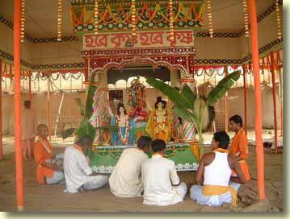
Then, by chanting the following mantra, one should meditate on Sri Caitanya Mahaprabhu who is seated on a golden throne at the Yogapitha, His birthplace in Mayapur:
sriman-mauktikadama-baddha-cikuram susmera-candrananam
sri-khandaguru-caru-citra-vasanam srag-divya-bhusancitam
nrtyavesa-rasanumoda-madhuram kandarpa-vesojjvalam
caitanyam kanaka-dyutim nija-janaih samsevyamanam bhaje
"I worship Sri Caitanya Mahaprabhu, who is being served by all His devotees and associates; whose hair is bound with strings of pearls; on whose moonlike face is the nectar of His gentle smile. His beautiful golden body is covered with lovely garments, smeared with sandalwood and aguru, and decorated with garlands and various shining ornaments. He is so charming, being absorbed as He is in the enjoyment of sweet mellows in dancing, and is more splendid in His dress than even Cupid himself. "
(b) yad advaitam brahmopanisadi tad apy asya tanu-bha
ya atmantaryami purusa iti so 'syamsa-vibhavah
sad-aisvaryaih purno ya iha bhagavan sa svayam ayam
na caitanyat krsnaj jagati para-tattvam param iha (Cc. Adi. 1. 3)
"What the Upanisads describe as the impersonal Barhman is but the effulgence of His body, and the Lord known as the Supersoul is but His localized plenary portion. He is the Supreme Personality of Godhead, Krsna Himself, full with six opulences. He is the Absolute Truth, and no other truth is greater than or equal to Him. "
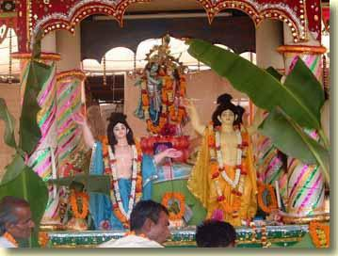
anarpita-carim cirat karunayavatirnah kalau
samarpayitum unnatojjvala-rasam sva-bhakti-sriyam
harih purata-sundara-dyuti-kadamba-sandipitah
sada hrdaya-kandare sphuratu vah sacinandanah (Cc. Adi. 1. 5)
"The loving affairs of Sri Radha and Krsna are transcendental manifestations of the Lord's internal pleasure-giving potency. Although Radha and Krsna are one in Their identity, They have separated Themselves eternally. Now these two transcendental identities have again united in the form of Sri Krsna Caitanya. I bow down to Him, who has manifested Himself with the sentiment and complexion of Srimati Radharani although He is Krsna Himself. "
sri-radhayah pranaya-mahima kidrso vanayaiva-
svadyo yenadbhuta-madhurima kidrso va madiyah
saukhyam casya mad-anubhavatah kidrsam veti lobhat
tad-bhavadhyah samajani saci-garbha-sindhau harinduh (Cc. Adi. 1. 6)
"Desiring to understand the glory of Radharani's love, the wonderful qualities in Him that She alone relishes through Her love and the happiness She feels when She realizes the sweetness of His love, the Supreme Lord Hari, richly endowed with Her emotions, appears from the womb of Srimati Sacidevi, as the moon appears from the ocean. "
dhyeyam sada paribhava-ghnam abhista-doham
tirthaspadam siva-virinci-nutam saranyam
bhrtyarti-ham pranata-pala-bhavabdhi-potam
vande mahapurusa te caranaravindam
"O Supreme Personality of Godhead, O protector of the surrendered souls, You are now playing the role of Your own devotee, and Your lotus feet are the only object of perpetual meditation for the pure living entities. They destroy the material existence of the living entity. They are the fulfiller of all desires, the abode of all holy places, worshipable even by Lord Brahma and Lord Siva, the shelter of all that exists, the destroyer of the troubles of Your devotees and the only boat for crossing over the ocean of material existence. Therefore I offer my obeisances unto Your lotus feet. "
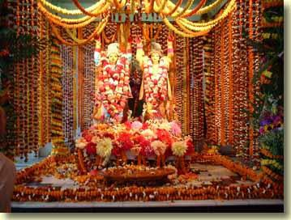
tyaktva sudustyaja-surepsita-rajya-laksmim
dharmistha arya-vacasa yad agad aranyam
maya-mrgam dayitayepsitam anvadhavad
vande mahapurusa te caranaravindam (SB 11. 5. 34)
"O Mahaprabhu, You have given up the goddess of fortune (Your wife), whose glance is desired by the great demigods and who is the most difficult attachment to renounce. In order to keep the word of some brahmana's curse, You have gone to the forest. Thus to show Your great mercy to the helpless living entities who are following maya - the illusory energy - You have chased after them to give them Your own devotional service. Therefore I offer my humble obeisances unto Your lotus feet. "
panca-tattvatmakam krsnam
bhakta-rupa-svarupakam
bhaktavataram bhaktakhyam
namami bhakta-saktikam (Cc. Adi. 1. 14)
"I bow down to Lord Krsna, who appears as a devotee (Lord Caitanya), as His personal expansion (Sri Nityananda), His incarnation (Sri Advaita), His devotee (Sri Srivasa), and His energy (Sri Gadadhara), and who is the source of strength for the devotees. "
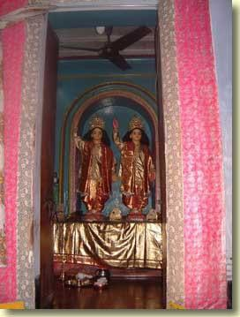
ananda-lilamaya-vigrahaya
hemabha-divyac-chavi-sundaraya
tasmai maha-prema-rasa-pradaya
caitanya-candraya namo namas te (Caitanya-candramrta)
"Obeisances unto Him, Sri Caitanya-candra, the giver of the mellow of the highest love of Godhead, who is the embodiment of blissful pastimes, and who is so beautiful, having a dazzing lustre, like gold. "
namo maha-vadanyaya
krsna-prema-pradaya te
krsnaya krsna-caitanya-
namne gaura-tvise namah (Cc. Madhya 19. 53)
"O most munificent incarnation! You are Krsna Himself appearing as Sri Krsna Caitanya Mahaprabhu. You have assumed the golden colour of Srimati Radharani, and You are widely distributing pure love of Krsna. We offer our respectful obeisances unto You. "
nityanandam aham naumi
sarvananda-karam param
hari-nama-pradam devam
avadhuta-siromanim
"I bow down to the Supreme Lord Nityananda Prabhu, who is the awarder of the highest joy to all, the bestower of the holy name and the crest jewel of all paramahamsa mendicants. "
sankarsanah karana-toya-sayi
garbhoda-sayi ca payobdhi-sayi
sesas ca yasyamsa-kalah sa nitya-
nandakhya-ramah saranam mamastu (Cc. Adi. 1. 7)
"May Sri Nityananda Rama be the object of my constant remembrance. Sankarsana, Sesa Naga and the Visnus who lie on the Karana Ocean, Garbha Ocean and ocean of milk are His plenary portions and the portions of His plenary portions. "
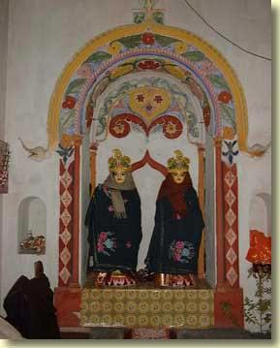
mayatite vyapi-vaikuntha-loke
purnaisvarye sri-catur-vyuha-madhye
rupam yasyodbhati sankarsanakhyam
tam sri-nityananda-ramam prapadye (Cc. Adi. 1. 8)
"I surrender unto the lotus feet of Sri Nityananda Rama, who is known as Sankarsana in the midst of the catur-vyuha (consisting of Vasudeva, Sankarsana, Pradyumna and Aniruddha). He possesses full opulences and resides in Vaikunthaloka, far beyond the material creation. "
maya-bhartajanda-sanghasrayangah
sete saksat karanambhodhi-madhye
yasyaikamsah sri-puman adi-devas
tam sri-nityananda-ramam prapadye (Cc. Adi. 1. 9)
"I offer my full obeisances unto the feet of Sri Nityananda Rama, whose partial representation called Karanodakasayi Visnu, lying on the Karana Ocean, is the original purusa, the master of the illusory energy, and the shelter of all the universes. "
yasyamsamsah srila-garbhoda-sayi
yan-nabhy-abjam loka-sanghata-nalam
loka-srastuh sutika-dhama dhatus
tam sri-nityananda-ramam prapadye (Cc. Adi. 1. 10)
"I offer my full obeisances unto the feet of Sri Nityananda Rama, a partial part of whom is Garbhodakasayi Visnu. From the navel of Garbhodakasayi Visnu sprouts the lotus that is the birthplace of Brahma, the engineer of the universe. The stem of that lotus is the resting place of the multitude of planets. "
yasyamsamsamsah paratmakhilanam
posta visnur bhati dugdhadbhi-sayi
ksauni-bharta yat-kala so 'py anantas
tam sri-nityananda-ramam prapadye (Cc. Adi. 1. 11)
"I offer my respectful obeisances unto the feet of Sri Nityananda Rama, whose secondary part is the Visnu lying in the ocean of milk. That Ksirodakasayi Visnu is the Supersoul of all living energies and the maintainer of all the universes. Sesa Naga is His further sub-part. "
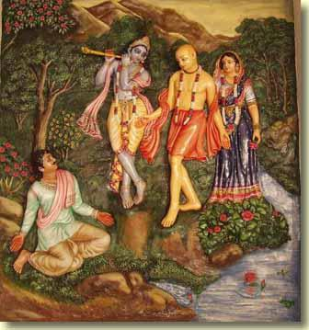
vande-sri-krsna-caitanya-
nityanandau sahoditau
gaudodaye puspavantau
citrau sandau tamo-nudau (Cc. Adi. 1. 2)
"I offer my respectful obeisances unto Sri Krsna Caitanya and Lord Nityananda, who are like the sun and moon. They have arisen simultaneously on the horizon of Gauda to dissipate the darkness of ignorance and thus wonderfully bestow benediction upon all. "
sri-krsna-caitanya prabhu-nityananda
sri advaita gadadhara srivasadi-gaura-bhakta-vrnda hare krsna hare krsna krsna krsna hare hare
hare rama hare rama rama rama hare hare
----------------------
Dear Godfamily, friends and well wishers,
Please accept our most humble obeisances
All glories to our beloved Gurumaharaja
All glories to ISKCON Founder Acharya Srila Prabhupada
A few days ago Gurumaharaja gave me a health update that was posted by Lila Katha, I wanted to follow up just to keep all of you informed about his daily challenges. Today was the 8th day of Kartikka and each day brought a different unfoldment for us in our service as care givers for Gurumaharaja. I mentioned in the last update that his foot was swollen, during the last few days, he was intensely naseous, for several days he ate very little, his glucose reading was very high, his stomach was cramping, his eyes and hands started turning yellow, we thought he was jaundiced so we took him to get a blood test, two days later, we were informed that his blood test was clear --no jaundice. A day or so later his face got swollen, Ekavira prabhu took him to a dentist, the dentist informed us that he had an infection in his tooth, so a minor operation wa performed for draining the fluid from his tooth, the next day he saw an accupunturist. yesterday morning, he suddenly had an attack almost like a seizure, his body was shaking violently, and his teeth was chattering non stop. Ekavira Prabhu rushed him to the hospital which is about 20mins from us (he later told me he made it there in 10mins) he immediately took him to the emmergency room, we later learned that he had a fever of 104 and that the infection may have gone into his blood. the doctor had to do a culture to see if the infection had got to his catharer. He was admitted to the hospital, it is a reputable one, small only 30 beds, and the doctor that cared for him in the emmergency had visisted Vrindavana, so we felt a little comfortable with him being attentive to Gurumaharaja. Presently he is in the hospital, tomorrow we should have the results of the culture. Last night he had a few visitors, Mahesh Prabhu and his wife Brhan, long time residents of New Vrindavan, Vidagha Madhava Prabhu and his wife, Prema , she actually works in the same hospital, we met her when we took Gurudeva to get the blood test several days before (actually this meeting is a sweet story, maybe in the next report when I have a little more time I will share this story) Pariksit Prabhu( one of the first artist, you can see his paintings in many Temples) and his wife Suzy. This was really nice for Gurumaharaj, he was sharing his health adventure with them. Today we stayed at the hospital most of the afternoon, he is a little rested and of course ready to leave. We all agrees that it is best for him to hear from the doctor tomorrow. about the status of the culture before he leaves. He agreed, (thank you Krsna) OF course spiritually Gurumaharaja is great, he says he is adjusting to the physical roller coaster of the body's challenges. Ekavira Prabhu and I are leaning how to see Krsna's hands in every situation, and to really take shelter of this wonderful month of Damodara, and of course all the wonderful Vaisnavas. Srila Prabhupada's Malati has been calling and encouraging us in our service, we thank you. HH Radanatha Maharaja called early this morning to speak with Gurumaharaja, fortunately for us we got the mercy. Ananda Vrindavana, the day Gurumaharaj went into the hospital, was the same day we received your gift for him from Mexico. We had ordered a shipment of medications and the package was in the big box of medications. It was so wonderful when we opened the package for him in the hospital and to our surprise see three large posters of Ugra Nrsingha from Mayapura with the back signed with loving words from all the devotees there in Croatia and Bosnia. This was most auspicious, and Gurumaharaja was so happy, he said he would read all of the writings when we left that night. Thank you Ananda for your thoughtfulness, even though it took almost 8 weeks, it came at just the right time. Krsna's hands is in everything. Kalpavrksa Prabhu and Lagimma Siddhi, for about two weeks, everyday when I chant my rounds, you both come into my thoughts, both Ekavira and I have so much love and respect for both of you, sometimes when we think of how much love Gurumaharaja has for both of you and how you both are always finding different ways to reciprocate, we feel most fortunate to be able to have both of your associations, even if now it can only be in the thoughts. Again and again, we want to thank all of the devotees that are praying and assisting with Gurudeva's ongoing health needs.
Jai Sri Damodara
Your aspiring servants
With Love
Ekavira and Vrajalila

Helsinki, Finland
7 November 2004
Scientific Quotations
on Darwin's Theory of Evolution
As far as I know, the quotations below originate in the pro-evolution camp, except for the very few labeled "Creationist". . .
"Despite the bright promise that paleontology provides a means of 'seeing' evolution, it has presented some nasty difficulties for evolutionists, the most notorious of which is the presence of 'gaps' in the fossil record. Evolution requires intermediate forms between species and paleontology does not provide them . . . "
David B. Kitts, PhD (Zoology)
Head Curator, Dept of Geology, Stoval Museum
Evolution, vol 28, Sep 1974, p 467
"The curious thing is that there is a consistency about the fossil gaps; the fossils are missing in all the important places. "
Francis Hitching
The Neck of the Giraffe or Where Darwin Went Wrong
Penguin Books, 1982, p. 19
"The absence of fossil evidence for intermediary stages between major transitions in organic design, indeed our inability, even in our imagination, to construct functional intermediates in many cases, has been a persistent and nagging problem for gradualistic accounts of evolution. "
Stephen Jay Gould, Prof of Geology and
Paleontology, Harvard University
"Is a new general theory of evolution emerging?"
Paleobiology, vol 6, January 1980, p. 127
". . . Yet Gould and the American Museum people are hard to contradict when they say there are no transitional fossils . . . I will lay it on the line, there is not one such fossil for which one could make a watertight argument. "
Dr. Colin Patterson, Senior Paleontologist,
British Museum of Natural History, London
As quoted by: L. D. Sunderland
Darwin's Enigma: Fossils and Other Problems
4th edition, Master Books, 1988, p. 89
"We do not have any available fossil group which can categorically be claimed to be the ancestor of any other group. We do not have in the fossil record any specific point of divergence of one life form for another, and generally each of the major life groups has retained its fundamental structural and physiological characteristics throughout its life history and has been conservative in habitat. "
G. S. Carter, Professor & author
Fellow of Corpus Christi College
Cambridge, England
Structure and Habit in Vertebrate Evolution
University of Washington Press, 1967
"The history of most fossil species includes two features inconsistent with gradualism: 1. Stasis. Most species exhibit no directional change during their tenure on earth. They appear in the fossil record looking much the same as when they disappear . . . 2. Sudden Appearance. In any local area, a species does not arise gradually by the steady transformation of its ancestors; it appears all at once and 'fully formed'. "
Stephen Jay Gould, Prof of Geology and
Paleontology, Harvard University
Natural History, 86(5):13, 1977
"But, as by this theory innumerable transitional forms must have existed, why do we not find them embedded in countless numbers in the crust of the earth?" (p. 206)
"Why then is not every geological formation and every stratum full of such intermediate links? Geology assuredly does not reveal any such finely graduated organic chain; and this, perhaps is the most obvious and gravest objection which can be urged against my theory (of evolution). " (p. 292)
Charles Darwin
The Origin of Species, 1st edition reprint
Avenel Books, 1979
"Darwin. . . was embarrassed by the fossil record. . . we are now about 120-years after Darwin and the knowledge of the fossil record has been greatly expanded. We now have a quarter of a million fossil species but the situation hasn't changed much. The record of evolution is still surprisingly jerky and, ironically, . . . some of the classic cases of Darwinian change in the fossil record, such as the evolution of the horse in North America, have had to be discarded or modified as a result of more detailed information. "
David M. Raup, Curator of Geology
Field Museum of Natural History, Chicago
"Conflicts Between Darwin and Paleontology"
Field Museum of Natural History
Vol. 50, No. 1, (Jan, 1979), p. 25
"Now, after over 120 years of the most extensive and painstaking geological exploration of every continent and ocean bottom, the picture is infinitely more vivid and complete than it was in 1859. Formations have been discovered containing hundreds of billions of fossils and our museums are filled with over 100-million fossils of 250,000 different species. The availability of this profusion of hard scientific data should permit objective investigators to determine if Darwin was on the right track. What is the picture which the fossils have given us? . . . The gaps between major groups of organisms have been growing even wide and more undeniable. They can no longer be ignored or rationalized away with appeals to imperfection of the fossil record. "
Luther D. Sunderland, Creationist
Darwin's Enigma: Fossils and Other Problems,
4th edition, Master Books, 1988, p. 9
"My attempts to demonstrate evolution by an experiment carried on for more than 40 years have completely failed. . . . The fossil material is now so complete that it has been possible to construct new classes, and the lack of transitional series cannot be explained as being due to the scarcity of material. The deficiencies are real, they will never be filled. "
Prof N. Heribert Nilsson
Lund University, Sweden
Famous botanist and evolutionist
As quoted in: The Earth Before Man, p. 51
"The family trees which adorn our text books are based on inference, however, reasonable, not the evidence of fossils. "
Stephen Jay Gould, Prof of Geology and
Paleontology, Harvard University
"Evolution's Erratic Pace"
Natural History, May, 1977, p. 13
". . . if man evolved from an apelike creature he did so without leaving a trace of that evolution in the fossil record. "
Lord Solly Zuckerman, MA, MD, DSc (Anatomy)
Prof. of anatomy, University of Birmingham
Chief scientific advisor, United Kingdom
Beyond the Ivory Tower
Taplinger Publishing Company, 1970, p 64
"The entire hominid (a so-called 'ape-man' fossil) collection know today would barely cover a billiard table. . . Ever since Darwin. . . preconceptions have led evidence by the nose in the study of fossil man. "
John Reader
"Whatever Happened to Zinjanthropus?
New Scientist, March 26, 1981, pp. 802-805
"The fossils that decorate our family tree are so scarce that there are still more scientists than specimens. The remarkable fact is that all the physical evidence we have for human evolution can still be placed, with room to spare, inside a single coffin. "
"Modern apes, for instance, seem to have sprung out of nowhere. They have no yesterday, no fossil record. And the true origin of modern humans -- of upright, naked, tool-making, big-brained beings -- is, to be honest with ourselves, an equally mysterious matter. "
Dr. Lyall Watson
"The Water People"
Science Digest, May 1982, p 44.
"The fossil record pertaining to man is still so sparsely known that those who insist on positive declarations can do nothing more than jump from one hazardous surmise to another and hope that the next dramatic discovery does not make them utter fools. . . As we have seen, there are numerous scientists and popularizers today who have the temerity to tell us that there is 'no doubt' how man originated. If only they had the evidence. . . "
William R. Fix
The Bone Peddlers (Macmillan, 1984), pp. 150
"A five million year old piece of bone that was thought to be a collarbone of a humanlike creature is actually part of a dolphin rib. . . The problem with a lot of anthropologists is that they want so much to find a hominid that any scrap of bone becomes a hominid bone. "
Dr. Tim White
Evolutionary anthropologist
University of California at Berkeley
New Scientist, April 28, 1983, p. 199
". . . not being a paleontologist, I don't want to pour too much scorn on paleontologists, but if you were to spend your life picking up bones and finding little fragments of head and little fragments of jaw, there's a very strong desire to exaggerate the importance of those fragments. . . "
Greg Kerby
From an address to the Biology Teachers
Association of South Australia, 1976
"Echoing the criticism made of his father's Homo habilis skulls, he (Richard Leakey) added that Lucy's skull was so incomplete that most of it was 'imagination, made of plaster of paris,' thus making it impossible to draw any firm conclusion about what species she belonged to. "
Richard Leakey (Son of Louis Leakey)
Director of National Museums of Kenya, Africa
The Weekend Australian, May 7-8, 1983, p. 3
"The evidence given above makes it overwhelmingly likely that Lucy was no more than a variety of pygmy chimpanzee, and walked the same way (awkwardly upright on occasions, but mostly quadrupedal). The 'evidence' for the alleged transformation from ape to man is extremely unconvincing. "
Albert W. Mehlert, Creationist and Former
Evolutionist & paleoanthropology researcher
"Lucy - Evolution's Solitary Claim for Ape/Man"
Creation Research Society Quarterly,
Vol 22, No. 3, (Dec 1985), p. 145
"In recent years several authors have written popular books on human origins which are based more on fantasy and subjectivity than on fact and objectivity. . . by and large, written by authors with a formal academic background. . . Prominent among them were On Aggression by Konrad Lorenz, The Naked Ape and The Human Zoo by Desmond Morris. . . " (p. 283)
"Yet the tendency for individual paleontologists to trace human history directly back to their own fossil finds has persisted to the present day. " (p. 285)
"So one is forced to conclude that there is no clear cut scientific picture of human evolution. " (p. 285)
Dr. R. Martin, Senior Research Fellow
Zoological Society of London
"Man is Not an Onion"
New Scientist, Aug 4, 1977
"The paleontologists have convinced me small changes do not accumulate. "
Francisco Ayala, Ph. d
Assoc Professor of Genetics, U of California
"Evolutionary theory under fire"
Science, Nov 21, 1980. p 883-887
"Evolutionism is a fairy tale for grown-ups. This theory has helped nothing in the progress of science. It is useless. "
Prof. Louis Bounoure, Former:
President Biological Society of Strassbourg,
Director of the Strassbourg Zoological Museum,
Director of Research at the
French National Centre of Scientific Research
The Advocate, March 8, 1984, p. 17
"We are told dogmatically that Evolution is an established fact; but we are never told who has established it, and by what means. We are told, often enough, that the doctrine is founded upon evidence, and that indeed this evidence 'is henceforward above all verification, as well as being immune from any subsequent contradiction by experience'; but we are left entirely in the dark on the crucial question wherein, precisely, this evidence consists. "
Wolfgang Smith, Mathematician and Physicist
Prof. of Mathematics, Oregon State University
Former math instructor at MIT
Teilhardism and the New Religion:
A Thorough Analysis of the Teachings of de Chardin
Tan Books & Publishers, 1988, pp. 1-2
"Scientists who go about teaching that evolution is a fact of life are great con-men, and the story they are telling may be the greatest hoax ever. In explaining evolution we do not have one iota of fact. "
Dr. T. N. Tahmisian, Physiologist
Atomic Energy Commission. As quoted in:
Evolution and the Emperor's New Clothes,
3D Enterprises Limited, 1983, title page
"One is forced to conclude that many scientists and technologists pay lip-service to Darwinian theory only because it supposedly excludes a Creator. . . "
Dr. Michael Walker
Senior Lecturer, Anthropology, Sydney University
Quadrant, Oct 1982, p. 44
". . . every single concept advanced by the theory of evolution (and amended thereafter) is imaginary as it is not supported by the scientifically established facts of microbiology, fossils, and mathematical probability concepts. Darwin was wrong. " (p. 209)
". . . The theory of evolution may be the worst mistake made in science. " (p. 210)
I. L. Cohen, Mathematician, Researcher, Author,
Member New York Academy of Sciences
Officer of the Archaeological Institute of America
Darwin Was Wrong - A Study in Probabilities
"Nine-tenths of the talk on Evolution is sheer nonsense, not founded on observation and wholly unsupported by facts. This museum is full of proofs of the utter falsity of their views. In all this great museum, there is not a particle of evidence of the transmutation of species".
Dr Etheridge, paleontologist of the British museum.
"If pressed about man's ancestry, I would have to unequivocally say that all we have is a huge question mark. To date, there has been nothing found to truthfully purport as a transitional specie to man, including Lucy, since 1470 was as old and probably older. If further pressed, I would have to state that there is more evidence to suggest an abrupt arrival of man rather than a gradual process of evolving".
Richard Leakey, world's foremost paleoanthropologist,
in a PBS documentary, 1990.

Wroclaw, Poland
8 November 2004
A letter about the 5th Canto description
of the universe
For many devotees the description of the universe in the 5th Canto of Srimad-Bhagavatam is very difficult to understand. I have a strong desire to understand the universal functions. I did a research about that. The result you can read in short words below.
My intention is to help people and the devotees to understand our philosophy, specially this point since it is very complicated.
If it is possible, please write to me what you think about the description and point out the mistakes I made.
According to the vedic writings, our universe is only one of many. These universes originate at the pores of Mahavishnu, which is a partial extension of God. When He breathes out, they come into existance, and when He inhales, they are again destroyed.
The energy that constitutes the universe is eternal. When it is withdrawn into the pores of the Lord, that energy resumes its pradhana state, which is of an unperceived nature, devoid of qualities. When the Lord breathes out, this energy expands with His breath, assuming the three material qualities. It is then known as guna-prakrti.
Each universe is egg-shaped, filled half-way with water and surrounded by eight layers: earth, water, fire, air, ether and three subtle elements. Each layer is 10 times as thick as the previous layer.
In Srila Prabhupada's translation of Bhag. 3. 26. 52, only 6 layers are indicated. In other places, 7 are counted. Where do you find reference to 8 layers?
The center of each universe is a golden mountain called Sumeru (Meru) which appears as a giant, upside-down golden pyramid standing on its tip. Meru, a Sanskrit term, translates "pyramid". It stands in the center of squarely arranged mountain ranges on a central circular island, which is surrounded by a circular ocean. This ocean is enclosed again by a circular island, etc. .
Are you sure about this translation you've given for meru? I find no such meaning as "pyramid" for meru in the Monier-Williams Sanskrit Dictionary.
Altogether seven islands and seven oceans surround the central island, and each ocean is just as broad as the island, which it surrounds. Each island is twice as broad as the previous, and on each of the islands seven golden mountains stand.
I believe you are mistaken that the 7 mountains on each dvipa are golden. To my knowledge, only Mount Sumeru is golden.
According to the vedic writings, only one galaxy and one sun exist in our universe.
Sumeru and the golden mountains on the seven islands work like an enormous mirror cabinet and are not directly visible to the human eye. We see this galaxy from many different angles and it also appears in many different sizes on account of the multiple reflecitons caused by the golden mountains. We conclude that there are, then, innumerable galaxies. In reality, however, these are only deceptive images. The whole thing with the circularly arranged mountains and Sumeru in the center resembles a golden lotus flower, whose seven islands are like the surrounding soil. In it, innumerable planets circle around, which are maintained in their courses by a cosmic wind.
As in a tornado water and dust particles whirl up, so the planets whirl by cosmic winds carried around mount Meru, and form our galaxy. Scientists designate this as the milky way.
Contrary to other planets, the sun moves around Sumeru on an axle with one wheel, like a one-wheeled chariot.
On one extreme, the seventh island is a high, closed mountain range, on whose burr as in a rail the enormous wheel of the axle runs. The other end the axle rests on top of Sumeru. The sun resides at the center of the axle.
I believe the mountain range upon which the wheel runs is called Manasottara; it is located on Puskaradvipa, the sixth circular island surrounding Mount Sumeru.
The golden mountains on the seven different islands focus the sunlight on Sumeru. The golden Sumeru reflects the focused light on the mountain ranges which are arranged in a square at its base. These ranges absorb the extreme heat and deliver it to the surrounding environment. Because of this, an upwind develops, causing an area of low pressure at Sumeru's base. This negative pressure seeks to right itself and causes a strong descending wind, which manifests itself in form of an enormous whilrwind. This whirlwind maintains the rotation of our galaxy and also of Sumeru , which is connected with the sun by the one wheel axle.
Briefly stated, the sun causes the whirlwind, which likewise carries all the planets, and so the drive for the movement is the sun itself.
This is a mechanistic description of phenomena. The famous 19th-century British scientist Lord Kelvin (William Thomson, 1824-1907), said in his Baltimore Lectures:
I never satisfy myself until I can make a mechanical model of a thing. If I can make a mechanical model I can understand it. As long as I cannot make a mechanical model all the way through, I cannot understand.
The picture you offer of sunshine-absorbing mountains that cause a whirlwind that moves the planets around is not what the 5th Canto Bhagavatam actually states in plain words. Your picture is a mechanistic model that you've imagined to help yourself understand the 5th Canto. But Vedic science is not, at the end of the day, mechanistic. It is personal.
In the Vedic scriptures physical forces are understood to be indicators of personality. The sunshine is an indicator of the demigod Surya. The wind is an indicator of the demigod Vayu. Such demigods are empowered representatives of the Supreme Person, Sri Krsna. On the contrary, mechanistic explanations are impersonal. Lord Kelvin's admission that he could not understand phenomena unless it be explained by a mechanical model reveals a bias in his thinking, a bias in favor of impersonalism.
In Gita Krsna declares the impersonalists to be less intelligent. Of course, impersonalists argue that personalism is less intelligent because it is too easy. But in fact an explanation that is at once the easiest and the most correct is always accepted by intelligent people as the best. The mechanistic approach can never be the easiest nor most correct. In its building of a conceptual machine to explain nature, it is complicated. At the same time, as it tries to answer questions of detail with the machine-model, a question of origin is raised overall: "How did it happen that nature works like a machine?" That question cannot be anwered by the mechanistic approach.
The rapid rotation of the pyramid-shaped Sumeru causes it to appear round. At times, then, it is described as a cone and at others as a pyramid.
This notion you have that Sumeru is shaped like a pyramid is not supported in Srila Prabhupada's books.
Sumeru, illuminated by the sun in the center of the galaxy, appears also to be a sun. Because of the different distances between Sumeru and the surrounding golden mountains, it is subject our view at different times and angles. This is why galaxies seem to appear in different forms and colors.
Another mechanistic explanation. Thing is, when we are considering what the upper regions of the cosmos are like, we would do well to acknowledge that the predominant element here where we live, on the Bhu-mandala, is bhumi, the earthly element--but on the next level up, Bhuvar-loka, bhumi does not predominate. Hence things there do not adhere to the rules of solid matter that condition our lives. Things there are subtle.
The higher you go, the more subtle things get. According to the Vedanta philosophy of Acarya Madhva, Bhuvar, Svarga and Maharlokas are manifest within the linga-sarira (astral plane) of the cosmos, while Jana, Tapa and Satyalokas are manifest within the karana-sarira (causal plane). As we read the Bhagavatam description of these upper regions of the universe, we are introduced to a realm of higher dimensions. Higher dimensions means higher consciousness--an expanded awareness of space, time, energy, spirit, personality, and relationship.
You have imposed a lower-consciousness, solid-matter model of a light-reflecting mechanism upon the upper region of the universe in order to explain why we see what we see at night through a telescope. I think Plato's analogy in Timaeus is much better. He compares human beings to fish underwater. When at night a fish look at the starry heavens above, all it sees is limited and distorted by the medium in which it lives: the water of the ocean. Similarly, we human beings live in a realm of perception that is limited and distorted by solid matter. The fish thinks the water in which he lives extends up to the stars. Similarly, your mechanistic explanation of why we see many galaxies and suns is constructed upon the assumption that solid matter extends up to the stars.

Wroclaw, Poland
9 November 2004
Evolution Case Opens in Georgia Court
By KRISTIN WYATT, Associated Press Writer
ATLANTA - A warning sticker in suburban Atlanta science textbooks that says evolution is "a theory, not a fact" was challenged in court Monday as an unlawful promotion of religion.
The disclaimer was adopted by Cobb County school officials in 2002 after hundreds of parents signed a petition criticizing the textbooks for treating evolution as fact without discussing alternate theories, including creationism.
"The religious views of some that contradict science cannot dictate curriculum," American Civil Liberties Union (news - web sites) attorney Maggie Garrett argued Monday before U. S. District Judge Clarence Cooper. The trial is expected to last several days.
But a lawyer for Cobb County schools, Linwood Gunn, held up a copy of a textbook's table of contents Monday that showed dozens of pages about evolution.
"The sticker doesn't exist independently of the 101 pages about evolution," Gunn said. "This case is not about a sticker which has 33 words on it. . . . It's about textbooks that say a lot more than that. "
The stickers read: "This textbook contains material on evolution. Evolution is a theory, not a fact, regarding the origin of living things. This material should be approached with an open mind, studied carefully and critically considered. "
One of the parents who filed the lawsuit, Jeffrey Selman, said the stickers discredit the science of evolution.
"It's like saying everything that follows this sticker isn't true," he said.
The U. S. Supreme Court (news - web sites) ruled in 1987 that creationism was a religious belief that could not be taught in public schools along with evolution.
Gunn said he expects the warning will hold up in court, saying it "provides a unique opportunity for critical thinking. "
"It doesn't say anything about faith," Gunn said. "It doesn't say anything about religion. "

Wroclaw, Poland
10 November 2004
Some Photos from my Final Days in Helsinki

  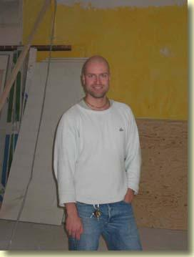
  This is Asvahari Prabhu, the chief engineer of the renovation project now taking place in Helsinki temple.
  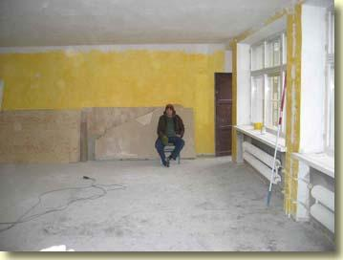
  As you can see, the temple is presently devastated. But in weeks to come it will be rebuilt much more beautifully than before.

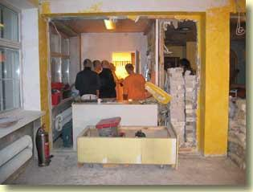
The temple program went on as long as possible amidst the devastation. When I left Helsinki for Wroclaw, the Deities were moved out of the temple altogether to a nearby apartment.
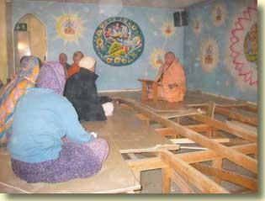
This was the last class that was at all possible to give in the temple. Later that day the rest of the platform on which we were sitting was removed.

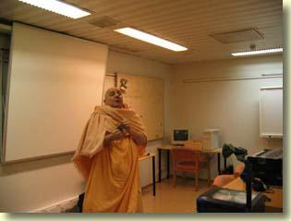 | 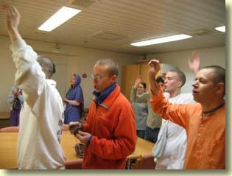
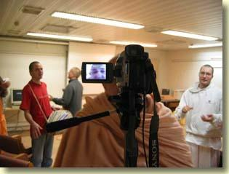 | 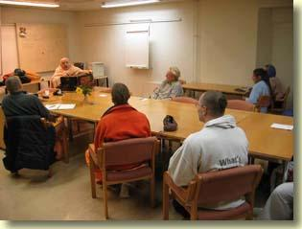

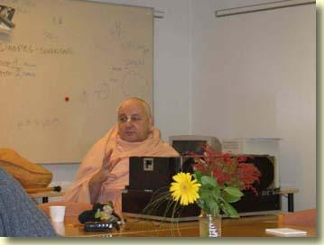
Thereafter classes were held at a nearby school, and then at a counseling center downtown at which the mother of a devotee works.
Wroclaw 9-10 November

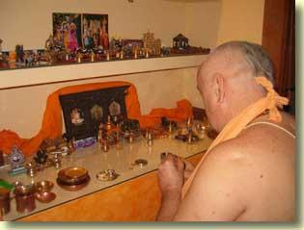
Morning shalagram puja at Rocan's flat.
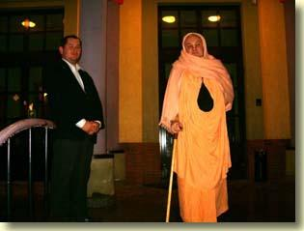
At the entrance to the philosophical faculty of the University of Wroclaw. I am standing with His Grace Garga Rsi Prabhu, who translated my talk there on the evening of 10 November.

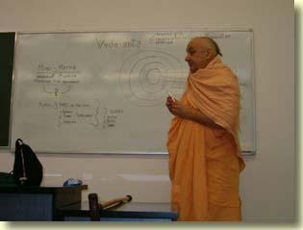 | 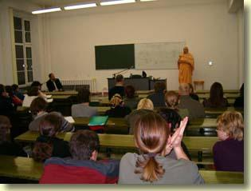
I spoke on The Philosophy of Vedanta. Student attendance was optional. Still, as you can see, there was a good deal of interest. The questions asked at the end showed that the students were listening carefully.

New Animations

  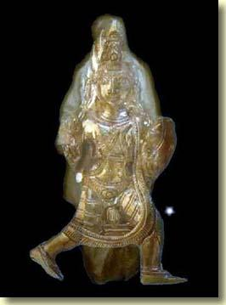
  Eternal Form
  
  Faces

Wroclaw, Poland
11 November 2004
Prayers in worship of Sri Sri Radha-Krsna
(a)
tato vrndavanam dhyayet
paramananda-vardhanam
sarvartu-kusumopetam
patatri-gana-naditam
bhramad-bhramara-jhankara-
mukhari-krta-din-mukham
kalindi-jala-kallola-
sangi-maruta-sevitam
nana-puspa-lata-baddha-
vrksa-sandais ca manditam
kamalotpala-kahlara-
dhuli-dhusaritantaram
tan-madhye ratna-bhumim ca
suryayuta-sama-prabham
tatra kalpatarudyanam
niyatam prema-varsinam
manikya-sikharalambi
tan-madhye mani-mandapam
nana-ratna-ganais citram
sarvartu-suvirajitam
nana-ratna-lasac-citra-
vitanair upasobhitam
ratna-torana-gopura-
manikyacchadananvitam
koti-surya-samabhasam
vimuktam sat-tarangakaih
tan-madhye ratna-khacitam
svarna-simhasanam mahat
kamalotpala-kahlara-
dhuli-dhusaritantara
(Gautamiya Tantra 4)
"Vrndavana-dhama is a place of ever-increasing joy. Flowers and fruits of all seasons grow there and that transcendental land is full of the sweet sound of various birds. All directions resound with the humming of bumblebees and it is served with cool breezes and the waters of the Yamuna. Vrndavana is decorated with wish-fulfilling trees wound with creepers and beautiful flowers. Its divine beauty is ornamented with the pollen of red, blue and white lotuses. The ground is made of jewels whose dazzling glory is equal to a myriad of suns rising in the sky at one time. On that ground is a garden of desire trees which always shower divine love. In that garden is a jewelled temple whose pinnacle is made of rubies. It is decorated with various jewels, so it remains brilliantly effulgent through all seasons of the year. The temple is beautified with bright-coloured canopies, glittering with various gems, and endowed with ruby-decorated coverings and jewelled gateways and arches. Its splendour is equal to millions of suns and it is eternally free from the six waves of material miseries. In that temple there is a great golden throne inlaid with many jewels. In this way, one should meditate on the divine realm of the Supreme Lord, Sri Vrndavana-dhama. "
Next, one should meditate on Radha and Krsna seated on that throne:
divyad-vrndaranya-kalpa-drumadhah-
srimad-ratnagara-simhasana-sthau
sri-sri-radha-srila-govinda-devau
presthalibhih sevyamanau smarami
(Cc. Adi. 1. 16)
"I meditate on Sri Sri Radha and Govinda, who sit on an effulgent throne underneath a desire tree in a temple of jewels in Vrndavana. They are being served by Their most confidential associates, the gopis. "
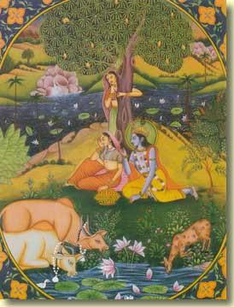
sat-pundarika-nayanam
meghabham vaidyutambaram
dvi-bhujam jnana-mudradhyam
vana-malinam isvaram
divyalankaranopetam
sakhibhih parivestitam
cid-ananda-ghanam krsnam
radhalingita-vigraham
sri krsnam sri-ghana-syamam
purnananda-kalevaram
dvi-bhujam sarva-devesam
radhalingita-vigraham
"I meditate on the Supreme Lord, Sri Krsna, who possesses beautiful lotus eyes, whose colour is that of a new cloud, whose clothes are like lightning, who possesses two arms and a beautiful forest garland, and whose hand is indicating divine knowledge by exhibiting the jnana-mudra. That Krsna is decorated with glittering ornaments and is surrounded by all the cowherd friends of Srimati Radharani. While being embraced by Srimati Radharani Herself, His form is intensified consciousness and bliss. Sri Krsna, who is intensely bluish-black, in His two-armed form, is the Lord of all the demigods, and His body is full of transcendental bliss. "
(b)
Atharva Vediya Gopala-tapani Upanisad (Purva Vibhaga 36-47)
om namo visva-rupaya
visva-sthity-anta-hetave
visvesvaraya visvaya
govindaya namo namah
"Lord Brahma, speaking to the great sages and saints, prayed to Lord Krsna as follows: 'I offer my humble obeisances to Lord Krsna, who is the giver of pleasure to the cows, whose external form is the form of the universe, who is the cause of the maintenance and dissolution of the material universe, and who is the Lord of the universe. '"
namo vijnana-rupaya
paramananda-rupine
krsnaya gopi-nathaya
govindaya namo namah
"I offer my obeisances to Lord Krsna, who is the giver of pleasure to the cows, who is the Lord of the gopis and who is the embodiment of unlimited knowledge and the highest bliss. "
namah kamala-netraya
namah kamala-maline
namah kamala-nabhaya
kamala-pataye namah
"I offer my o beisances to Krsna, who possesses lotus-petal eyes, who wears a garland of sweet-smelling lotus flowers, who has a lotus navel and who is the Lord of the gopis, who are as beautiful as lotus flowers. "
barhapidabhiramaya
ramayakuntha-medhase
rama-manasa-hamsaya
govindaya namo namah
"I offer my obeisances to Lord Govinda, who looks very beautiful wearing a peacock feather upon His head. His plenary expansion is Lord Ramacandra, His intelligence is eternal and ever-fresh, and He is the swan that swims in the mind of Laksmi-devi. "
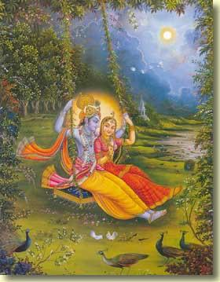
kamsa-vamsa-vinasaya
kesi-canura-ghatine
vrsabha-dhvaja-vandyaya
partha-sarathaye namah
"I offer my obeisances unto Krsna, who is the destroyer of the dynasties of demons headed by King Kamsa. He is the slayer of the Kesi demon and the wrestler Canura. He is offered prayers by Lord Siva, whose chariot flag is marked with the insignia of Nandi, the bull, and He is the chariot driver of the son of Prtha, Arjuna. "
venu-vadana-silaya
gopalayahi-mardine
kalindi-kula-lolaya
lola-kundala-dharine
"I offer my obeisances to Krsna, who is accustomed to playing on a flute, who is the protector of the cows and the chastiser of the Kaliya serpent. He is fond of wandering here and there on the banks of the Yamuna and He is beautified by wearing swinging earrings. "
ballavi-vadanambhoja-
maline nrtya-saline
namah pranata-palaya
sri-krsnaya namo namah
"I offer my obeisances again and again unto Sri Krsna, who wears a garland of kisses from the lotus mouths of the gopis. He is conversant with the art of dancing and is the protector of the surrendered souls. "
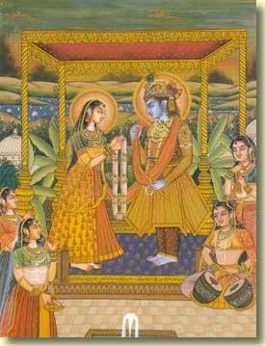
namah papa-pranasaya
govardhana-dharaya ca
putana-jivitantaya
trnavartasu-harine
"I offer my obeisances unto Lord Krsna, who is the destroyer of the sins of the fallen souls. He is the lifter of Govardhana Hill. He brought about the end to the life of Putana and He took away the life of the demon Trnavarta. "
niskalaya vimohaya
suddhayasuddha-vairine
advitiyaya mahate
sri-krsnaya namo namah
"I offer my humble obeisances again and again unto the great Lord Krsna, who is beyond the illusion of maya and from whom that illusion comes. He is the supreme pure, the enemy of the demons and is one without a second. "
prasida paramananda
prasida paramesvara
adhi-vyadhi-bhujangena
dastam mam uddhara prabho
"O Supreme Lord, O reservoir of the highest pleasure, be pleased upon me. I have been bitten by the poisonous snake of mental and bodily miseries. Therefore, O Lord, please deliver me. "
sri-krsna rukmini-kanta
gopi-jana-manohara
samsara-sagare magnam
mam uddhara jagad-guro
"O Lord Krsna, O lover of Rukmini, O attractor of the minds of the gopis, please uplift me, for I am immersed in the ocean of birth and death, O spiritual preceptor of the universe. "
kesava klesa-harana
narayana janardana
govinda paramananda
mam samuddhara madhava
"O Lord Kesava, O destroyer of the threefold miseries, O only refuge of all souls, O destroyer of the Jana demons, O Govinda, O reservoir of pleasure, please uplift me who am fallen, O husband of the goddess of fortune. "
he krsna karuna-sindho
dina-bandho jagat-pate
gopesa gopika-kanta
radha-kanta namo 'stu te
"O my dear Krsna, You are the friend of the distressed, the ocean of mercy, and the Lord of creation. You are the master of the cowherdsmen and the lover of the gopis, especially Radharani. I offer my respectful obeisances unto You. "
Radha-Stuti
radha rasesvari ramya
rama ca paramatmanah
rasodbhava krsna-kanta
krsna-vaksa-sthala-sthita
"Beautiful Srimati Radharani is the queen and the origin of the rasa dance. She is the giver of pleasure to Krsna, who is the Supersoul in the hearts of all. She is the lover of Krsna and is always situated upon the chest of the Lord. "
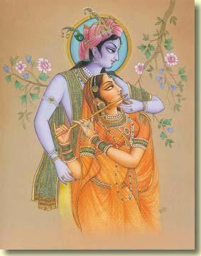
krsna-pranadhidevi ca
maha-visnoh prasur api
sarvadya visnu-maya ca
satya nitya sanatani
"She is the presiding Deity of Krsna's very life, and She is the first of all persons, the energy of Lord Visnu, the embodiment of truthfulness - eternal and ever-youthful. "
brahma-svarupa parama
nirlipta nirguna para
vrnda vrndavane tvam ca
viraja-tata-vasini
"Her form is spiritual, therefore She is transcendental and beyond mundane qualities. She is divine energy and is unattached. O Radha, in Vrndavana You are the leader of the gopis, and You reside on the banks of the Viraja River. "
goloka-vasini gopi
gopisa gopa-matrka
sananda paramananda
nanda-nandana-kamini
"She is a resident of Goloka Vrndavana and is a cowherd damsel. She is the queen of the gopis and the divine mother of the cowherd boys. She is joyful and always experiencing the highest bliss, and She incites lusty desires in the heart of the son of Nanda. "
vrsabhanu-suta santa
kanta purnatama tatha
kamya kalavati-kanya
tirtha-puta sati subha
"Radha is the daughter of Maharaja Vrsabhanu. She is very peaceful and lovely. She is completely contented and fulfilled, very pleasing and is the daughter of Kalavati. She is the purifier of the tirthas and She is most auspicious and chaste to Lord Krsna. "
samsara-sagare ghore
bhitam mam saranagatam
sarvebhyo 'pi vinirmuktam
kuru radhe suresvari
"O Radha, I have fallen into the horrible ocean of birth and death and am frightened, but I am seeking Your shelter. O Queen of the demigods, please free me from all fears. "
tvat-pada-padma-yugale
pada-padmalayarcite
dehi mahyam param bhaktim
krsnena parisevite
"O Radhika, please give me transcendental devotional service to Your lotus feet, which are worshipped by Lord Brahma and Laksmi, and which are served even by Lord Krsna. "
tapta-kancana-gaurangi
radhe vrndavanesvari
vrsabhanu-sute devi
pranamami hari-priye
"O Srimati Radharani, I offer my respects to You whose bodily complexion is like molten gold. O Goddess, You are the queen of Vrndavana. You are the daughter of King Vrsabhanu and are very dear to Lord Krsna. "
mahabhava-svarupa tvam
krsna-priya-variyasi
prema-bhakti-prade devi
radhike tvam namamy aham
"O Srimati Radharani, You are the exalted form of mahabhava, therefore You are the most dear to Krsna. O Goddess, You alone are able to bestow pure love for the Supreme Lord; therefore I offer my humble obeisances unto You. "
Padya-pancaka
samsara-sagaran natha
putra-mitra-grhanganat
goptarau me yuvam eva
prapanna-bhaya-bhanjanau
"O Radha-Krsna, You are my protectors from the ocean of material existence which is characterized by sons, friends, household and land. Therefore You are known as the destroyers of the fear of those who are surrendered unto You. "
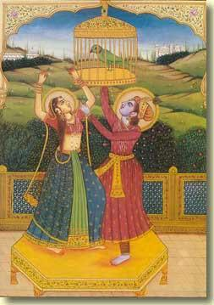
yo 'ham mamasti yat-kincid
iha loke paratra ca
tat sarvam bhavato 'dyaiva
caranesu samarpitam
"O Your Lordships, myself and whatever little bit is mine in this world and in the next, all that, I now offer unto Your lotus feet. "
aham apy aparadhanam
alayas tyakta sadhanah
agatis ca tato nathau
bhavantau me para gatih
"O Your Lordships, I am certainly the abode of many offences and am completely devoid of the practice of devotional service; neither do I have any resort or shelter. Therefore, I am taking You as my ultimate goal. "
tavasmi radhika-natha
karmana manasa gira
krsna-kante tavaivasmi
yuvam eva gatir mama
saranam vam prapanno 'smi
karuna-nikarakarau
prasadam kuru dasyam bho
mayi duste 'paradhini
"O Lord of Srimati Radharani, I am Yours, my actions, mind and words. O lover of Sri Krsna, Srimati Radharani, I belong to You alone. You both are my only shelter. O Radha and Krsna, ocean of mercy, I am taking shelter of You. Please be pleased upon me and make me Your servant, although I am such a fallen offender. "
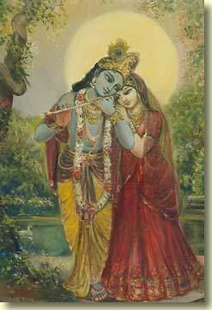
Vijnapti-pancaka
mat-samo nasti papatma
naparadhi ca kascana
parihare 'pi lajja me
kim bruve purusottama
yuvatinam yatha yuni
unam ca yuvatau yatha
mano 'bhiramate tadvan
mano me ramatam tvayi
"O Purusottama, there is no sinful person or offender who is equal to me. How can I describe my shame? Just as the minds of young ladies take pleasure in a young man and the minds of young men take pleasure in a young woman, kindly let my mind take pleasure in You, alone. "
bhumau skhalita-padanam
bhumir evavalambanam
tvayi jataparadhanam
tvam eva saranam prabho
"Just as the ground is the only support for those whose feet have slipped, so also You alone are the only shelter, even for those who have committed offence to You. "
govinda-vallabhe radhe
prarthaye tvam aham sada
tvadiyam iti janatu
govindo mam tvaya saha
"O Srimati Radharani, the dearest of Lord Govinda, this is always my request to You - please let Lord Govinda, along with Yourself, consider me to be one of Your assistants. "
radhe vrndavanadhise
karunamrta-vahini
krpaya nija-padabja-
dasyam mahyam pradiyatam
"O Srimati Radharani, O queen of Vrndavana, You are a river flowing with nectar of mercy. Please be kind upon me and give me a little service at Your lotus feet. "

Wroclaw, Poland
12 November 2004
You've probably seen this already. . .
It's posted at
http://magma.nationalgeographic.com/ngm/0411/feature1/index.html
and, since it features a quotation from HDG Srila Prabhupada, it's been circulating around Pamho. net.
Evolutionary theory, though, is a bit different. It's such a dangerously wonderful and far-reaching view of life that some people find it unacceptable, despite the vast body of supporting evidence. As applied to our own species, Homo sapiens, it can seem more threatening still.
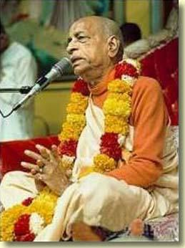
Many fundamentalist Christians and ultra-orthodox Jews take alarm at the thought that human descent from earlier primates contradicts a strict reading of the Book of Genesis. Their discomfort is paralleled by Islamic creationists such as Harun Yahya, author of a recent volume titled The Evolution Deceit, who points to the six-day creation story in the Koran as literal truth and calls the theory of evolution "nothing but a deception imposed on us by the dominators of the world system. " The late Srila Prabhupada, of the Hare Krishna movement, explained that God created "the 8,400,000 species of life from the very beginning," in order to establish multiple tiers of reincarnation for rising souls. Although souls ascend, the species themselves don't change, he insisted, dismissing "Darwin's nonsensical theory. "
Other people too, not just scriptural literalists, remain unpersuaded about evolution. According to a Gallup poll drawn from more than a thousand telephone interviews conducted in February 2001, no less than 45 percent of responding U. S. adults agreed that "God created human beings pretty much in their present form at one time within the last 10,000 years or so. " Evolution, by their lights, played no role in shaping us.
Only 37 percent of the polled Americans were satisfied with allowing room for both God and Darwin--that is, divine initiative to get things started, evolution as the creative means. (This view, according to more than one papal pronouncement, is compatible with Roman Catholic dogma. ) Still fewer Americans, only 12 percent, believed that humans evolved from other life-forms without any involvement of a god.
The most startling thing about these poll numbers is not that so many Americans reject evolution, but that the statistical breakdown hasn't changed much in two decades. Gallup interviewers posed exactly the same choices in 1982, 1993, 1997, and 1999. The creationist conviction-- that God alone, and not evolution, produced humans--has never drawn less than 44 percent. In other words, nearly half the American populace prefers to believe that Charles Darwin was wrong where it mattered most.

108 Names of Radha-Krishna
Astottarsat Namavali
1. Sri Radhagolok Viharine Namah
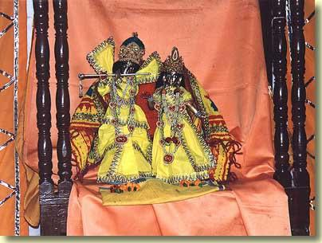
Sri-Sri Radha-Damodara
2. Sri Radha Kunja Viharine Namah
3. Sri Radha Nikunjavilasaya Namah
4. Sri Radhavallabhaya Namah
5. Sri Radhayugalaviharine Namah
6. Sri Radha Madana Mohanaya Namah
7. Sri Radha Damodaraya Namah
8. Sri Radha Muralidharaya Namah
9. Sri Radha Govindaya Namah
10. Sri Radha Gopinathaya Namah
11. Sri Radha Kantaya Namah
12. Sri Radha Syam Sundaraya Namah
13. Sri Radha Gopijanavallabhaya Namah
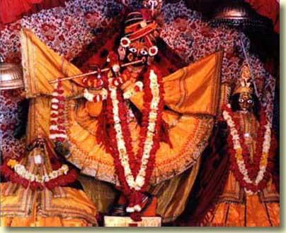
Sri-Sri Radha-Gopinatha
14. Sri Radha Bhaktavatsalaya Namah
15. Sri Radha Goverdhanadharaya Namah
16. Sri Radha Vrndavana Sancarine Namah
17. Sri Radha Yamunakula Viharine Namah
18. Sri Radhacira Samharine Namah
19. Sri Radha Hrdayacauraya Namah
20. Sri Radha Gopidukula Cauraya Namah
21. Sri Radha Kesibhanjaya Namah
22. Sri Radha Dhirasamira Viharine Namah
23. Sri Radha Pataye Namah
24. Sri Radharadhayitre Namah
25. Sri Radha Citta Pramodakaya Namah
26. Sri Radha Cittasammohanaya Namah
27. Sri Radha Mohanatatparaya Namah
28. Sri Radhahrdayambhojasatpadaya Namah
29. Sri Radha Chintanasammohanaya Namah
30. Sri Radha Nartanakautukaya Namah
31. Sri Radhakamaphalapradaya Namah
32. Sri Radhanam Cintakaya Namah
33. Sri Radharadhanatatparaya Namah
34. Sri Radhasevana Kusalaya Namah
35. Sri Radha Mukhabjamartandaya Namah
36. Sri Radha Yasodanandanaya Namah
37. Sri Radha Nandanandaya Namah
38. Sri Radha Devakisutaya Namah
39. Sri Radha Vasudevaya Namah
40. Sri Radha Bhandira Vana Viharine Namah
41. Sri Radha Ramanaya Namah
42. Sri Radha Sampujakaya Namah
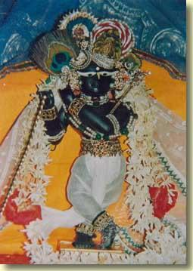
Sri-Sri Radha-Ramana
43. Sri Radha Dhyanarataya Namah
44. Sri Radha Sarveshvaraya Namah
45. Sri Radha Vamshivataviharine Namah
46. Sri Radha Jagannathaya Namah
47. Sri Radha Vrajavallabhaya Namah
48. Sri Radha Bhaktasamraksanaya Namah
49. Sri Radha Yogisvaraya Namah
50. Sri Radha Sharanagata Vatsalaya Namah
51. Sri Radha Padaprapujakaya Namah
52. Sri Radha Jagatpataya Namah
53. Sri Radha Rasaviharine Namah
54. Sri Radha Rasarasesvaraya Namah
55. Sri Radha Rasaratikaraya Namah
56. Sri Radha Mohanaya Namah
57. Sri Radha Cittacintamanaye Namah
58. Sri Radha Samkalpasuradrumaya Namah
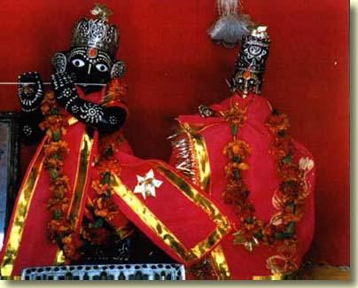
Sri-Sri Radha-Vinoda
59. Sri Radha Premapradaya Namah
60. Sri Radha Bhaktakripakaraya Namah
61. Sri Radhasaksigopalaya Namah
62. Sri Radha Hrsikesaya Namah
63. Sri Radha Sakhisahasresaya Namah
64. Sri Radha Gopisvaraya Namah
65. Sri Radha Ranganathaya Namah
66. Sri Radha Navaniradabhaya Namah
67. Sri Radha Pitambaradharaya Namah
68. Sri Radha Vanamaline Namah
69. Sri Radha Varhavatamsakaya Namah
70. Sri Radha Purnacandraya Namah
71. Sri Radha Candrananaya Namah
72. Sri Radhanana Saundaryapriyaya Namah
73. Sri Radha Mukhacandracakoraya Namah
74. Sri Radha Kaustubhadharaya Namah
75. Sri Radha Purnendusundaramukhaya Namah
76. Sri Radha Nityalilalitaya Namah
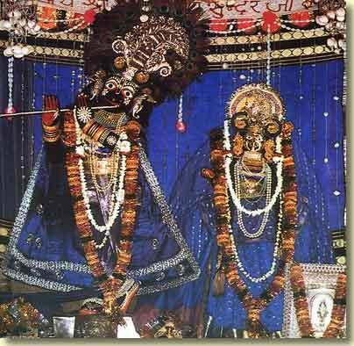
Sri-Sri Radha-Syamasundara,
77. Sri Radha Lalitesvaraya Namah
78. Sri Radhastasakhinartakaya Namah
79. Sri Radhadadhicauraya Namah
80. Sri Radhatribhangalalitaya Namah
81. Sri Radha Gokulanathaya Namah
82. Sri Radha Vrajesvaraya Namah
83. Sri Radha Tulasipriyaya Namah
84. Sri Radha Divakaraya Namah
85. Sri Radhasnehaviharine Namah
86. Sri Radha Vasanta Viharine Namah
87. Sri Radha Davanala Viharine Namah
88. Sri Radha Nrtya Gopalaya Namah
89. Sri Radhananta Viharine Namah
90. Sri Radha Balagopalaya Namah
91. Sri Radha Kamadhenupriyaya Namah
92. Sri Radha Makarakrtikundalaya Namah
93. Sri Radha Kuncitakesaya Namah
94. Sri Radhadharasudhapanarataya Namah
95. Sri Radha Navanitacauraya Namah
96. Sri Radha Giridharagopalaya Namah
97. Sri Radhanantagopijanaparivestitaya Namah
98. Sri Radha Lalitasekharaya Namah
99. Sri Radha Vrajarajasutaya Namah
100. Sri Radhamukhapadmadinesaya Namah
101. Sri Radhagopalacudamanaya Namah
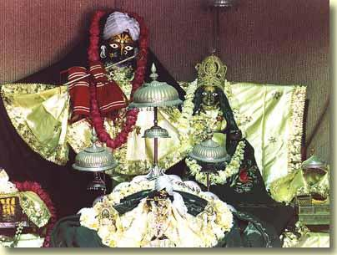
Sri-Sri Radha-Vrndavana Candra
102. Sri Radhanayanakamalarcitadehaya Namah
103. Sri Radha Pasupangajaya Namah
104. Sri Radhavrndavan Viharine Namah
105. Sri Radhanikunjasimhasanarajitaya Namah
106. Sri Radha Vrajaikamandanaya Namah
107. Sri Radha Nityakunjavilasine Namah
108. Sri Radhagolokdhamdhipataye Namah

Wroclaw, Poland
13 November 2004
Govardhana Puja Ki Jaya!
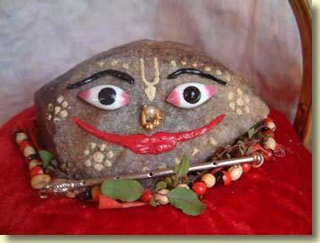 | 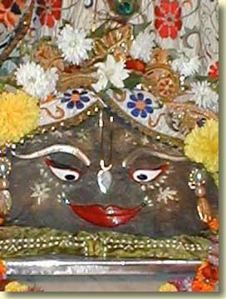

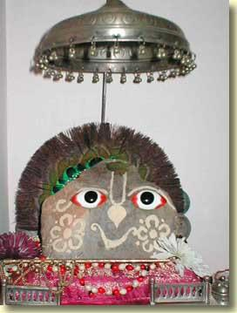 | 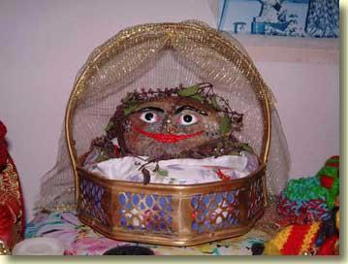

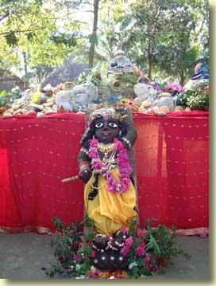
Giridhari made of cowdung
Chapter 3 of Vraja-riti-cintamani
1 Govardhana Hill is like a flag of intense sweetness placed in the opulent land of Vrndavana. As the king of mountains Govardhana Hill offers very pleasing royal service to the young prince of Vraja.
2 The rocks of Govardhana Hill are many kinds of splendid jewels that provide thrones, couches, and other kinds of furniture for Sri Krsna, the supreme monarch of all nectar mellows.
3 Govardhana Hill's beautiful forests and caves are Krsna's nectar pastime palaces, each one perfect for the supreme good fortune of His beloved and Her friends.
4 Govardhana Hill's trees and vines serve Sri Krsna by offering Him blossoming branches with sweet fruits, and flowers filled with honey, nectar and fragrant pollen.
5 The red, vermilion, yellow and other coloured pigments of Govardhana Hill decorate Lord Krsna's transcendental body for the pleasure of His beloved gopis.
6 The musk left by deer, as well as the kunkuma, camphor, and aguru naturally produced by Govardhana Hill, were all used to give a sweet fragrance to the transcendental body of Lord Krsna.
7 There is a pleasant grove of sandalwood trees on Govardhana Hill. Although snakes generally flock to sandalwood trees, no snakes ever come here, or if sometimes a snake may come it is not poisonous, or if sometimes a poisonous snake may come its poison is automatically counteracted, and it can do no harm. As the best servant of Lord Hari, Govardhana Hill has made this wonderful arrangement for the Lord's pleasure.
8 One time a contrary fawn-eyed gopi left Sri Krsna. A short time afterwards She saw a snake on the road. Frightened, She took shelter of Lord Krsna, embracing Him and begging for protection. As Lord Hari's best servant, Govardhana Hill made all these nectarean arrangements for His pastimes. Note: This verse may also be translated in the following way: Rejected by a certain contrary fawn eyed gopi, Sri Krsna said: "I have just been bitten by one of Govardhana Hill's snakes". When the gopi heard this, she became repentant and came before the Lord with many apologies. As Lord Hari's best servant, Govardhana Hill made all these arrangements for His pastimes.
9 The rocks of Govardhana Hill are all precious gems. Some are sapphires, some emeralds, some rubies or crystals. They provide the perfect backdrop for Lord Krsna's pastimes.
10 If, while walking on Govardhana Hill, Krsna's elder brother Balarama sees a series of golden stones, He thinks: 'the daughter of King Vrsabhanu must have just now walked before Me', and He changes course to avoid an awkward situation. In the same way, if She sees a series of crystal stones, She thinks: 'Balarama must have just now walked before Me', and She changes Her course.
11 If, on Govardhana Hill, which is the best of Lord Hari's servants, Sri Krsna sees a golden stone, He takes it to be His beloved. In the same way, His beloved sees a sapphire, She assumes it is Her lover.
12 The gopis' necklaces, ornaments, red foot cosmetic, betelnuts, and other paraphernalia gaze on the beauty of Govardhana Hill's groves and caves. Who would not become enchanted by the beauty of Govardhana Hill?
13 Sri Krsna is the sapphire and the gopis the golden necklaces ornamenting Govardhana Hill. The pastimes of Krsna and the gopis are the sons and daughters of Govardhana Hill. Who is able to describe the glories of Govardhana Hill?
14 The peacocks dance enthusiastically, the bees and cuckoos sing melodiously and may other birds chirp a rhythmic accompaniment, as they all gaze on the serve to Lord Hari done by Govardhana Hill, the best of Lord Hari's servants.
15 The land around Govardhana Hill in all directions is filled with many lakes, groves, and other charming places of Lord Krsna's pastimes. Many lovely streams flow from Govardhana Hill onto these lands in all directions.
16 To the east is Dana-nivartana-kunda. When Sri Radhika's handsome beloved remembers it, He begins to tremble, and the hairs on His body stand erect.
17 To the east of that is Candra-sarovara, where the divine couple enjoyed many rasa dances. The memory of this place makes Them dance in ecstatic love.
18 Southeast of Govardhana Hill is Sanksarsanananda-sarovara, and to the east of that is Gauri-tirtha, which is scrupulously avoided by Gauri's husband, Lord Siva.
19 The nectar flood of supreme good fortune rising from His eternal pastimes with Her has made Her beloved supremely learned in the philosophy of forest-pastimes.
20 In between Sankarsana-sarovara and Dana-nivartana-kunda is Anandaraja-tirtha, where the Mahanna-kuta festival delighted the young prince of Vraja.
21 West of that are two splendid places in the mouth of Krsna's pastimes. They are Sri Dhana-ghata and Sri Sumani-ghata, where the divine couple playfully talked and joked.
22 At this place the divine couple enjoyed the playful quarrel pastimes known as dana-keli. Who would not be astonished by this pastime? When this pastime enters the ears it makes both the body and mind dance.
23 Govardhana Hill resembles a gigantic peacock that has Govinda-kunda as its tail. The Manasa-ganga, where the divine couple eternally enjoys boat-sailing pastimes, enters into the waters of Govinda-kunda.
24 If one hears about the divine couple's boat-sailing pastimes, he will become stunned in ecstasy and it will not be possible for him to stop hearing about them.
25 On the Manasa-ganga's shores are many madhavi-vine pavilions with nectar beauty that shines in the three worlds. There the divine couple enjoys splendid pastimes that are eternally remembered in the world's hearts.
26 With its nearby forest groves and the limitless nectar-trickling flowers in its waters, Kusuma-sarovara shines with great splendour. Is it the handsome face of Govardhana Hill, the king of mountains?
27 This lake is known as Kusuma-sarovara because of the many blossoming flowers, destined to become gopis in the future, that grow in its waters. Simply by one bathing in this Kusuma-sarovara, Narada Muni attained a gopi-form. This fact is directly confirmed in the words of the enchanting Supreme Personality of Godhead.
28 The Supreme Personality of Godhead eternally enjoys pastimes on Govardhana Hill. He personally lifted Govardhana Hill with His own hand to protect His cowherd associates. Who is able to describe the glories of Govardhana Hill, the best of Lord Hari's servants?
29 Radha-kunda and Syama-kunda are Govardhana's two love-filled eyes. Because it nourishes the gopas, gopis, and surabhi cows with Lord Madhava's sweetness, it shines with the name 'govardhana'.
30 Syama-kunda and Radha-kunda are two great floods of the nectar of beauty. They are two great oceans of splendour. They are two beautiful roots from which sweet devotional service grows.
31 They are two jewel-mines of love. They are two seeds from which grow the jewel-vines of transcendental pastimes. How did they become two splendid and nectar-sweet lakes?
32 By seeing these two lakes, Radha and Krsna believe They are present in them. It is as if They directly see each other there. The wise say that by approaching these lakes one directly approaches Radha and Krsna.
33 Longing to meet, but forced to remain separate, Radha and Krsna assumed the forms of Radha-kunda and Syama-kunda. In this way They becomes splashed with the nectar of meeting each other.
34 I think that when Radha saw Krsna She melted with ecstasy and thus assumed the liquid state of the waters of Radha-kunda, and in the same way when Krsna saw Radha He also melted in ecstasy and became the waters of Syama-kunda. In this way these two lakes bear the names and qualities of the divine couple.
35 Out of great kindness to the people, so they could directly taste Their sweetness, Radha and Krsna have become these two lakes. Shining with happiness, the devotees bathe in these two lakes.
36 I think these two lakes are the divine couple's love. They who are fortunate bathe there. Because bathing there is like bathing in Their transcendental love, these two lakes bear the names of the divine couple.

Wroclaw, Poland
14 November 2004
Govardhana Puja in Wroclaw

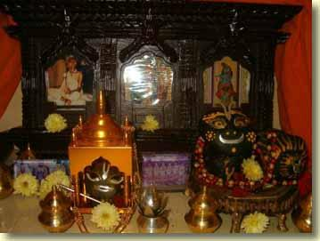
My Govardhana Sila (inside the "golden temple" asana) on the day of His appearance.

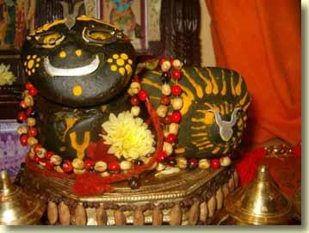 | 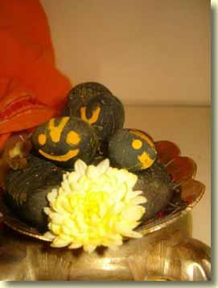  Sri-Sri Jagannatha-Sudarsana, Sri-Sri Laksmi-Sesasayi, Sri-Sri Yajna-Purusa silas.
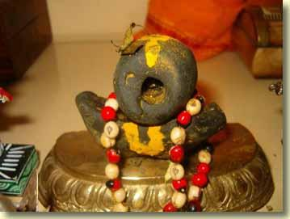

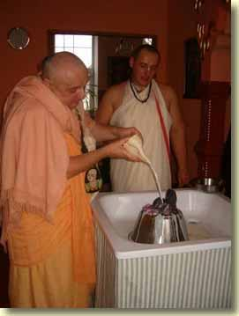
  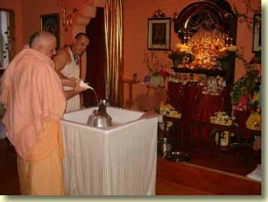
  Abhiseka of Govardhana silas in Wroclaw ISKCON temple. Gouranga-Avatara Prabhu, who now lives in the temple with his wife Kaveri dd, is the head pujari.

 | 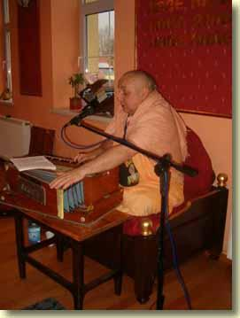
  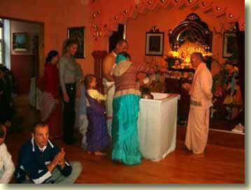
  I chant Jaya Radhe Jaya Krsna Jaya Vrndavana while the devotees bathe Sri Govardhana.

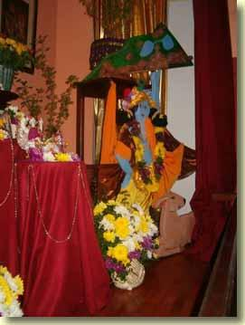 | 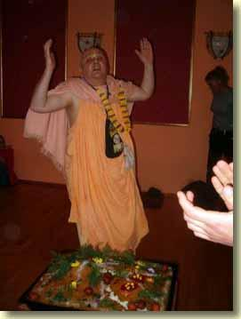

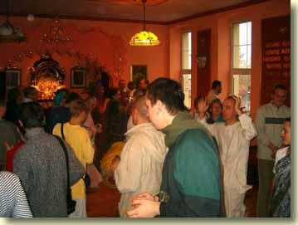
Sri Giri-Govardhana ki jaya!
HH Bhakti-tirtha Maharaja update
Dear Godfamily, Friends and Well Wishers,
Please accept my most humble obeisances
All glories to our beloved Gurumaharaja
All glories to ISKCON Founder Acharya Srila PRabhupada
As of yesterday evening, the 16th day of Kartika, Gurumaharaja is stable and back to his routine of getting his daily cancer treatments.
The last few days Gurudeva has been to an oral surgeon to have his tooth pulled, he had to go to a specialist so that all traces of the infection from his tooth area could be removed. The Hospital confirmed from the culture that the catheter area was infected, however the Doctor at the hospital would not perform the operation to replace the catheter until the infection was totally cleared up. Remember in the hospital he was having antibiotics administered by IV in his arm. The dentist also prescribed another antibiotic for the infection in his mouth. The hospital Doctor scheduled the operation for the catheter replacement on the other side of his chest area yesterday, and he recommended that Gurumaharaja start taking another antibiotic specfically for the infection from his catheter. Of course taking all these different antibiotics really compromise his immune system, which is already weak, but what to do, the infection had to be cleared up.
Yesterday we spent the day in the hospital with Gurumaharaja waiting for the catherter to be replaced. We returned back to the house in the early evening and Gurudeva resumed his cancer treatments, which he had to suspend for over a week while dealing with the infection. A few more supplements , more juicing and ozone theraphy have been added to his protocol in hopes that he can regain some of his strength back. Today, Paramahamsa Prabhu, one of Gurumaharja's godbrothers came and associated with Gurudeva for some hours. This was really nice for him. Saturday Gurudeva is invited to give a class for Govardhana Puja at the Temple here in Honoka'a. He has accepted, we will definitely tape the class.
Thank you, Thank you, Thank you for all your love and support. Yamuna and Dina, it was so inspiring hearing from both of you, I will write soon, Sangita thank you so much for your advice, we really value your sharing with us. Hauri Sari Prabhu, thank you for your encouraging words, I will send the address, please send Maharaja the book by email. His Grace Bhurijana Prabhu, we are eternally grateful for your care. Nimai Caitanya, please call again you have the correct number. Devavati, I will send the info. you asked for soon.
PS. Gurumaharaja is physically weak, although he is not bed ridden, he does not have the same energy level as he did before his body was attacked by the infection. He is concerned about the ccncer in his foot, because the foot is still swollen and some areas are obviously growing.
Your aspiring servant
With love
Ekavira and Vrajalila

Wroclaw, Poland
15 November 2004
Srila Prabhupada explains his mission to today's world
(Bhagavad-gita lecture, 23 August 1973 in London)
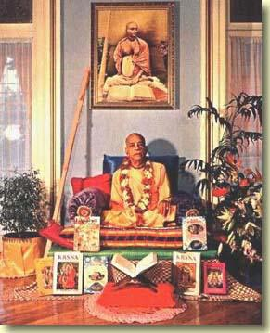
We are trying, even our Krsna consciousness mission, we are trying to awaken (them). Still they are so unfortunate they cannot give up sense gratification. So unfortunate. Condemned, unfortunate. Repeatedly we are spending our gallons of blood--"don't do this"--still they are doing. Cannot give up even sleeping. So condemned. Kali-yuga. Mandah sumanda matayo. So it is very difficult with these rascals. Very very difficult. Therefore my Guru Maharaja's Guru Maharaja, Gaur Kisore das Babaji Maharaja, (he was) they were not preaching. They were (He was) disgusted that, "I have no power to reform these rascals. Better don't bother. Let them go to hell. At least. . . let them. " But still, my Guru Maharaja preached. He was so kind. And he asked us also to do the same thing. But it is very, very difficult job. People are so rascal, so condemned, so sinful. It is very, very difficult to raise them. Very difficult. Manda sumanda-matayo manda-bhagya hy upadrutah.
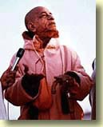
So only those who are very fortunate, they will understand that "I am eternal," avinasi, "I am imperishable. I am put into this condition of perishable condition due to this my material body. " So how to get out of it. They have no ambition. Just like dogs and cats. Simply sense gratification. Krsna is so kind, how, very clearly explains. You try to understand what is the soul. So who does not understand there is consciousness all over the body? Tad viddhi. Yena sarvam idam tatam.
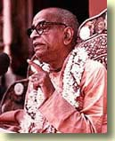
They'll jump over, "Yes, I am the Supreme God. " God's consciousness is also spread all over. that's all right. But is your consciousness spread all over the universe? Both of us, we are conscious. But He is supreme consciousness. Therefore His consciousness is spread all over the universe, all over the creation. In the Thirteenth Chapter, you'll find Krsna (said) says: ksetrajnam capy mam viddhi sarva ksetresu bharata: "I am also ksetrajnam. " Supersoul. What is the difference between Supersoul and soul. Soul? consciousness, is spread all over this body. You are soul, your consciousness spread all over your body. I am soul, my consciousness spread all over the body. But my consciousness not spread all over your body, neither your consciousness spread all over my body. But God's, Krsna's, consciousness is spread over your body and my body, His body and everyone (body). So Krsna is the super or the supreme because His consciousness is spread all over the universe. You cannot hide anything from Krsna. That is not possible. You cannot hide.
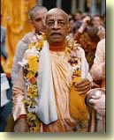
Sarvasya caham hrdi sannivisto. After all you are making your plan with your heart and soul. The soul is there and the heart is there, mind is there. Now we are making plan. But you cannot hide the plan from the consciousness of Krsna. He is sitting there. That is super-consciousness. One, you know the Aurobindo. He was trying to get super-consciousness. His philosophy is super-conscious. Everyone who is here knows about Aurobindo. The Super-consciusness you cannot get. That is not possible. Super-consciousness is for Krsna, the Supreme Personality of Godhead. Vedaham samatitani. Krsna says, "I know everything. " In the Bhagavat it is said: janmady asya yatah anvayad itaratas carthesv abhijnah. The Absolute Truth is that from whom everything is emanating. And He knows everything. Anvayad itaratas carthesu. We have explained many times. Arthesu. Just like I am conscious. But I do not know actually what is there within my body, how it is constituted, how, how many veins are there, how the blood is becoming red, how. . . We have no, actually, information. I do not know what is within this finger. I am claiming it is my finger. Here it is my finger, but I do not know how the finger is constituted. Therefore I am not abhijnah. Although there is my consciousness, I am not abhijnah. Abhijnah means expert in the knowledge. That is called abhijnah. Very experienced. But Krsna is abhijnah.
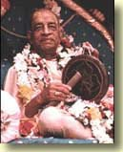
That is described in the Srimad-Bhagavatam. Krsna is abhijnah. That is said. Janmady asya yatah, in the Bhagavata, beginning. Janmady asya yatah anvayad: indirectly or directly. Anvayad means directly. Itaratas ca: or indirectly. We may know directly that: "This is my finger. " But indirectly I do not know what is the constitution of finger, how it is working, how it is moving. You (we) do not know. I know directly this is my hair. But indirectly how I am cutting hair and again it is growing, it is unknown. I say these are my hairs but I cannot count how many hairs are there. So I am conscious to a certain extent only, not fully. I am not abhijnah. I am not very expert. These are simple truths. But these rascals are claiming that "I am God. " The God is, means he is conscious, not only conscious, He's abhijnah, very expert, knows everything, and svarat. Now, to get abhijnah, abhijnatah or experience , we have to consult somebody. But God is svarat. Svarat means He's personally so independent that he doesn't require to take knowledge from anyone else. That is God. Svarat. Svarat means fully independent. That is God. Now how he become? Sva-bhaviki jnana-bala-kriya ca. These are the description in the Veda. Sva-bhaviki. His knowledge is very natural. Sva-bhaviki. Just like here('s) something itching. Immediately my hand, attention, yes. Sva-bhaviki. It is not that I have to think, "Now here it is itching, what I have to do?" No, you have. . . Immediately, hand comes. Sva-bhaviki, by nature. Similarly when God has to create, as soon as He desires, let there be a creation, immediately creation. He hasn't got to think, make a plan, how to do it, how to execute it, where to get the ingredients. No. His energies are so perfect that as soon as He desires, everything is there. That is God. That is God. And that is happening. Mayadhyaksena prakrti suyate sa caracaram. He desires: "Prakrti, nature, immediately produce a rose flower. " Prakrti helps immediately. The color is coming, the beauty is coming, everything is coming. These rascals say it is automatic. No automatically. There is expert knowledge behind it, that is God. So let us utilize this consciousness. The sense how to understand that supreme consciousness, supreme God. Because I am not supreme, although I am conscious, I am not supremely conscious. I am not expert. God is expert. So always there is difference between God and ourself. We cannot be equal with God. That is not possible. This is sense. Otherwise all rascaldom. Don't be victim of the rascals. Thank you very much. (end)
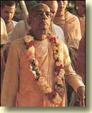

Wroclaw, Poland
19 November 2004
University Program (Economics Department)
Namahatta Program

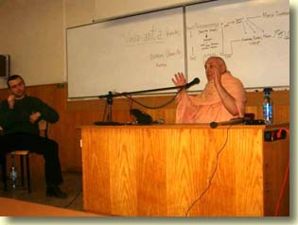 | 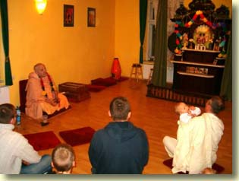

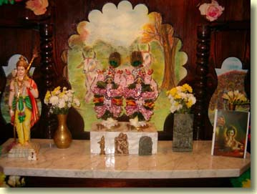
HH Bhakti-tirtha Maharaja update
Please accept our most humble obeisances
All glories to our beloved Gurumaharaja
All glories to ISKCON Founder Acharya Srila Prabhupada
In our last update, we informed everyone that Gurumaharaja condition had stabilized and he would be undergoing some additional treatments to increase his strength. His foot is still swollen, and the antibiotics definitely weakened his immune system, however with much determination, Gurudeva is deligently following the cancer protocol.
Gurudeva was invited by a godbrother to give the lecture for Govardana puja at a nearby Temple, even though his body is weak, he went. His voice was really strong as he shared pastimes of Govardana and the importance of addressing the false ego. The devotees reciprocated very lovingly with Gurumaharaja.
When we returned to the house that night, we received a call from another godbrother, Gopavrindapal Prabhu, the husband of the late Mulikapriti mataji, asking if Gurudeva could speak at the program for Srila Prabhupada's disapearance day. This program was over an hour away, so we requested that Gurumaharaja spend the night, as the program was in the evening. Gopavrindapal Prabhu was happy to make arrangements for all three of us, on his property he has a guesthouse, that he readily made available. He also has a large Temple, with beautiful Radha Krsna Deities. In the absence of his wife, he and his son maintain all the Deity services, and hosts programs regularly for the devotees.
Here again, Gurumaharaja did not seem sick when he spoke, as his voice is very strong. After speaking, he stayed to hear all the other devotees share their heartfelt rememberances of Srial Prabhupada, then he excused himself to go to the cabin for Ekavira Prabhu to administer the last two IV's for the evening.
After a very sober meeting regarding his health with Guurdeva last Sunday, Gurumaharaja will be getting a liver scan next week to see if the cancer has grown in the liver. We will keep you informed of the decision after we receive the results of the scan. Presently we have discussed going to, California, Mexico , or perhaps Gita Nagari on the way to the Bhaktivedanta Hospital in Bombay, where Gurudeva would be under the care of devotee doctors. Ekavira Prabhu is keeping a close watch on Gurudeva's progress, as he is the one that administer all the medical theraphies. He is also quite straight forward with Gurudeva regarding what he feels is not working.
I have shown Gurudeva Dhira Nitai's letter about our dear gobrother Bhagvat Prabhu, of course he was quite shocked, and at the same time fully understanding what Bhagavat Prabhu is going through. He sends his love and asks if Bhagavat's wife could write to him.
Ekavira Prabhu and I are so blessed, so many devotees have been writing and calling to encourage us in our services, thank you so much.
H.H. Kavichandra Maharaja, thank you for checking in regularly, it helps.
Dasaratha Prabhu, your last mail to Bhakti Tirtha Swami really made him happy.
His Grace Bhurijana Prabhu, you are keeping us remembering Krsna and his dearmost devotees. Thank you.
Kunti Devi, thank you, thank you for the care package, so many goodies, yipee!!
Yasoda-Mayi, thanks for the long phone conversation, I needed it.
Mangala Arati, thank you for your beautiful update of the disciple's meeting in Mayapur, Abhi and Arati, please write.
The liver scan is scheduled for early next week, we will keep everyone updated.
Your aspiirng servant
With love
Ekavira and Vrajalila
Pink Locusts from North Africa Swarm Through Cairo
By Amil Khan and Tom Perry
CAIRO (Reuters) - Swarms of pink locusts swept through the Egyptian capital on Wednesday, evoking the biblical description of the plagues which struck in the time of Moses.
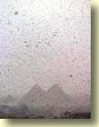
The swarms of millions flew high above tall towers or swooped down onto treelined streets, where scared pedestrians stamped on them or ran for cover.
The flying insects arrived from neighboring Libya after devouring the countryside in central and western Africa in past months. But locust experts said they were unlikely to wreak similar havoc in Egypt, where agriculture is a cornerstone of the economy.
"This is really horrible," said one man as he ran past a building where locusts, some of them more than 3 inches (7.6 cm) long, smacked into office windows or landed on cars.
Some of the locusts, which arrived and disappeared in waves, settled on shrubs and trees. Authorities battled swarms at Cairo international airport, but flights were unaffected.
"They are driven by strong winds ... Under current climatic conditions they will not likely cause damage," Christian Pantenius, a locust expert with the United Nations (news - web sites) Food and Agriculture Organization (news - web sites) (FAO), told Reuters.
Pantenius said the locusts would not feed voraciously when the temperature was under 30 degrees Celsius (86 degrees Fahrenheit). Forecasts put Cairo's temperature for the coming days at below 25 degrees Celsius.
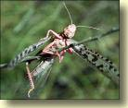
Pantenius said the locusts were arriving in medium-sized swarms. "They will very likely either die or migrate further to the south," he said, adding that the Saudi and Sudanese authorities had been alerted.
The locusts appeared to be passing through Egypt and did not pose a threat to agriculture, Egypt's official Middle East News Agency quoting Agriculture and Land Reclamation Minister Ahmed el-Laithi as telling a news conference.
Agriculture is a key sector of the Egyptian economy, employing millions of people in the North African country, which has a population of about 70 million.
The locust swarms have already traveled on the wind from North Africa to Cyprus. They can form swarms of tens of millions, occupying hundreds of square kilometers (miles).
In the Old Testament, locusts were the eighth of 10 plagues which God brought on the Egyptians before Pharaoh, their ruler, relented and let the enslaved children of Israel go. (Additional reporting by Esmat Salaheddin)

Prague, Czech Republic
22 November 2004
Israel Hit by Worst Locust Plague Since 1950s
By Megan Goldin
JERUSALEM (Reuters) - Millions of locusts swarmed through Israel's Red Sea resort town of Eilat on Sunday, devouring crops and flowers in the country's south.
Israeli agriculture officials sent crop dusters into the air to spray against the locusts that swept in from North Africa in the first such invasion since 1959. Eilat residents reported clouds of locusts eating palm trees bare and wiping out entire gardens.
"You watch as trees that are covered with flowers are devoured. They ate everything, even a grassy roundabout which is covered with locusts," said Meir, an Eilat resident.
Curious residents swatted locusts as long as 10 cm (3. 9 inches) which filled the air as they walked outside to inspect the damage. "It's like the plagues of Egypt," said one resident.
In the Bible, locusts were the eighth of 10 plagues that God inflicted on the ancient Egyptians before Pharaoh, their leader, let the Israelites go.
Locusts ventured across the Negev desert as far north as the Dead Sea where farmers worried that larger numbers of insects said to be heading their way might eat through their crops.
"They have landed to sleep for the night . . . tomorrow we are expecting greater numbers," explained farmer Shalom Shoshana who feared for his tomato and pepper crops. "It's frightening. "
But agriculture officials said they were not overly concerned as a cold front forecast on Monday would prevent the locusts from breeding and would keep them grounded where they would be easy prey for crop dusters.
"The question is whether the locusts know that," piped up Shoshana.
The locusts were heading east toward Jordan and Saudi Arabia and were not expected to move to Israel's more fertile north as well as the West Bank and Gaza Strip (news - web sites) where Palestinian farmers are less equipped to deal with the scourge.
The last major invasion of African locusts 45 years ago ravaged crops in the Jewish state.
But some Israelis as well as labourers from Thailand, where locusts are a delicacy, made the best of the current outbreak by collecting the insects and taking them home for dinner.
"Delicious," said one Israeli man in Eilat, licking his lips after picking a locust off the ground and eating it raw. "They're a delicacy fit for a king. "
A Web Site in Eilat listed recipes for locusts including locust shish-kebab, locust chips (French fries) and stir-fried locusts. The recipes said it was essential to cook the insects while alive "as otherwise they become bitter. "
The locust is the only type of insect that is kosher and permissible for religious Jews to eat under Jewish law.

Prague, Czech Republic
23 November 2004
Revision Marches to Social Agenda
By Scott Gold Times Staff Writer
SPRING, Texas-—Outside the Spring Church of Christ, a large roadside sign says a lot about the prevailing sensibility in this cordial town. It reads: "Support New Testament Morality. "
This is the home and powerbase of Terri Leo, a state Board of Education member representing 2. 5 million people in East Texas.
At the urging of Leo and several other members-—who describe themselves as Christian conservatives-—the board this month approved new health textbooks for high school and middle school students after publishers said they would tweak references to marriage and sexuality.
One agreed to define marriage as a "lifelong union between a husband and a wife. " Another deleted words that were attacked by conservatives as "stealth" references to gay relationships; "partners," for example, was changed to "husbands and wives. " A passage explaining that adolescence brings the onset of "attraction to others" became "attraction to the opposite sex. "
Leo said she pushed for the changes to combat the influence of "liberal New York publishers" who by "censoring" the definition of marriage were legitimizing same-sex unions.
Some education advocates have criticized the board's decision.
"This was never about defining marriage," said Samantha Smoot, president of the Texas Freedom Network, an Austin-based nonprofit that opposes what it calls religious "extremism. " "It was an effort to get anti-gay propaganda in the books. "
Gilbert Sewall, director of the New York-based American Textbook Council-—an independent organization that reviews textbooks—-also criticized the Texas-approved books' promotion of abstinence-only sex education.
Such programs are "naive and confused," said Sewall, who described himself as an "educational conservative. "
Research, much of it conducted by the federal government, has raised a host of questions about the effectiveness of abstinence programs in preventing disease and pregnancy. Teenage girls who are taught in the programs do wait longer before having sex, many experts believe, but are less likely to use protection when they do-—causing them to contract sexually transmitted diseases at the same rates as those who have sex earlier.
"I have very little use for this religion-driven curriculum," Sewall said. "This confuses sex and moral education. "
Texas is the second-largest buyer of textbooks in the nation, after California. Books purchased here wind up in classrooms across the nation, because publishers are loath to create new editions for smaller states.
As a result, five social conservatives on the 15-member Texas board, frequently joined by five more moderate Republicans, have enormous clout—-and often control the content used to teach millions of children.
Publishers have no choice but to heed many of the group's wishes, said Don McLeroy, a dentist, Sunday school teacher and Texas Board of Education member.
"They've got to sell books," he said. "It's business. "
Conservatives' efforts over the years to edit textbooks are legendary here. In a nod to those who believe God created the Earth 6,000 years ago, a sentence saying the ice age took place "millions of years ago" was changed to "in the distant past. " Descriptions of environmentalism have been attacked as antithetical to free-enterprise ideals; a passage describing the cruelty of slavery was derided as "overkill. "
The pace of such efforts to alter curriculum is expected to increase because Christian conservatives are "emboldened" by the Republican gains on election day, Leo said.
The board's stance on the health texts, some observers said, speaks to a critical factor in the GOP's recent success: a recognition by evangelical conservatives that all politics is local.
The political ascendance of Christian conservatives in the 1980s and 1990s was fueled by their coordinated effort to win seats on school boards, city councils and other local bodies. A leader of the Christian Coalition said at the time that he would be willing to train an evangelical to run for dogcatcher.
Conservative forces began targeting the Texas Board of Education in the 1990s. Some, including Leo, ran for election unopposed.
Success at the local level has been used as a springboard to national power, said Robert Simonds, president of California-based Citizens for Excellence in Education; the group, which helped train the first wave of Christian conservative candidates, recently has lobbied for the withdrawal of Christians from the "secularist" public school system.
"It's like an athlete," Simonds said. "If you want to be a top-level baseball or football player, first you have to learn to run. So we ran.
"The secular world has jumped on it, but only after seeing so much success in Christian education and the like. "
But Evan Wolfson, director of Freedom to Marry-—a New York group that seeks marriage rights for gays and lesbians-—said that the conservatives' drive to control local and state political boards might not look smart in the long run if their agendas were seen as mean-spirited.
"It does not help our kids to use them as pawns for divisive social agendas," he said. "It might be astute in the short term, but not in any meaningful sense for our kids or our country. "

5 Killed, 3 Hurt in Wisconsin Hunting Dispute
By JOSHUA FREED, Associated Press Writer
BIRCHWOOD, Wis. --A deer hunter shot and killed five people and wounded three others in northwestern Wisconsin following a dispute about a tree stand during the hunt's opening weekend, authorities said.
The 36-year-old alleged gunman was arrested Sunday afternoon, Sawyer County sheriff's officials said. Jake Hodgkinson, a deputy at the county jail, identified the suspect as Chai Vang but would give no additional details.
Paul Schnell, a spokesman for the St. Paul, Minn. , police department, said the man was from St. Paul.
The incident began when two hunters were returning to their rural cabin on private land in Sawyer County when they saw the suspect in one of their hunting platforms in a tree, County Chief Deputy Tim Zeigle said. A confrontation and shooting followed.
It's not known who shot first, Zeigle said.
Both hunters were wounded and one of them radioed to the cabin a quarter mile away. Other hunters responded and were shot. About 20 shots were fired, but it's unclear who shot them, he said.
The dead included a teenage boy and a woman, Zeigle said. A father and son were among them, he said. Some of the victims were shot more than once.
All five, from the Rice Lake area, were dead when officers arrived to the area in southwestern Sawyer County, he said. Authorities found two bodies near each other and the others were scattered over 100 yards.
"It's absolutely nuts. Why? Over sitting in a tree stand?" asked Zeigle.
Zeigle said the suspect was "chasing after them and killing them," with a SKS 7. 62 mm semiautomatic rifle, a common hunting weapon. Wisconsin's statewide deer gun hunting season started Saturday and lasts for nine days.
Two young people who stayed in the cabin emerged safely after the shootings.
The suspect, who did not have a compass, got lost in the woods and two hunters, not knowing about the shootings, helped him find his way out, Zeigle said. When he emerged, a Department of Natural Resources officer recognized the deer license on his back, given to police by a victim, Zeigle said.
The man was out of bullets and was arrested, Zeigle said.
One of the injured hunters was in critical condition at St. Joseph's Hospital. Another was listed in serious condition and the third was in fair condition, both at Lakeview Medical Center.
Hunter Bill Wagner, 72, of Oshkosh, was about two miles away near Deer Lake with a party of about 20 other hunters. After they got word of the shooting, he and others went to round up the rest of the party. He said they heard sirens, planes and helicopters and noticed the surrounding roads blocked off.
"When you're hunting you don't expect somebody to try to shoot you and murder you," he said. "You have no idea who is coming up to you. "
It took about three hours to round up the other hunters, who were up to four miles apart, Wagner said. "We're all old, dyed-in-wool hunters," he said. "We wouldn't go home because of this but we will keep it in our minds. We're not forgetting it. "

Saudi Arabia Is Braced for Locusts
Abdul Wahab Bashir, Arab News
JEDDAH, 20 November 2004-—Saudi Arabia is braced for a possible invasion of locusts that over the past months have been invading swaths of Northwest and West Africa and have over the past days crossed into Egypt and southern Israel. Officials at the Ministry of Agriculture said the possibility of locusts reaching the Kingdom is high while the UN Food and Agriculture Organization (FAO) said most of the swarms in northern Egypt were expected to move toward the Red Sea.
“The possibility of the locusts crossing into Saudi Arabia, especially along coastal areas, is high now that the swarms have reached Egypt and with the favorable weather conditions adding to the risk,” said Ghazi Hawari, director of the National Locust Research and Combating Center, an affiliate of the Saudi Ministry of Agriculture.
The locusts first appeared on the coast of Egypt from Libya and then moved southward in the Red Sea trench to traditional winter breeding areas on the coast. FAO has warned a few swarms could cross the Red Sea and reach the coastal plains north of Jeddah.
The locust infestation this year was described as “one of the most severe in a decade”, by FAO which warned that the swarms which also visited Lebanon, Cyprus and the Greek island of Crete could have the situation develop into a plague unless urgent control measures were taken. Such measures have successfully prevented widespread damage to food crops, it added.
Mauritania, Morocco and Algeria in Northwest Africa as well as Cape Verde islands, northern Mali and Niger were all affected. Mauritania has been the worst-hit country, with up to half of all cereal crops consumed by the insects. FAO has urged these countries to prepare themselves for another upsurge in locust numbers next year.
The stakes in the locust war are enormously higher today than they were in the past since the Saudi government has invested heavily in developing a modern agro-industry, not only in the traditional oases, but also in new areas of the desert made fertile through pivot irrigation.
The authorities said they have taken the necessary measures to meet any eventuality adding they have received early warnings from FAO and acted accordingly. Deputy Minister of Agriculture Abdul Aziz Al-Shitri said the Kingdom has made the necessary arrangements to face a possible flow of locusts into the country from Egypt.
He said early ground teams have been dispatched to monitor the situation along the Kingdom’s border areas, with workers operating round the clock even during Eid holidays that have been canceled to allow for a close monitoring of the situation.
Locusts can eat their own body weight in food, two to three ounces, each day. A single square mile swarm can contain from between 100 million to 200 million locusts, which can eat 220 tons to 720 tons of food every day. This is a quantity enough for 200,000 humans.
A single swarm of locusts can be small, extending over a hundred of square meters, or huge, composed of billions of the insects. In one day, they can fly 100 kilometers in the general direction of prevailing winds. They may breed in one country and attack in another.
In the past Saudi Arabia usually had desert locusts invading from East Africa with the anti-locust activity mainly concentrated along the Red Sea coast. The locust season usually runs from November through May. Most of the Saudi coastal areas are about 300 kilometers (190 miles) from the African shoreline and the port city of Jeddah is 200 kilometers (125 miles) away.
The southwest tip of the Arabian Peninsula is less than 50 kilometers (30 miles) from Djibouti. Locusts are known to hold the flight endurance record for insects, a confirmed distance of 2,500 kilometers (1,600 miles) from the Canary Islands to the British Isles. Riding the air currents from Africa they have no trouble reaching Saudi Arabia.
Hawari said the Kingdom maintains nationwide locust surveillance through a network of scores of offices run by the Ministry of Agriculture. FAO officials said they were confident the Kingdom could deal with any dangerous upsurge within its borders. It is self-sufficient in locust control and uses modern techniques, quickly mobilizing helicopters and ground control teams.

Prague, Czech Republic
25 November 2004
From my postings here in the last five or seven days--or more accurately, from the paucity of postings during that period--it might seem that not much has been happening. Well, I was held back from writing due to website construction here at In2-MeC. On the Links page you'll find some new features. Links were added to animations that I retired from the startpage (new startpage animations, launched by clicks to different planets, have replaced these). Also, there's a link to a new site called In2-DeepFreeze. Best to describe this as the recycle bin for In2-MeC. Plus there's a link to the astrology homepage of my Godbrother Syamasundara Prabhu. He's put a link to In2-MeC on his site, so netiquette compels me to reciprocate.
I think it will take another week's time before I'm settled in my thoughts enough to be able to sit down at the keyboard and get into some serious writing. By that time I'll be in Amsterdam. Until then I will post brief updates about what I've been doing here in Prague. Today, actually, I didn't do much at all because I was sick with a stomach condition. Yesterday I gave a public program at the Govinda's restaurant downtown. Tomorrow I'll visit another restaurant, Balaram. I'll have photos of that...I think I've not run pix of the Balaram restaurant here yet.
This email arrived today:
Hare Krishna Maharaj! PAMHO AGTSP! I have a one question for you. I have been in India in 2000 year. In Mayapur I receive second initiation (from HH Prabhavishnu Swami).
Since that year I have a very deep and strong desire for worshiping Shalagram. I am planning to go to India in 2005 (Mayapur festival and so on). Can You answer my question – how and were can I get this Shalagram Deity?
y.s. Vedanta Krit das
If your spiritual master approves, you may seek the blessing of Lord Salagram sila's appearance in your devotional life by going to the Gandaki River Valley in Nepal. I have published a report of my own trek there in this journal, which you may see by going to the entries for May 13-15 2004. For even more informaton, go to the Sri Shaligram Tirtha Pradarshini website at this address:
http://www.salagram.net/sstp-1.html

Prague, Czech Republic
26 November 2004
The isolation, the alienation, of the individual. That's one of the oft-cited hallmarks of modern "civilization"--exemplified by tall apartment buildings populated by lonely people who have little or no relationship with their fellow apartment dwellers. In the last decade the computer addict has come to symbolize this alienation. Click on this web address--
http://www.nobodyhere.com/justme/
--and be patient, a little time is needed for the animation to load. Move your mouse pointer over the words on the right of the figure to see the action. That's it: nobody here, just me and my mind, trying to forge a personal relationship with a cathode ray tube and a keyboard.

Here at In2-MeC I've several times published reports about exploding cell phones. In the past when such reports hit the news, the phone manufacturers would issue a declaration that it is simply impossible for these wonderful devices to blow up. Thus for a while, the notion of the hand phone as a potential hand grenade existed only as an urban legend. Not any longer. They're finally admitting that it does happen. They put the blame on cheap batteries.
Exploding Cell Phones a Growing Problem
Tue Nov 23, 6:38 PM ET
By ELIZABETH WOLFE, Associated Press Writer
WASHINGTON - Curtis Sathre said it was like a bomb going off. His 13-year-old son Michael stood stunned, ears ringing, hand gushing blood after his cell phone exploded. Safety officials have received 83 reports of cell phones exploding or catching fire in the past two years, usually because of bad batteries or chargers.
Burns to the face, neck, leg and hip are among the dozens of injury reports the Consumer Product Safety Commission (news - web sites) has received. The agency is providing tips for cell phone users to avoid such accidents and has stepped up oversight of the wireless industry. There have been three voluntary battery recalls, and the CPSC is working with companies to create better battery standards.

"CPSC is receiving more and more reports of incidents involving cell phones, and we're very concerned of the potential for more serious injuries or more fires," said agency spokesman Scott Wolfson.
U. S. phone makers and carriers say most fires and explosions are caused by counterfeit batteries and note that in a country with some 170 million cell phone users, the number of accidents is extremely low.
"Is it a problem? It has turned up, you bet. But statistically it is extraordinarily rare," said John Walls, spokesman for the Cellular Telecommunications & Internet Association. "But the fact that it has happened certainly has the industry's attention. "
Some consumer advocates say the cause goes beyond bad batteries making their way to the market. They point to the increasing pressure on battery and phone makers to fit more capabilities into small instruments.
"If you're cramming more and more power in a small space, what you're making is a small bomb," said Carl Hilliard, president of the California-based Wireless Consumers Alliance, which has been tracking incidents of cell phone fires and explosions.
Though legitimate batteries can go wrong, there is a greater chance that poorly made, counterfeit ones will lack safety devices to detect overheating or overcharging. The lithium-ion batteries found in most cell phones can overheat if, for example, heat vents are covered.
The CPSC is trying to determine if improved venting is enough by itself to ensure safety. "We have seen temperatures as high as 600 degrees, and you can have a torch-like effect if these batteries don't function properly," Wolfson said.
The commission has announced three battery recalls since January, one from Verizon Wireless and two from Kyocera Wireless Corp. Kyocera's first recall was blamed on a supplier whose standards had slipped. The other recalls were attributed to suppliers bringing counterfeits into distribution chains.
Kyocera, which recalled 1 million batteries last month, said it has changed vendors and doubled efforts to test its own batteries.
Hoping to address problems that may lie beyond their supply lines, members of the wireless industry began collaborating last week with the Institute of Electrical and Electronics Engineers (IEEE), a standard-setting organization, to create voluntary design and performance standards for all batteries.
"There needs to be high-quality batteries for these cell phones. You have a lot of power in a very small product, so it's really key," said Wolfson of the CPSC, which is participating in the meetings between wireless industry members and IEEE.
Carriers and manufacturers also are urging cellular users to exercise reasonable care of batteries, chargers and phones and to purchase them directly from phone companies rather than secondhand dealers or off the Internet.
But even following those recommendations sometimes isn't enough, as bad products inevitably find their way onto store shelves.
Angela Karasek, a 21-year-old paralegal in Philadelphia, bought her Motorola phone and battery together from a Nextel store. She awoke one night a few weeks ago to what she described as a pinging sound and then saw fire. Her cell phone battery had blown out, igniting a doll about three feet away. She ran to her parents' room for help, and her father quickly put out the fire.
"I'm just a light sleeper, and for some reason I sat up and saw all the flames on the doll," Karasek said.
Marcelino Gonzalez of Brentwood, N. Y. , said he suffered second-degree burns after his Kyocera phone exploded in his hand as he turned it on to make a call.
"If it was to my face it would have blown up in my face," said Gonzalez, 62, who has contacted a lawyer.
Michael Sathre, who is expected to fully recover from his wounds, was picking his fully charged Verizon LG cell phone off the floor when it exploded by his side. The family chose not to sue and has instead allowed the companies involved and a consumer group to come to their house to study the damage, in the hopes it won't happen to someone else.
"It took my son two months to decide to even be near a cell phone," said his mother, Cris. "But he needs one. "
We can't live without 'em, right?

Srila Prabhupada used to mention in lectures how the American government was spending millions on finding a way to stop drug addiction among the youth--even as the Hare Krsna movement was demonstrating that it can be done by bhakti-yoga, and quite cheaply at that. The present administration of the USA is similarly trying to halt illicit sex among the youth.
Bush Seeks Money for Abstinence Education
By MARK SHERMAN, Associated Press Writer WASHINGTON - President Bush's re-election insures that more federal money will flow to abstinence education that precludes discussion of birth control, even as the administration awaits evidence that the approach gets kids to refrain from sex.
Congress last weekend included more than $131 million for abstinence programs in a $388 billion spending bill, an increase of $30 million but about $100 million less than Bush requested. Meanwhile, a national evaluation of abstinence programs has been delayed, with a final report not expected until 2006. Ten state evaluations, compiled by a group that opposes abstinence-only education, showed little change in teens' behavior since the start of abstinence programs in 1997. The president has been a strong proponent of school-based sexual education that focuses on abstinence, but does not include instruction on safe sex. "We don't need a study, if I remember my biology correctly, to show us that those people who are sexually abstinent have a zero chance of becoming pregnant or getting someone pregnant or contracting a sexually transmitted disease," said Wade Horn, the assistant secretary of Health and Human Services (news - web sites) in charge of federal abstinence funding. Those who say schools also should be teaching youths how to use contraceptives say Horn's argument ignores reality. Surveys indicate that roughly 50 percent of teens say they have sex before they leave high school. While the nation's teenage pregnancy rate is declining, young people 15 to 24 account for about half the new cases of sexually transmitted diseases in the United States each year. Teaching only about abstinence means students will be less able to prevent pregnancy and sexually transmitted diseases, say supporters of comprehensive sexual education. "The only 100 percent way to avoid a car collision is not to drive, but the federal government sure does a lot of advocacy for safety belts," said James Wagoner, president of Advocates for Youth, a group that promotes education about birth control and condom use. The push for abstinence is one of several Bush policies popular with religious conservatives. Also topping the agenda: the faith-based initiative, which aims to open more government programs to religious groups. That push will continue into a second term, said Jim Towey, who directs the White House Office of Faith-Based and Community Initiatives. "This is a culture change in the way the government provides social services," he said in an interview. "It's a change to recognize if we really want to help our poor, we want to give them some choice of programs and providers. " The argument about sexual education has raged for years, between those who say teaching about sex promotes promiscuity and those who say teens will make better choices if they are fully informed. The "abstinence-only" initiative was part of the 1996 welfare law. Because programs are so young, there has been little conclusive research about their effectiveness. Independent researchers said in 2002 there is no reliable evidence whether these programs are effective in reducing teen sex, pregnancy or the transmission of disease. The same team has been updating its findings for the Department of Health and Humans Services. A second report was supposed to be released earlier this year, but has been pushed back, said HHS spokesman Bill Pierce. The final installation is expected in 2006. Advocates for Youth recently compiled state evaluations that found little change in teens' behavior since the start of the abstinence programs. The states evaluated are: Arizona, Florida, Iowa, Maryland, Minnesota, Missouri, Nebraska, Oregon, Pennsylvania and Washington. Leslee Unruh, president of National Abstinence Clearinghouse in Sioux Falls, S. D. , said those state programs are not true abstinence programs because they talk about delaying sexual activity, but not specifically waiting until marriage. Wagoner said backers of abstinence-only education are now distancing themselves from programs that don't work. He noted that the state programs all qualified for and received money from the federal pot of abstinence education money. Horn and Unruh acknowledged a paucity of data. "So many of our programs are in their infancy. The jury is still out," Unruh said. Horn said, "The research is not as adequate as it needs to be. " Still, he is not willing to wait for more evaluations, calling abstinence education "something that parents and children want. "
___

Associated Press writer Laura Meckler in Washington contributed to this report.

The Amazon: I've often read that the sprawling primeval forest of that region is the lung of the planet earth--the billions of trees convert carbon dioxide into oxygen to keep our atmosphere breathable. If the following report is correct, it means that modern "civilization" is busy suffocating itself.
Half of Brazil's Amazon Jungle Occupied-Study
By Andrew Hay
BRASILIA, Brazil (Reuters) - About half of Brazil's original Amazon rainforest has been occupied by man, deforested or used for industry like logging and its destruction is worse than government data shows, a leading environmental group said on Tuesday.
The study using satellite photos shows that land occupation and deforestation covers some 47 percent of the world's largest jungle, an area bigger than the continental United States, the Brazilian non-government organization Imazon said.
The respected group has received funding from a series of sources including the Ford Foundation, the German and U. S. governments.
While Brazil's government says only 16 percent of Brazil's Amazon has been deforested, the Imazon study indicates a much larger area is threatened or being destroyed by man, researcher Carlos Souza said.
"This shows the real pressure on the forest," said Souza, who used satellite images up to 2002 to produce the study.
Deforestation of the Amazon hit its second-highest level ever last year as ranchers, farmers and loggers cleared an area larger than the U. S. state of New Jersey.
President Luiz Inacio Lula da Silva faces criticism from environmentalists that he is more interested in building roads and dams to drive Brazil's farm export-led economy than slow Amazon destruction.
Lula's government says it is using satellite monitoring, reserves and better law enforcement to slow destruction of an area that is home to ten percent of the world's fresh water and 30 percent of plant and animal species.
The center-left government is particularly concerned about an "arc of deforestation" that marks an agricultural and settlement frontier sweeping from east to west across the lower, southern half of the Amazon.
Imazon said its survey shows reserves must be created deep within the forest, as well as on the frontier of Brazil's portion of the Amazon -- about two thirds of the rainforest.
"Vast areas of forest that were previously considered empty (especially in the north and west areas) show signs of growing human pressure, especially from forest fires," the Imazon study said.
Brazilian Environment Ministry officials were not immediately available to comment on the survey.
Some 70 percent of Brazil's tropical savannah -- once the size of the Amazon -- has been deforested to create the world's biggest grain growing area, environmental groups say.
The Amazon will go the same way if agriculture, business and government use it as a resource to fuel economic growth, Silva said last week as she opened an environmental police academy.

Prague, Czech Republic
27 November 2004
I visited Balarama Restaurant yesterday.

  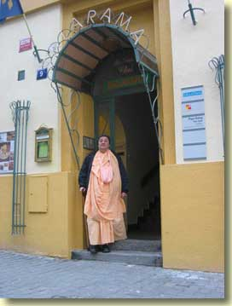
  At the entrance. and...
  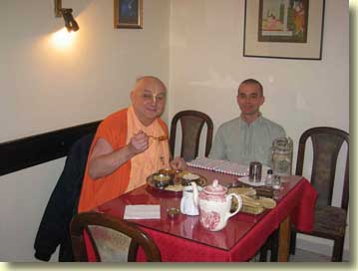
  ...inside with disciple Kasya Prabhu.
HH Bhakti-tirtha Maharaja Update
Haribol Devotees, friends and well wishers,
Please accept our most humble obeisances
All glories to our beloved Gurumahahraja
All glories to ISKCON Founder Acharya Srila Prabhupada
Maharatha Prabhu, I just read your letter, thank you very much for your encouragement. You also inspired me to send some words out to everyone.
I am sorry I have not writeen anything thus far, the challenge is we still dont have a clue more than we did on Wednesday regarding whether the cancer has spread.
Gurudeva had the ultrasound of the liver and xray of his lungs because he was having a difficult time breathing. We were told by his doctor that we will have the official result of the ultrsound on Monday.
Gurudeva's doctor from Mexico will be coming here to Hawaii to see him next week Dec 1st-3rd . At that time we hope to get more clarity on the swelling of his foot as he is experiencing some pain and it is getting more difficcult for him to walk.
As soon as we know something definite we will definitely inform everyone.
Gurudeva is somewhat tired both physically and mentally with the illness. At night it is more difficult for him to sleep because his foot hurts and also shakes. I could go on however what is really important is that Gurudeva is depending on all his disciples to support each other during this critical time.
Thank you
With love
Vrajalila
Interesting, but rather weird, news report from India...
India's "suicide tree" is also a tool for murder
PARIS (AFP) - An Indian tree with poisonous fruit is used by more people to commit suicide than any other plant in the world and has a barely-investigated role in murder, French and Indian scientists say.
In one Indian state alone, deaths from the Cerbera odollam tree are running at an average of almost one a week, they say.
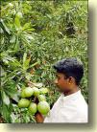
According to their investigations in the southwestern state of Kerala, 537 deaths can be attributed to odollam poisonings in the 11 years between 1989 and 1999, with the annual toll running from 11 to as high as 103.
"The odollam tree is responsible for about 50 percent of the plant poisoning cases and 10 percent of the total poisoning cases in Kerala," say the team, led by Yvan Gaillard of France's Laboratory of Analytical Toxicology.
"To the best of our knowledge, no plant in the world is responsible for as many deaths by suicide as the odollam tree."
Between 70 and 75 percent of suicide victims are women, raising questions about marital strife and in-law problems in India, and the fruit "is also occasionally used for homicide," according to their probe.
The odollam tree grows to a height of 15 metres (48 feet), with dark green lives and a milky white latex sap.
It has large white flowers with a delicate, jasmine-like perfume and a fruit that, when still green, looks like a small mango and is sometimes eaten by children, with tragic consequences.
Those who commit suicide mash up the white kernel with sugar and eat it, while for murder, "a few kernels are mixed with food containing plenty of chillies to cover the bitter taste of the poison. Death is likely to occur three-to-six hours after ingestion."
Odollam's weapon is a toxin called cerberin, which works by stopping the heart, which is why many poisonings -- unless samples are tested by liquid chromatography and mass spectrometry -- are likely to to be written off as fatal heart attacks, Gaillard's team say.
The risk of using odollam for suicide or worse may also apply in countries where it does not grow naturally, because the fruit may be brought in by the Asian diaspora, Gaillard's team says.
Odollam is "an extremely toxic plant that is relatively unknown to western doctors, chemists, analysts and even coroners and forensic scientists."
Their study is published in the October issue of a US publication, the Journal of Ethnopharmacology. The British weekly New Scientist reports on the findings in next Saturday's issue.
C. odollam grows in coastal salt swamps and creeks in south India and along riverbanks in southern and central Vietnam, Cambodia, Sri Lanka and Myanmar. In Kerala, the tree is known as othalanga maram, while in the adjacent state of Tamil Nadu it is known as kattu arali.
In Southeast Asia, where the oily seeds are used as insect repellent or are burned for light, the common names for it are pong-pong, buta-buta or nyan.
One of its relatives, Cerbera venenifera, grows widely in Madagascar, and was used as an "ordeal poison" in previous centuries to determine guilt or innocence among suspected witches or groups accused of plotting against the king.
In Madagascar's central province, as many as 6,000 people are thought to have died in a single ordeal, according to a 1991 study.

Prague, Czech Republic
29 November 2004

Hare Krsna Maharaj,
please accept my humble obeisances.
AGTSGASG. AGTSP.
Maharaj, I just met my friend whom i had preached some years back and he is still chanting 16 rounds but otherwise not in a good spiritual mood. Yesterday we had a discussion and he had a doubt that why Krsna gives us suffering if we dont want to be with him. He says he wanted to enjoy without Krsna and when i told him its not possible he says then where is he free will because there are only two ways: be with Krsna and be happy or suffer without Him so he says there is no free will for he has to be go for the first one even if he himself wants to opt for the second one because he thinks he can enjoy there. He also thinks that there are many things he wanted to achieve which are on the other path.
I didnt argued with him for long. Would you please give more input in this regard Maharaj.
His statement expresses a concept of God that more resembles the Yahweh of Judeo-Christianism than the Krsna of Gaudiya Vaisnavism. In J-Cism, it's God that does the punishing. But in G-Vism, it is maya.
"If we are meant to serve Krsna, why did He create maya?" a Godbrother of mine once asked Srila Prabhupada. HDG replied, "Krsna did not create maya, you did. " That is a fact. In tattva (truth), there is only Krsna and His yogamaya (internal potency). But as He declares in chapter 7 of Gita, naham prakasa sarvasya yoga maya samavrtah, "I am never manifest to the foolish, for my yogamaya pushes them away. "
For foolish souls who desire to enjoy sense gratification instead of the real happiness of loving exchange with the Anandamaya Purusa, Bhagavan Sri Krsna, yogamaya, the spiritual potency, acts as mahamaya, the material potency. That is how she reciprocates with the foolish souls' ignorant, selfish plans to become so-called enjoyers. Actually there is no maya except yogamaya. Maya is just yogamaya playing as mahamaya. And she does this because of the choice of the jiva.
As mahamaya she helps the jiva forget all about Krsna, which is the next stop for your friend if he doesn't shape up. When he's forgotten all about Krsna, then he can exercise his so-called free will without this doubt that troubles him now.
It's all up to his desire. So he cannot argue that there is no free will. There is, but because he is not God, his choice is limited. Choosing maya instead of Krsna means to choose to try to be God. Under the illusion of "I am God" it seems that the soul has unlimited free will. As I said, if he desires this strongly enough, that is precisely what your friend will get by maya's grace. But what he will get is really just an illusion.
He cannot blame Krsna for imposing this illusion upon him. Krsna is the reservoir of transcendental pleasure, and He wants your friend to be happy. When your friend argues "I want to enjoy separately from Krsna," he's really saying "I want to be Krsna. " Problem is, because he is only a jiva, he can't be happy separate from Krsna. Only Krsna is independently blissful. But if your friend insists, then maya will bless him with that illusion that he too can be independently happy. She will even help him enjoy the suffering of being separate from Him.

Prague, Czech Republic
30 November 2004
After I read this astonishing news story, I was so stunned I could only conclude that it speaks for itself. The devotee-parents that I know who have children in ISKCON schools will thank their lucky stars after reading this.
Principals freaked out by students' dance, dress
By Dahleen Glanton Tribune national correspondent
Gaoda McFadden still wonders what all the fuss is about. The way the 16-year-old sees it, the principal overreacted by ending his school's homecoming party early because kids were dancing, well, the way kids dance.
Like many of his friends at Stephenson High School, McFadden sees nothing wrong with bumping and grinding on the dance floor or being sandwiched between two girls with their hips gyrating against him. After all, he said, you can turn on MTV or Black Entertainment Television and see it all day.
"It wasn't at all like what they tried to say. It was juicy," said McFadden, a junior who was present last month when Principal Morcease Beasley abruptly ended the party because of what he called "disgraceful dancing." In teenager talk, "juicy" means exciting.
In an era when sexy music videos and scantily clad pop stars set the standard for many young people, parents and educators across the country are waging what appears to be an uphill battle over values.
Discord over lewd dancing and dress is hardly new, but the goalposts for indecency have shifted radically in recent times. School officials find themselves trying to ban students from sporting gold teeth like rappers and from "freaking," or dancing in ways that explicitly imitate sex. It is a moral challenge in suburban and rural areas where values, as suggested by the 2004 presidential election, have become one of the top issues among millions of Americans.
While each generation pushes the limits, some parents feel that pop culture, fueled by the Internet, Hollywood and cable television, has prodded teenagers further across the line of decency than ever imagined in the 1950s when some wanted to ban Elvis Presley.
These days, some schools are banning certain kinds of dance moves--or canceling dances altogether. Educators are setting strict dress codes as early as elementary school, forbidding girls from wearing skin-bearing outfits such as low-rider jeans, thong underwear and midriff tops and banning attire for boys such as oversized T-shirts and pants that sag, often exposing their backside.
Sandra McGary-Ervin, principal of Sandtown Middle School in Atlanta, said such hip-hop attire, for example, is not only distracting to learning but is potentially dangerous.
"If we were in a crisis and the children had to get out of the building, they couldn't get out quick enough because their pants would trip them up," McGary-Ervin said.
About half of all teenagers between 15 and 19 are sexually active, according to a survey by the National Centers for Disease Control, though statistics show a decline in teenage pregnancy in recent years. Still, parents and educators are alarmed by the sexual content in pop culture and its influence on young people.
Fifties parallels
Some, however, say modern critics of teen dancing and attire are the equivalent of those in the 1950s who wanted to stop Elvis from shaking his hips.
Charles Haynes disagrees. The senior scholar at the First Amendment Center, an Arlington, Va.-based center that works to protect 1st Amendment freedoms, said:
"This is a lot different than the '50s. There are now dances with a lot of body contact in ways that imitate sexual practice. Some schools are teaching abstinence, and if they are trying to send the message that sexual activity is something to be taken seriously and that there are emotional and medical implications for young people who engage in it, then they must do something."
Some schools are teaching courses in "character education," Haynes added, and to teach teenagers "about moral issues and character issues in a very powerful way. It is a movement in education that is spreading across the country."
Like many principals, McGary-Ervin has a dress code at her school. Each morning, she stands at the school's entrance and monitors what the students are wearing: If boys don't have a belt on, she gives them one. If a girl's skirt doesn't reach her fingertips when she extends her arms down her legs, she has to go home and change. Continual violations lead to more serious consequences, including expulsion.
Several districts have banned "Britney Spears-like" clothing and require students to cover their stomachs and backs and not show their underwear. Others, like Chicago, have no districtwide dress code, but allow individual schools to set standards. Chicago Public Schools spokesman Mike Vaughn said there is a broad range, from schools that require uniforms to those that have no rules.
Some officials have tried more drastic measures. A Louisiana legislator unsuccessfully this year tried to get a bill passed as part of the state's obscenity law that would have made it illegal for anyone, not just young people, to wear below-the-waist pants.
School officials in Merrillville, Ind., near Chicago banned pink clothing and accessories for middle and high school students, fearing that gangs had adopted the color. Though there was no evidence of gang activity in the district, officials said they had noticed many students wearing pink, so they issued the ban as a precaution.
In Augusta, Ga., high school students cannot wear large belts, sagging pants or removable gold or platinum bridges that cover their front teeth--a style popular with rappers.
"We have things such as gangs that spill over into the school, so we have to deal with it," said Richmond County Schools spokeswoman Mechelle Jordan. Getting youngsters to follow rules prepares them for the workforce, too, she added.
One of the biggest challenges school officials have dealt with in recent years is the sexually explicit dancing known as "freaking," where groups of teens pack together on the floor and simulate sexual moves. Problems have surfaced in numerous cities, including Anchorage, Ft. Wayne, Ind., Palo Alto, Calif., and Norristown, Pa.
The school district in Oceanside, Calif., near San Diego, won't allow songs that have obscene or sexually demeaning lyrics to be played at school functions.
Some principals have eliminated school dances. In some schools, chaperones walk around with flashlights to make sure the dancing does not go too far. Still, when the dance has ended and the lights come on, some principals say, they have found condoms and underwear on the floor.
A committee of parents, teachers and students at Stephenson High School in Stone Mountain, an affluent town on the outskirts of Atlanta, are devising a policy on the kind of dances that can be done and music that can be played at school events. The group, which also will define what students can wear to prom or homecoming dances, was formed after principal Beasley said he had tried for three years to get students to conform.
"The student dancing is immoral and reflective of much that is wrong within our society and the base values that are often communicated through our media and that significantly contribute to many of our society's problems," Beasley, who also is a minister, said in an e-mail to parents.
Murray Forman, a professor of communication studies at Northeastern University in Boston, said young people are affected because they are exposed to sexual images continually through the media. He said it is wrong to blame hip-hop music, as some do, for problems that should be addressed at home.
"Hip-hop is part of a media matrix. . . . It is part of the culture and young people are very attentive to it," said Forman, who co-edited a collection of hip-hop articles, titled "That's the Joint! The Hip Hop Studies Reader." He said young people are doing more than "consuming the images," adding: "They are not just replicating what they see in the media, they are making it and reinterpreting it wherever they live."
Students fight back
Though the Supreme Court has sided with schools over issues of dress codes involving children under 18, some students are protesting.
In Purcellville, Va., students at Loudoun Valley High School circulated a petition claiming that the board's decision to ban dancing violated their 1st Amendment right of free speech. In some cities, students have held alternative parties to protest a dance ban at their high schools.
But the homecoming dance was the first party Zecheiah Martin, 16, attended at Stephenson, and she was surprised at what she saw.
"We were around adults and we should carry ourselves better," said Martin, a 10th-grader. "I didn't know people danced like that at homecoming. It looked like people were having sex."

Amsterdam, the Netherlands
2 December 2004
A letter of appreciation
> To: <speak@in2-mec. com>
> Subject: Appreciation
> Date: Wed, 1 Dec 2004 00:09:48 -0000
>
> Dandavats,
> Sir I am a middle-aged Englishman who has
> rediscovered his faith in Lord
> Krishna and Srimati Radharani. I wanted to express my
> appreciation of your
> site,and the inspiration it gives to one who does
> not live a surrendered
> life like yours.
>
> Namaste, Peter Bartlett.
>

Amsterdam, the Netherlands
3 December 2004
Lecture at a College in The Hague
02 December 2004
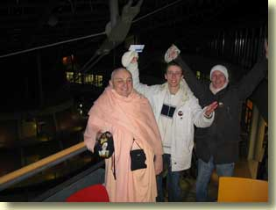
With Bhaktas Jerry and Michael, in front a backdrop of space age architecture.
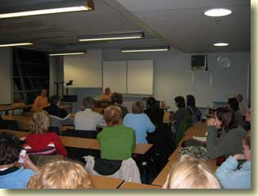
These students are training to become elementary school teachers. I spoke on the necessity of higher philosophy and character education in today's world. Good questions at the end, and email feedback assured me that the class was very satisfied with my presentation.
HH Bhakti-tirtha Maharaja Update
Dear Godfamily, friends and well wishers,
Please accept our most humble obeisances
All glories to our beloved Gurumaharaja
All glories to ISKCON Founder Acharya Srila Prabhupada
In our last letter we informed everyone that we will give the details of Gurudeva's situation in a couple days.
MONDAY Nov.29th
Monday was an extremely busy day for Gurudeva, he and Ekavira Prabhu accompanied by one of Gurudev's godbrothers, who offered to drive Ekavira and Gurudeva, left early in the morning to take Gurudeva to a town an hour away for some treatments. That evening, Guurmaharaja had an appointment that was scheduled by the recommendation of his Doctor here in HAwaii, to see a wound specialist. After examining the wound she informed us that the wound was healing nicely however the foot was hot up to the knee, this was a concern for her. Ekavira Prabhu then took Gurudeva's temperature, it was 102. The wound specialist called the doctor, we took Gurudeva to see the Doctor, he examined him, then immediately admitted him to the hospital, bypassing going to the emmegency room. The doctor's explanation was that Gurudeva may have another infection, this time possibly in the foot. We stayed with Gurudeva in the hospital until the nurses had finished with the usual--- drawing of blood, vital signs, and administering the antibiotic IV. We hoped Gurumaharaja could sleep a little more comfortably.
Tuesday Nov.30th
Gurudeva is in the hospital. In the morning when we spoke to him, he had a difficult night, the foot was twitching and paining, his breathing is still difficult and he has a cough, he had dificulties sleeping. In the afternoon, we left for the hospital with Gurudev's lunch, and anxious to hear the reports from the morning doctor. GOOD NEWS.... One of the nurses gave Gurudeva the results of his ultrasound and the catscan. There are no traces of cancer in the liver or the lungs. The cancer that was in the liver initially had totally disappeared. Ekavira and I were happy, but we tried to remember to be equiposed in happiness and distress, because the foot is still a BIG problem. We silently thanked Srila Prabupada and Krsna for it seems that it is not time for Gurudeva to leave. Gurudeva was also relieved, because he is torn with staying and wanting whatever Srila Prabhupada wants.
Wednesday Dec.1st
Gurumaharaja is still in the hospital. Today his doctor arrives from Mexico. Gurudeva's godbrothers and godsisters are reaching out, H.H. Bir Krsna Maharaja, Malati Devi, H.H. Rtadvajna(sp) called to check on Gurudeva. It is always so comforting to speak with these dedicated senior vaisnavas. Mahesh Prabhu offered to pick up Gurudeva's doctor as he arrived at the airport that is an hour away from where we are presently staying.
MEETING WITH GURUDEVA and THE DOCTORS in the Hospital:
Last night Dr. Wong one of the surgeons here at the hospital in Hawaii, and Tony Jiminez, the doctor from Mexico examined Gurudeva's foot and the lymph nodes in his leg area. The suggestion of this meeting after thorough examination is that Gurudeva should request a biopsy on the foot, so that there can be 100% confirmation that it is only Melanoma in his foot, Dr. Tony think there could possibly be a fungus growing in his foot, in addition to the melonoma or perhaps it may be the fungus that is creating all these problems. After the results of the biopsy, if it is only Melanoma, then the suggestion from both doctors was that Gurudeva should consider amputation of the foot. The reasons for this decision are:
1. The present tumor on his foot is extremely big and it is stressing out the rest of Gurudev's body.
2. He would have a better chance of the cancer not spreading to other parts of the body.
3. He would live longer and have a better quality of life. He would walk with a prosthesis.
Guurdeva has a lot to think about. He shared some thoughts of going to Mayapur now, rather than go through all the drama, however Dr. Tony who is quite spiritual, spoke with him about all the things he could offer if he makes the decision to stay on the planet. We left the hospital late last night with Dr. Tony who we are hosting for the next two days.
Thursday Dec 2nd.
Ekavira had to pick up Dr. Tony at 6:00am to take him to the hospital. (we have a wonderful sharing about where Dr. Tony is staying, please remind ius to share this pastime later) Dr. Tony is meeting with Dr. Keeney in Gurudeva's room this morning at 7:15am. Tony wanted to go over Gurudeva's chart with Dr.Keeney. I stayed at the house so that I could update all of you, as I know it can be so stresful just waiting to hear what is going on with Gurudeva.
We will keep you updated. Please continue praying.
Your aspiring servants
With love
Ekavira and Vrajalila

Amsterdam, the Netherlands
4 December 2004
Had a recent email exchange with HG Jayatirtha Caran Prabhu. He uses these interesting definitions in his preaching:
Mantra: is from the Sanskrit prefix "MAN" (mind) and the suffix "TRA" (tool) is literally the science of using sound vibration, audible and inaudible, to bring about the physical, psychological and psychic changes. Our Guru often used to refer to Mantra as a "psychic elevator'" that changes levels of consciousness.
Yantra: is from the Sanskrit prefix "YAN" means "to conceive", a mental conception. So Yantra is also a "tool" or more accurately an "instrument" that allows us to visualise a complex geometrical form (RUPA) or trace out a two-dimensional psychic circuit, otherwise known as a "magical diagram".
Tantra: is the "tool" for dealing with Prakrit or the solid physical world as manifested by and experienced through the Annamayakosha (literally, "the food sheath or physical body"). The Sanskrit root "TAN" suggests extension and attenuation, giving us such English words as "tender". Hence, I will define Tantra as TANgible, TRAnscendence utilising Prakrit as it manifests though the five senses. In other words TAN-TRA is the sublime state that ensues when the mind [Manes], the Ego (Ahamkara and the intellect (Buddhi), become quiescent through a (W)holistic, Sattwic, aesthetic experience of sensory fusion.

Cosmology--the branch of modern science that attempts to inform us about the nature of the universe--is theory-based. That means that cosmologists start with a speculation. They add to that some observational data, and hey presto: here's a recipe for what the universe is and where it came from.
For 20 years, the Big Bang theory has been the only scientifically respectable explanation of the origin of the universe. It used to have a competitor, called the steady-state theory, but that fell by the wayside when the so-called background radiation of the universe was measured. This background radiation--a sort of heat signature supposed to pervade all of space--was identified as the leftover "bang" from which universe arose. It serves as the main evidence that the Big Bang theory is correct.
Like women's hats, theories, however fashionable, gradually lose their hold on the mind until they look ridiculous. The prestigious science magazine Nature of 22 May 2004 published a statement signed by 33 prominent international scientists arguing that it is high time for the Big Bang to go the way of the leopardskin pillbox hat. Their main objection is that it continues to stand on center stage only because its advocates keep it propped up by some very big and very hypothetical assumptions.
These assumptions are 1) dark energy, 2) dark matter, and 3) inflation. None of these have actually been observed. Without the first, Big Bang theory predicts a universe younger than many of the stars in it. Without the second, it makes wildly wrong predictions about the density of the universe. As it stands, the matter of our material world is 20 times less dense than it should be according to Bangism. So Bangists have to draw dark (i. e. invisible) matter up from the wishing well to make up the shortfall. Most interestingly, the third item, inflation, is needed to account for the smoothly-distributed background radiation. In other words, even the foremost proof of the Big Bang does not actually support the theory except for the pulling of the inflation rabbit out of the magician's hat.

Yes, but as somebody might argue, better to believe in the Big Bang than to wear the label of a fundamentalist who believes in the Bhagavatam explanation of cosmic creation. All right, instead of acknowledging Brahma-Visnu-Siva as the cosmic creator-maintainer-destroyer, you can do your puja to the metaphysical trimurti of dark energy, dark matter, and inflation.
In addition, the 33 scientists point out that there is a wealth of inconvenient data from outer space that does not fit the Big Bang model. Another problem is that from its beginning it predicted exactly nothing that was later observed to be true. Even its old rival, the steady-state theory, made predictions that have been verified.

Amsterdam, the Netherlands
5 December 2004
In Srila Prabhupada Uvaca Srutakirti Prabhu writes:
"Sometimes, the snake's mission is to kill a certain person," he [Srila Prabhupada] told us. "They will not stop until they succeed. Particularly at the end of the snake's life, sometimes, the snake grows wings. He has a particular person he is to kill. The snake will kill that person and then it goes off to die. "
One evening Srila Prabhupäda pointed out a particular sound in the stillness of the night.
"Hear that sound?" he asked. "That is the snakebird. It has a special sound. "
Once the mother of a devotee, worried that her son was obliged by his membership in ISKCON to believe in weird notions like flying snakes, wrote to a herpetologist. He answered that there most definitely is no such thing as a flying snake. She sent her son a copy of the letter.
Well, it turns out there is a species of snake called Chrysopelea that does have the ability to glide through the air. Now, this is not the snake Srila Prabhupada spoke of, for it doesn't really have wings. But it does fly, after a fashion, and it does live in India. There are numerous websites that offer information about this snake, complete with videoclips of it flying. Here's a summary from one such site:
Flying snakes are a small group of species of tree snakes that live in South and Southeast Asia. At rest they appear unremarkable, but on the move they're able to take to the air by jumping from the tree, flattening the entire body, and gliding or parachuting to the ground or another tree.
In the field of cryptozoology (the study of animals not yet scientifically classified), other kinds of flying snakes are under investigation. For example, there are accounts of a winged snake native to Wales. The Navajo Indian people of the American Southwest are very sure that a type of winged snake inhabits their land.

Amsterdam, the Netherlands
6 December 2004
Here's some quotations written by a person who suffers from NPD, Narcissistic Personality Disorder. Narcissism is a psychological condition in which a person is unhealthily self-absorbed. I took these quotations from a few different articles, and separated them with subheadings of my own.
Some basic symptoms
Prone to magical thinking, the narcissist is deeply convinced of the transcendental meaning of his life. He fervently believes in his own uniqueness and "mission". He constantly searches for clues regarding the hidden - though inevitable - meaning of his personal life. The narcissist is forever a "public persona", even when alone, in the confines of his bedroom. His every move, his every act, his every decision and every scribbling is of momentous consequence. The narcissist often documents his life with vigil, for the benefit of future biographers. His every utterance and shred of correspondence are carefully orchestrated as befitting a historical figure of import.
This grandiose background leads to an exaggerated sense of entitlement. The narcissist feels that he is worthy of special and immediate treatment by the most qualified. His time is too precious to be wasted by bureaucratic trifles, misunderstandings, underlings, and social conventions. His mission is urgent. Other people are expected both to share the narcissist's self-assessment - and to behave accordingly: to accommodate his needs, instantly comply with his wishes, and succumb to his whims.
The narcissistic "guru"
The narcissist is the guru at the center of a cult. Like other gurus, he demands complete obedience from his flock: his spouse, his offspring, other family members, friends, and colleagues. He feels entitled to adulation and special treatment by his followers. He punishes the wayward and the straying lambs. He enforces discipline, adherence to his teachings, and common goals. The less accomplished he is in reality--– the more stringent his mastery and the more pervasive the brainwashing.
The – often involuntary – members of the narcissist's mini-cult inhabit a twilight zone of his own construction. He imposes on them a shared psychosis, replete with persecutory delusions, "enemies", mythical narratives, and apocalyptic scenarios if he is flouted.
The narcissist's control is based on ambiguity, unpredictability, fuzziness, and ambient abuse. His ever-shifting whims exclusively define right versus wrong, desirable and unwanted, what is to be pursued and what to be avoided. He alone determines the rights and obligations of his disciples and alters them at will.
Narcissism and depression
Many scholars consider pathological narcissism to be a form of depressive illness. This is the position of the authoritative magazine "Psychology Today". The life of the typical narcissist is, indeed, punctuated with recurrent bouts of dysphoria (ubiquitous sadness and hopelessness), anhedonia (loss of the ability to feel pleasure), and clinical forms of depression (cyclothymic, dysthymic, or other). This picture is further obfuscated by the frequent presence of mood disorders, such as Bipolar I (co-morbidity).
Narcissim and the Internet
To the narcissist, the Internet is an alluring and irresistible combination of playground and hunting grounds, the gathering place of numerous potential Sources of Narcissistic Supply, a world where false identities are the norm and mind games the bon ton. And it is beyond the reach of the law, the pale of social norms, the strictures of civilized conduct.
As you may have guessed by now, I personally find that these descriptions of NPD hit very close to home. There are even more revelant articles. One is about narcissism and religion. Yes, religion is an area that offers unhealthy opportunities to the narcissist.
Scary. He's written dozens of articles and several books on this subject. There's no cure for NPD, he says. A person who suffers from narcissism, must try to live with it in as healthy a manner as possible. So--do you think that translates into Krsna conscious terminology as "engagement"?--e. g. "You should engage your propensity in Krsna's service, Prabhu. "
Srila Prabhupada writes (SB 1. 10. 30p):
The devotees of the Lord are purified souls. As soon as the devotees surrender unto the lotus feet of the Lord sincerely, the Lord accepts them, and thus the devotees at once become free from all material contaminations. Such devotees are above the three modes of material nature. There is no bodily disqualification of a devotee, just as there is no qualitative difference between the Ganges water and the unfilthy drain water when they are amalgamated.
Sincere surrender is stipulated here. And, if it is truly sincere, such surrender will be accepted by the Lord. Then like drain water that has entered the Ganges, the "material" aspects of a devotee's life are purified. Often it is asked, "What does it mean to be sincerely surrendered to the Lord? How do we know that the Lord accepts our surrender?"
Yasya prasada bhagavat prasado. . . The mercy of the spiritual master is essential to sincere surrender. Sheltered by that mercy, then iha yasya harer dasye. . . One who engages in the transcendental service of the Lord in body, mind and word is to be considered liberated in all conditions of material existence.
Yasyasti bhaktir bhagavaty akincana sarvair gunais tatra samasate surah. All good qualities manifest. If you remain with the fire, you become warm. The quality is acquired. If you remain in the sunshine, you become warm. Because sun is warm. So you acquire the quality. So if we remain always with Krsna, then we acquire the qualities of Krsna. So God is all-good. Therefore I become good, by association with God. It is very simple reasoning. Yes. God is all-good. So if you remain always with God, then you become good. The same example: if you remain with fire, you become warm, the quality of the fire. If you remain in sunshine, you become warm. (12 July 1973 room conversation, London)
Every living entity is already with God, because He dwells in everyone's heart. But to acquire the quality of God, as Srila Prabhupada describes above, one must associate with Him on His terms. When we cling to our own self-concocted terms, we continue to associate with our self-concocted bad qualities.
Our expert on NPD writes:
In my mind, I am not human. I am a machine at the service of a madman that snatched my body and invaded my being when I was very young. Imagine the terror I live with, the horror of having an alien within your own self. A shell, a nothingness, I keep producing articles at an ever accelerating pace. I write maniacally, unable to cease, unable to eat, or sleep, or bathe, or enjoy. I am possessed by me. Where does one find refuge if one's very abode, one's very soul is compromised and dominated by one's mortal enemy-- oneself?
Scary. Hare Krsna!

Amsterdam, the Netherlands
7 December 2004
From the Net:
Shampoo Ingredient Kills Rats' Brain Cells
Mon Dec 6,
By Steven Reinberg
HealthDay Reporter
Experiments with the brain cells of rats show that contact with an ingredient found in shampoos, hand lotions and paint causes neurons to die.
The chemical, methylisothiazolinone (MIT), belongs to a class of compounds called biocides. These are used in the manufacture of many common household products and industrial water cooling systems to prevent bacteria from developing.
According to the National Institutes of Health (news - web sites), brands containing MIT include the shampoos Head and Shoulders, Suave, and Clairol, as well as Pantene hair conditioner and Revlon hair color.
"As far as I can tell, no neurodevelopmental testing has been done on MIT," said lead researcher Elias Aizenman, a professor of neurobiology at the University of Pittsburgh School of Medicine.
Aizenman said he is concerned that without such testing it is not known if, for example, a pregnant woman who is exposed to MIT could put her fetus at risk for abnormal brain development. People working directly with MIT are those most at risk, he said.
In earlier experiments with rat brain cells, Aizenman's team found that direct exposure to MIT in concentrations like those found in hand cream was enough to kill neurons. In the current series of experiments, also with rat cells, the researchers found that a long exposure to low concentrations of MIT caused a malfunction in the ways neurons communicate with each other.
"One of the things that this compound was very good at was preventing neurons from communicating with other neurons," he said.
Aizenman presented his findings Dec. 5 at the American Society for Cell Biology annual meeting in Washington, D.C.
Whether long-term exposure to products containing MIT is dangerous is not known, Aizenman said. "Can I say that these products are safe to use? No," he said. "Can I say that these products are unsafe to use? No."
Aizenman believes that testing needs to be done to determine if MIT is harmful to humans in the concentrations found in household products.
"It appears that the Environmental Protection Agency (news - web sites) [EPA] does not require neurodevelopmental testing," Aizenman said. "That is bothersome. Maybe there are substances that have made it into general use that could be damaging to the nervous system. Regulators need to take a hard look this and require more tests."
The work that Aizenman has been doing "is important in understanding the things that people are exposed to on a chronic, daily basis," said Beth Ann McLaughlin, an assistant professor of pharmacology at Vanderbilt University.
McLaughlin added that people using products containing MIT should be skeptical. "There is a healthy dose of skepticism that needs to come when using any products or being intensely exposed to any compound," she said.
"These findings are expected," said Gerald McEwen, vice president for science at the Cosmetic, Toiletry and Fragrance Association. "MIT is a biocide. The purpose of it is to kill bacteria. You would expect it to be detrimental to any type of cells."
McEwen said that direct exposure to high concentrations of MIT will be irritating to the skin, because it can damage skin cells. However, he doesn't believe that MIT poses any dangers to consumers in the low concentrations found in household products.
"The ability of MIT to cause neurotoxicity has been studied," McEwen said. In animals exposed to MIT, there has been no hint of neuro-damage, because MIT affects only the cells it touches and there is no way for it to get into the bloodstream and go to the brain, he said.
"It can't get to your brain cells, period," he emphasized.
MIT has been approved as a biocide by the EPA, which looked at the neurological effects, McEwen added. This information was published by the Cosmetic Ingredient Review, an industry program that reviews the safety of cosmetic ingredients, he explained.
However, McLaughlin remains concerned. "The quantity of compounds that we can make that make the quality of life wonderful, in the short term, is growing," she said. "But we are lagging in our understanding of what those compounds can do to our health and our children's health."
Mystics Can Pocket a Million--When Pigs Can Fly
By Sven Nordenstam
STOCKHOLM (Reuters) - A sworn enemy of superstition, Canadian-born magician James Randi has thrown down the gauntlet to mystics, promising $1 million to anyone who can prove supernatural powers or a phenomenon beyond the reach of science.
An arch-skeptic who demonstrates with his own sleight of hand how easily it is to dupe the gullible into mistaking trickery for the supernatural, the bearded 76-year-old has written nine books and lectured at the White House, NASA and several top U.S. universities.
The million-dollar "paranormal challenge" lends publicity to Randi's life-long mission.
His pursuit of skepticism was sparked by a visit to a spiritualist church in his native Toronto when he was just 15.
Already an amateur magician, he was upset at seeing "common tricks" pass for divine intervention. But his attempts at enlightening the churchgoers cost him four hours questioning at the police station.
Sixty years on, Randi is still trying to persuade people to give up their belief in mystic forces beyond their control.
"It's a very dangerous thing to believe in nonsense. You're giving away your money to the charlatans, you're giving away your emotional security, and sometimes your life," he explained in an interview before giving a lecture in Stockholm.
A MAN OBSESSED
Deeply concerned with the spread of beliefs not based on the principles of science, Randi is especially worried about the growing popularity of exotic cures and therapies catering to sick people who are then lured away from effective treatments.
"It's a mission, and also an obsession," he said.
The challenge also serves to dent the image of professional psychics, as they so far have balked at the chance to win the million.
"They offer all kinds of strange excuses," he said.
On a European tour of Germany, Italy, Ireland, Belgium and Sweden, Randi tested people who wanted to go for his million. Most applicants sincerely believe they have supernatural gifts, the vast majority claiming to possess the power of dowsing -- the ability to detect water with the help of a cleft stick.
Dowsing has never been proved to work in a controlled setting, said Randi.
"But no one ever changes their mind," he said, recalling only one single case throughout the years where a man backed down from his claim after being tested.
At a lecture to promote critical thinking, a Swedish audience of about 300 applauded and laughed as Randi blasted away at astrologers, homeopathists, faith healers and psychic mediums, accusing them of defrauding the sick and the desperate.
Riddling his performance with tricks--divining the symbols on cards put in an envelope by an apparently randomly chosen audience member--Randi says his own expertise at "magic" helps him expose fraudsters.
"As a magician I know two things -- how to deceive people and how people deceive themselves."
OFFENDING SPOON-BENDERS
On one particular night Randi was in the company of hundreds of cheering fellow skeptics, but not everyone appreciated seeing their beliefs shattered.
"I get threats all the time. I don't answer the door unless I know who's there," he said.
His most famous adversary is Uri Geller, the Israeli psychic who became a celebrity in the '70s for bending spoons. Geller sued him for libel for his book "The Truth About Uri Geller." It has cost Randi a fortune in legal fees, but he has not yet been able to get the book removed from the shelves.
Randi demonstrated to a reporter how he too is capable of mystically mistreating cutlery, but as a magic trick.
He carefully pointed out that he does not deny Geller might have supernatural talent -- just as he does not rule out the existence of supernatural phenomena.
"If Geller does it by divine power, he does it the hard way," he said.
Randi said he would be happy to hand over the prize if presented with solid evidence.
"That would be such an advance for our knowledge of the universe that it would be well worth $1 million," he said. "The possibility is very, very small, but it's there."
The prospects for the mystically minded don't look too rosy, though. The James Randi Educational Foundation, based in Fort Lauderdale, Florida, has tested hundreds of applicants. But no one has ever passed even the preliminary tests.
On the lapel of his jacket, Randi wears a pin with the mascot of the organization, a winged pig called Pigasus.
"We say that we will give away the million dollars when pigs can fly."

Amsterdam, the Netherlands
8 December 2004
From Teaching of Lord Caitanya Chapter 13
In Bhakti-rasamrta-sindhu (1. 3. 1) the state of being in love with the Godhead is compared to the sunshine emanating from the sun; this shining makes the devotee's heart more and more lovely. The heart of such a devotee is situated in a transcendental position beyond even the mode of goodness. The process for making the heart even more sterilized by the sunshine of love is called bhava. A description of bhava is given by Rupa Gosvami. Bhava is called the permanent characteristic of the living entity, and the crucial point of progress for bhava is called the marginal state of love of Godhead. When the bhava state becomes deeper and deeper, learned devotees call it love of Godhead. As stated in the Narada-pancaratra:
ananya-mamata visnau
mamata prema-sangata
bhaktir ity ucyate bhisma-
prahladoddhava-naradaih
"When one is firmly convinced that Visnu is the only object of love and worship and that there is no one else--not even a demigod worthy of receiving devotional service, one feels intimacy in his love relationship with God, and this is approved by such personalities as Bhisma, Prahlada, Uddhava and Narada. "

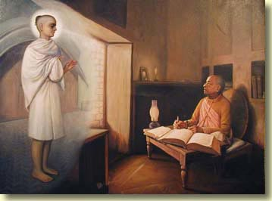
Srila Rupa Goswami blessings Srila A. C. Bhaktivedanta Swami Prabhupada

Amsterdam, the Netherlands
9 December 2004
Dear Vaisnavas
Please accept my humble obeisances.
All glories to Srila Gurudeva and Srila Prabhupada!
Vraja Lila prabhu may still send in an update but I'm going to share some of what is happening as she and Ekavira are preparing to leave Hawaii right now. We spoke on the phone yesterday and I took a few notes on the situation. Forgive any weakness of memory.
Gurudeva was still in the hospital yesterday. The foot has increased in size. Tests have been run on his foot checking for blood clots but they were negative. He was feeling weak and his hemoglobin was low. He's had two blood transfusions to try and restore some strength.
This past weekend, Gurudeva met with his doctor from Mexico and the doctor he was working with here in Hawaii. As VL mentioned in her last email the main suggestion was to aputate the foot. Gurudeva has agreed to the amputation.
When we spoke, the location of where the surgery would be done was still being decided. VL said Madhavacarya prabhu was helping make some arrangements in the DC area. We spoke again briefly last night and it appears this is where they are going. The surgery would also include a removal of the lymph nodes in the groin so they can be dissected.
Let's continue to chant, pray and come together to help Gurudeva and elevate our service to him and Krsna.
much love
Maharatha dasa
Honolulu, Hawaii
Dear Maharaja and devotees,
Please accept my humble obeisances
All glories to ISKCON Founder Acharya Srila Pabhupada
By now you have heard that I had to go back into the hospital. During my stay there, I received two blood transfusion, and a series of additional tests. The sonogram and catscans gave us information of what is directly going on with the cancer. The other tests were to find out why I am always extremely tired and having constant breathing problems. I seem to be always gasping for breath, even when I brush my teeth or shave. The foot is still swelling, actually I am unable to walk due to pain in the foot and the breathing problem. Of course the good thing is that the cancer that was in the liver when I arrived in Mexico has disappeared from doing the alternative treatments. The cancer that was suspected to be in the lungs was also negative from the test results. However, we are now back to the original problem--- heavy concentration of melanoma in the foot and lymphs in the groin. Our present plan is for me to get stronger,to build up my immune system in preparetion for amputation of the leg, although there is still a 50% possibility that the cancer can still spread. However if I am to stay in this body, then I will have the amputation close to the knee. Of course in these last two days a miracle can happen, at the same time I am seeing that some miracles have already happened. For example, the cancer did not spread to other parts of the body, and the fact that Srila Prabhupada and Krsna sent so many caring doctors and nurses that went out of their way to assist me. An even greater miracle is the large number of devotees around the world that have been praying for me and sending their love. I am so fortunate, I am constantly feeling the love from the vaisnava Community. I am sure I will still find a way to dance if the operation is successful, I will get a flamboyant prosthesis that will have mystical powers. (smile) My constant mantra now is : "I am blessed by the best and praying to Srila Prabhupada and Krsna that I pass all the tests". I do have a more conditional prayer that is posted in my bathrooms in Maryland and Gita Nagari. I would like to share this prayer with all of you. This prayer is in no way as simple as the prayer I offered to Srila Prabhupada and Krsna asking Them to let me experience whatever I need to experience to become a better servant of Theirs and the Vaisnavas.
Yours in service to Srila Prabhupada
With Love
BTSwami
P.S. A couple days ago I was still thinking that I would simply go to Mayapur and fast to make a quick transition from the body, but I realized this would be imposing my own will on Krsna's plan. With so much suffering from the body, it is easy to get excited with the opportunity to get out of the body.

Amsterdam, the Netherlands
10 December 2004
The Lesson of Krsnadasa
. . . the Lord’s associate, an irresolute brahmana Krsnadasa with an unsteady mind, fell into their clutches and forgot that being a servant of Mahaprabhu is supreme and the only dharma of the living entity. The Lord, the rescuer of the poor, grabbed him by the hair and thus liberated him from these servants of maya, proving that He is worthy of the predicate ahaituki-krpa-sindhu, or “the ocean of causeless mercy. ”
--From the Anubhasya commentary of Sri Caitanya-caritamrta Madhya 1. 112 by Srila Bhaktisiddhanta Sarasvati Thakura.
The Bohemians of those days,
Bhattatharis as they were known,
tempted Krsnadasa away
from the straight path back to Home.
Under the cover of the night
he made, restless, for the camp,
led by a bearded cenobyte
whispering "Eager women, powerful hemp. "
Why call them Bohemians?--go back to Century XII,
University of Paris enrollees
from Bohemia raised the most hell--
"Bohemian" so came to mean a saint of all unholies.
An easy path to go,
so-called way to liberation,
Mystical overtones
Dressing up gross sense gratification.
But Mahaprabhu-krpa blazed up,
to dispell all the haze--
Krsnadasa yanked from the wicked
and restored amongst the saved.
With weapons raised they charged,
these wild-haired Bhattatharis,
to do Mahaprabhu grave harm
for plucking a soul from iniquity.
Sharp blades leaped from their hands
to gouge their own sinful flesh.
In dismay they screamed and ran
to what fate we can only guess.
Krsnadasa, place restored,
later endured a heavy shame,
when the Lord His associates informed
of His servant's double game.
Vaisnava divine grace--
to reject is not the way--
they found poor Krsnadas a place
in bhakti to remain.
As it was, so it is,
Bohemian moksa pandered on the cheap,
Weak of mind seek Kali's compromise,
so much confusion there to reap.
Weak and lead astray,
a Kali-yuga fool--
I beg to be pulled away
from maya's hellish rule.
On this day I pray to Thee,
Lord Caitanya, my life do guard!
I swear to shun the Bhattatharis'
Seduction of my heart.
Raise my arms, raise my voice,
the holy names to sound!
However far one falls there is still a choice
to regain the soul's lost ground.
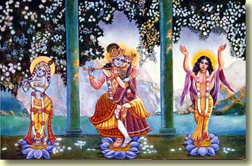

Amsterdam, the Netherlands
11 December 2004
A story of Jesus about rasa
In the Gospel of John, there is a story about Jesus' passing through a town called Sychar in Samaria. It was here that at mid-day, apparently weary from his travels, Jesus stopped at Jacob's well. A Samaritan woman came with a water jar to fill it. Jesus asked her to give him a drink. Sarcastically she asked why a Jew was asking a Samaritan for water.
The background is that both the Jewish and Samaritan communities claimed to be descended from the nation of Israel; but neither community approved of the other. The Jews believed Jerusalem to be the only true place of worship, while the Samaritans worshiped at Mt. Gerizim. More than a century before the time of this story of Jesus at Jacob's well, the Jews had destroyed the Samaritan temple at Mt. Gerizim. It was because the Jews thought the Samaritans to be impure in their religious practices that the woman demanded to know why Jesus asked her for water.
In spite of her sarcasm, Jesus did not desist. He assured her that his teaching were for everyone, Samaritans too. As they conversed, he told the woman things about her life that she had tried to keep hidden from others--that she had five husbands, and that the man she was with at present was not one of these to whom she was married. Instead of being offended, the Samaritan woman was astonished. She wondered if this Jew waiting at the well was a prophet.
Jesus spoke to the woman of a spring of water that welled within her up to eternal life. He said if she drank of this water, she would never thirst again. This water is different from ordinary water, which cannot permanently quench thirst.
Leaving her jar by the well, the Samaritan woman hurried to the town to tell her neighbors about this mysterious man. For two days Jesus stayed in Sychar to preach. The people welcomed him as their savior.
It can be seen that this story is about rasa. In the Vedic analysis, each element is associated with a kind of sense-experience. Water (apa) is associated with taste (rasa). When Jesus spoke of a spring of water that rises up within the soul to eternal life, which quenches thirst for good, he was indicating the higher rasa or taste of love of God. Thirst (in Sanskrit, trsna) is used in the Vedic scriptures to indicate unsatisfied, lustful desire--see for example Bhagavad-gita 14. 7. When Jesus pointed out the six relationships the woman was secretly maintaining, the purpose was to teach her that despite all these attachments she was keeping with men, she was still not satisfied.
At the end of the story, her leaving the water jar at the well is significant. She realized that the water of the well would not satisfy her. Enlivened by the higher taste that Jesus provided by his words, she ran to tell the whole town that at Jacob's well the water of eternal life was now being supplied by the Christ.

Amsterdam, the Netherlands
12 December 2004
Letter from HH Bhakti Tirtha Maharaja
Dear Maharaja and Prabhus,
Please accept my humble obeisances
All glories to ISKCON Founder Acharya Srila Prabhupada
Sending updates is rather difficult, because there is always some good news, some surprises, and seemingly bad news. My situation changes from day to day. Before leaving Hawaii, I was admitted again into the hospital for six days having to undergo blood transfusions and a host of other tests. Upon returning to Dasaratha's house I took a few steps on my crutches and immediately collapsed. My body is extremely weak. A short time later, I realized I had an accident and had to get cleaned up. While lying in bed that night I was thinking I was experiencing so much discomfort and suffering that I preferred to leave the body, but only if it could also be Srila Prabhupada's desire. After many sleepless nights due to the discomfort, it seemed like it could be so refreshing just to move on. However, I think most of you are praying, as I am, for whatever is best to take place.
The tumor in the foot has grown much bigger and the cancer is getting worse, although the cancer in the other parts of the body are seemingly gone. We are still waiting for he results of one biopsy to see if there is cancer in the lymph nodes in the groin area.
The alternative treatments I was undergoing from 8.00am to 8.00pm were successful in stopping the cancer from spreading to other parts of the body, but has not eliminated the cancer from my foot. The mass of tumor and concentration of melanoma is most significant in the case of the foot.
I am now in the process of scheduling amputation of the foot and part of the leg, also possibly disection of the lymph nodes. According to the doctors, this is a much more difficult operation than the amputation of the foot. In the next correspondence I will inform you about the day and time of the operation.
Once again I see all that I am going through is due to:
1. My desire to understand and assist others with their many different kind of sufferings.
2. My own karma, and my intense journey of purification which is perhaps rough due to my stubborness and contamination.
I requested 100% purity and nothing else, but when you are far from the mark a lot of things has to be put in place to fully alter consciousness.
As most of you know Srila Prabhupada himself once embraced me with tears in his eyes and told me, "Your life is successful." Knowing that Srila Prabhupada does reveal one's original svarupa, I naturally thought perhaps I am not so far from dropping my remaining anarthas. i.e attachments and false ego. These challenges and tests I must now undergo are for purification to transcendence.
Will I stay in the body? or will I leave? only Srila prabhupada knows for sure.
Please try in your own lives to keep surrendering, otherwise if you are stubborn like me, you may also receive some tough love. The beauty is that we want Krsna to speed up all our abilities to become selfless, unmotivated, unconditional servants. Additionally auspicious is knowing that at the end of the road there is even more opportunity to serve Srila Prabhupada's mission in connection with other dimensions. Again I close with my mantra: " I am blessed by the best, and I am praying to Srila Prabhupada and Krsna to pass all the tests."
Yours in service to Srila Prabhupada
With love
BTSwami
P.S. I think this is a special time that Srila Prabhupada is looking out to give additional blessings and empowerment to those who are ready. Be greedy, dont miss out. Yes, there are some unusual statements in this letter, I continue to be persistent in being unorthodox (smile) for many important reasons.
HARE KRSNA

Groningen, the Netherlands
14 December 2004
Jaya Prabhupada!
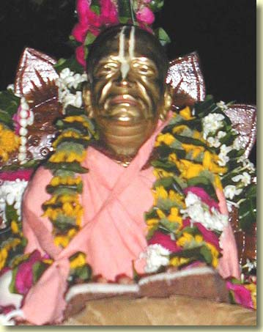

Groningen, the Netherlands
15 December 2004
Krsna! KRSNA! K R S N A !!!!!
There's this cartoon figure that American kids of my generation loved. Tinkerbelle is her name. She's a little golden fairy who darts through the air leaving a trail of magic dust behind her as she goes. She has a magic wand with which she does wonders.
It's a big mistake to think of Lord Krsna, His holy name, in "Tinkerbelle terms. " He's not a busy little magic helper of the so-called needs of the conditioned soul. He's not a mystic of the type that is popular in India today, who smiles benignly and with a gesture or a nod makes everything all right. (The popular mystics don't really make everything all right either. They help a foolish soul misunderstand what his real problem is. )
In Bhagavad-gita Lord Krsna blesses Arjuna by making clear to him where the grief that overcame him at Kuruksetra was rooted. The quick answer to where grief begins is ignorance. But ignorance grows deep roots in the heart in the form of attachment. And attachment, as we can see from Arjuna's arguments to the Lord given in the first chapter, takes on the guise of virtue in material existence. Hence Arjuna's "compassion" for those about to die on the field of battle. Hence his "nonviolence. "
Arjuna lamented because he was attached by ignorance to the unreal. Even Srila Vyasadeva lamented when his son Sukadeva abandoned his home immediately after his birth.
Krsna is the Dark behind the dark behind the dark. What I mean by that is, life is made dark with misery because of attachment. Behind that attachment is the darkness of ignorance. And behind ignorance is Sri Krsna Himself. Not that He forces ignorance upon us. But He does grant the desire of the living entity who, wanting to go the "easy way" (which is really the way of misery), wishes that Krsna was not always there within him. No, this living entity wants to be alone in the heart. He wants to decide for himself, take credit for himself, and enjoy by himself.
So Krsna's blessing to Arjuna was to point out the cause of his grief. This knowledge relieved Arjuna but also annointed him with a duty. Once the Lord shines His light of divya-jnana upon ignorance and attachment, the duty of the soul so instructed is to fight and overcome this same ignorance and attachment under the Lord's guidance. That is the next step.
Srila Prabhupada once explained that a devotee who receives in sincerity this knowledge of Krsna consciousness is fortunate, even if he is weak and falls down. Prabhupada explained that he is weakened due to misusing the instruction of his spiritual master. I think this means that, for whatever personal motives, this devotee does not take the next step.
Knowledge of where ignorance and attachment lies in the heart gives relief and answers for philosophical and psychological problems. But if it does not quicken into action that proves beyond all doubt that ignorance and attachment are defeated, then this knowledge is theoretical. And theory that does not go beyond the mental plane is certainly weak. Anyway, Srila Prabhupada assured that even this stage is fortunate because sooner or later the knowledge will act.
So there's hope.
The Dark behind the dark behind the dark. In the material world, death is the ultimate Dark that swallows our ignorant attachments. Death is Krsna, as He declares in Gita. It isn't morbid or somehow distasteful to meditate upon Krsna in this way. We hurtle closer to death at every moment. It's Krsna consciousness to face the fact that this ultimate meeting with Him is getting closer and closer as we breath.
I think of Dronacarya as a man of knowledge who forgot this truth. He was learned enough to be Arjuna's teacher, but he remained in the employ of the forces of ignorance and attachment--the Kurus. It was a comfortable material situation. So comfortable that Drona chose to fight against Krsna and Arjuna. Thus he became an obstacle for Arjuna to overcome by surrendering to the uncorruptable knowledge spoken by Sri Krsna.
Arjuna did it because he loves Krsna. That is important. Success is gained by something more than just knowing about the darkness that covers the heart. Success is had in pure bhakti. It is the higher taste that insures that those strong attachments, like Arjuna's fealty to Drona, are renounced for good.
Yes, is is not magic. It is transcendental knowledge, practical action, and pure devotion.
Being far away from this, yet at the same time so near, I am depressed. Well, enough of that. There's always hope. Srila Prabhupada assured it. Krsna! KRSNA! K R S N A !!!!

Groningen, the Netherlands
16 December 2004
The main disease in material life is the bodily conception. Being baffled again and again in material activity, the conditioned soul temporarily thinks of the futility of material enjoyment, but he again tries the same thing. By the association of devotees, a person may become convinced of the material futility, but he cannot give up his engagement, although he is very eager to return home, back to Godhead. Under these circumstances, the Supreme Personality of Godhead, who is situated in everyone's heart, compassionately takes away all the material possessions of such a devotee. As stated in Srimad-Bhagavatam (10. 88. 8): yasyaham anugrhnami harisye tad-dhanam sanaih. Lord Krsna says that He takes everything away from the devotee whom He especially favors when that devotee is overly attached to material possessions. When everything is taken away, the devotee feels helpless and frustrated in society, friendship and love. He feels that his family does not care for him any longer, and he therefore completely surrenders unto the lotus feet of the Supreme Lord. This is a special favor granted by the Lord to a devotee who cannot fully surrender to the Lord due to a strong bodily conception. As explained in Caitanya-caritamrta (Madhya 22. 39): ami-vijna, ei murkhe 'vijnaya' kene diba. The Lord understands the devotee who hesitates to engage in the Lord's service, not knowing whether he should again try to revive his material life. After repeated attempts and failures, he fully surrenders to the lotus feet of the Lord. The Lord then gives him directions, and, attaining happiness, he forgets all material engagement.
(Srimad-Bhagavatam 5. 14. 10p)
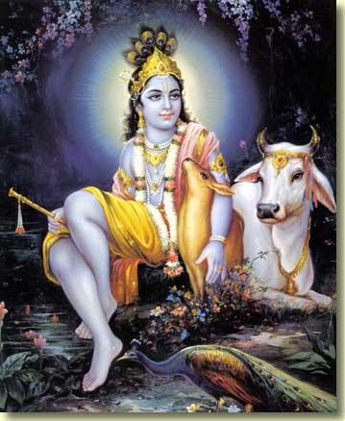

Timisoara, Romania
20 December 2004
I was called to Romania by Murari Krsna Prabhu. It’s no exaggeration to say that he ordered me here. And here he wants me to stay until my health – physical, mental, and spiritual – is completely in order.
Murari Krsna Prabhu is a university professor of computing and cognitive science. He also teaches a course in psychology. I never thought of turning myself over to him, because was considering a guru ought not do that in relationship to a disciple. But he says, “then you saved us, now let us save you. ”
I won’t be writing nearly as much as before in this journal as I will be very engaged by the program he is devising for me. Anyway, there is so much already at this site to read, see, and do.
But from time to time I’ll put an entry in to bring you up to date. If you like this website, then please pray for me. Hare Krsna! Jaya Prabhupada!

Timisoara, Romania
4 January 2005
A short note to let you know things are fine. My situation here is very simple and regulated, with nice association at all times. I have not much opportunity for Internet access, so please understand and not expect to see big texts here in the future. I shall be going to the Mayapur Festival in February-March. HARE KRSNA!



